Batonbearers
Queen’s Baton Relay
January 2022

Batonbearer Selection and Timelines
This document is a summary of the selection process for the Batonbearers for the domestic (England) segment of the Queen’s Baton Relay (4-28 July 2022) and the Queen’s Jubilee weekend (2-5 June 2022). There will be a total of 2022 Batonbearers for the domestic Relay.
Batonbearers for the Relays in Scotland, Northern Ireland and Wales will be selected using criteria set by Commonwealth Games Associations (CGAs) in each country.
The Batonbearer process can be one of the most scrutinised public process of the Queen’s Baton Relay programme. We must ensure that all aspects of the process are carefully considered and can stand up to public scrutiny.
Milestones
Selection Criteria
All Batonbearers will be required to meet the following selection criteria. The criteria are intended to reflect a broad cross-section of society and encourage nominations that align with the themes of the Relay.
A Batonbearer can be someone who meets one or more of the following criteria:

- Always willing to take on a challenge and has a unique and inspiring story.
- Has made a meaningful contribution to sport, education, the arts, culture, or charity.
- Is a figure of inspiration that positively challenges others to achieve their best.
- Has taken on a challenge or cause and made a positive impact within their community
Categories and Allocations
There are five categories of Batonbearer for the QBR domestic sector as listed below.
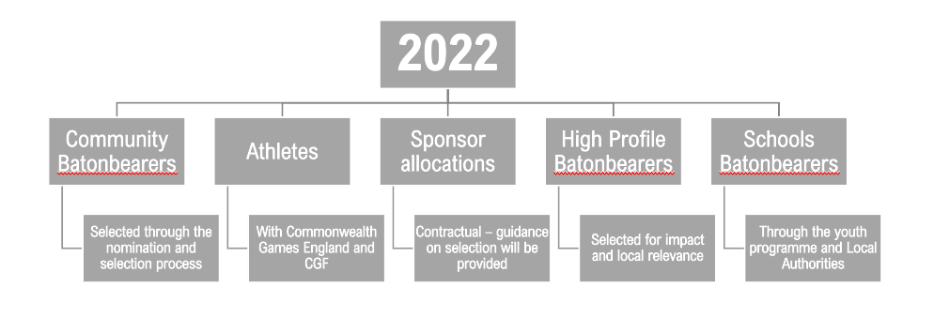
Public Nominations
The public nomination process for Batonbearers will launch on 11 January 2022 and close on 14 February 2022, allowing 4 weeks for the public to make their nominations via the website.
- Nominators will be asked to provide information on how the Nominee meets one or more of the selection criteria (max 100 words).
- The minimum age of Batonbearers is 12, on 2 June 2022 (the first day of the England relay).
- Nominees must be a UK citizen or have permission to reside in the UK between 2 June – 28 July 2022.
- All nominees will undergo a security background check.
- Nominees will be given one week to accept their nomination and provide further details.
- Under 18s will require permission from a guardian to nominate and to accept a nomination.
- All Nominees will be security checked prior to the selection panels.
- Elected officials cannot be Batonbearers in the England relay.
Please submit nominations for Batonbearers via the public nomination process. These will be anonymised and scored by the selection panels based on the story submitted. There is no separate allocation of ring-fenced positions for Local Authorities or Local Authority staff.
Please see ANNEX 1 for a flowchart of the public nomination process.
Pre-selected Batonbearers
Athletes, Sponsor allocation, High Profile Batonbearers and School Batonbearers will be pre-selected by the relevant stakeholder(s).
Pre-selected Batonbearers will be required follow the same selection criteria as the public nominations, however they will not be included in the selection panels.
High-profile Batonbearers
High-profile Batonbearers apply to well-known people and celebrities, it can also apply to a Batonbearer position that is considered high-profile, where we need to select a specific Batonbearer. For example, if we need someone to abseil from a building, we may wish to select someone with experience of abseiling.
High-profile Batonbearers will come from several sources:
- Outreach by Birmingham 2022
- Existing contacts with Local Authorities or venues on the route
- Sponsor Ambassadors
The Batonbearer Operations Team will create a list of all high-profile Batonbearer suggestions to ensure people are not approached multiple times. If your Local Authority has existing contacts with a high-profile individual and would like to approach them to be a Batonbearer, please contact the Batonbearer Operations Team before contacting the individual.
Selection Panels
Nominations will be judged on a regional basis, wherever possible, successful Batonbearers will be allocated to the route that is closest to their home. Selection panels will be formed of 5-8 representatives from a cross-section of the communities in the region they are representing and will be chosen to reflect the themes of the QBR.
In the West Midlands, we will increase the size of the selection panels to reflect the number of Batonbearers required for the region.
Selection Panel representatives will be provided with a toolkit and will meet online prior to the judging process to ensure that all participants are fully informed of the scoring process. Scoring will take place remotely, using the online nomination portal from 14-28 March 2022.
The grid below is representative of the types of organisations we will be approaching to provide individuals for the selection panels. The list is not exhaustive and changes will be made to reflect regional variations.
We will start approaching representatives for the Selection Panels in January 2022.
Theme/Stakeholder | Description | Types of people/organisations
Youth | QBR team, in nation conversations | Youth City Boards  Youth Organisations (identified by Local Authorities)  DofE participants / Prince’s Trust / Scouts / Girl Guiding – other national youth charities
Digital | Smart baton, content team | Science - Universities  Social media influencers, content creators
Common Ground | International relations, modern commonwealth | Regional Charity – working with refugees, disadvantaged people, community cohesion  Local Authority Community Engagement teams
Untold Stories | Athletes stories, Batonbearers | Regional athlete  Local hero – MBE for volunteering as an example, or retired teacher, or foster parent
Journeys that matter | Sustainability, Maximising impact, UNSD goals | LA – Sustainability lead  Charity or social movement – environmental (Surfers for Sewage, Fridays for Futures etc)
Media |  | BBC
Tourism |  | Visit Britain – regional representative
Local Authorities |  | Number will depend on number of LA representatives from other categories listed above  DLUHC, Local Authority representatives in West Midlands

Judging Process
All nominations will be scored by two members of the selection panel to provide a total score. Nominees will be anonymous, with all personal details removed for the judging process.
Scores will be given based on the supporting statement (100 words maximum) provided, following the below guidelines:
0 Does not meet any of the selection criteria
1-9 Below the expectations for a Batonbearer
10-19 Meets the expectations for a Batonbearer
20-25 Exceeds expectations for a Batonbearer

All nominations will be anonymised prior to scoring. Birmingham 2022’s commitment to equality and inclusion will be reflected during the Batonbearer judging process and no nominee will be disadvantaged due to any factor including their age, disability, gender, race/ethnic origin, religious belief or sexual orientation.
If any member of the Selection Panel has been nominated as a Community Batonbearer, then it is imperative that they are not involved with the assessment, scoring and ranking of their application. It is the responsibility of the individual judges to declare any conflict of interest to the QBR Team.
If two nominees score equally, and there are not sufficient spaces to accommodate both, a third judge will score both submissions.

Questions and Answers
General
- Who do I contact if I have a Batonbearer enquiry?
Our help centre https://helpcentre.birmingham2022.com/ has lots of useful information.
- Who can carry the Baton?
Batonbearers, who are inspiring individuals that are striving for change in their community, will have the once-in-a-lifetime role of carrying the Baton. In England alone, there will be around 2,000 Batonbearers that will carry the Baton with pride in July 2022. Batonbearers in England will be nominated by members of the public in recognition of their inspiring achievements and stories.
- Do you have to be a certain age to carry the Baton?
Yes, Batonbearers must be 12 or over before 2 June 2022 (the first day of the relay in England). People aged 12-18 will require consent from a parent/guardian to participate.
- How do I become a Batonbearer?
We will need around 2,000 Batonbearers to carry the Baton through England in July 2022. Batonbearers will be selected following a public nomination process. Nominations will open in January 2022.
Batonbearer nomination selection criteria is as follows:
- Always willing to take on a challenge and has a unique and inspiring story.
- Has made a meaningful contribution to sport, education, the arts, culture, or charity.
- Is a figure of inspiration that positively challenges others to achieve their best.
- Has taken on a challenge or cause and made a positive impact within their community
- How many Batonbearers will there be?
Over 7,500 of Batonbearers will carry the Baton across the Commonwealth, but in England alone, there will be 2,022 Batonbearers.
- How far will Batonbearers carry the Baton?
Each Batonbearer segment is approximately 200 metres.
Nominations
- How can I access the nomination form?
Nominations open at 09:00 on 11 January 2022 and close at 17:00 on 14 February 2022. You can make a Batonbearer nomination by visiting our website at www.Birmingham2022.com.

- What information does the nomination form require?
The nomination form requires you to complete your own name and contact details and to provide your nominees’ first name, surname, email address and to select the Region (in England) where the nominee lives. You will also be asked to write in 100 words or less the reasons why you believe that your nominee meets the selection criteria to become a Batonbearer.

- What is the deadline for nominations to be received?
The deadline for nominations to be made and the application form details to be submitted is 17:00 on 14 February 2022.

- Can I nominate more than one person as a Batonbearer?
Yes, there is no limit to the number of people that you can nominate as a Batonbearer.

- Can I nominate myself as a Batonbearer?
No, everyone should be nominated by someone who recognises your contribution to the local community.

- Do I have to know the person I nominate?
Preferably the nominee should be someone you know from your local area, so you can adequately to tell us in 100 words or less why they meet the selection criteria to become a Batonbearer. You will also be required to supply their email address.

- Will the person I nominate be notified of their nomination?
If you are the first to nominate this person then they will receive an email informing them that you have nominated them and asking if they are willing to accept this nomination as a Batonbearer. If they accept then they will be required to complete the Batonbearer application form. If your nominee has already accepted a nomination, they will not receive further communication as they will already have completed the process. However, all testimonies for a particular nominee will be captured and submitted to the judging panel for consideration and to assist them in reaching a decision.

ANNEX 1 – Public Nomination Flowchart

