Exciting FREE Training Opportunity!
NEW Virtual Sessions in Health Literacy Awareness
Is it your job to communicate with people about health?
Did you know that nearly half of the UK adult population does not have the required literacy skills to routinely understand health information, with even more not having the necessary numeracy skills?
Health Literacy involves:
- people having the skills, knowledge, understanding and confidence to make decisions about their health and wellbeing

and, equally important, it is about:
- the services and systems, that we work in, providing health and social care information and services that can be accessed and understood by everyone who needs them.

Derbyshire County Council’s Public Health team are funding 12 x 2-hour virtual sessions over the next 12 months which will be delivered via Microsoft Teams. They are open to partners across the wider public health workforce who work wholly or predominantly in Derbyshire County.
So if you’re interested in transforming the way you work by understanding more about health literacy and why it’s important…
Then why don’t you register for one of our upcoming online sessions?
- Tuesday 18th January 9.30 – 11.30am
- Wednesday 23rd February 9.30 – 11.30am
- Monday 21st March 1.30 – 3.30pm

To reserve your place on one of the above dates, please complete this Booking Form

(More dates will be released in the coming months for the virtual sessions so do keep checking the Booking Form link to see new dates).

In the meantime if you prefer to access the FREE 35-minute Health Literacy E-Learning module please see details here:

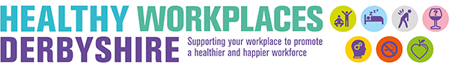
Or for more information contact: ASCH.healthliteracy.admin@derbyshire.gov.uk

