June
Social media posts
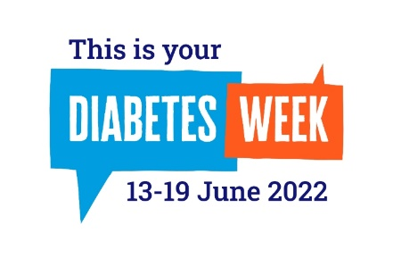
Diabetes Week (13- 19 June)
It's #DiabetesWeek which aims helps tackle the stigma many people
with all types of diabetes feel. Find out more about diabetes, the
risks and how to manage the condition at Diabetes.co.uk here:
https://www.diabetes.co.uk/
During #Diabetes Week find out more about the condition and what
causes it here: https://www.diabetes.org.uk/diabetes-the-basics
Your week. Your voice. Your #DiabetesStories For #DiabetesWeek this year @DiabetesUK will be telling #DiabetesStories from all corners of the UK. Why not share yours too? You can share your story online here: https://forms.office.com/Pages/ResponsePage.aspx?id=ttpCandJoEqPigWE3_m10g_dn8ywMs1Ntd_azEIWZd5UNkJEWDJVOEo2SU1aOENXRzlXRVlCU0xZSi4u
Men’s Health Week (13 - 19 June)
#Men’sHealth Week aims to raise awareness of preventable health issues and encourage men and boys to seek professional advice for health-related problems.
Find out more https://www.menshealthforum.org.uk/mhw
Men - is it time for a health MOT? During #MensHealthWeek the Men's Health Forum is encouraging you to see if you can get healthier. Find out more here: https://www.menshealthforum.org.uk/mhw

Cervical Screening Awareness Week (20 - 26 June)
During #CervicalScreening Awareness Week it’s time to talk about how to make the test better. Find out more here:
https://www.jostrust.org.uk/get-involved/campaign/cervical-screening-awareness-week#:~:text=During%20Cervical%20Screening%20Awareness%20Week,cervical%20screening%20(smear%20tests)
It’s #CervicalScreening Awareness week. Find out more about what it involves, and why it’s so important to take up your invitation. https://www.jostrust.org.uk/information/cervical-screening/what-happens-during-cervical-screening
If you, or someone you know, has concerns or questions about #cervicalcancer then Jo's Trust can help. Can them to talk through anything you need to: https://www.jostrust.org.uk/get-support/helpline

June
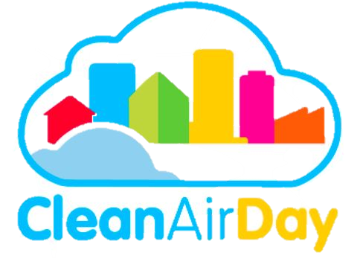
National Clean Air Day (16 June)
#NationalCleanAir Day is a chance for the whole country to
come together and improve air quality through collective action.
Find out more here: https://www.cleanairday.org.uk/

What small steps can we take to help improve the air that we all breathe? Find out more about the little changes that can make a big difference during #CleanAirDay https://www.actionforcleanair.org.uk/campaigns/clean-air-day

Newsletter /intranet / payslip letter messaging
Diabetes Week (13 - 19 June)
Diabetes afflicts more people in the U.K. than any other serious health condition. One in 15 people in the UK have diabetes, including one million people who have type 2, but haven't been diagnosed.
Diabetes can have serious, long term health impacts so it is important to be aware of the disease, the risk factors and how to manage the condition. Around 8% of people in the UK have Type 1 diabetes and while it is not preventable it is manageable.
Type 2 diabetes is preventable in the majority of cases. Changes to lifestyles and diet can help prevent it along with the risk of serious complications that can come with it.
Find out more about Diabetes, the risk factors and how to manage the condition online here: https://www.diabetes.org.uk/

Cervical Screening Awareness Week (20 - 26 June)
Around 3,200 women are diagnosed with cervical cancer in the UK each year and more than half of cases in the UK are diagnosed in women aged 45 or under.
But the good news is that the majority of cervical cancers are preventable, or highly treatable if caught early.
That’s why it’s so important to take up your cervical screening invite when you receive it.
To find out more about what to expect, and why it’s so important to attend your screening, online here: https://www.jostrust.org.uk/information/cervical-screening/what-happens-during-cervical-screening

Clean Air Day (16 June)
June 16th is National Clean Air Day. A chance for the whole country to get talking about air pollution and how we can all help tackle it.
Whether that’s walking to work, campaigning for clean air zones or getting involved in spreading the word, there’s lots that we can all do to help improve the air that we breathe.
Find out more about Clean Air Day, and what you can do to help support it, online here: https://www.cleanairday.org.uk

