Promoting the North Derbyshire Recruiting Talent Event:
For press releases:
Please use the information below:
Smaller Article:
Businesses in North Derbyshire can learn how to improve their chances of recruiting the right people at an event next month.
The D2N2 Recruiting Talent series, which has held events in Derby city and Nottinghamshire since 2019, is expanding into a new area for organisations in Chesterfield, Bolsover and North East Derbyshire.
It will help employers to understand the current landscape around employment and skills in North Derbyshire with a keynote address, act as a catalyst for positive change to help firms adapt to better prepare for their future recruitment needs, showcase the benefits of inclusive recruitment with case studies, and adapt recruitment practices to encourage more local people to work for their business.
The series brings together local businesses and experts, with partners including the Chamber, D2N2 Local Enterprise Partnership, Building Better Opportunities stakeholder managers, local authorities and employment support agencies.
The Recruiting Talent in North Derbyshire event takes place at Chesterfield College on 19 July from 8.15am to 12pm. To register, visit bbo-d2n2.org.uk/events/rtnderbys
Larger Article:
Recruiting Talent moves into North Derbyshire
Since 2019, D2N2 Recruiting Talent events have taken place across Derby City and Nottinghamshire, focusing on Inclusive Recruitment. Hundreds of businesses have attended the workshops and networking activities, with experts from a range of organisations helping them to recruit future talent by using more inclusive approaches.
An event is now being planned for North Derbyshire (Chesterfield, Bolsover and North East Derbyshire) taking place on 19th July 2022.
Recruiting Talent is bringing together local businesses and experts. Its partners include: D2N2 Local Enterprise Partnership, Department of Work and Pensions, East Midlands Chamber (Derbyshire, Nottinghamshire, Leicestershire), County and Borough & District Councils, Building Better Opportunities Stakeholder Managers and Local Business Clubs in each district.
The event will:
• Help employers to understand the current landscape around employment and skills
• Include a keynote address from a range of partners
• Act as a catalyst to positive change around recruitment enabling employers to better prepare and adapt to meet their future recruitment needs
• Showcase the benefits of inclusive recruitment, with case studies and input from employers who are reaping the benefits of increased productivity and growth
• Show how you can change the way you recruit to encourage more local people to work for your business and the opportunity to tell us what support you need to make this happen
• Help to change the way you work to retain your best talent
• Highlight how your Local Enterprise Partnership (D2N2) and other partners can help your business to increase productivity
If you are an employer in North Derbyshire, come along to share good practice and find out more.
Book or register your interest for the Recruiting Talent event here:
North Derbyshire Recruiting Talent – 19th July 2022 8:15am – 12pm:
RECRUITING TALENT in North Derbyshire 19/7/22 Registration, Tue 19 Jul 2022 at 08:15 | Eventbrite
For more information or media enquiries on these events contact:
Rosie Morton - Derbyshire Stakeholder Manager via rosie.morton@derbyshire.gov.uk or 07850503171
Mike Reid – Derby City Stakeholder Manager via mike.reid@derby.gov.uk or 07850503192

Posting on social media:
Post image of the poster or banner with the following text:
Want to know how best to recruit for your business? Join alongside @D2N2LEP, @DerbyshireCC @nedDC @BolsoverDC @ChesterfieldBC and others on Tuesday 19th July 2022 to learn, share, and discuss new ways of recruiting talent. #RT2022 Sign Up: https://bit.ly/3moOu1I
(Banner)
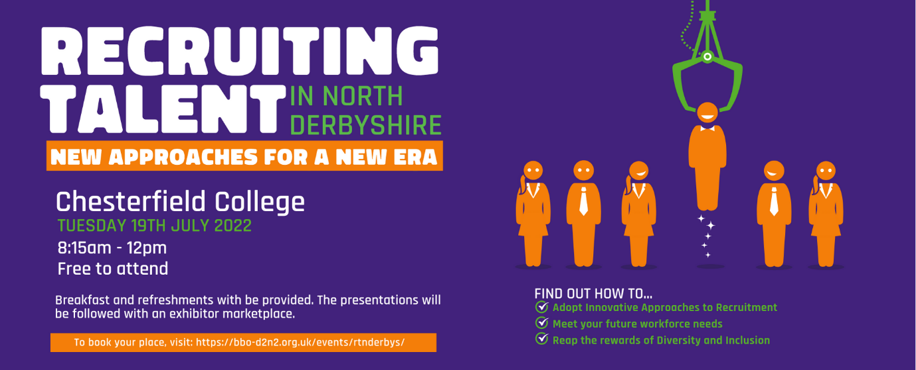
(Poster)
Emailing out to business networks and contact lists:
Please email out to businesses through your existing networks inviting them to the event and please chase / provide reminders to book on a week before the event.
Please use the following email draft:
EMAIL SUBJECT HEADER <<<(PLEASE REMOVE BEFORE SENDING): BOOKING OPEN - Recruiting Talent in North Derbyshire 19 July 2022
Recruiting Talent in North Derbyshire is an inclusive recruitment event aiming to bring together local businesses and experts to help your business to recruit your future talent.
Taking place at Chesterfield College, the event will:
- Help employers to understand the current landscape around employment and skills in North Derbyshire
- Keynote speeches from a range of partners including SME businesses demonstrating how inclusive recruitment has benefitted their business
- Act as a catalyst to positive change around recruitment enabling employers to better prepare and adapt to meet their future recruitment needs
- Showcase the benefits of inclusive recruitment, with case studies and input from employers who are reaping the benefits of increased productivity and growth
- Understand how you can change the way you recruit to encourage more local people to work for your business and what support is available to make this happen
- Help to change the way you work to retain your best talent
- Find out how your Local Enterprise Partnership (D2N2) and other partners can help your business to increase productivity
Breakfast and refreshments will be provided, and the event will be followed by a networking session providing the opportunity to meet local partners that can provide further support.
If you are an employer in Bolsover, Chesterfield, North East Derbyshire and the surrounding area book your place now!
Book here: RECRUITING TALENT in North Derbyshire 19/7/22 Registration, Tue 19 Jul 2022 at 08:15 | Eventbrite

