HARC ADVERT FOR VOLUNTEER CENTRE NEWSLETTER

A bit about HARC….

HARC has been providing a safe and warm day shelter in Sheffield city centre for homeless, rootless, and vulnerable people between Christmas and New Year since 1989.

As well as three hot meals a day, we also provide some guest services such as hairdressing, podiatry, and access to emergency accommodation advice.

This year we will be opening from Christmas Eve to New Year’s Day.

You can find out more information on our website - https://www.harcsheffield.org.uk/

Where are we?

Last year, we moved our project to the Lower Hall at Victoria Hall, Norfolk Street, Sheffield S1.

Volunteering for us

We have several volunteer roles available –

General volunteers
- Socialise with guests. Chat and play games.
- Welcome guests and monitor those entering the project
- Work in the clothing store
- Help with activities (games, bingo etc.)
- Serve meals to guests at mealtimes and clear up afterwards
- Serve hot and cold drinks and snacks to guests

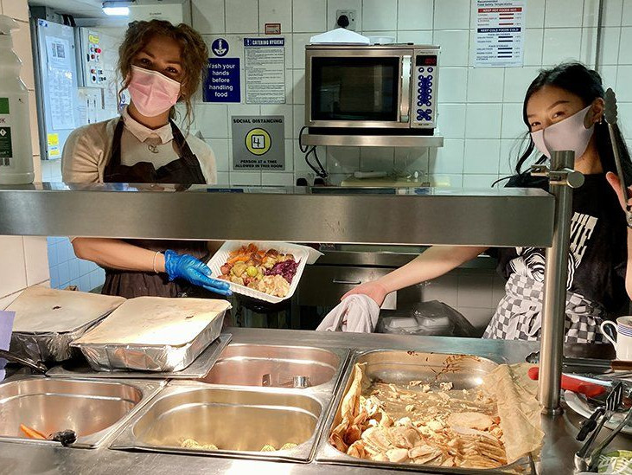

Kitchen volunteers
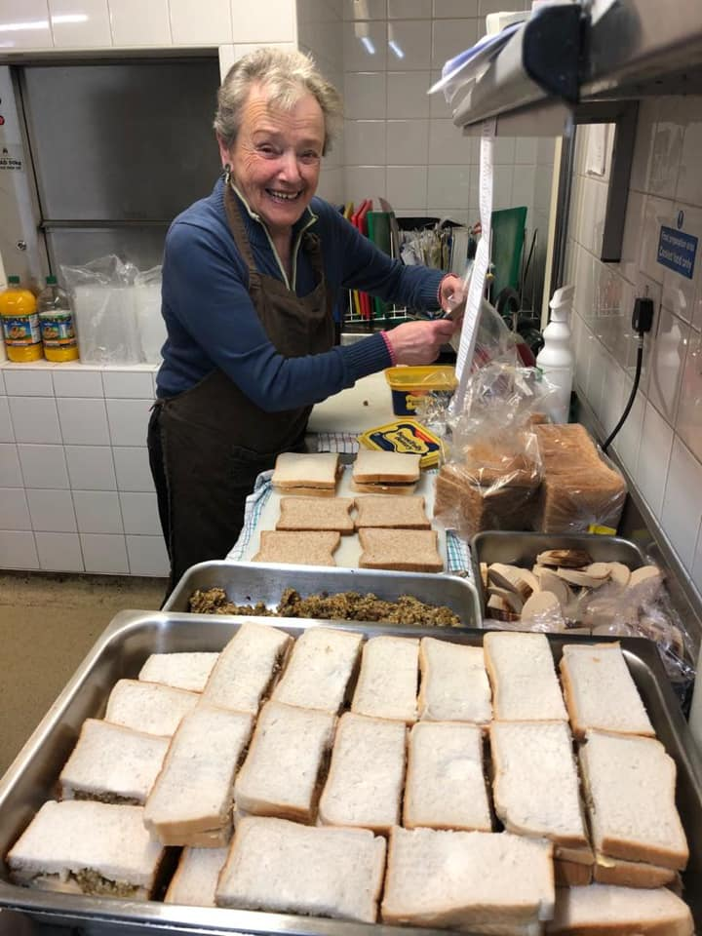
- Prepare and cook food
- Plate up food
- Work with general volunteers to get food to guests efficiently
- Clean kitchen equipment and carry out other kitchen duties
- Help with maintaining the food store

Community Ambassadors

We have a small team of community ambassadors to help inform about and promote the project. It helps if you have been a general volunteer so that you have experience of the project. You should also be confident with public speaking. We now have a projector to help with presentations.
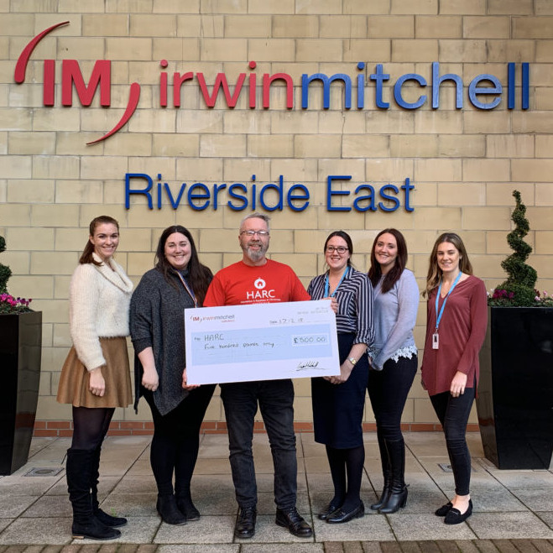
What would I do as a community ambassador?
- Speak to groups about the project
- Thank people for their donations
- Attend fundraising events
- Attend photo opportunities
- Occasionally take part in a radio interview
- Promote and inform about the project wherever possible

How do I sign up to volunteer?

If you are interested in volunteering, we open our recruitment on Monday 10th October 2022.

On this day, we will put a volunteer application form onto our website. Once we have received this, we will process your application and send you log in details to our online shift booking system, and send you details of our volunteer training.

If you can’t access the form for any reason, or would like to be added to our mailing list prior to October, please drop us an email at harc.sheffield@virgin.net

