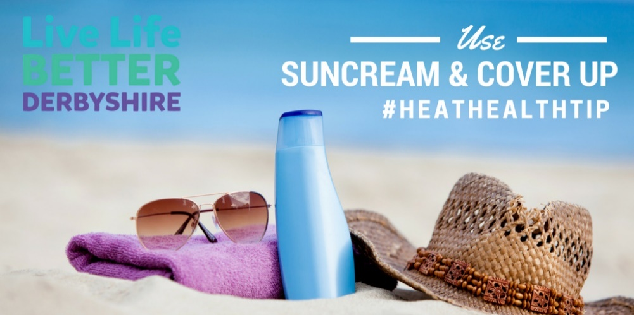

**Stay cool**

Avoid direct sunlight during the hottest times of the day from 10am – 4pm

**Be Prepared**

Between 1st of June and 15th of September the Met Office has heatwave alerts which comprises of levels 0 – 4. Please consider signing up for alerts on the link [Heat Health - Met Office](https://www.metoffice.gov.uk/public/weather/heat-health/?tab=heatHealth&season=normal) Useful information can also be found here Beat the heat: staying safe in hot weather - GOV.UK (www.gov.uk)

**Staying safe indoors**

Monitor and record indoor temperatures Ensure thermostats are working in their house/your organisation so you can monitor temperatures

Keep curtains closed especially in rooms when the sunlight comes through

Be aware plastic pads and mattresses can be particularly hot during a heatwave

Create cool rooms/cool areas 26 0c or below

Once the temperature outside has dropped lower than the temperature inside, open the windows - this may not be until very late at night or the early hours of the morning.

Turn off unnecessary electrical equipment and lighting

Fans - it is important that fans are cleaned. So should be added to their usual cleaning schedule.

Discuss cooler food options with high water content such as fruit and salads with your loved one or at-risk person

**Did you know..**

* Severe heat can be dangerous and even prove fatal in some cases
* Some people are more vulnerable to hot weather than others.
* Some of the factors that increase people’s risk include but are not limited to, age, chronic or severe illness, some medications and those who are unable to adapt their behaviour to keep cool.

**The below information can help keep people more vulnerable to heat stay safe**

**Keeping safe during hot weather**

**Remember:**

 The best way to enjoy the suns safely and protect your skin is to use shade, clothing, and sunscreen

 Shade and clothing are better than sunscreen at protecting your skin.

Checkmark with solid fill Sunscreen shouldn’t be used to spend longer in the sun. But they can be useful for protecting the parts of the body not covered by clothing or shade.

**If you suspect someone has heat stroke dial 999** [Heat exhaustion and heatstroke - NHS (www.nhs.uk)](https://www.nhs.uk/conditions/heat-exhaustion-heatstroke/)

**Staying safe outside**

Dress in loose-fitting, light-coloured clothing that covers as much of the body as possible.

Hats should be worn that shade the face, neck, and ears.

Apply sunscreen before going outdoors and reapply every 2 hours.

Stay in the shade as much as possible.

**Stay hydrated**

Provide and encourage frequent drinks to stay hydrated, make sure they are easy to access all day