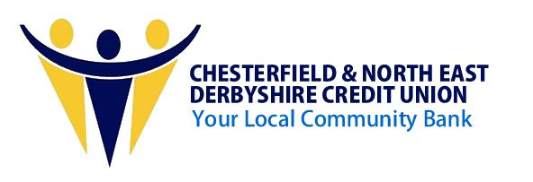
Your Community Bank is here to Help
If Inflation, increased fuel bills and tax rises are putting your finances under strain, perhaps your Community Bank could help ease the pressure.
Chesterfield and North East Derbyshire Credit Union is a not-for-profit financial co-operative owned and controlled by its members and based in Chesterfield. We offer a range of loan and savings products designed to help our members make the most of their money. Members typically borrow for home appliances, holidays, home repairs, paying bills and back to school. We will consider most reasons to borrow and all loans are at fair and reasonable rates of interest with flexible repayment terms.
The Community Bank is here to help and you do not need savings or a perfect credit record to get a loan. Saving is however regarded as important and all members are encouraged to save as they borrow. As Manager Alan Ward says: “Learn to save, it can be done. When you borrow from us, it’s your fellow members’ savings you are borrowing, so you need to be mindful of the trust placed”. (All loans are subject to affordability and credit checks).
CNEDCU’s services are available to everyone who lives or works in Derbyshire. For more information about joining, borrowing from and i saving with your Community Bank see the Community Bank website.
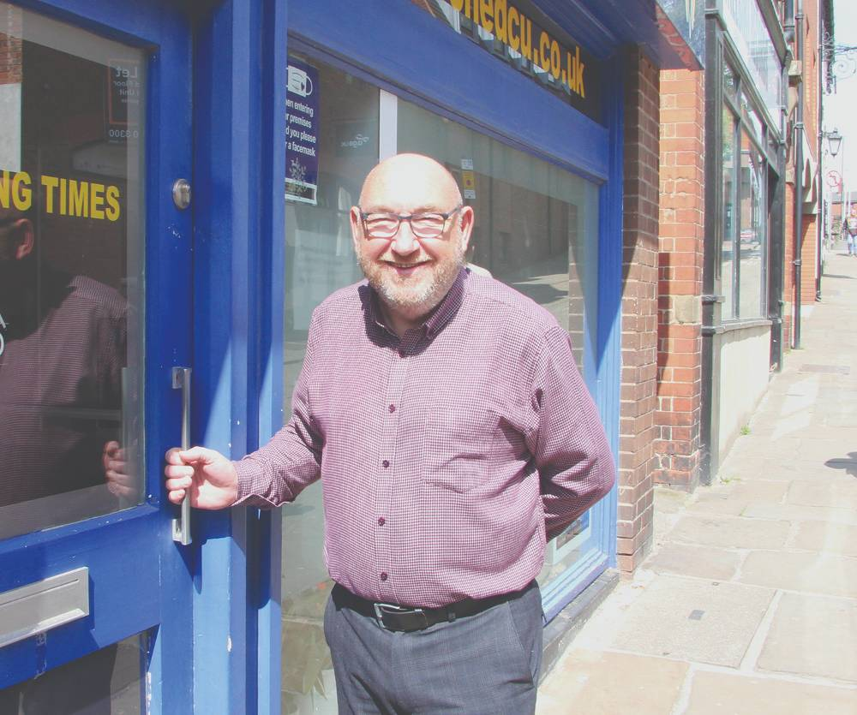
Pictured: Manager of Chesterfield and North East Derbyshire Credit Union, Alan Ward at the office on Soresby Street, Chesterfield.

