The Social Action Hub is a community support organisation based in Rainworth, Mansfield, which became a registered Charity in the spring of 2003. It originally formed in 1993 in response to the social and economic issues that arose after the closure of local pits.
There are a variety of projects running from their premises at Kirklington Rd, Rainworth, including a youth club, monthly social eating events, play schemes and a Social Supermarket.
The scheme is supported and run by both paid staff and volunteers.
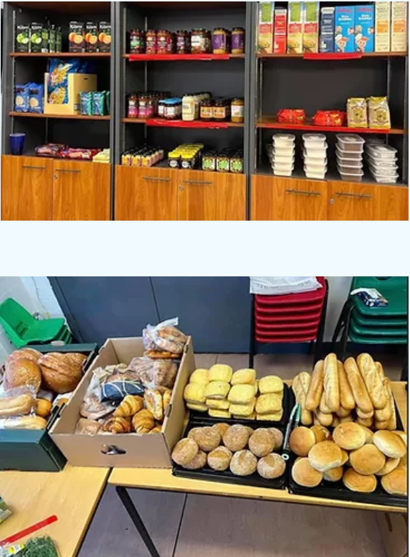

Produce seen in the
Social Action Hub’s
Social Supermarket

The Social Action Hub’s most recent project is to purchase a community fridge, which for them will be a Youth Community Fridge (it has only been running for a few weeks). This has been purchased through the Community Fridges | Hubbub Foundation scheme. The fridge will offer free or subsidised food, available in the evenings, for the families of those attending the youth clubs and summer play schemes. The social supermarket already receives food supplies from Fareshares, a regional organisation who redistributes surplus food to charities, and local supermarkets, including ASDA, Tescos and Marks & Spencers.
There is a weekly membership fee of £3.50 for people using the social supermarket and volunteers collect donated produce from the supermarkets and upkeep the store.
The Social Action Hub continues to evolve its services and projects to meet community needs and there are currently 7 Trustees made up of local community members and people who have an interest in the area.
You can read more about what the Charity does through their website: The Social Action Hub

