Bolsover Woodlands Trust

Jayden Scott, one of our Community Engagement Trainees, interviewed Karen Sansom, the newly appointed Wellbeing Officer with Bolsover Woodland Enterprise. This venture has its base in the Business park off Woodhouse Lane, Bolsover.

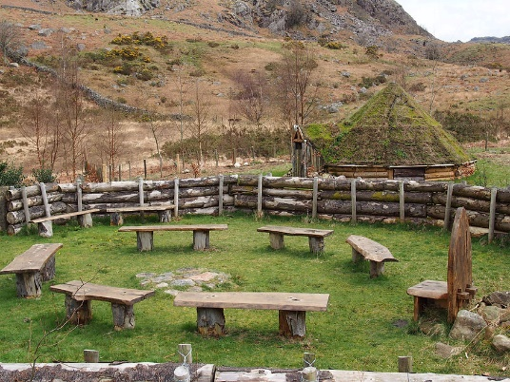
Jayden asked Karen, “Can you give me a few sentences or paragraphs about what you do, and what services you offer?”

Karen told Jayden about the support provided to adults with learning disabilities. Tasks include learning woodland and countryside management skills by taking participants out to work on countryside projects. The projects can include tree planting, tree felling, path clearances and orchard management. Most of the wood that is felled is used to make products like birdhouses and furniture. They also don’t waste any wood because all unused wood gets sold as logs, shavings or bark. Eskdale’s Story Telling Circle,
Created by team members.
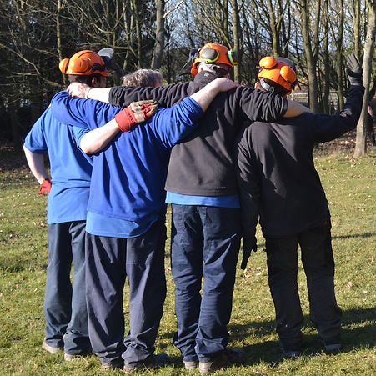

“How many volunteers do you involve, and what do they do?”

Bolsover Woodland Enterprise prefer the term team member and their workforce consists of 34 team members. Team members are service users who volunteer their time and in return get skills. The enterprise does also have other volunteers to support the welfare of staff and team members. These volunteers also help organise any events BWE may want to do.

“Have you been involved with Bolsover Together / Bolsover CVS? How do you think we could support you or help you develop?”

This was Karen’s first contact with BCVS personally but she has been signed up to the newsletter and she signposts it to the rest of the organisation. Karen stated that BCVS could support BWE through supporting volunteer retention and engagement as they need more volunteers to help support staff and team members in the country side.

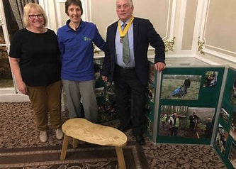

Edwina Edwards, Enterprise Manager, with members of Bolsover Rotary.

You can read more about the Bolsover Woodlands Enterprise on their website;
Home | Mysite (bolsoverwoodlands.org)

