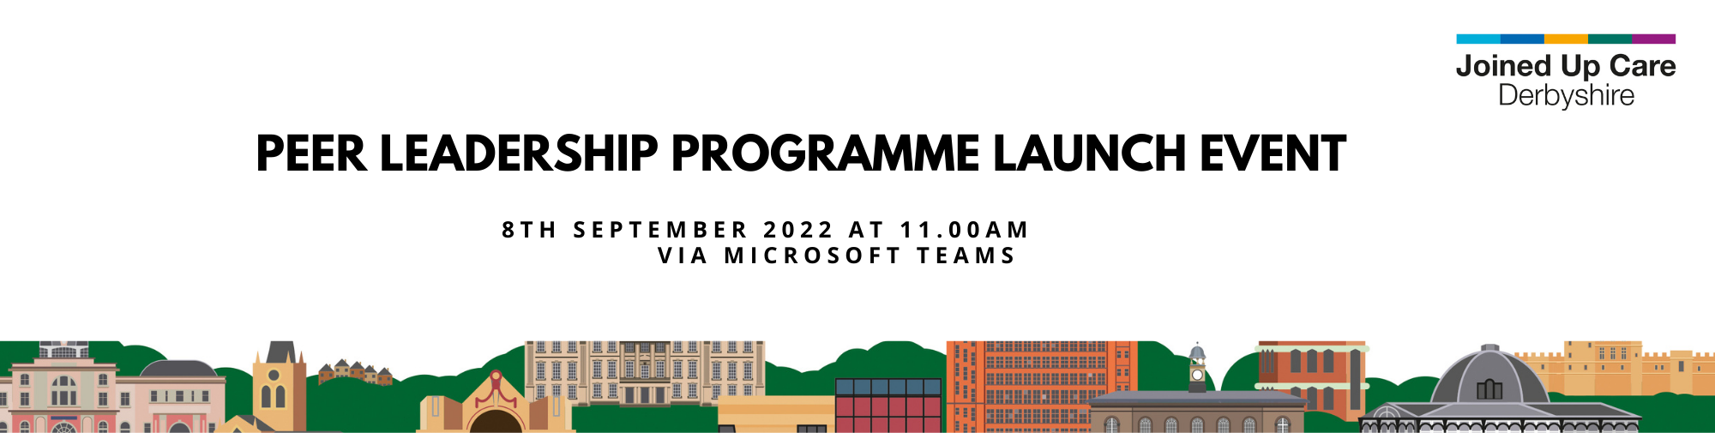

Exciting new opportunity to join our 'Peer Leadership Programme'
You are invited to the exciting launch of our Peer Leadership Programme on 8th September 2022 at 11.00 am.
In Derby and Derbyshire, our Integrated Care System (ICS) is known as Joined Up Care Derbyshire. Integrated Care Systems bring together the NHS, local authorities and the voluntary sector, to provide people with personalised care. It takes into account individual needs, preferences, and circumstances and is based on ‘what matters to you’. for their health and wellbeing.
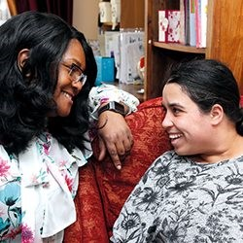
To do this well, we need to listen to what matters most to people in Derby and Derbyshire. We can only do this, by involving those who use our services, particularly who are living with long term conditions, disabilities or who are carers. Therefore, we are excited to offer a free personal development programme, called the Peer Leadership Development Programme, in partnership with NHS England.
The aim of the programme is:
- To tell people what personalised care is and how this can benefit them.
- To develop new Peer Leaders. Peer Leaders are people with lived experience of using health and care services and who would like to work together with the ICS to shape and influence how health and care is delivered.
Who is the programme for?
It is mainly aimed at people with long-term health conditions, disabilities or who could benefit from personalised care, but it is also suitable for people working in the health, care and voluntary sector.
What can you expect on the Peer Leadership Development Programme?
The course is delivered online, through an accessible learning platform called Future Learn. It is organised into bite-size chunks using language that is easy to understand. It also includes videos with sub-titles and transcripts. Every stage of the programme is designed to support you to learn through storytelling, discussion, visual aids and lots of support to celebrate progress. There will be opportunities to discuss your thoughts and experiences with other learners. Throughout the programme you will hear from people who have experienced the benefit of personalised care and inspiring stories will be shared from Peer Leaders who are guiding how personalised care is developed and delivered. This is all within the comfort of your own home!
The programme begins by helping build your knowledge, skills and confidence about personalised care. Then as you move through the programme, you’ll be encouraged to reflect on these skills, qualities and behaviours that enable you to be a good Peer Leader.
The first two stages of the programme run continuously so you can join at any time.
The third stage of the programme is more in depth and builds on the learning of the first two stages. This will be about learning to become a peer leader and is open to people with lived experience. You will be invited to join this part of the course, if appropriate and will be asked to join specific training every week for 3 weeks.
We are delighted to be able to offer this personal development programme. Not only will you have the chance to reflect on your own experience and how you do things, but you’ll be also learning alongside other people with lived experience. If you can complete all 3 stages, you will have further opportunities to:
- Become involved in ICS activities, that will help shape and influence how health and care services in Derbyshire are delivered.
- Apply for regional and national opportunities to shape and influence health services.
- Take the learning further and become a Peer Leader Facilitator, to support other people through the programme.

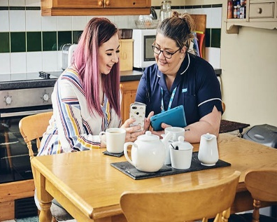
If you would like to get involved, please book a place at the launch event here. This will give you an opportunity to hear more about the programme and meet others with a similar interest.
If you are unable to attend the launch event, we can chat with you separately about the programme, by emailing ddicb.engagement@nhs.net
You can find out more about what the programme entails here.
We will be following up with participants on the programme at regular intervals to offer support and answer questions, so please put the following dates in your diary as well as the launch event:
- 5th October 11am – 12 noon
- 3rd November 11am – 12 noon
