If you
’
re worried
about money,

talk to us

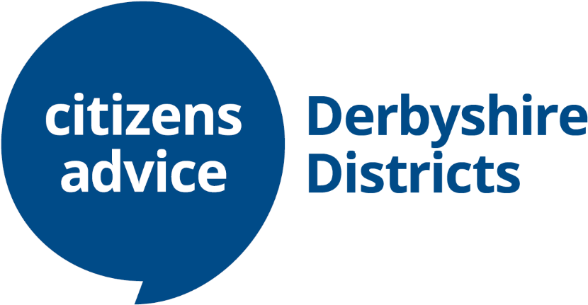
Our advisers can help you find a way forward with advice on energy, benefits, debt and money issues, housing, access to grants, schemes and other support.
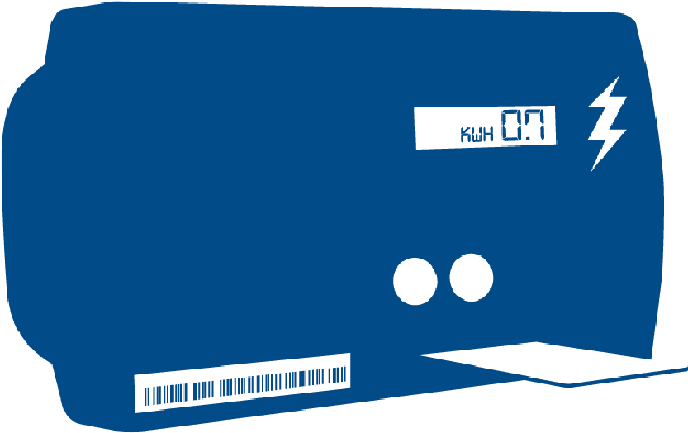
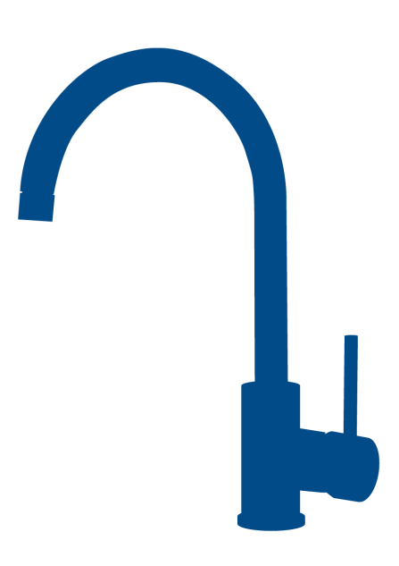
Did you know we can also help by…
Issuing free pre
-
payment
meter energy vouchers

Providing sim cards with up to six months
worth of free data, calls and texts

Reducing your water bill via

the big difference scheme

Call our freephone Adviceline on

Making referrals for food parcels

0808 278 7954 open Monday-Friday 9am-4pm
You can access via text relay by calling 18001 then our Adviceline number or you can access us online at
www.citizensadvicederbyshiredistricts.org.uk

