East Midlands Devolution

East Midlands Devolution Public Consultation Toolkit

#Eastmidlandsdevolution

East Midlands Devolution

- More investment in our area

- Economic growth

- More and better jobs

- Better transport, skills training, housing

- An enhanced greener environment

- More power in local hands

Your chance to have your say on devolution in the East Midlands

Introduction
Earlier this year the leaders of the four county and city councils in Derbyshire, Nottinghamshire, Derby, and Nottingham were offered a historic devolution deal by the Government.

Since August the four councils have been looking at details of how devolution would work locally, and how new functions and powers could be established to access increased investment from national Government to our region.

Devolution would mean more local control, and £1.14 billion of funding from 2024. The new local powers and funding would be used on key areas such as transport, adult skills, the economy, housing, regeneration, and improving the environment.

Devolution would result in more important decisions could be taken in the East Midlands by people who know and understand the region, to bring benefits to people who live in, work in, or visit Derbyshire, Nottinghamshire, Derby, and Nottingham, to improve quality of life.

Devolution would also mean a directly elected regional mayor covering both counties and cities, with an election taking place in May 2024.

Devolution would mean:

- £38 million a year for 30 years from 2024, addressing years of historically low investment in our region – the joint largest Investment Fund in the country.
- An extra £16.8 million for new homes on brownfield land.
- Control over a range of budgets like the Adult Education Budget.
- £18 million to support housing and Net Zero ambitions in the East Midlands.
- New and better standards for homes, low carbon measures, and improvements to existing housing could be made.
- New smart integrated ticketing on public transport and new concessionary fare schemes could be developed
- New commercial spaces could be developed to attract businesses and new jobs
- Retrofit measures could be put in place, as well as clean heat coordination, and a local energy plan, which could generate new jobs.
- A directly elected regional mayor for Derbyshire, Nottinghamshire, Derby and Nottingham.

The public consultation
A public consultation on devolution in the East Midlands, which includes proposals for a directly elected regional mayor, will be held from 14 November 2022 to 9 January 2023.

Steps are being taken to ensure the consultation is as accessible as possible to people across the area and other interested parties.

- An online survey will be available from 14 November to 9 January. A link to the survey will be added to www.eastmidlandsdevolution.co.uk/have-your-say

- A link to the online survey will also be added to the websites of Derbyshire County Council, Nottinghamshire County Council, Derby City Council and Nottingham City Council.

- Print copies of the survey, or copies in alternative languages, can be requested by emailing eastmidlandsdevolution@ipsos.com or calling 0800 260 0536.

- Completed print versions of the survey can be sent in by post using the freepost address which is included on printed copies of survey.

- Local organisations are encouraged to share details of the consultation with their local networks. This toolkit is intended to support that effort.

The consultation will be publicised to local and regional media, will be supported by a social media campaign and there will also be communications with partners and key stakeholders across the region to ensure the widest possible audience knows about the consultation and has the opportunity to contribute.

The consultation will also be publicised at events taking place in the lead up to and during the consultation period.

Purpose of this toolkit
Securing this historic opportunity for devolution is good news for our region. However, it is vital that people can have their say on the proposals through the public consultation. It is important that any proposed changes to governance, decision-making and funding arrangements meet the needs of local communities.

The four county and city councils want to give as many people as possible the opportunity to take part in the consultation. This toolkit aims to provide organisations and individuals who want to promote the public consultation on East Midlands devolution with materials to help them do that.

It includes:

- Key messages
- Social media assets
- Media content
- Website and newsletter content
- Stakeholder e-mail
- Supporting messages and proof points
- FAQs
- Key contacts

Key messages
The East Midlands devolution public consultation centres on the following key messages:

- More funding for our area: devolution will give our region more funding and powers to improve transport, adults skills training, housing, the environment, and to encourage the creation of good quality jobs that give people a decent standard of living and a better quality of life.
- More decisions about the East Midlands taken in the East Midlands: devolution is a chance for the people who live in our region to have a much greater say over issues that affect them, including by directly electing the first regional mayor for our area.
- More opportunities for our region: devolution will provide us with more of the tools to help our area recover from Covid-19 and put us at the front of the queue for further devolution of funding and powers in future.
- Have your say: this consultation is your chance to have your say on devolution, which will shape the future of our region for many years to come.

The devolution deal covers Derbyshire, Nottinghamshire, Derby and Nottingham.

Put simply if the devolution proposal is approved it would mean:

- significantly more funding for services in our region
- more major decisions made locally, near the people they affect
- our region has a bigger voice.
- The opportunity to level up the East Midlands following years of under-investment.

Devolution plans are all about getting a better deal for our area. We don’t want to miss out on this opportunity.

This is not about local government reorganisation, and no local councils will be abolished or merged.

When publicising the consultation in your area, please localise messages where possible, for example ‘People of Mansfield: have your say on devolution.’

Timing
The consultation will run from 14 November 2022 to 9 January 2023, providing eight full weeks for people to consider the proposals and provide responses to the consultation.

Social media
Social media assets and content are available for you to use across your social media channels to promote the East Midlands devolution consultation. Example assets are below. For more content and assets, please email your local council contact (see Key Contacts, on page 18). Please also share posts about devolution where possible.

To signpost people to further information, including a link to the online survey, please use:
www.eastmidlandsdevolution.co.uk

The hashtag is #Eastmidlandsdevolution

Individuals and organisations you may wish to tag on Twitter include:

- Derby City Council @DerbyCC
- Derbyshire County Council @Derbyshirecc
- Nottingham City Council @MyNottingham
- Nottinghamshire County Council @NottsCC
- Michael Gove, Secretary of State for Levelling Up, Housing and Communities: @michaelgove
- UK Prime Minister: @10DowningSt
- Jeremy Hunt, Chancellor of the Exchequer @Jeremy_Hunt
- Ministry of Housing, Communities and Local Government @mhclg
- Lee Anderson MP, Member of Parliament for Ashfield @leeandersonmp
- Brendan Clarke MP, Member of Parliament, Bassetlaw @Bren4Bassetlaw
- Darren Henry MP, Member of Parliament, Broxtowe @DarrenG_Henry
- Tom Randall MP, Member of Parliament, Gedling @Tom_Randall
- Robert Jenrick MP, Member of Parliament, Newark @RobertJenrick
- Ruth Edwards MP, Member of Parliament, Rushcliffe @MsRuthEdwards
- Mark Spencer MP, Member of Parliament, Sherwood @Mark_Spencer
- Pauline Latham MP, Member of Parliament, Mid Derbyshire @Pauline_Latham
- Sarah Dines MP, Member of Parliament, Derbyshire Dales @Dines4Dales
- Robert Largan MP, Member of Parliament, High Peak @robertlargan
- Nigel Mills MP, Member of Parliament, Amber Valley @nigelmills
- Toby Perkins MP, Member of Parliament, Chesterfield and Staveley @tobyperkinsmp
- Lee Rowley MP, Member of Parliament, North East Derbyshire @Lee4NED
- Maggie Throup MP, Member of Parliament, Erewash @maggie_erewash
- Heather Wheeler MP, Member of Parliament, South Derbyshire
- Amanda Solloway MP, Member of Parliament, Derby North @ASollowayUK
- Lilian Greenwood MP, Member of Parliament, Nottingham South @LilianGreenwood
- Alex Norris MP, Member of Parliament, Nottingham North @AlexNorrisNN
- Nadia Whittome MP, Member of Parliament, Nottingham East @NadiaWhittomeMP

Example social media assets:
Place focused imagery – which could be used by all partners:

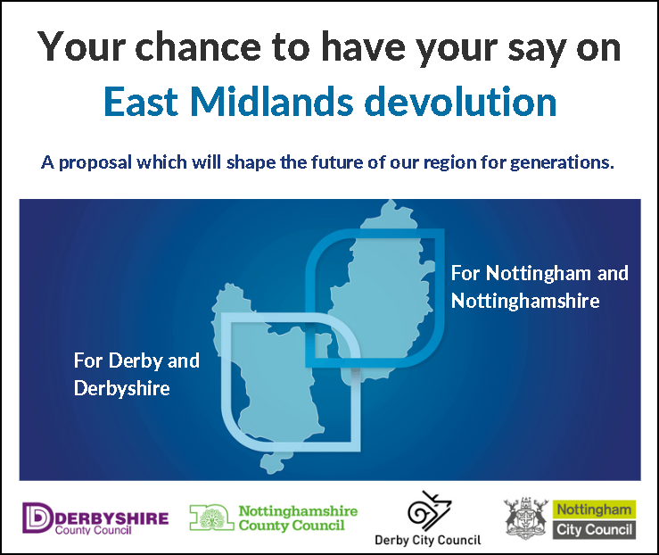

People-focused imagery – which could be used / shared by all partners:

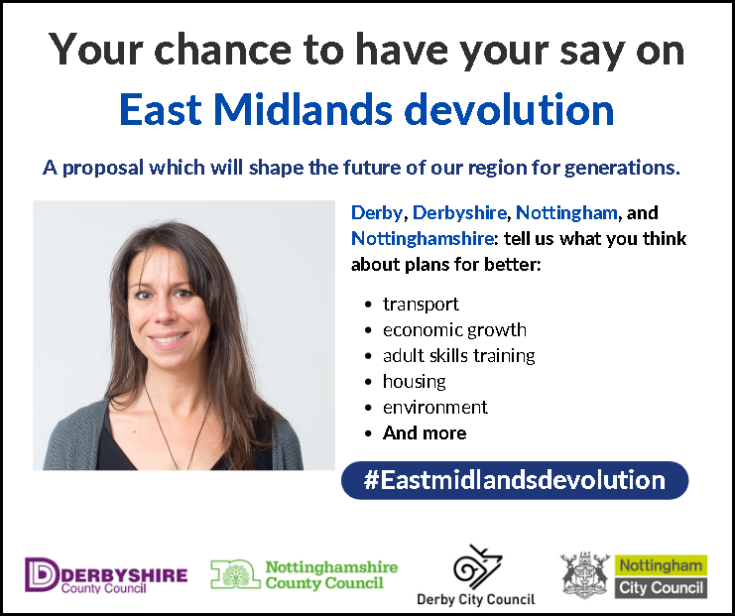

Imagery focused on aspects of the deal – which could be used / shared by all partners:

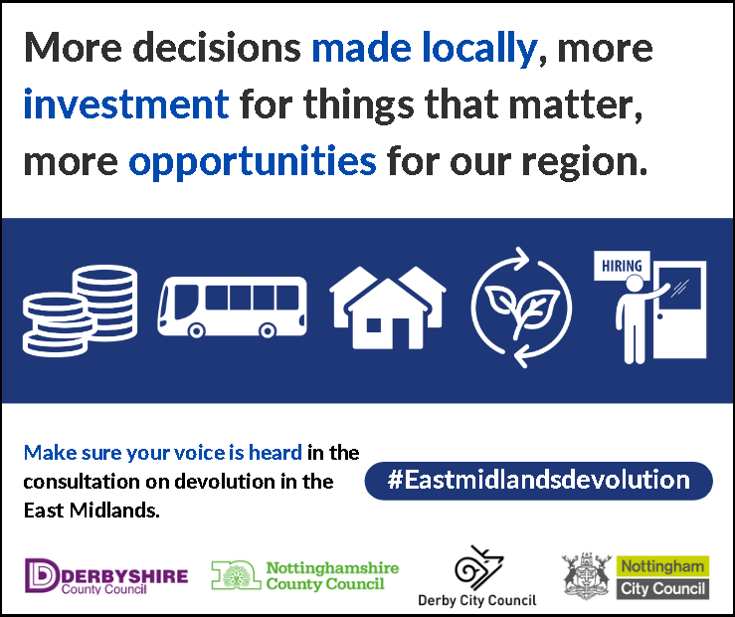

Media content

Local and regional media content will be a key part of the communications strategy to promote the opportunity for the people of the East Midlands to have their say during the eight-week consultation period. The timescale enclosed (Appendix 1) sets out key milestone dates in the leadup to the consultation and beyond it.

The four county and city councils will be sending out press releases, which will include quotes to the local media referencing the key messages set out above and may be asked for statements and responses to questions which could appear in the media.

If your organisation can support this aspect of the consultation, you would like to discuss this, or talk about media opportunities, please get in touch with communications contacts (see “Key contacts” section on the final page of this document).

We’d be very grateful if you could keep us informed of any local media coverage you generate, so that we can keep a log of all activity.

Press release announcing devolution consultation
A copy of the press release announcing the devolution consultation, after all city and county councils agree to go ahead with public consultation, is available on each of the four councils’ websites. This was sent out on 4 November 2022:

- Nottinghamshire County Council
- Nottingham City Council
- Derby City Council
- Derbyshire County Council

Website and newsletter content

Below is some wording that you may wish to use to promote the consultation on your website or in newsletters.

Please use the following link to signpost people to the consultation survey: www.eastmidlandsdevolution.co.uk/have-your-say

Website and newsletter copy:
Leaders of the four county and city councils in Derbyshire, Nottinghamshire, Derby and Nottingham have secured an ambitious devolution deal with Government. If implemented, the proposed devolution will see a historic transfer of powers and investment from Whitehall to our region. It will give local control of at least £1.14 billion of funding to be spent on things that matter to the people who live in our region.

The proposal means decisions across key areas, such as better transport, skills, the economy, housing, and regeneration would be taken in the East Midlands by people who know and understand the region, bringing benefits for rural and urban communities and improvements to people’s quality of life.

It would also mean a directly elected mayor for Derbyshire, Nottinghamshire, Derby and Nottingham, with elections being held in May 2024.

A consultation is being held from 14 November 2022 to 9 January 2023 on the devolution deal and proposals for a directly elected regional mayor. To take part please visit www.eastmidlandsdevolution.co.uk/have-your-say

More details can be found at www.eastmidlandsdevolution.co.uk

Stakeholder email copy
Please ensure that your local stakeholders and community networks hear about the consultation, so they all have the opportunity to take part.

Where possible, please highlight the consultation to local councillors and MPs, as well as other organisations and stakeholder groups.

Below is some template text that you can use for communications with your stakeholders.

Stakeholder email copy:
In August 2022 the leaders of Derbyshire County Council, Nottinghamshire County Council, Derby City Council and Nottingham City Council signed up to work on a £1.14 billion-plus devolution proposal for the East Midlands, which would see more decisions about the region taken here instead of London, more investment for the things that matter to local people and more opportunities for our region.

This proposal would mean that decisions in key areas, such as better transport, skills, the economy, housing, and regeneration will be taken in the East Midlands by people who know and understand the region, which could bring significant benefits for rural and urban communities and for people’s quality of life. The proposal would provide more funding and powers to help our region recover from the Covid-19 pandemic from 2024 onwards.

A public consultation is being held from 14 November 2022 to 9 January 2023 on the devolution proposal. We would strongly encourage you to take part and to share details with your networks, so that as many people as possible across Derbyshire, Nottinghamshire, Derby and Nottingham can share their views.

- An online survey will be available from 14 November to 9 January. A link to the survey will be added to www.eastmidlandsdevolution.co.uk/have-your-say

- A link to the online survey will also be added to the websites of Derbyshire County Council, Nottinghamshire County Council, Derby City Council and Nottingham City Council.

- Print copies of the survey, or copies in alternative languages, can be requested by emailing eastmidlandsdevolution@ipsos.com or calling 0800 260 0536.

- Completed print versions of the survey can be sent in by post using the freepost address which is included on printed copies of survey.

For further information about devolution in the East Midlands, please visit www.eastmidlandsdevolution.co.uk

Frequently Asked Questions (FAQs)

Please feel free to share these FAQs with your contacts and members of the public who want to know more about devolution in the East Midlands.

What is devolution?

Devolution is the transfer of powers and funding from national government to local government. It means that more important decisions can be taken as near as possible to where they will have an impact.

Some decisions make sense to be made at national level, others at local level. For example, the Government in London making decisions about defence, and your local council deciding when your bins will be emptied.

Currently, a large number of decisions about what happens in the East Midlands are made by the national Government and its departments. Through a process known as ‘devolution deals’ the Government is giving areas more powers to make their own decisions on issues such as transport, skills, and support for business.

What is a devolution deal?

A devolution deal is a way for groups of councils to reach an agreement with the Government to take greater control over funding for their area and take more major decisions, currently taken in London, locally.

Once a deal is agreed, a formal proposal for the devolution is prepared which sets out how devolution will work in practice, and what areas it will cover. It is the draft proposal for devolution which is being consulted on.

What sort of devolution are we looking at in the East Midlands?

We are looking at the creation of a mayoral combined county authority. If the devolution proposal is approved by central government, it would create a new East Midlands Combined County Authority. This is known as a ‘level 3 deal’. Level 1 and level 2 deals offer considerably fewer transfers of powers and budget from central government.

A combined county authority is a legal body that enables a group of two or more upper tier (city or county) councils to collaborate and take collective decisions across council boundaries.

A combined county authority is more than an informal partnership or even a joint committee. It is a new authority that empowers member councils to be more ambitious in their joint working, taking advantage of powers and resources devolved to them from national government.

Who is proposing it?

The Leaders of Derbyshire County Council, Nottinghamshire County Council, Derby City Council and Nottingham City Council, Councillor Barry Lewis, Councillor Chris Poulter, Councillor Ben Bradley, and Councillor David Mellen, signed up to work on a devolution proposal with the Government on 30 August 2022.

The four councils have been working with the Government on the details of the deal, creating a draft proposal document, which will now be the subject of a public consultation, after each council formally considered the draft proposal and voted to go ahead with a consultation.

The devolution proposal is subject to consultation, and still needs to be formally agreed by central Government.

What does this mean for people who live and work here?

This is a proposal that guarantees long term funding that will allow us to invest in better local transport, support businesses, encourage growth, improve skills, housing and living standards while tackling the climate emergency. It will mean more of the decisions with major impacts on our region which are currently taken in London will be taken here. And it means being at the front of the queue for future powers and funding.

How will it work?

Derbyshire County Council, Nottinghamshire County Council, Derby City Council and Nottingham City Council would be part of a new combined county authority for the region. Existing District and Borough Councils, as well as other local organisations, would also have a voice. The new combined county authority would be led by a newly elected regional mayor.

Local councils already work together in many different ways across a broad range of different areas. The proposed devolution represents the next step forward in that partnership working.

What area will it cover?

The proposal covers Derbyshire, Nottinghamshire, Derby City and Nottingham City.

Why do we need an elected regional mayor?

The Government believes the public should be able to directly elect a mayor to ensure accountability for the additional powers and funding made available through devolution, therefore one of the conditions for a level 3 devolution deal, which offers the most local powers and funding, is having an elected mayor.

The role of an elected regional mayor would be to look at major issues which affect our whole area, a prominent, accountable person who can look at the big picture and give the region more of a voice.

A mayor with a clear and direct mandate, strong accountability, and the power to make change happen, could be a powerful driving force for the East Midlands.

The mayor would work together with leaders of local councils and will also have some powers reserved to them. These will include powers around regeneration, housing, transport, and energy, allowing the mayor to drive key initiatives for the area. This is a critical role, and it is essential that this person should be democratically accountable.

Local councils would still be responsible for most public services, such as waste management, schools, recreational facilities, and so forth. The mayor would focus on wider issues that span across the area, like transport, regeneration, and employment.

What powers will the mayor have?

The mayor will chair the new Combined County Authority. The mayor’s powers will include:
- Functional power of competence (the power to do anything reasonably related to the exercise of their functions).
- Power to designate a Mayoral Development Area and then set up a Mayoral Development Corporation.
- Housing and land acquisition powers to support housing, regeneration, infrastructure and community development and wellbeing.
- Power to draw up a local transport plan and strategies.
- Bus franchising powers.
- Option to set a precept on Council Tax to fund mayoral functions.
- Option to charge a business rate supplement, subject to a ballot of local businesses.

How would the mayor be held to account?

The mayor would be part of the East Midlands Combined County Authority. Council leaders in Derbyshire, Nottinghamshire, Derby and Nottingham, would all be members of the combined county authority and have a say in the decisions taken at a regional level. There would also be an Overview and Scrutiny process similar to that in place in local councils. The mayor would be responsible to voters and re-elected every four years.

Who will choose the mayor?

The mayor will be elected by the people of Derbyshire, Nottinghamshire, Derby and Nottingham.

When will the mayor be elected?

The first mayoral election is expected to take place in May 2024. The mayor would be reelected every four years.

Will this cost more? Would it mean a rise in Council Tax?

As part of the devolution deal, funding has been secured to meet the additional costs of the new arrangements. The mayor will have limited tax-raising powers and will be accountable to the electorate for that decision and how that money is spent.

It would not inevitably lead to a rise in Council Tax. Although the mayor would have the power to set a precept on Council Tax, they would have to answer to voters at election time. Of the nine existing mayoral combined authorities, eight have this power, but only two have ever actually used it.

What would happen to existing local councils in Derbyshire, Nottinghamshire, Derby and Nottingham? Will they be merged, so they no longer exist?

We are not talking about merging councils together. If the devolution deal goes ahead, all local councils in Derbyshire and Nottinghamshire - including Derby City and Nottingham City – will continue to exist, as they do now.

Will this mean more politicians?

This arrangement would draw its membership from elected councillors and non-elected officers who are already part of local councils, and potentially other non-elected representatives to represent certain non-political interests.

The only new political representative would by the mayor.

Isn’t this just more bureaucracy?

Devolution is about reducing bureaucracy. By taking decisions closer to where they will have an impact, we can reduce the lengthy processes involved with dealing with the Government and secure better outcomes, offering better value for money.

This isn’t about adding a layer of unnecessary bureaucracy but moving resources and decision-making powers which already exist from London to the East Midlands and making all of this democratically accountable to the people who live here.

Devolution is mainly about strengthening regional arrangements. If the proposed combined county authority is approved, it would come with new wide scale powers not currently available at a local level.

These new powers would be exercised across the whole region, with the consent of local councils in our area. This is because they would add value by addressing issues like transport that benefit from being planned on a wider geographical basis.

What does this mean for existing councils?

Councils will continue to have the responsibilities they do now, providing vital services to their communities and championing their towns, rural communities, and cities. This is about moving powers and money from Whitehall to the East Midlands for the benefit of all our communities.

What happens if devolution doesn’t go ahead?

It would be a major missed opportunity. We’d miss out on the chance of getting more funding for services in our region, and the efficiency of working at scale.

It is likely to mean we would get left behind compared to other areas who benefit from devolution, giving them a bigger voice, as well as being able to make more major decisions locally, near the people they affect.

It would also mean we would have less influence over future government investment priorities, less financial certainty, would have to compete more for national funding, and we would lose the chance for a guaranteed funding stream.

Ultimately, we’d lose a big chance to improve public transport, get more investment for business growth, bring in more jobs, skills, and training, and improve the places where we live and work, as well as potentially much more. Devolution is all about getting a better deal for our area, and we don’t want to miss out.

Why is it being called the East Midlands Combined County Authority, when parts of the East Midlands - Leicester, Leicestershire, Lincoln, and Lincolnshire - aren’t included?

Although it doesn’t include every area in the East Midlands, the proposed Combined County Authority is referred to as the East Midlands Combined County Authority because it is the only devolution proposal being considered which covers any part of the East Midlands.

Why isn’t devolution across the whole of the East Midlands an option?

At some point in the future other cities and counties in the East Midlands - Leicester and Leicestershire, or Lincoln and Lincolnshire - could decide to join a new combined authority area. For this to happen there would need to be local consensus and agreement, and a desire to take part, as joining is entirely voluntary.

From a local perspective the door is always open for other areas to join later, subject to agreement from national Government.

This consultation is to get opinions about the devolution proposal as it currently stands, which covers Derbyshire, Nottinghamshire, Derby and Nottingham, as that’s what’s on the table from the Government right now.

Is now the right time to be consulting on the proposed devolution?

We are keen to carry out the consultation ahead of local elections in May 2023 so that the formal Proposal can go to the Government at a time which will allow for the first election of a regional Mayor in May 2024. If we do not consult now, we may be unable to elect a Mayor until May 2025, which we think is too late, given that funding is available from 2024.

Why are local councils backing devolution?

Some of the main reasons are:
- to address underfunding in the East Midlands
- to focus spending on local priorities
- to work together across services and use local knowledge to get better value for money
- to bring in new investment, better training, and job opportunities, and upgraded and more connected public transport to the area
- to be more self-sufficient and have more responsibility for the future of the local area
- so that more major decisions can be taken by locally elected politicians who better understand local issues, and can be held to account more easily

Ultimately, the reason we are doing this is to make sure that services across the region are the best they can be, for the benefit of our residents.

Why would more local decision making be better?

Local decision making tends to result in better local economic performance, as policies are tailored to the needs of specific areas.

Local leaders often know and understand the areas much better than politicians and civil servants based in the capital, and their knowledge and experience can deliver what is appropriate and what will work for their region, especially when they work with nearby public and private sector partners.

What new powers are proposed to be devolved?

We are focussing on key areas including transport and infrastructure, business growth,
inward investment, strategic regeneration, employment, employment skills, housing, and the environment.

We believe that these are areas the entire region would benefit from, in terms of greater investment and more decision making at a local level.

Proposed devolved functions and powers of the mayor and combined authority would include:

Mayoral functions

- Duty to set a Mayoral budget, relating to the cost of exercising the Mayoral budget.
- Power to impose a business rate supplement on non-domestic ratepayers in the Area to fund Mayoral functions as part of the Mayoral budget.
- Power to issue a precept on council tax (a precept is an amount added to council tax) to fund Mayoral functions as part of the Mayoral budget.
- Power to provide relief from non-domestic rates in areas covered by a Mayoral Development Corporation.
- Power to create a Mayoral Development Area, and to form a Mayoral Development Corporation to take responsibility for planning functions in the part/s of the Area covered by the Mayoral Development Area (the exercise of these functions is subject to the consent of all the local planning authorities affected).
- Housing and land acquisition powers to support housing and regeneration (the exercise of these functions is subject to the consent of all the local planning authorities affected).
- Functional power of competence (this means that the Mayor will have the power to do anything reasonably related to the exercise of their functions).

Combined County Authority functions

- The duty to set a budget for the Combined County Authority (as opposed to the Mayoral budget).
- The power to borrow.
- Duty to prepare an economic assessment of the Area.
- Adult education and training functions which will be transferred from the Secretary of State.
- Compulsory purchase, land acquisition and disposal and development of land powers (the exercise of compulsory purchase functions is subject to the consent of all of the local planning authorities affected).
- Housing supply and regeneration functions.
- Duty to review air quality plans and propose and undertake steps to support the delivery of those plans by Districts/Boroughs/Unitary Councils in the Area.
- Incidental powers in relation to its functions (the power to do anything which is incidental to the exercise of its functions).

If devolution is about getting access to more funding, why couldn’t we have that in the first place?

The East Midlands has long been overlooked, in comparison to other areas like the West Midlands and Greater Manchester in terms of government investment. Public spending per person is lowest in the East Midlands at £12,113 – 10% below the UK average.

The government has made it clear through their Levelling Up White Paper that they believe more local decision-making leads to better outcomes for communities, and so the greatest benefits are attached to devolution arrangements which include more local accountability.

Supporting messages and proof points

The following statistics and proof points can be used to support the key message “A better deal for our area”.

- £1.14 billion for our region, in the form of a guaranteed funding stream of £38 million a year for 30 years from 2024 onwards.
- An extra £16.8 million for new homes.
- £18 million to support housing and Net Zero ambitions in the East Midlands.
- Powers for new and better standards for homes, low carbon measures, and measures to improve existing housing.
- Control over the adult skills budget so this can be tailored to local needs.
- Local powers to develop smart integrated ticketing on public transport and new concessionary fare schemes.
- Powers to develop new commercial spaces to attract businesses and new jobs.
- Powers to put retrofit measures in place, as well as clean heat coordination, and a local energy plan, which could generate new jobs.

Key contacts

You can get in touch with county and city council communications teams using the details below:

Derbyshire County Council
news@derbyshire.gov.uk
Derby City Council
CommunicationsAndMarketing@derby.gov.uk

Nottinghamshire County Council
news@nottscc.gov.uk

Nottingham City Council
communications@nottinghamcity.gov.uk

Print copies or alternative language formats of the survey

For print copies or alternative language formats of the survey please email eastmidlandsdevolution@ipsos.com or call 0800 260 0536.

Completed print versions of the survey can be sent in by post using the freepost address which is included on printed copies of survey.

Appendix 1

Key milestone dates

- 31 October 2022: Nottingham City Council meeting votes to approve devolution proposal to go to public consultation.

- 2 November 2022: Derbyshire County Council meeting votes to approve devolution proposal to go to public consultation.

- 2 November 2022: Derby City Council meeting votes to approve devolution proposal to go to public consultation.

- 4 November 2022: Nottinghamshire County Council meeting votes to approve devolution proposal to go to public consultation.

- 14 November 2022: Devolution consultation begins.

- 9 January 2023: Devolution consultation ends.
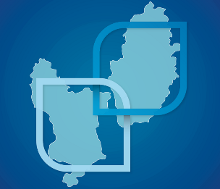

More information

Web: www.eastmidlandsdevolution.co.uk
Email: eastmidlandsdevolution@ipsos.com
Phone: 0800 260 0536

All information correct at time of writing (November 22).

