November
Social media posts
Stay warm, stay well
Winter is heading our way and with it the usual sniffles, colds and seasonal ailments. Over the coming months we'll be sharing information around how to stay well during winter. For general advice visit www.derbyshire.gov.uk/staywellinwinter
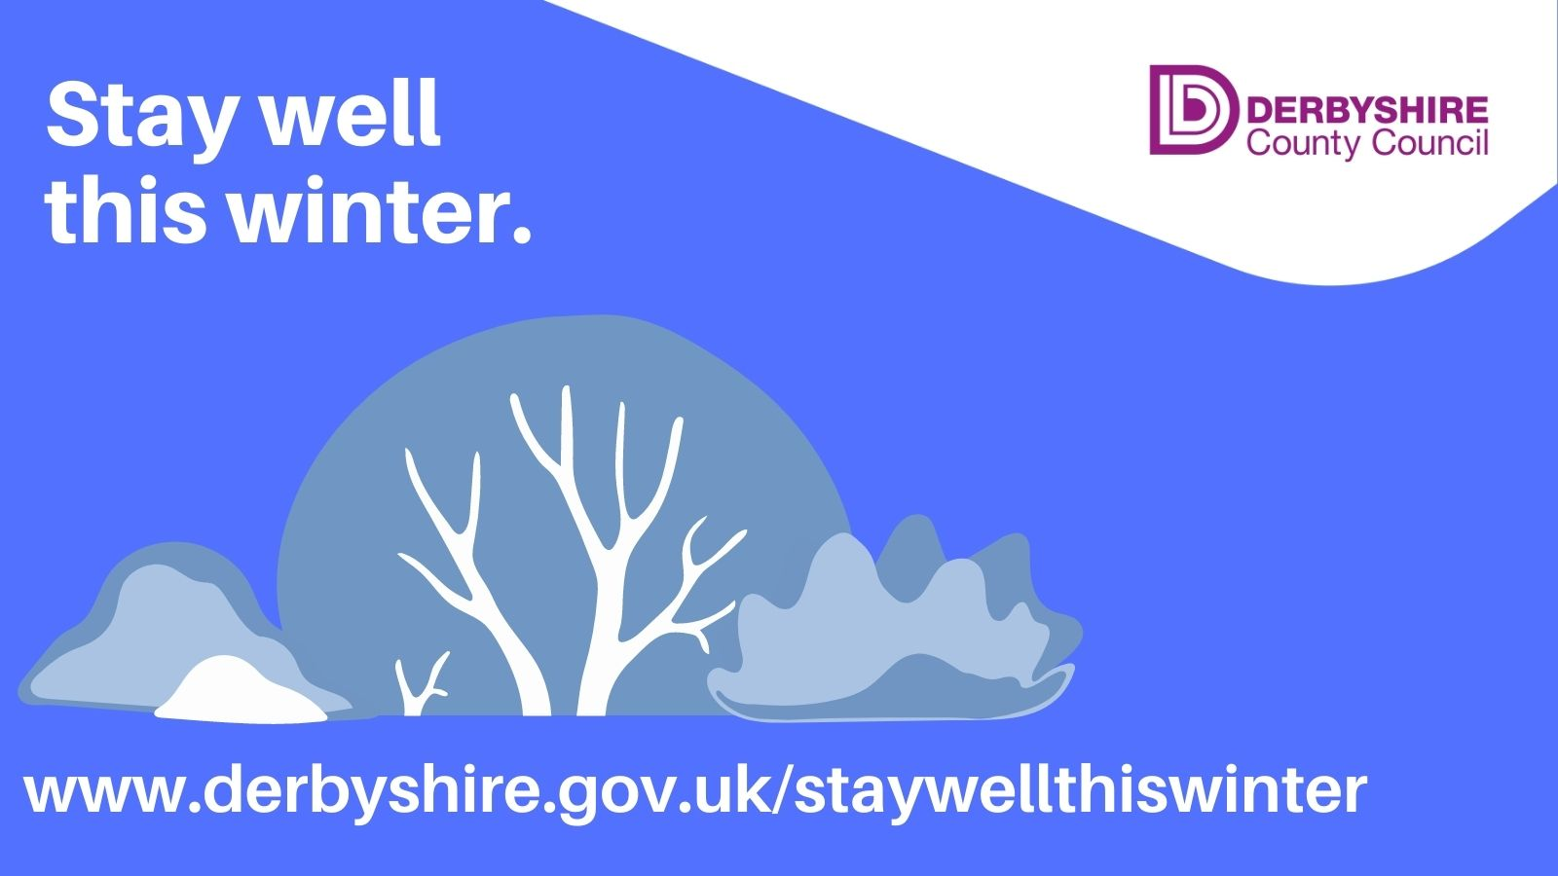
Cold weather can have a serious impact on vulnerable people. Can you help someone to keep healthy and safe this winter? Checking in older people to ensure they’ve got stocks of food and medicines can really help them #staywell this winter. For more advice visit www.derbyshire.gov.uk/staywellinwinter
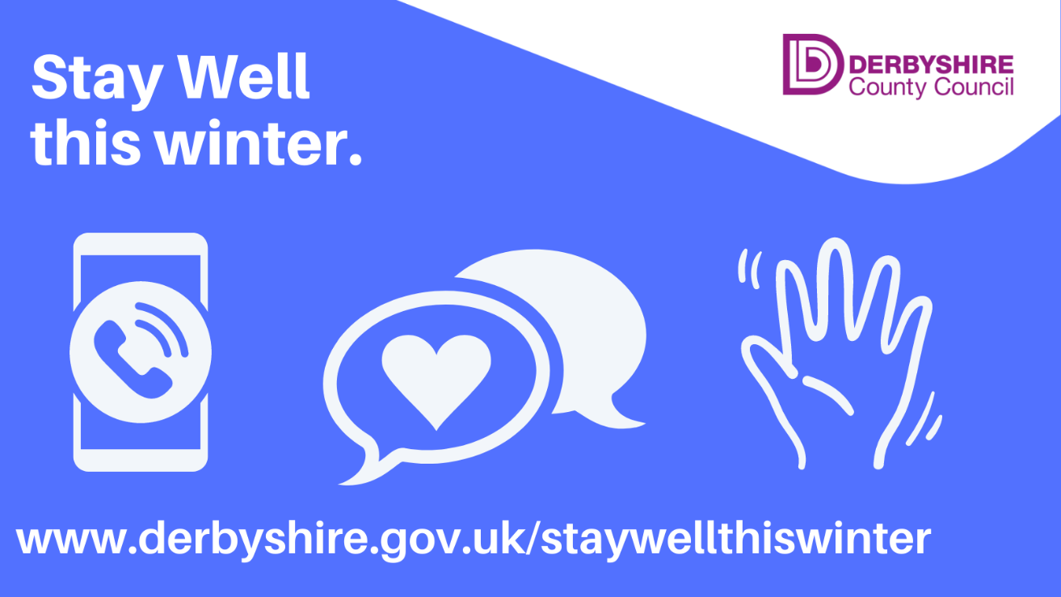

With winter arriving, and heating costs increasing, there are steps you can take to keep your home warm without turning up the heat.
Draw your curtains at dusk
Keep doors closed to block out draughts
Have regular warm drinks and try to have at least one hot meal a day if possible
Get more advice to #staywarm in winter here: www.derbyshire.gov.uk/staywarminwinter
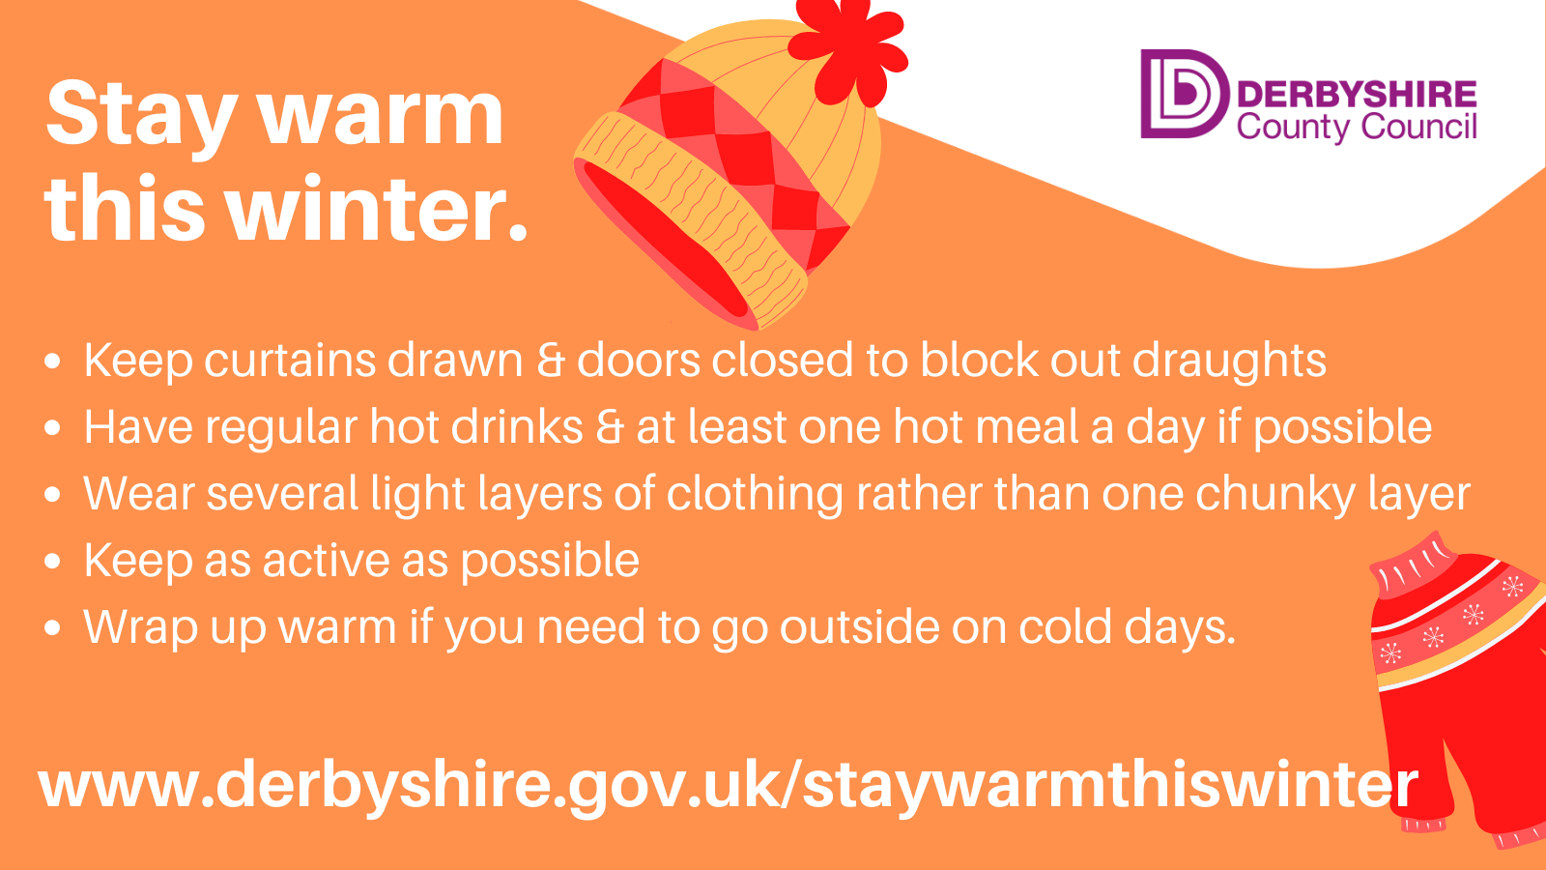

National NHS Winter Vaccinations campaign
All assets can be downloaded from the PHE campaigns resource centre here: https://campaignresources.phe.gov.uk/resources/campaigns/34-winter-vaccinations-public-facing-campaign
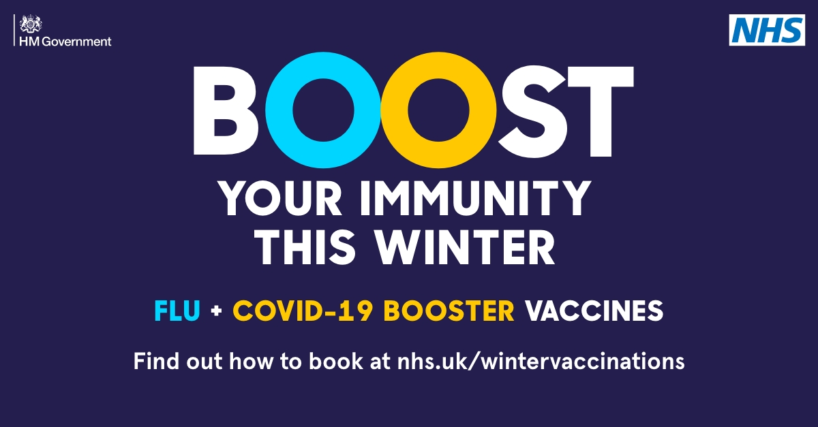
Vaccines are the best protection we have against viruses like #flu and #COVID19. Find out more: https://www.nhs.uk/conditions/vaccinations/flu-influenza-vaccine/
If you are pregnant, flu and COVID-19 can cause serious harm to you and your baby. The flu and COVID-19 vaccines offer the best protection against these viruses. https://www.nhs.uk/conditions/vaccinations/flu-influenza-vaccine/
Stress Awareness Week 7th – 11th November
During #Stress Awareness Week we're looking at ways to deal with stress, and also how to spot if it’s becoming an issue. Find out more @mentalhealth: https://www.mentalhealth.org.uk/a-to-z/s/stress
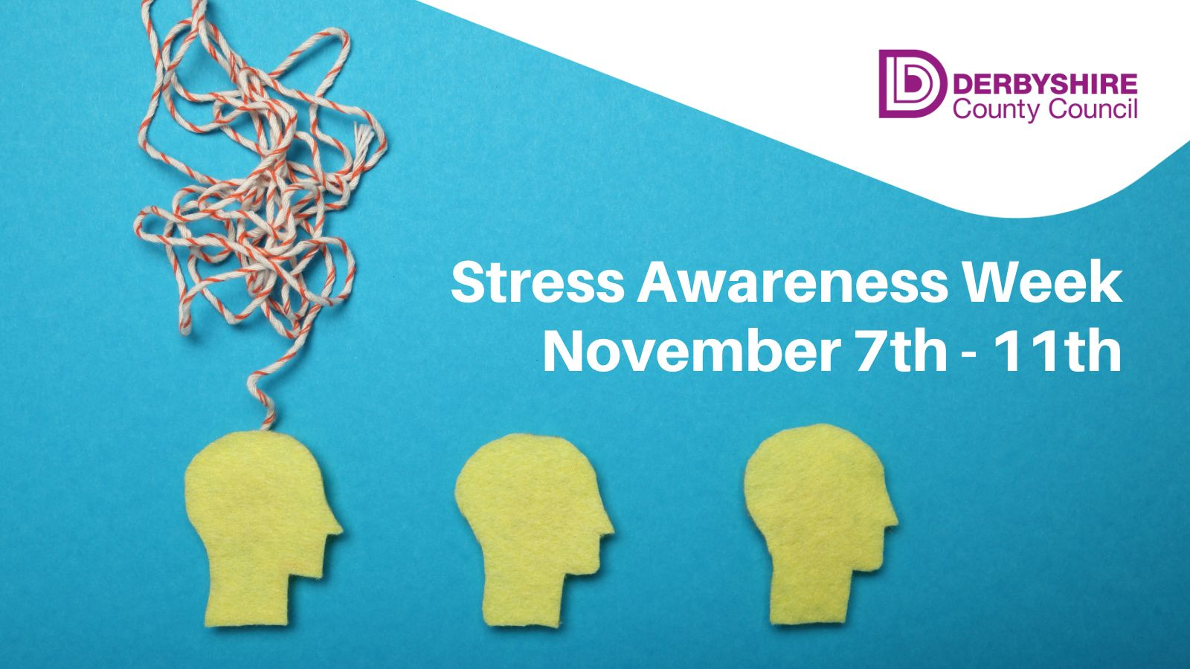

The Five Ways to Wellbeing are simple, everyday things we can do to help boost our mood and reduce #stress. Find out more, and get some ideas, at www.derbyshire.gov.uk/wellbeing
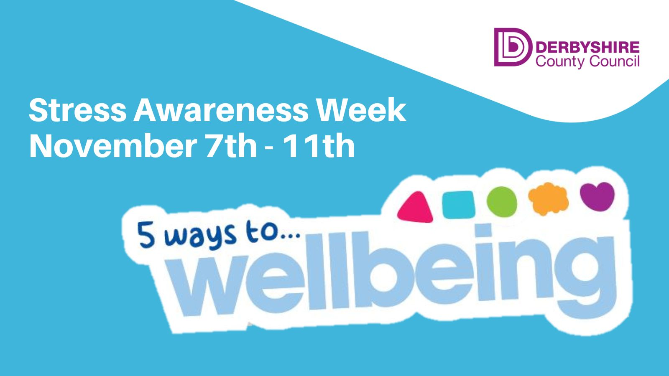

If #stress is starting to impact on your day to day life then there’s support and advice on hand to help. Get emotional wellbeing help online here: www.derbyshire.gov.uk/mentalhealth
Long term stress can impact your health and wellbeing, so it's important to get help if you're struggling. You can find mental health support online at www.derbyshire.gov.uk/mentalhealthsupport
If you’re struggling with #stress or other emotional wellbeing issues, then Every Mind Matters has a helpful mind plan that can help. Take a look here: https://www.nhs.uk/every-mind-matters/mental-wellbeing-tips/your-mind-plan-quiz/
During #Stress Awareness Week there’s lots of help on how cope if things are starting to get on top of you. The NHS has lots of advice here: https://www.nhs.uk/mental-health/feelings-symptoms-behaviours/feelings-and-symptoms/stress/
Lung Cancer Awareness Month
November is #LungCancer awareness month and we’ll be highlighting the signs & symptoms to be aware of. Find out more online at the NHS: https://www.nhs.uk/conditions/lung-cancer/symptoms/
Around 48,500 people are diagnosed with #lungcancer every year in the UK. Find out more on the NHS website here: https://www.nhs.uk/conditions/lung-cancer/

Cost of Living campaign
We’re rolling out the second phase of our cost of living campaign and all assets can be downloaded from our google drive here:
https://drive.google.com/drive/u/0/folders/1znX1BgXJnxFe1D7Vh8TIwOmPTERsMUQt
We’d really appreciate your ongoing support with sharing our campaign messages with your audiences, and if you feel there is additional information that you would like us to provide, then please drop me an email at colleen.marples@derbyshire.gov.uk

Newsletter / intranet / payslip letter copy
Stay warm, stay well
Winter is heading our way and with it comes the usual sniffles, colds and seasonal ailments.
While the cold weather can make us all feel a bit glum, it can have a serious impact on the health and wellbeing of older and more vulnerable people.
But there's lots of advice available on how to keep you - and the people around you - safe, warm and well this winter.
From making sure you are up to date with all your winter vaccinations, to help keeping you and your home warm.
Get advice on how to stay well in winter here: www.derbyshire.gov.uk/staywellinwinter

