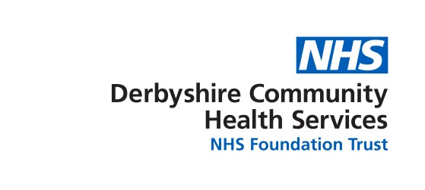
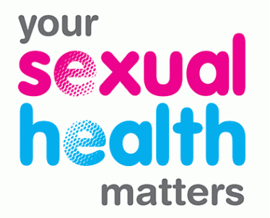

Derbyshire Integrated Sexual Health Service
Community Action Fund

Grant Application Form 2022-2023

Background information
Derbyshire Integrated Sexual Health Services (ISHS) is looking to fund organisations and groups which work with communities most vulnerable to poor sexual health (a list of vulnerable groups can be found in Appendix 1). Whilst ISHS proactively works to address stigma around accessing sexual health services, we understand that for some hard to reach communities there are often significant barriers to accessing our mainstream services. ISHS knows that effective sexual health support begins with the ability to establish and maintain relationships, in which sexual health and wellbeing can be openly discussed, and that many opportunities to develop these relationships exist within our diverse community networks.

ISHS would therefore like to invest in community projects and activities which aim to address these barriers and improve sexual health outcomes for vulnerable groups. We would like to increase opportunities for our multi-agency networks to provide:
- Innovation around the best methods for meaningful engagement with hard to reach communities around their sexual health.
- Information, education and support around sexual health and wellbeing in accessible community based settings.
- Access to sexual health supplies (e.g. condoms, STI screening, signposting and referrals).
Examples of the kinds of applications that may be funded are to support the costs associated with:
- Setting up a new community project or group with a sexual health focus.
- The development of promotion or campaign materials to engage our hard to reach communities with ISHS.
- The development of resources to deliver sexual health focused activities or projects.
To support the delivery of these sexual health projects and activities, ISHS will provide:
- Access to up to £5,000 funding from the ISHS Community Access Fund.
- Sexual Health Promotion training to successful fund applicants to equip workers to deliver brief interventions around sexual health and wellbeing.
- Supplies of condoms, STI screening postal kits and ISHS promotional materials.
Please note: projects involving capital funding for buildings or equipment alone will not be considered.

We are seeking to fund a wide range of new or innovative activities and so the maximum financial support we can allocate to one project will not normally exceed £5,000. Applications for funding must be to benefit Derby City and/or Derbyshire residents. Preference will be given to Derby City/Derbyshire based organisations; however organisations from outside of Derbyshire may also apply.

If you are interested in discussing further a project idea then please contact your local ISHS Sexual Health Promotion Manager or the ISHS Accredited Provider Lead. - see contact details below.

The application process is:
- Complete the application form below and email to our ISHS Sexual Health Promotion Manager by 5pm on Friday 18th November 2022
- The funding panel will meet in December 2022 to review applications and make funding decisions.
- Once applicants have been advised of the panel outcome, an agreement will be drawn up that specifies; what the funding will be used for, identifies the project outputs, project outcomes and evaluation process.
- Projects will begin as soon as possible after this agreement process is complete.

Contact details for further discussions or fund applications:

Accredited Provider Lead:
Tracey Palmer (Derbyshire and Derby City) tracey.palmer@nhs.net

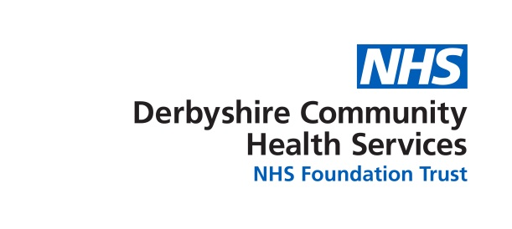

Derbyshire Integrated Sexual Health Service
Community Action Fund 2022-2023

Name of project or activity
Name of organisation/group
Organisation/group address
Receiving organisation named lead
Lead contact email
Lead contact telephone number
Date submitted

- Your Organisation/Group (250 words max)
Please give a description of the main purpose of your organisation/group

- Project/Activity Summary (500 words max)
Please give a brief description of your project or activity.
Be specific about what it will do, how it will do it, who it will benefit, and what you will be spending the grant on. Include how your project will be delivered in light of COVID-19 and safe working practices.

- Will your project benefit (please tick)
Derby City residents
Derbyshire County residents
Both areas

- Improving sexual health outcomes and reducing sexual health inequalities (250 words max)
Please describe how your project/activity will improve sexual health outcomes and/or reduce sexual health inequalities.

- Evidence of Need (250 words max)
What evidence do you have that people in your area want or need this project/activity?
Where is the activity being delivered? How have you identified a need for this project in your area?

- Project/Activity Outputs & Outcomes (250 words max)
What benefits do you expect vulnerable people or groups will experience from this?
What will it deliver? How many people will benefit? How will this impact on the sexual health of local people?

- Measuring Impact (250 words max) Please note: completing an evaluation report is a condition of the agreement when accepting a grant.
Please outline how you intend to evaluate your project or activity.
How will you measure if you have achieved your expected outputs and outcomes?

- Timetable
Please give a proposed start and finish date for the project/activity or outline a proposed timetable.

- Budget
Breakdown of costs requested from this fund for the project/activity | £
Total requested from the Derbyshire Integrated Sexual Health Service Community Action Fund | £
Please detail any additional funding you have received for this project/activity from other sources (including contributions from reserves/other funding applications)
Total additional funding received | £

Have you applied for money from this fund previously? If so, please provide details below.
Name of project/activity | Amount requested | Funding received (yes/no)?

Please return your completed form by email to: tracey.palmer@nhs.net

If this is not possible please call Tracey on 07795 318901 to make an alternative arrangements. Please get in touch with if you have any queries about completing this form.

Appendix 1

Vulnerable groups
The following vulnerable groups have been identified in the overarching specification between DCHS and Derbyshire County Council.
- People living with HIV (PLHIV)
- MSM
- Young people under 25
- Vulnerable young people including those at risk of offending or who are excluded from school
- Homeless young people
- Teenage parents
- Lesbian, gay, bisexual and transgender (LGBT) young people
- Those who are rurally isolated
- Those not in education, employment or training
- Those with learning disabilities or mental health problems
- Children in the care of the local authority

- Other at risk groups have also been identified including...
- Injecting drug users
- Sex workers
- Vulnerable adults
- Travellers
- Offenders
- Homeless
- Victims of sexual assault
- Ethnic minority groups
- LGBT+

The Public Health Outcomes Framework provides local information and STI prevalence details. This can be found at https://fingertips.phe.org.uk/profile/SEXUALHEALTH

Derby City footprint, as defined by Derby City Council. Derbyshire County footprint, as defined by Derbyshire County Council

