December
Social media posts
World Aids Day (December 1st)
It's #WorldAids Day. A chance for people worldwide to unite in the fight against HIV, to show support for people living with HIV & the highlight the importance of getting tested. Find out more: https://www.worldaidsday.org/
It's #WorldAids Day. Did you know you can get FREE HIV testing kits online? Visit @yshmderbys here: https://www.yoursexualhealthmatters.org.uk/stis-and-hiv/hiv-testing-and-care

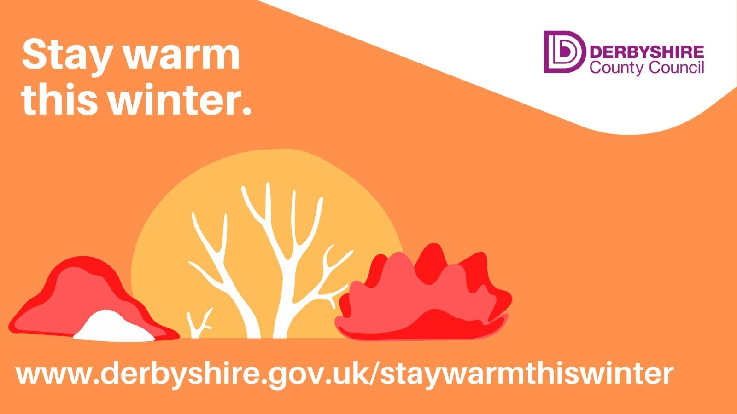
Stay Warm in Winter
During the colder months, while we can’t reduce the price of energy, there’s lots of advice on how to help reduce the amount you use. Get ideas on how to be as energy efficient as possible, while staying warm, here: https://www.derbyshire.gov.uk/environment/climate-change/how-you-can-help/how-you-can-help-tackle-climate-change.aspx

Cold weather can have a serious impact on vulnerable people. Can you help someone to keep healthy and safe this winter? Checking in on older people to ensure they’ve got enough food and medicines can help them #staywell this winter. For more advice visit www.derbyshire.gov.uk/staywellinwinter

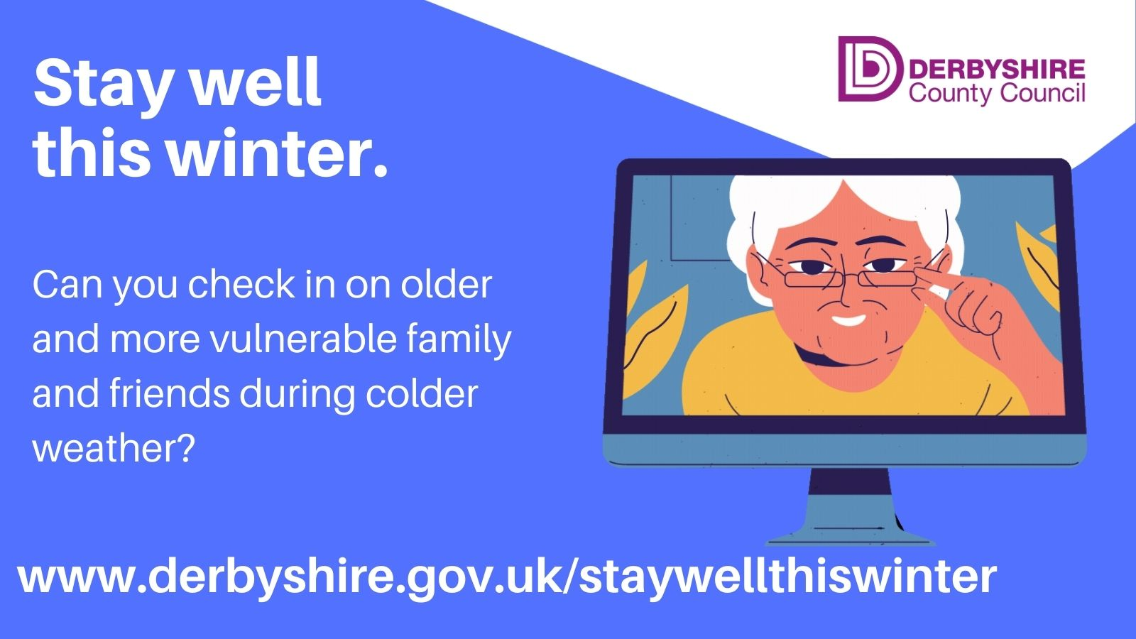

Winter is heading our way and with it the usual sniffles, colds and seasonal ailments. Over the coming months we'll be sharing information around how to stay well during winter. For general advice visit the NHS: https://www.nhs.uk/live-well/healthy-body/keep-warm-keep-well/
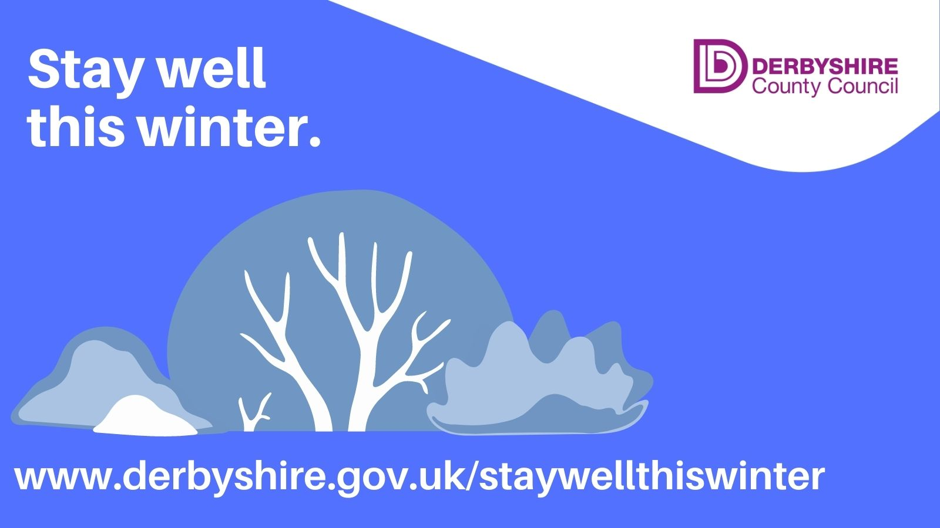
Warm spaces funding
Voluntary, community and charity organisations across #Derbyshire can still apply to Derbyshire County Council’s Warm Spaces Fund to help residents this #winter. They could get up to £1,000 to provide a space where people can meet and stay warm during the colder months. Apply here: www.derbyshire.gov.uk/warmspaces

Cost of living
Derbyshire County Council is running the second phase of its Cost of Living campaign. Thank you for all your support in sharing messages and we hope you will continue to do so.
We’d welcome any suggestions for additional messages that we might be missing. Please email colleen.marples@derbyshire.gov.uk
We’ve launched a new cost of living email so please spread the word and encourage people to sign up. There’s suggested newsletter copy below.
Newsletter / intranet / copy
Cost of Living emails
Derbyshire residents can get the latest news, advice and information about the Cost of Living support on offer by signing up to Derbyshire County Council’s new cost of living emails.
The council will be sending out regular news and updates on the local and national cost of living support that’s available. There will also be information on how to check you’re claiming the benefits you’re entitled to, managing debt, cutting energy bills and reducing food waste.
You can sign up to receive the emails here.
You can also find more information and advice at www.derbyshire.gov.uk/costofliving
Other local health and wellbeing campaigns to support
I Choose
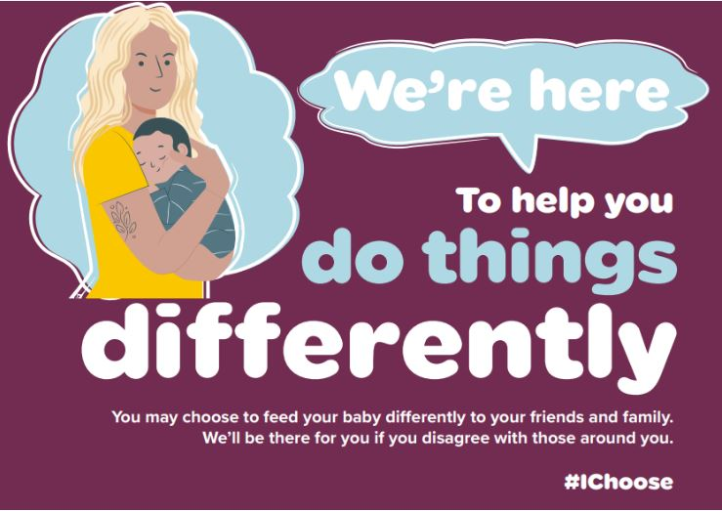

Derbyshire Community Health Services NHS FT have launched I Choose. A campaign to support mums and families around infant feeding.
You can download campaign assets and a campaign toolkit from the Google Drive here: I Choose: Infant feeding campaign - Google Drive
Please follow them at www.facebook.com/DerbysFamilyHealth and on Twitter @DCHStrust and share messages through your channels.
Find out more about the new campaign here: derbyshirefamilyhealthservice.nhs.uk/i-choose

PrEP
PrEP stands for pre-exposure HIV prophylaxis. It’s a way of preventing HIV infection. PrEP is now available for free on the NHS in England and given to people who are at high risk of HIV infection.
Follow Your Sexual Health Matters to share and retweet advice and information about sexual health services in Derbyshire @yshmderbys and www.facebook.com/yshmderbys
You can follow us on the following social media accounts:
Twitter: @DCCPublichealth
Facebook: www.facebook.com/derbyshirepublichealth
Instagram: www.instagram.com/livelifebetterderbyshire

