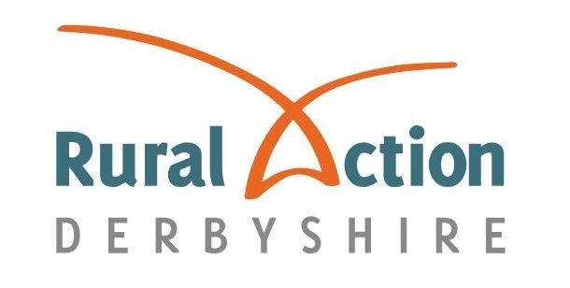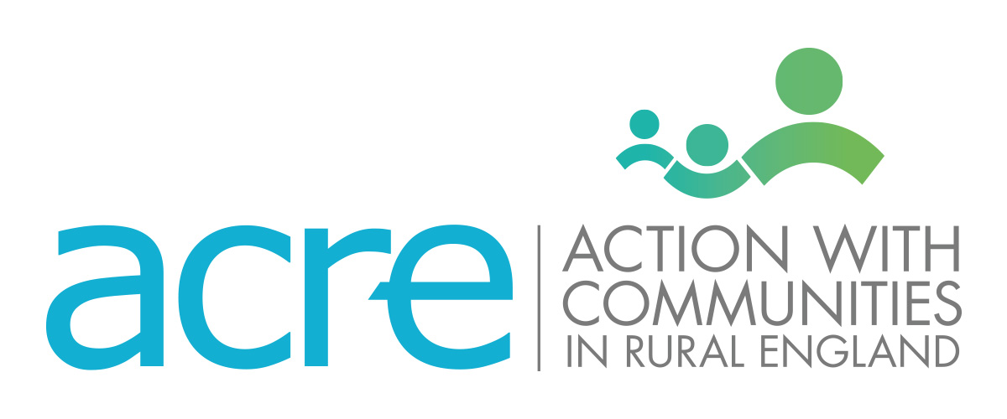

For immediate release: Tuesday 10 January 2023

Derbyshire charity to celebrate the importance of community buildings during Village Halls Week 2023

A local charity is taking part in Village Halls Week 2023 to celebrate community buildings across Derbyshire.

Rural Action Derbyshire will join the long-running event, organised by national partner Action with Communities in Rural England (ACRE), to shine a light on the importance of the county’s 250+ village halls as “warm, welcoming and inclusive spaces”.

Activities from Monday 23 to Sunday 29 January 2023 will include open days at local halls, touching stories from regular users of community buildings, and an engaging social media campaign.

These activities will aim to raise awareness of the vital role halls play in providing a warm, safe space for rural residents in Derbyshire to learn new skills, try new things and meet new people.

Research by ACRE found that in 60% of countryside areas, community buildings are the only place for local people to socialise. This makes them crucial for tackling loneliness and isolation, which affects over ⅓ of over-45s, according to NASEM findings.

These buildings also offer environmentally-friendly heated areas for people to chat and have a cup of tea, with 60% adopting or looking into energy-saving methods - helping people to beat the winter cold sustainably as energy prices soar.

Not only are halls important socially, though, but they are key contributors to the economy. Community buildings in Derbyshire help to maintain the livelihoods of over 200 people, from Zumba instructors to karate teachers. A further 2,500 volunteer in different capacities, offering an important source of purpose for many retirees and experience for those looking to build their skill set.

RAD’s involvement in Village Halls Week builds on their extensive support for halls across Derbyshire, with their Community Buildings Advisory Service first launching in 1924.

This service provides year-round support to village hall trustees, supplying specialist advice and guidance, regular policy updates and discounts on a wide range of information sheets and consultancy options.

Beverley Parker, CEO of RAD, said: “We are proud to support Derbyshire’s vibrant village halls, which offer warm, safe and inclusive spaces for so many in countryside communities.

“We’re looking forward to celebrating both the history and future of community buildings during Village Halls Week, as well as the fantastic work volunteers and committee members do to ensure they can continue to act as a social and economic hub for rural people for a long time to come.”

For more information on Rural Action Derbyshire’s Community Buildings Advisory Service, please visit ruralactionderbyshire.org.uk.

Village Halls Week takes place from Monday 23 to Sunday 29 January 2023.

--
Notes for Editor

Rural Action Derbyshire (RAD), formerly Derbyshire Rural Community Council, is an independent organisation and registered charity operating across the county since 1924. RAD aims to improve the life of those living and working in rural Derbyshire, by providing direct services to help people and groups in rural communities, and by raising awareness of the issues faced by rural communities. For more information, go to the RAD website. RAD is a network member of ACRE.

Action with Rural Communities in England (ACRE) is a national charity speaking up for and supporting rural communities. They support the 38 county-based organisations working across rural England to help communities to help themselves.

