February
Social media posts
Time to Talk Day. Thursday 2nd February

We're supporting #TimeToTalk because 1 in 4 people will experience a mental health problem – it’s time for the stigma to end. Visit www.derbyshire.gov.uk/timetotalk to get help on how to start the conversation about mental health.
We're encouraging everyone that it’s #TimeToTalk so that no one feels alone when they’re experiencing a mental health problem. Get help & support online at www.derbyshire.gov.uk/mentalhealth
If you're experiencing emotional health struggles then it's #TimeToTalk - talk to a friend, family member or pick up the phone. If you're struggling to cope, then Derbyshire Mental Health helpline can offer support on 0800 028 0077
World Cancer Day. Saturday 4th February.
Never underestimate the power of cooperation and collective action to save lives. Who are you and what will you do on 4 Feb? Speak up, stand up and take action together this #WorldCancerDay Find out more at www.worldcancerday.org

Grab a Cab. Until March 31st 2023.
If you need help getting to certain routine health appointments, then there is FREE transport available. Find out more at the Grab a Cab scheme www.derbyshire.gov.uk/grabacab
Did you know that you can get FREE transport to certain routine health appointments including vaccinations and some cancer screenings until March 31st? Find out more about @Derbyshirecc #grabacab scheme here: www.derbyshire.gov.uk/grabacab

Every Mind Matters loneliness campaign. All month.
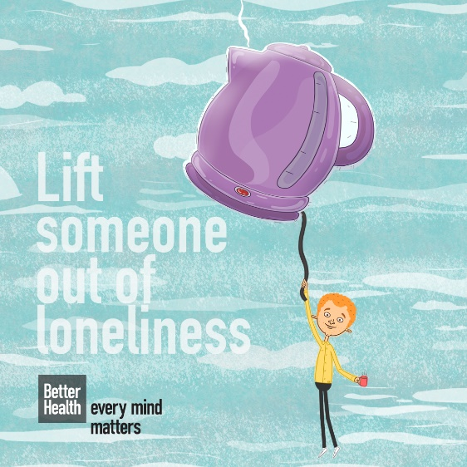
Loneliness can have a huge impact on our wellbeing, but there are lots of simple actions you can take to help lift yourself or others out of loneliness.
Every Mind Matters has launched its Lift someone out of loneliness campaign.
Resources including images, social media copy and a campaign guide can be downloaded from the PHE campaign resource centre here. You will need to log in first.
You can also link to www.derbyshire.gov.uk/getconnected for local support about tackling loneliness and the Derbyshire Mental Health helpline can offer support on 0800 028 0077.

Other national campaigns you might want to support
Tinnitus Awareness Week 2023. 6th – 12th February
For support and information about tinnitus visit https://tinnitus.org.uk
International Epilepsy Day 2023. Monday 13th February
International Epilepsy Day promotes awareness of epilepsy in more than 120 countries each year. Find out more: www.internationalepilepsyday.org
Cancer Prevention Action Week 2023. 20th – 26th February
Cancer Prevention Action Week is an annual event aiming to raise awareness of cancer and cancer prevention and encourage you to take action.
About 1,100 people are diagnosed with cancer every day in the UK, but 40% of all cancer cases could be prevented. Find out more: www.wcrf-uk.org/preventing-cancer/cancer-prevention-awareness-week
Eating disorders week. 27th Feb – 5th March 2023
Eating Disorders Awareness Week is an international awareness event, fighting the myths and misunderstandings that surround anorexia, bulimia, binge eating disorder and EDNOS.
For support and information about eating disorders visit www.beateatingdisorders.org.uk
Local support is also available with Derby based charity First Steps. Visit www.firststepsed.co.uk or call 01332 367571

Newsletter / intranet / payslip copy
Time to Talk
Mental health problems affect one in four of us but there’s still a stigma attached to opening up and talking about it.
Time to Talk is on Thursday 2nd February.
The campaign aims to encourage everyone to be more open about mental health – to talk, to listen, to change lives.
What are you doing to start the conversation? Get ideas about how to start talking about mental health at www.derbyshire.gov.uk/timetotalk
There's lots of ways to help improve your emotional wellbeing. Have you tried the Five Ways to Wellbeing?
They're simple, everyday things to give your mood a little boost. Find out more at www.derbyshire.gov.uk/wellbeing
If you, or someone you know is struggling with feelings of loneliness or isolation then the Derbyshire Mental Health support line is available 24/7 on 0800 028 0077.

