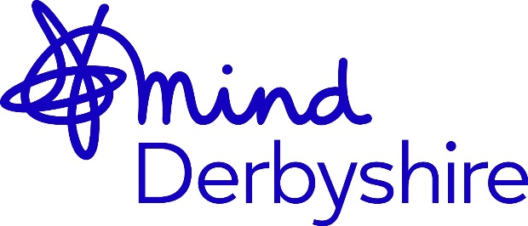

Derbyshire Mind Advocacy Administrator Vacancy

Hours: 37 hours per week.
Salary: £22,084 per annum
Contract: Permanent

Derbyshire Mind is looking for a well-organized, enthusiastic and committed Administrator who enjoys talking to people on the phone and believes in providing excellent customer service to everyone who contacts us.

This key role would suit someone with strong administrative and customer service skills with an interest in mental health, advocacy or working for a charity.

The role will be based in our Derby offices with some flexible working from home plus with occasional travel across Derbyshire. Full driving license with access to own vehicle needed.

You will be inputting data into a database on a daily basis and working alongside a colleague in the same role, you will be the administrative support hub for advocates and managers.

Many of our clients and people who contact Derbyshire Mind are vulnerable people who have a mental health problem, dementia, learning disabilities, or autism. They will have differing support needs and may be distressed, so you will need to have an empathetic, non-judgemental and calm approach.

The purpose of the role is to: -

- Provide a first response to clients and others contacting Derbyshire Mind by telephone, email or online.
- Respond effectively and efficiently to all enquiries, providing high standards of customer service.
- Provide a high standard of administration support for the advocacy services and the Advocacy Service Managers.
- Accurately record all enquiries and referrals on a client management database.

Derbyshire Mind is a local mental health charity focused on improving mental health and wellbeing for people across Derbyshire. We are one of a federated network of local Mind charities across the country. We provide a range of advocacy and mental health and wellbeing services designed to support people with mental health problems as well as the wider population. We are committed to developing innovative and responsive services which further promote mental health awareness and wellbeing.

Our Vision is: -

For everyone in Derbyshire to have good mental wellbeing and to live their best life.

Our Values are: -

WORKING TOGETHER: We work alongside others for the greater good.
LEARNING TOGETHER: We always aim to do things better.
EMPOWERING: We support people to fulfil their potential.
RESPECTFUL: We don’t judge, we treat others as equals.
POSITIVE: We are progressive and focus on solutions.

Job description and person specification are available for download from www.derbyshiremind.org.uk

or email recruitment@derbyshiremind.org.uk

All candidates must submit a CV and covering letter, detailing how you meet the requirements of the person specification.

CLOSING DATE: Wednesday 8th March 2023 at 5pm

Interviews will be held on Thursday 16 March 2023.
This post is subject to a criminal records check with the disclosure and barring service.

Derbyshire Mind aims to be an Equal Opportunities Employer

