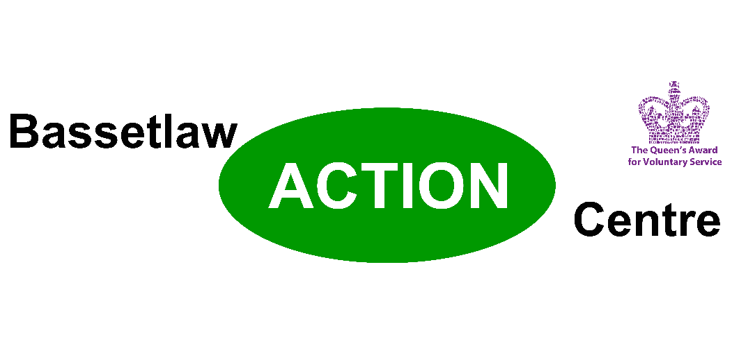

Volunteer Drivers Urgently Needed
Bassetlaw Action Centre provides transport to vulnerable people throughout the District, including people in your town, or your village. As we emerge from the restrictions of the Covid 19 pandemic our clients really need the support of local volunteer drivers to enable them to stay in touch with family and friends, attend appointments or to get out to the shops. We also put on regular trips using our minibus which have really made a difference to people who might not ever get a day out without this service. This is what one of our drivers has to say about his volunteering has meant to him:
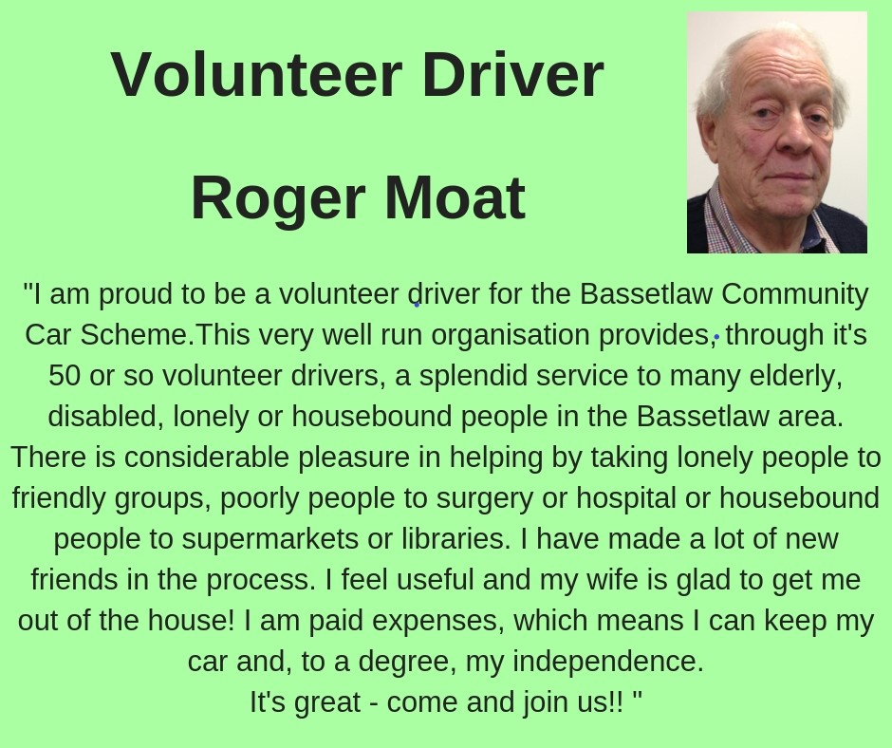

At Bassetlaw Action Centre we run three transport schemes:

The Car Scheme; where volunteer drivers use their own cars to provide transport for our clients.
The Car Scheme Plus; where volunteer drivers use our WAV (wheelchair accessible vehicle) to transport clients.
Minibus; where volunteer drivers take groups out for trips to a wide variety of destinations, for example Skegness, Meadowhall, or local garden centres.
In all cases our volunteer drivers are paid expenses.
Full training is provided, including professionally recognised MIDAS training for minibus and WAV drivers.
Our drivers set the pace! They decide how much time they can give and when they can give it and we match our clients to our driver’s availability.
Are you a Forces Veteran?
Bassetlaw Action Centre is currently developing partnerships with Forces charities to enable us to support veterans by providing transport. If you are a Veteran and would be able to help others who might need support to access services, go shopping or just meet up with their mates, even if you can only spare a couple of hours a week, then please get in touch as your comrades need you!
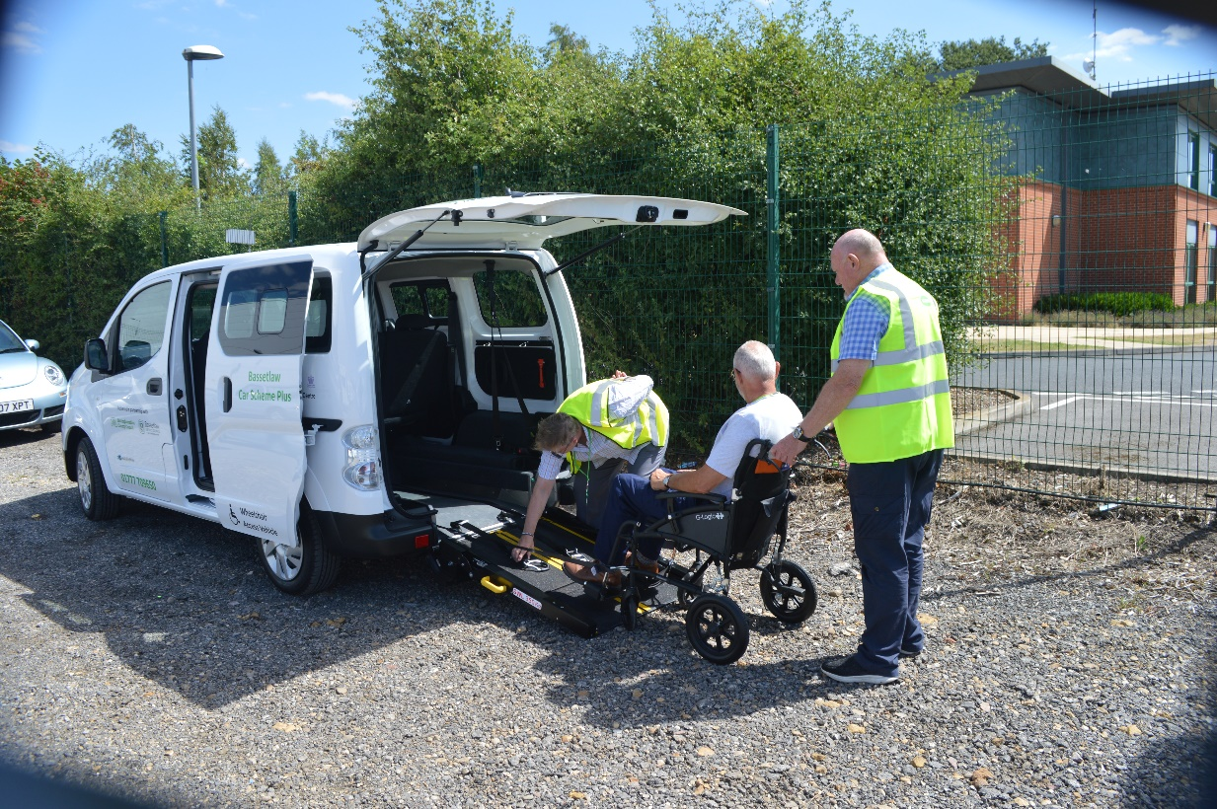

And this is the feedback we’ve had from some of our clients:

“Always been very grateful and happy with the service”
“It’s a really needed service”
“Absolutely fantastic service”
“It’s a lovely service, went to York on the minibus and had a lovely day”
“More than happy with the service, delighted with it”

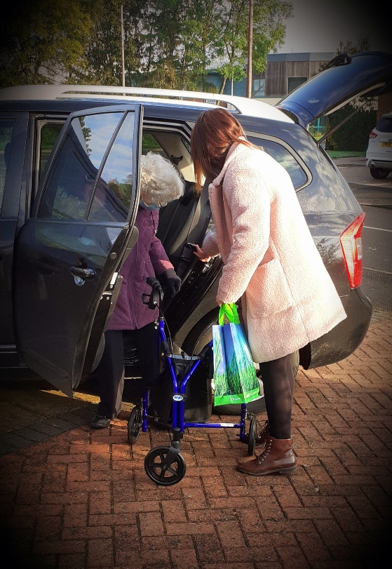

As you can see, our drivers make a real difference to their local communities and their time and effort are genuinely appreciated.
As well as drivers, there are a number of other volunteering opportunities, so if you can spare a little time please contact us at:
Bassetlaw Action Centre, Canal Street, Retford, Nottinghamshire, DN22 6EZ.
www.basetlawactioncentre.org
email transport@actioncentre.org
telephone 01777 709650

