June
Social media posts
Join the Smile Squad
Internal info only: Our children's oral health campaign is running until June 15th 2023.
Please help us to share messages. Download resources including social media posts, flyers and posters online here:
https://drive.google.com/drive/folders/1lGNxIf_CpcxodhKRtF97mjKfUOLkMFee
It’s competition time! Get your child to design @DCCPublicHealth an #oralhealth character and be in with the chance of getting it turned into a mini plushie toy! The competition form, and entry conditions, can be found here: https://drive.google.com/drive/folders/1-a25FCi2Jj0yCkkhbP2umftNRpechZ4a
Diabetes Week (12th – 18th June)
It's #DiabetesWeek which aims helps tackle the stigma many people
with all types of diabetes feel. Find out more about diabetes, the risks and how to manage the condition at Diabetes.co.uk here: https://www.diabetes.co.uk/
During #Diabetes Week find out more about the condition and what
causes it here: https://www.diabetes.org.uk/diabetes-the-basics
Men’s Health Week (12th – 18th June)
#Men’sHealth Week aims to raise awareness of preventable health issues and encourage men and boys to seek professional advice for health-related problems.
Find out more https://www.menshealthforum.org.uk/mhw
This year’s #MensHealth week is looking at the impact of the internet on men’s health and wellbeing. Find out more here: https://www.menshealthforum.org.uk/mhw
Cervical Screening Awareness Week (19th – 24th June)
During #CervicalScreening Awareness Week it’s time to talk about how to make the test better. Find out more here:
https://www.jostrust.org.uk/get-involved/campaign/cervical-screening-awareness-week#:~:text=During%20Cervical%20Screening%20Awareness%20Week,cervical%20screening%20(smear%20tests)
It’s #CervicalScreening Awareness week. Find out more about what it involves, and why it’s so important to take up your invitation. https://www.jostrust.org.uk/information/cervical-screening/what-happens-during-cervical-screening
If you, or someone you know, has concerns or questions about #cervicalcancer then Jo's Trust can help. Can them to talk through anything you need to:
https://www.jostrust.org.uk/get-support/helpline
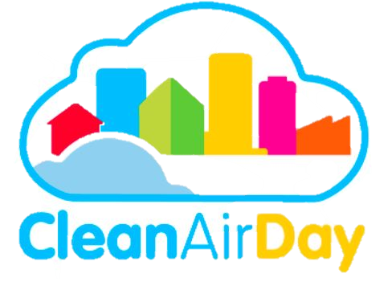
June

National Clean Air Day (15th June)
#NationalCleanAir Day is a chance for the whole country to
come together and improve air quality through collective action.
Find out more here: https://www.cleanairday.org.uk/

What small steps can we take to help improve the air that we all breathe? Find out more about the little changes that can make a big difference during #CleanAirDay https://www.actionforcleanair.org.uk/campaigns/clean-air-day

Relationships and Sex Education (RSE) day (29th June)
Relationships and Sex Education (RSE) day this year is on 29th June and the theme is Launch into Kindness. Find out more https://www.rseday.com/
Newsletter /intranet / payslip letter messaging
Join the Smile Squad
A new campaign is offering lots of support around how to care for your family’s teeth.
‘Join the Smile Squad’ offers lots of advice and support around how to care for your children’s teeth.
Oral health affects a wide range of things including your child’s confidence, education and self-esteem.
However most oral health problems are preventable if the right tooth care routine is set up from the start.
NHS dental treatment for children is free so take your child for their first appointment as soon as their first baby tooth comes through.
Find out more at www.derbyshire.gov.uk/oralhealth

