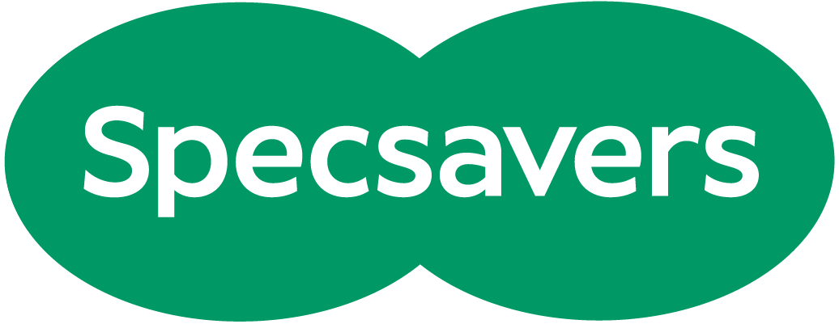
Want a guaranteed interview for a job at Specsavers Support Office?
Specsavers Support Office: Cirrus House 10 Experian Way, Nottingham NG2 1EP
Learn more about the support centre by clicking here
Salary: Minimum Starting Salary of £21,472 + 10% bonus paid quarterly (every 3 months on performance, a total of up to £24,270 and annual pay review)
Working hours: 37.5 hours a week
Mon-Fri 08:00-19:00 on a rota, (+ weekends on a rotation, Shorter days) we offer up to 50% home working once you have passed probation which is 3 months.
Plus the below benefits and more!
- Private medical plan*
- Dental scheme*
- Pension
- Annual leave: 25 days (+ more for extra service)
- Profit share scheme*
- Cycle to work scheme
- Perks Your portal to a world of great retail discounts and savings.
- Birthday club To recognise your birthday, enjoy an additional paid day off to celebrate however you wish.
- Permanent health insurance (PHI)*
- Eyecare vouchers
- Flu vaccinations
- Headspace app

