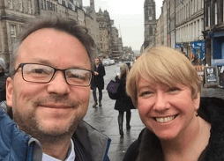
Greetings from the Think CO team at the Gas Safe Charity and we hope you are enjoying the summer. Although Autumn and Winter are the highest risk seasons for carbon monoxide (CO) poisoning in the home (when people put the heating on etc), we continue to promote CO awareness throughout the year via our free training (details below) as well as planning a series of face to workshops in partnership with the Gas Distribution Networks (GDNs) starting in September. This newsletter provides some information about recent CO developments in the UK and abroad.
Our impact Survey – have you completed it yet?
Some of you will have received our Think CO survey in June. This is to help us assess the impact of the training but we’re also looking for feedback on our priorities and ideas for new developments next year. Many thanks for those of you who have responded and provided some really useful reflections and ideas. There is still time to complete the survey and we’d appreciate it if you can spare a few minutes. The closing date is the 31st July. Click HERE to complete. We’ll provide a summary of the results in our Autumn newsletter.

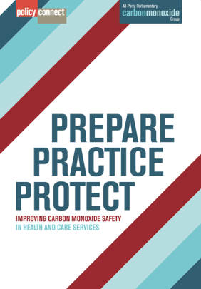
Launch of new CO Awareness report for front line care staff
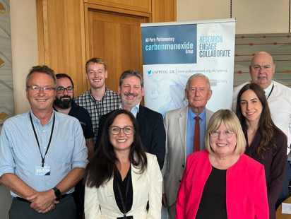
On the 17th July, Policy Connect and the CO Research Trust launched the long awaited report of their inquiry into CO awareness and training for front line health and social care staff. Begun pre-Covid, it has faced many challenges but the report itself highlights many of the issues that the Think CO programme also seeks to address. Based on over 100 interviews, it gives an excellent picture of existing awareness levels and comes up with practical proposals and recommendations. The MPs Liz Twist (Chair of Inquiry) and Barry Sheerman attended the launch of the report (see photo), which is called ‘Prepare, Practice, Protect – Improving CO Safety in Health and Care Services’. If you would like to read the summary (2 sides), which highlights the ‘top tips’ for employers and individuals, then click HERE and if you would like to read the full report click HERE

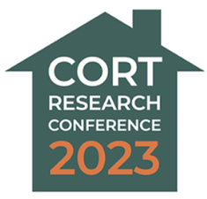
CO Research Trust Annual Conference
We were delighted to attend this year’s conference in Sheffield. It brought together experts from a wide range of specialist areas and was a great demonstration of the diverse range of impacts that carbon monoxide poisoning can have. The broad theme of the conference was around ‘CO and the indoor environment’ which reflected the increased concerns about air quality in general. It also highlighted the range of current research projects. Of particular interest to Think CO is the research around the impact on the brain of very low levels of CO, which indicates there is no such thing as a safe level of CO and endorses our focus on long term, low level poisoning.

Research from the USA
Some interesting new research from across the pond, this time by the Consumer Product Safety Commission. It is based on statistics between 2009 and 2019 and focussed on non fire deaths. For example, in 2019 there were 250 consumer-product CO deaths related to what they call ‘Engine-Driven Tools’, in particular portable generators. They were responsible for 765 of the 2000 deaths over the 10 years of the research. Half of all the deaths were in November, December, January and February and the overwhelming majority of deaths were men over the age of 45. To read about it, click here: CO research from USA

Overall though the numbers of CO related deaths in the United States are going down, primarily because of greater awareness. As in the UK, capturing robust data about low level poisoning is almost impossible.

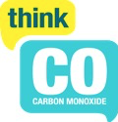
Think CO resources – all free

- Face to face workshops
As we move into Autumn, we will be running a number of face to face workshops, in partnership with the local GDN and in most cases the local Fire and Rescue Service. We are in Northern Ireland (7th Sept), Jersey (3rd Oct), Central Scotland (mid October), Swindon/Yeovil (during CO Awareness Week – 20 – 24th November).

If you would like to attend or discuss arranging a workshop in your area, please contact us on thinkco@gassafecharity.org.uk.

- E-learning and Zoom workshops
Anyone can register for our e-learning by sending their name and email address to e-learning@gassafecharity.org.uk or book a Zoom workshop on this link: Free Think CO workshop

- Materials
We have a range of publications/leaflets that can be downloaded via this link: Gas Safe Charity

Contact us on thinkco@gassafecharity.org.uk if you have any questions

