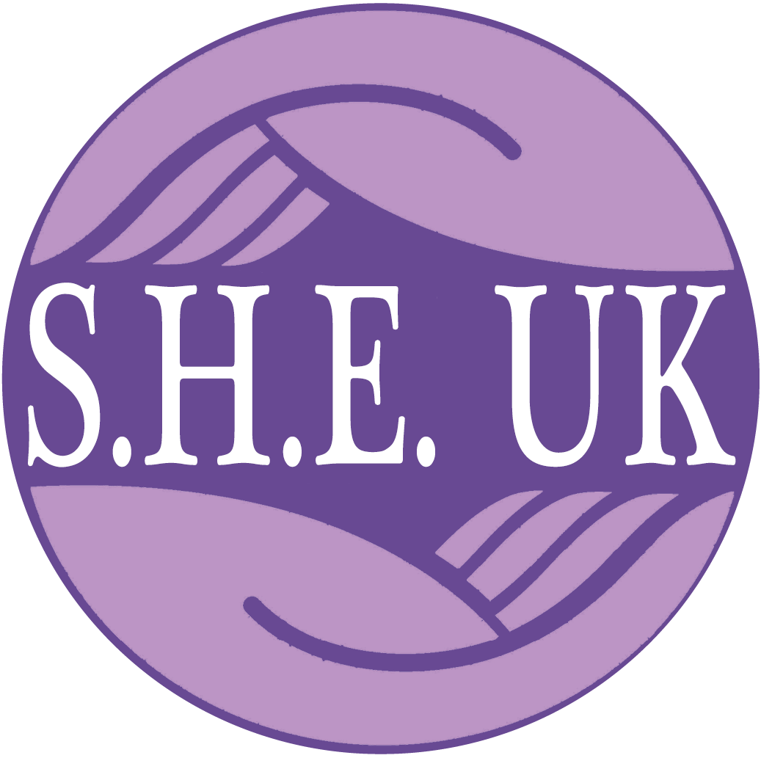

Supporting; Healing; Educating

TRUSTEE
RECRUITMENT INFORMATION PACK
2023

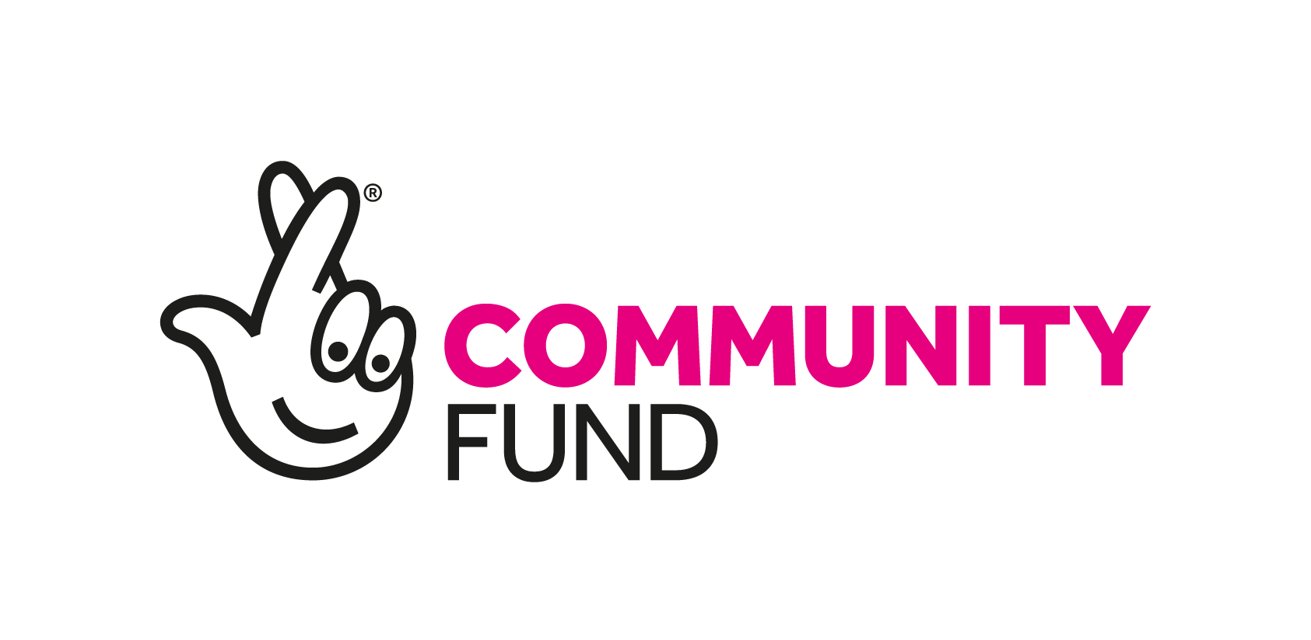

SHE UK Vision

Survivors are met with compassion and openness, in a world where childhood sexual abuse is exposed, tackled and not associated with feelings of shame.

SHE UK Mission

At SHE UK, our mission is to improve the lives of victims of childhood sexual abuse and sexual violence. We believe all survivors of childhood sexual abuse (CSA) and sexual violence have the right to reclaim the life stolen from them by their abusers.

We provide a wraparound, long term, tailored support system and range of services to empower and rebuild and to enable clients to move from surviving to thriving. We are based in Mansfield and deliver face-to-face services, as well as virtual support sessions, to survivors across Nottinghamshire.

WHY WE DO OUR WORK

The impact of sexual abuse on survivors is underestimated by society, it is often deeply ingrained and difficult to move on from. Survivors present with a range of complex difficulties due to the trauma they have experienced; a survivor of sexual abuse is three times more likely to develop psychological disorders in adulthood than those who aren’t. Unhelpful coping strategies often emerge including self-harm, substance abuse, risk taking behaviour and seeking unhealthy relationships leading to further abusive experiences.
Pressures on public finance results in statutory services that are short term and only scratch the surface of the pathway to healing. Voluntary Sector services are often longer term and more holistic, research recently undertaken by the Independent Inquiry into Child Sexual Abuse (IICSA) showed that survivors reported specialist voluntary sector services were the most helpful to them in their recovery.

WHAT WE DO

SHE UK offer long-term wrap-around support (up to two years but tailored to each person) with highly trained professionals. Around two-thirds of our clients self-refer, others are referred by health services, the Police, victim support groups and GP’s. Most of our clients are female survivors of non-recent childhood sexual abuse. Services offered to clients include:
- Assessment: including planning support and signposting to specialist services (e.g. Drug & Alcohol) if required.
- Telephone support service: weekly telephone calls with a qualified therapist to emotional ‘hold’ clients whilst they wait for therapy to start.
- Evaluative-Need Therapy: Up to two years counselling primarily from volunteers who are often completing the final year of their own training.
- SHE-roes Lounge: Meeting weekly the lounge provides a safe environment for people to meet, learn, undertake activities (e.g. arts & crafts) and attend facilitated group meetings.
- Self-Development Courses: Workshops are run as part of the SHE-roes lounge, these range from an empowerment emphasis (e.g. ‘How has trauma affected you’ and ‘Self-worth’) through wellbeing (e.g. relaxation and creative skills) to practical life skills (e.g. budgeting and employability).

In 2022/23 we had 122 active clients and we delivered over 3800 sessions of therapy or support.

Structure & Finance

SHE UK was formed in 1998 and was registered as a charity in 2001 (No: 1086697). The charity is currently governed by a board of 6 trustees who meet bimonthly.
SHE UK is based in Mansfield, the organisation has 6 employees (2 FTE, 4 part time) and 14 regularly active volunteers (excluding trustee roles).
The last independently examined accounts, year ending March 31st 2022, show an income of £162k and an expenditure of £152k. Our accounts 2022/23 are currently being drawn up but we estimate income of circa £198K and expenditure £159K, showing a surplus of approximately £39K.
The main source of income is grants including Nottinghamshire Police & Crime Commissioner, Lloyds Bank Foundation, The National Lottery, The Tudor Trust and a number of local trusts. Additional income is received through community fundraising and donations from organisations and individuals.

Our strategic Plan

Following a strategic review in 2022, S.H.E UK has developed strategy on a page. This document will be shared separately. We operate under three key pillars:

- We support - We empower survivors to rebuild their lives by providing long term, tailored support & development.
- We connect - We enable survivors to thrive, by connecting them to peer networks and wider support services in their community.
- We educate - We work with others to improve the support structures for survivors, by raising awareness, training and campaigning.

In terms of current challenges and priorities:

- Building capacity and reach of our services in the light of increasing demand.
- Developing a more financially sustainable model that reduces reliance on grant funders.
- Reviewing and improving our approach to equity, diversity and inclusion
- Becoming a Charitable Incorporated Organisation
- Ensuring we have the right skills mix on our Board to take us forward

Role of the TRustee

A charity is best placed to achieve its ambitions and aims if it has effective governance and the right leadership structures. Good governance enables and supports a charity’s compliance with relevant legislation and regulation. It also promotes attitudes and a culture where everything works towards fulfilling the charity’s vision.
The Charity Governance Code highlights seven principles for good governance:
- Organisational purpose - The board is clear about the charity’s aims and ensures that these are being delivered effectively and sustainably.

- Leadership - Every charity is led by an effective board that provides strategic leadership in line with the charity’s aims and values.

- Integrity - The board acts with integrity, adopting values and creating a culture which help achieve the organisation’s charitable purposes. The board is aware of the importance of the public’s confidence and trust in charities, and trustees undertake their duties accordingly.

- Decision-making, risk and control - The board makes sure that its decision-making processes are informed, rigorous and timely and that effective delegation, control and risk assessment and management systems are set up and monitored.

- Board effectiveness - The board works as an effective team, using the appropriate balance of skills, experience, backgrounds and knowledge to make informed decisions.

- Equality, diversity and inclusion - The board’s approach to diversity supports its effectiveness, leadership and decision-making.

- Openness and accountability - The board leads the organisation in being transparent and accountable. The charity is open in its work, unless there is good reason for it not to be.

More details on the trustee role can be found in the Role Description and Person Specification document.

Recruitment Process

If you are interested in joining the board please send your expression of interest to Maria Peggs, Chair of Trustees at: opportunities@she-uk.org.uk

Please include:
- Full contact details
- Details of relevant experience/qualifications
- A brief outline of why you are interested in the role and what you feel you can bring to the organisation (around 500 words).
Following submission of an expression of interest, if shortlisted, there will be an opportunity to attend a short interview, via Teams. The date will be confirmed with each individual. Successful candidates will be invited to observe a board meeting and assuming both parties wish to continue, the role will then be formalised.

