Langwith Show Press Release - For Immediate Release
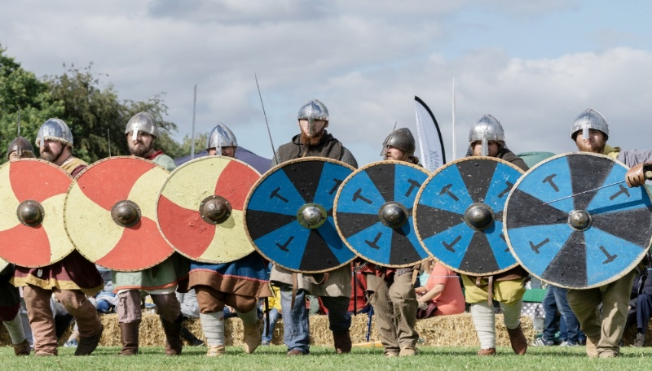

The Vikings at Langwith!
Welbeck has the tunnels, Creswell has the Crags and now, Langwith has the Vikings.
The name of “Langwith” itself comes from the old Norse language – ‘Langr’ (long & tall). Centuries later they have returned and set up camp on the Langwith Recreational Ground as part of Rhubarb Farms annual Langwith Show.
There will be a Viking encampment with live battles in the big show ring that you and your family can get involved with.
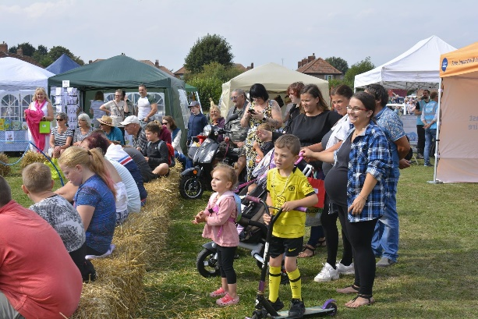
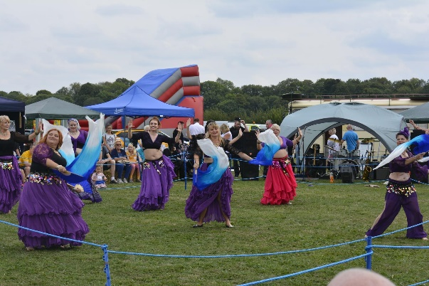

The Langwith show is a not-for-profit community event that hosts stalls for local business, a fun dog show, entertainment for children (and adults alike!) and a traditional village produce show.
From Apples to Victoria sponge the produce show has it all!
So, either get your pinny on and start baking your best buns, or perhaps don a pair of wellies and bring in your abnormally long runner beans. You can even enter your egg-cellent eggs! The produce show has a diverse range of over 60 categories from Crochet and jewellery to biscuits and oddly shaped vegetables – there really is a category for every talent.
If that’s not enough to entice you – this year, there’s a brand-new category all inspired by current trends and arts and crafts – perfect for your little ones to get involved with.
Download a registration form from Rhubarb Farms website, or even pop in to grab one, and enter your perfect pickles! The cost per entry is just 50p, with first prize being awarded a whopping £3.
Best in the show will take home a crisp £20 note.
Rhubarb Farm hosts this event each year for the local and surrounding communities to enjoy. When they are not hosting village fetes, they are a horticultural-based environmental social enterprise, right on your doorstep on the Derbyshire/Nottinghamshire border.
They provide volunteering opportunities to the unemployed, substance misusers, young people, people with learning disabilities, people who suffer mental health difficulties and many more. This is done by using therapeutic organic horticulture-based activities that develop skills, confidence and employability as well as improve the health and well-being of those people they support.
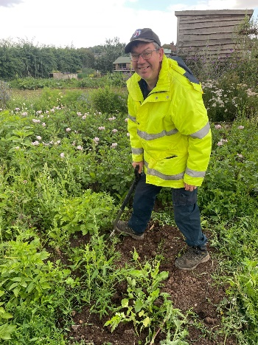
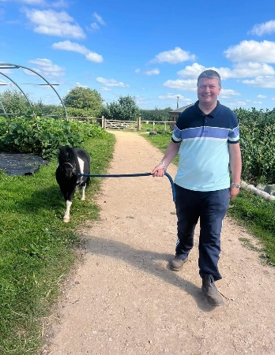
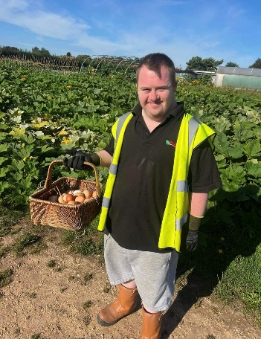

Every penny raised at Langwith Show will go towards supporting the valuable work and upkeep of The Farm and its offshoots, such as Rhu-Baby, a pay what you can, baby essential shop based at Langwith Parish Council, community cafe and the weekly food hubs that help families in need.
As well as judged entries in the Produce show, there are lots of stalls and activities from a variety of local crafters and community organisations, which includes sowing winter salads and seeds to take home, children’s crafts and much more. Entertainments include belly dancers, live music, a Fun Dog Show and a birds of prey display. There will be food and drink vendors, Facepainting, the opportunity to walk an Alpaca and much more.
Are you ready for a fun filled family day out?
We can’t wait to see you there!
The Langwith Show takes place on Saturday 2nd September at Rhubarb Farm, Hardwick Street, Langwith NG20 9DR from 12pm until 4pm.

