September
Social media posts
Take Five to Age Well
Take Five to Age Well aims to give people simple, practical advice around how to age well. From eating healthily to moving more – there’s useful tips for everyone to follow.

The campaign officially launches on September 1st by encouraging people to sign up and pledge to choose, and keep up a healthy change, throughout September

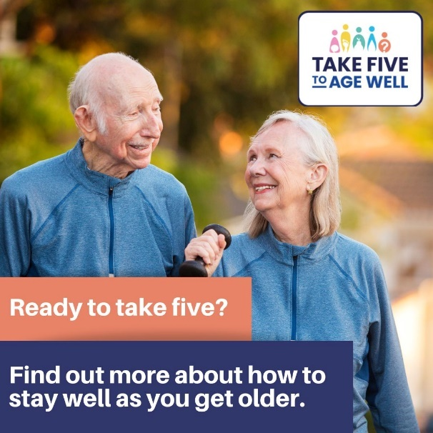
Here is the link to the website and sign up page as well as engagement materials
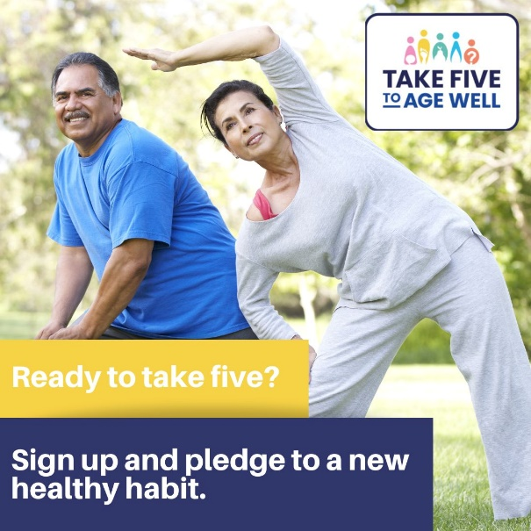

(sept 1st)
Take Five to Age Well kicks off today with advice about how we can all live healthily as we get older. Sign up to the first ever ‘ageing well’ pledge here: https://nquire.org.uk/mission/take-five-to-age-well/contribute

(mid sept)
Have you signed up to a new healthy habit this September? Take Five to Age Well aims to help us all stay healthy and happy as we age. Pledge to try a new healthy habit online here: https://nquire.org.uk/mission/take-five-to-age-well/contribute

Suicide Prevention Day (September 10th)
(Sept 9th post) Tomorrow is #SuicidePrevention day. A chance to have open, frank discussions about mental wellbeing & to find out about the support and help on offer if you’re struggling. Visit www.derbyshire.gov.uk/suicideprevention for more information
Sept 10th is World #suicideprevention day. There’s lots that we can all do to help prevent suicide including taking part in free suicide awareness training. Find out more here: https://www.zerosuicidealliance.com/suicide-awareness-training
It’s World #SuicidePrevention day and sadly thousands if people in the UK take their own lives each year. If you’re struggling to cope it’s ok to reach out for help. www.derbyshire.gov.uk/mentalhealth

It’s World #SuicidePrevention day. If you have concerns about someone you know then there’s advice about how to talk to them about how they are feeling here: https://www.derbyshire.gov.uk/social-health/health-and-wellbeing/mental-health-and-wellbeing/suicide-prevention/suicide-prevention.aspx

Suicide prevention is everyone’s business. During #WSPD we’re raising awareness of the support on offer. Find out more at www.derbyshire.gov.uk/suicideprevention
If you’re struggling to cope, then help is out there. The Derbyshire Mental Health Helpline is open 24/7 for mental health support. Call them on 0800 028 0077.

(after the 10th) #SuicidePrevention isn’t just about one day of the year. By continuing to raise awareness, reduce the stigma around suicide and show our support, we can all help to prevent more people from feeling alone. https://www.derbyshire.gov.uk/social-health/health-and-wellbeing/mental-health-and-wellbeing/suicide-prevention/suicide-prevention.aspx

Sexual Health week (11th – 17th September)
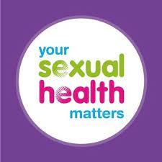
It's #SexualHealth week and this year @BrookCharity will be looking at the theme of ‘playing it safe’. Find out more online: https://www.brook.org.uk/shw/
During #Sexualhealth week. Do you know which free services are on offer in Derbyshire if you need them? Find out more at @yshmderbys online at https://www.yoursexualhealthmatters.org.uk
It’s #SexualHealth week and @yshmderbys offers free STI checks, contraception support and relationship help for Derbyshire residents. Find out more at https://www.yoursexualhealthmatters.org.uk/

Know your Numbers Week (4th to 10th September)
It's #KnowyourNumbers week - encouraging adults to know their blood pressure numbers and to take action to reach a healthy blood pressure. Find out more: http://www.bloodpressureuk.org/know-your-numbers/know-your-numbers-week/

@DCCPublicHealth are offering FREE blood pressure checks during #KnowYourNumbers week. Follow us to find out where we’ll be.
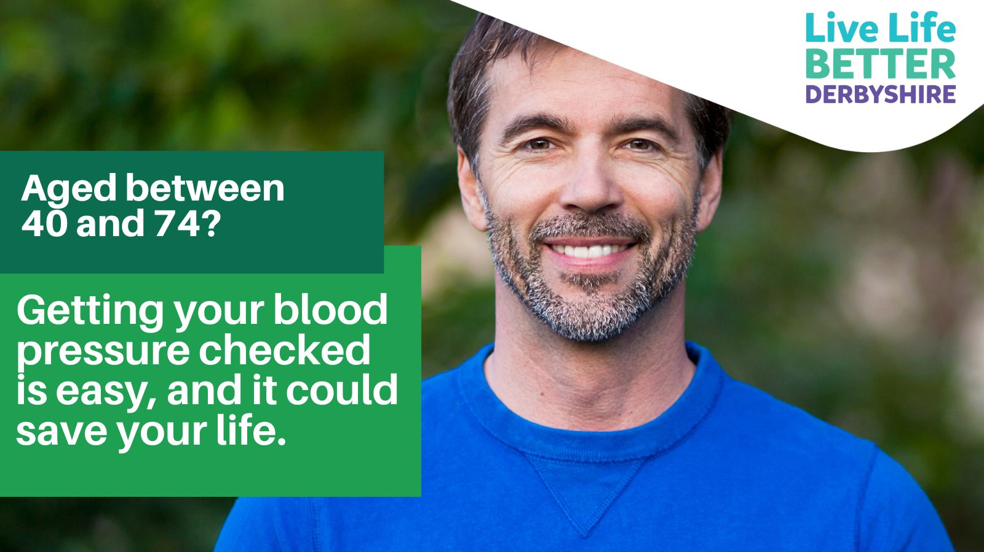

During #KnowYourNumbers week @BloodPress_UK are encouraging us all to find out more about our blood pressure and how we can help to control it. http://www.bloodpressureuk.org/know-your-numbers/
Newsletter / intranet / payslip letter copy
World Suicide Prevention Day
September 10th is World Suicide Prevention Day – an annual event which aims to start open, frank conversations around suicide and what we can all do to help prevent it.
Every suicide is devastating and has a huge impact on friends, family and the wider community.
By raising awareness, reducing the stigma around suicide and encouraging action, we can all help to reduce the instances of suicide and offer support to people who need it.
World Suicide Prevention Day is an opportunity to talk about this all too often taboo subject and offer support and understanding.
No one needs to feel alone - please help us to support people in mental health distress.
Find out more about the help and support on offer in Derbyshire at www.derbyshire.gov.uk/suicideprevention
Organisations can take part in the Zero Suicide Alliance’s free suicide awareness training. You can find a link to the training here: www.zerosuicidealliance.com/suicide-awareness-training
The Derbyshire Mental Health Helpline offers 24 hour a day support and advice and you can call them on 0800 028 0077.

