October
Social media posts
Stoptober
It's #Stoptober - the perfect time to #quit smoking. If you're ready to kick the habit, then get in touch with #LiveLifeBetterDerbyshire & join a FREE stop smoking clinic. Call 0800 085 2299 or visit www.livelifebetterderbyshire.org.uk
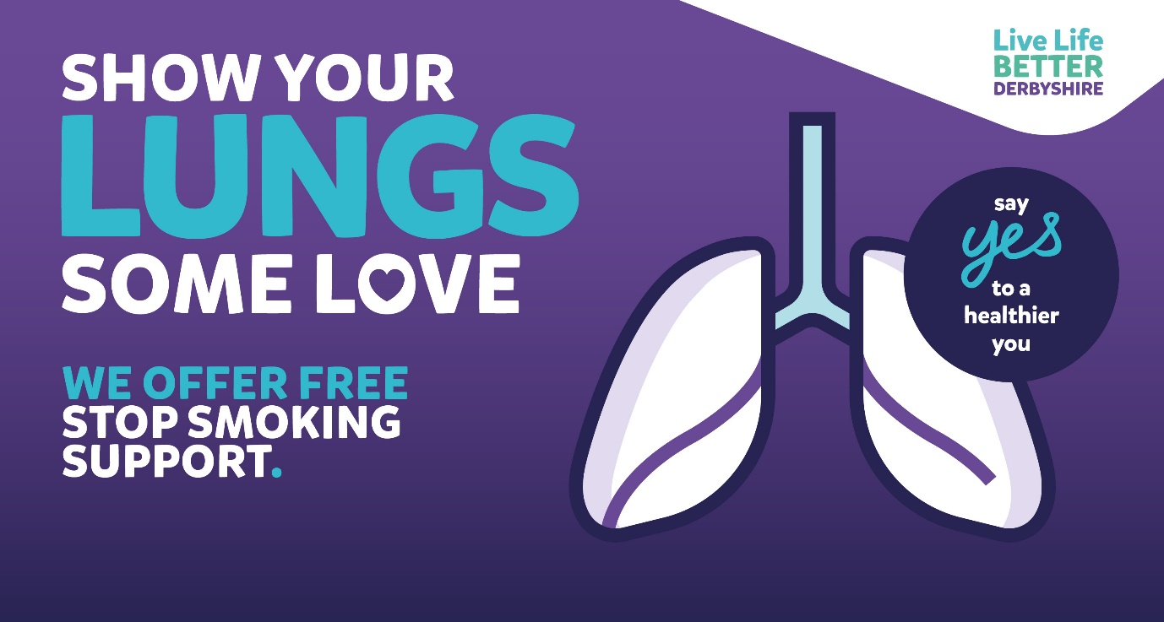

If you’re trying to quit smoking this #Stoptober then why not download Derbyshire County Council’s FREE My Quit Route app? It’s designed to help you kick the habit for good. Find out more online: https://www.livelifebetterderbyshire.org.uk/services/digital-and-online-health-apps/online-health-apps.aspx
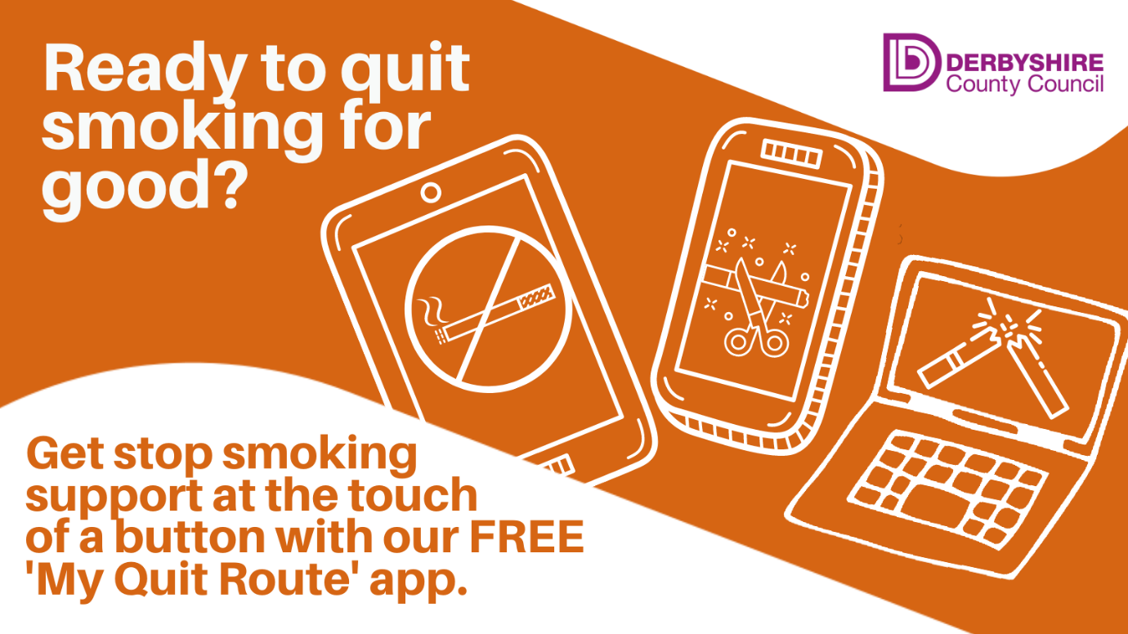

Breast Cancer Awareness month
It's #breastcancer awareness month. Breast cancer is the most common cancer in the UK, representing 15% of all new cancer cases. You can find out more about what to look out for on here: https://breastcancernow.org/information-support/check-your-breasts/learn-signs-breast-cancer
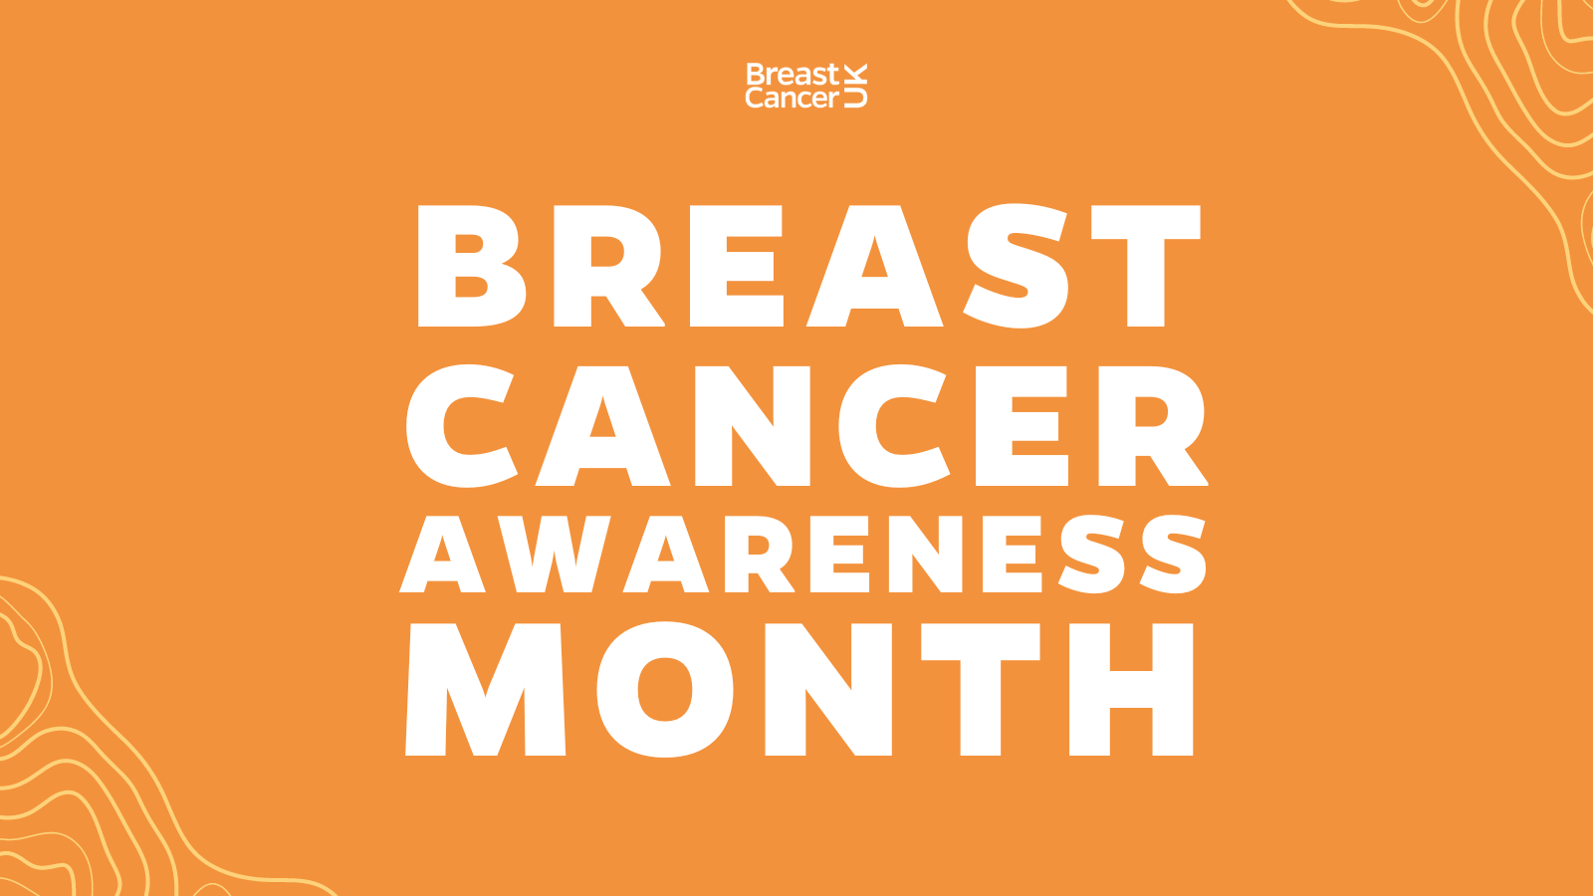

Everyone has some risk of getting #breastcancer, but there are easy everyday ways to help reduce your risk. Take a quick quiz and learn more about prevention plans here: https://breastcancerprevention.org.uk
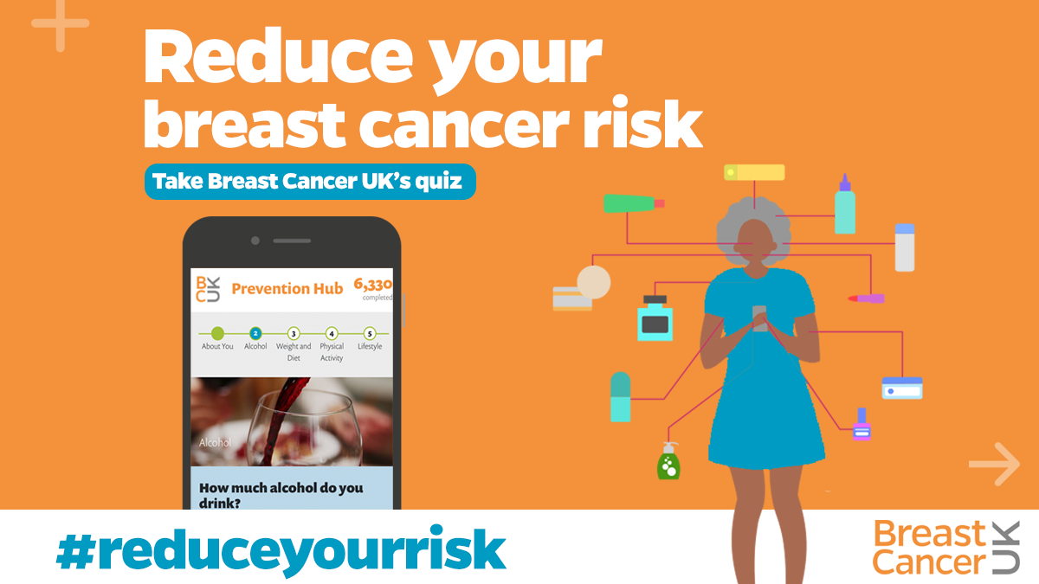

During #breastcancer awareness month find out more about the signs & symptoms at Breast Cancer UK here: www.breastcanceruk.org.uk
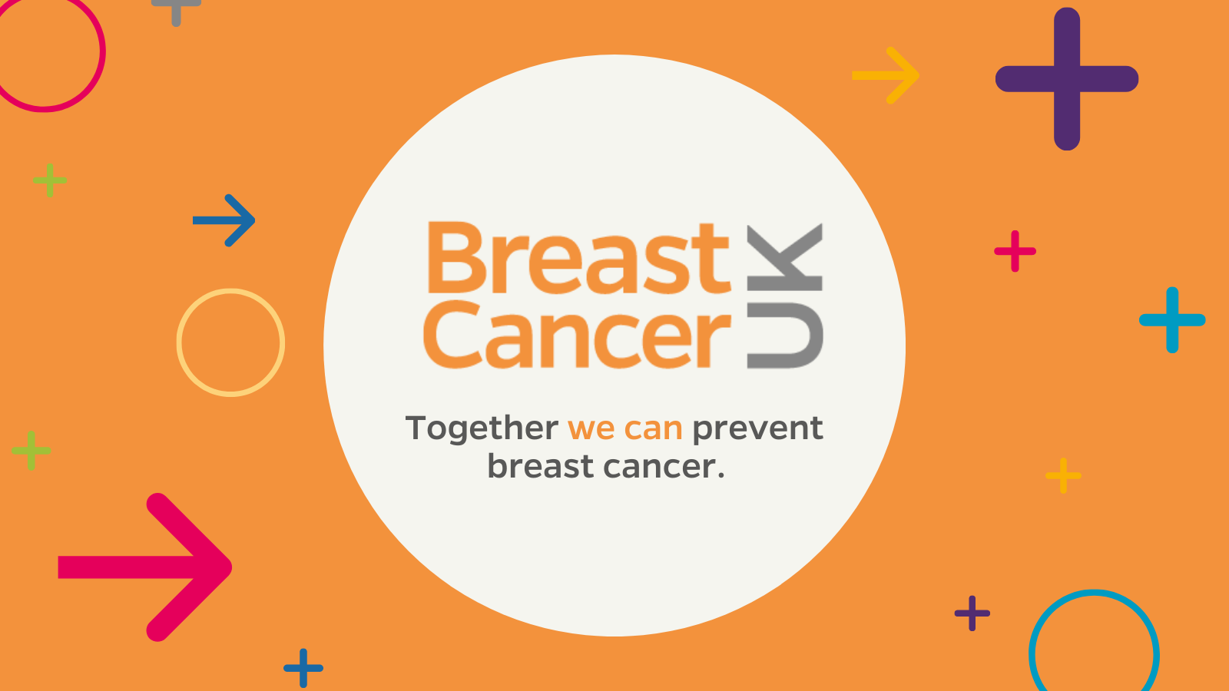

World Mental Health Day (October 10th)
It's World #MentalHealth day today. A perfect chance to stop and have a conversation about how you're feeling & to reach out for help if you need it. There's lots of support on hand to help. Visit www.derbyshire.gov.uk/mentalhealth
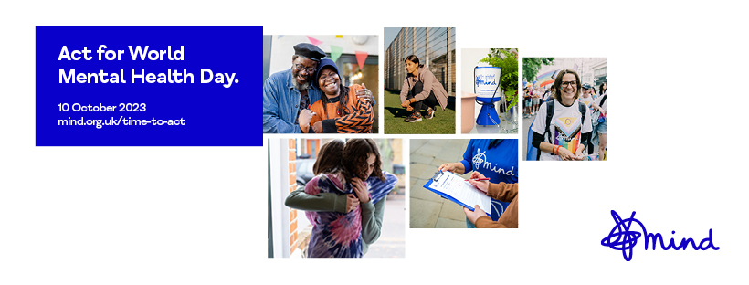

Talking is good for your mental health. And talking about mental health is important. But starting a conversation isn’t always easy. Here are some tips that can help. https://www.derbyshire.gov.uk/social-health/health-and-wellbeing/mental-health-and-wellbeing/talking-about-mental-health/talking-about-mental-health.aspx

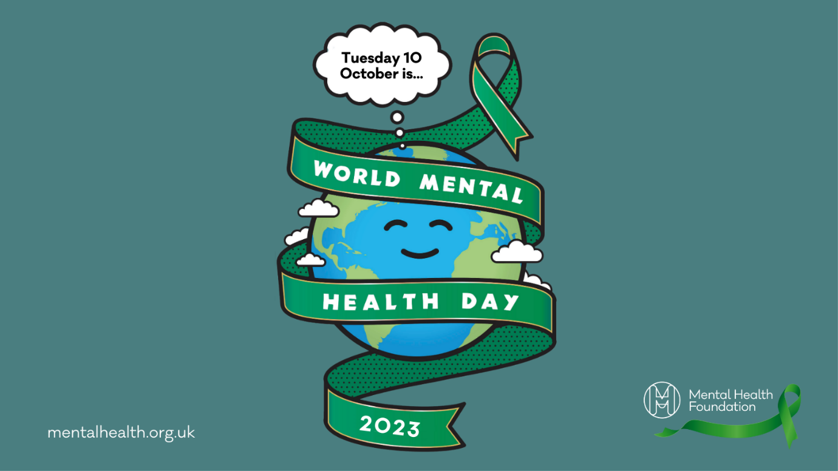

Newsletter / intranet / payslip letter copy
Stoptober
Stoptober is the perfect time to stop smoking for good and there’s lots of support on offer both locally and nationally.
If you're ready to kick the habit, then get in touch with Live Life Better Derbyshire and join a FREE stop smoking clinic. Call 0800 085 2299 or visit www.livelifebetterderbyshire.org.uk
Alternatively, if you’re not quite ready to join a stop smoking service then why not download Derbyshire County Council’s FREE My Quit Route app?
It’s full of expert advice and tips – straight to your phone or tablet.
Find out more, and download the app, online here: https://www.livelifebetterderbyshire.org.uk/services/digital-and-online-health-apps/online-health-apps.aspx

