Waiting for friends to arrive for a sleep over .Have you heard the news? 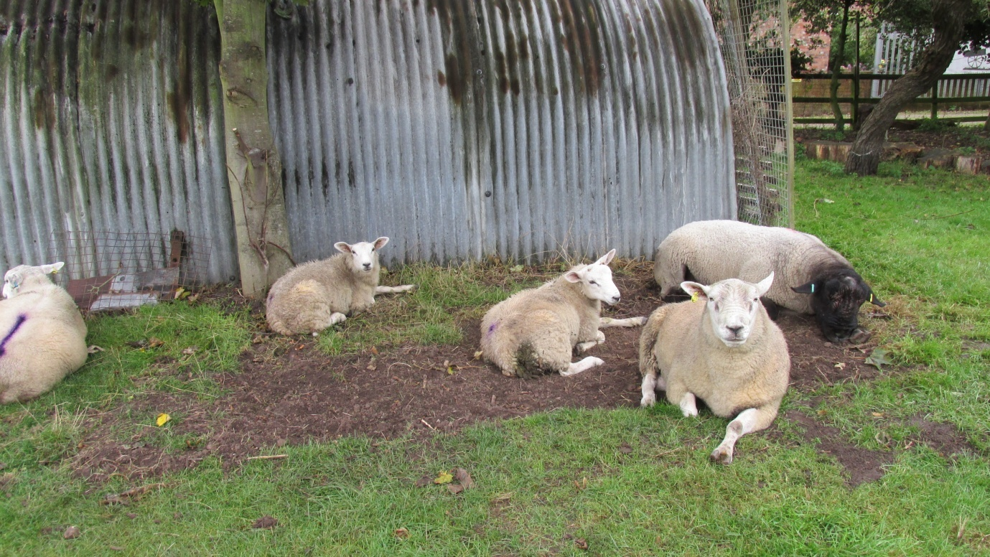The Walks of life museum has two friends who are going to sleep in the Nissen hut to raise money for the Royal British legion poppy appeal .We are very excited think they may bring us treats .Wonder if they will have carrot marmalade like they made in the war yummy

