Local Authority
Promotional Pack:
Round 3 Window 3 Launch
December 2023

COMMUNITY OWNERSHIP FUND
COF@Levellingup.gov.uk

Contents
1. BACKGROUND 3
2. ROUND 3 4
Round 3 Changes 4
EOI (Expression of Interest) and Main Application Stage 4
Round 3 Timings 5
3. ELIGIBILITY FOR PUBLICLY OWNED ASSETS 5
4. KEY LINKS 6
5. PROMOTION 7
Social Media Post Drafts 7
DLUHC Social Pages 8
5. CASE STUDIES 8
6. PHOTOS OF PROJECTS 38
7. SUCCESSFUL PROJECTS 40
8. Q&A 44
General Q&A 44
Fund-Specific Q&A 44
Round 3 Changes Q&A 46

BACKGROUND
  - The £150m Community Ownership Fund helps communities across England, Scotland, Wales and Northern Ireland to take ownership of assets at risk of closure.

  - The Community Ownership Fund helps to ensure that important parts of the social fabric, such as pubs, sports clubs, theatres and post office buildings, can continue to play a central role in towns and villages across the UK.

  - This Fund forms part of the UK Government’s levelling up agenda, helping support ambition and building opportunity, with support targeted towards places where community assets can make the most difference. The Community Ownership Fund helps to safeguard the small, but much-loved local assets on which we cannot put a price.

  - The Community Ownership Fund has awarded £49.3 million to 195 projects across the UK, with £35 million allocated to 131 projects across England, £6.2 million allocated to 28 projects in Scotland, £4 million to 18 projects in Wales and £4.1 million to 18 projects in Northern Ireland.

  - There is a long-term trend of communities losing assets that foster a sense of community pride and bring people together. This has a knock-on impact on people’s satisfaction with the place they live in, and the strength of local communities.

  - There is evidence that assets of this variety can be successfully and sustainably brought into community ownership. This both enables people to continue to benefit from the places that matter most to them and empowers communities to shape their local areas.

  - However, we recognise it can be hard for community groups to raise the initial funding required to buy the asset. The Community Ownership Fund will help enable community groups to overcome these barriers.

  - The Fund ensures that local people across the UK can support and continue benefiting from treasured local institutions whose future may be in doubt. We will invest in community ownership projects where these assets make the biggest difference to the local place.

  - Community ownership of assets can boost local connections, participation and pride of place, and bolster community resilience. By investing in the capacity of communities across the UK to take ownership of the places and spaces that matter to them, the Fund will help to strengthen the social infrastructure that supports communities to thrive.

ROUND 3

Round 3 Changes
  - We have made positive changes to the Community Ownership Fund for future bidding windows. Changes to the design of the programme and the eligibility requirements are informed by applicant feedback, stakeholder engagement, and lessons learned from previous bidding windows.
A summary of the key changes to the eligibility requirements for the Fund include:
- Implementing a consistent match funding reduction for all bids, bringing the requirement down from 50% to 20%, and further reducing the requirement for projects where they are eligible for in-depth support and have been assessed as having the highest need to 10%
- Extending the funding cap for all asset types from £250,000 to £2 million (2 million uplift announced at open of Round 3 Window 2).
- Allowing applications from parish councils (and town and community councils).
- Permitting parish councils (and town and community councils) to credit a capital receipt from the Community Ownership Fund.
- Allowing energy inefficiency that threatens long-term sustainable operations as a risk of loss.
- Allowing applications from connected companies in certain circumstances.
A summary of the key changes to the design of the programme include:
- Increasing the number of bidding windows per year.
- Removing the 2-application limit for all projects.
- Having a fully onboarded and operational development support provider (available via the MyCommunity page), now offering in-depth support to projects of greatest need alongside initial advice and support with queries for all applicants.
- Clarifying and strengthening our guidance documents and application form for applicants (read full details of the assessment criteria guidance).
- Introducing 2 additional considerations the Secretary of State can use to exercise discretion on shortlisted bids (read full details of the decision-making process).
Changes made to the fund are explained in full in section 15 of the updated prospectus.

EOI (Expression of Interest) and Main Application Stage
  - Applicants need to submit an EOI form and have this approved before being sent a link to the full application for the Fund. The EOI form will test whether a project is likely to be eligible through a pass/fail assessment based on the eligibility requirements.
  - The EOI stage is designed to strengthen the application process by ensuring that applicants are fully aware of the eligibility requirements ahead of submitting a full application to the Fund.
  - The EOI stage will be always open so that applicants can submit an EOI form at a time that is right for their project.
  - If applicants pass the EOI stage, they can then apply in any bidding window suitable for the timings of their project and applicants will be notified via email when the bidding windows open and close.
  - There will be four bidding windows each year to submit a full application to the Fund. Applicants will have an opportunity to apply approximately every 3 months until March 2025.

Round 3 Timings
  - Round 3 Window 1 opened on 31 May and closed 12 July 2023.
  - Round 3 Window 2 opened on 30 August 2023 and will close on 11 October 2023. We aim to inform applicants of their outcome in December 2023.
  - Round 3 Window 3 opened on 6 December 2023 and will close on 31 January 2024. We aim to inform applicants of their outcome for this window in Spring 2024.
  - There will be four bidding windows in a year and each bidding window will close at 11:59am on its respective closing date. The dates of future bidding windows will be announced in due course.

ELIGIBILITY FOR PUBLICLY OWNED ASSETS
  - From Round 3 onwards parish, town, and community councils (depending on meeting all other eligibility requirements) can now submit an application for funding. In addition, parish, town, and community councils can now also credit a capital receipt from the Community Ownership Fund and we will fund projects to purchase assets owned by these councils, provided additional evidence requirements related to public sector asset transfers are met.
  - In all cases, the Fund will work alongside existing Community Asset Transfers to support these transfers by funding the costs of renovation and refurbishment. For example, if an applicant was able to secure an asset transfer or raise the funds through another route, they could be eligible for funding from the Community Ownership Fund for any refurbishment needed in order to save that asset.
  - Local authorities (except parish, town, and community councils) and local authority-controlled companies are not eligible to apply to the Community Ownership Fund and cannot act as an accountable body.
  - Alongside the mandatory eligibility requirements that every applicant will need to fulfil, bids relating to publicly owned assets will also need to demonstrate the following additional requirements. These additional requirements are that:
    - The responsibility for delivering any statutory services is not transferred from the public authority to the community organisation.
    - The Community Ownership Fund grant received will only be used for renovation and refurbishment costs following the transfer of an asset into community ownership; the public authority will not credit a capital receipt from Community Ownership Fund funding, except in the case of parish, town, and community councils.
  - For projects relating to publicly owned assets, we will require additional, specific evidence covering the following points:
    - Risk facing the asset - The Fund will only invest in community assets which would otherwise be lost. We will therefore need evidence from both the current public owner and applicant about the current status of the asset and why its future is at risk.
    - Impact on service provision - Evidence that any statutory services currently delivered from the asset at risk will be continued by the public authority. This may be evidenced by a letter or appropriate cabinet paper from a local authority, for example.

KEY LINKS
COF Prospectus - https://www.gov.uk/government/publications/community-ownership-fund-prospectus
COF Assessment Guidance - https://www.gov.uk/government/publications/community-ownership-fund-round-3-application-form-assessment-criteria-guidance
COF Expression of Interest Guidance: https://www.gov.uk/guidance/community-ownership-fund-round-3-how-to-express-your-interest-in-applying
List of Successful COF Bidders: https://www.gov.uk/guidance/community-ownership-fund-first-round-successful-bidders
Levelling Up Website: https://levellingup.campaign.gov.uk/projects-near-me/
Useful links from the Development Support Provider:
- Advice service for applicants: https://mycommunity.org.uk/community-ownership-fund#enquiry-form
- Resources: https://mycommunity.org.uk/community-ownership-fund
- How to write a strong COF application webinars: https://mycommunity.org.uk/how-to-write-a-strong-community-ownership-fund-application-webinar
- Case studies: https://mycommunity.org.uk/community-ownership-fund-stories

PROMOTION
  - We encourage you to share the Round 3 Window 1 successful bids announcement with your networks. Below you will find some supporting communication products.

Social Media Post Drafts
Short posts:
The Community Ownership Fund Round 3 Window 3 opened for application on 6th December! Read the prospectus and find out how to apply to save your community asset here: https://tinyurl.com/2skzc8bx

The Community Ownership Fund Round 3 Window 3 is now open! Read the prospectus and find out how to apply to save your community asset here: https://tinyurl.com/2skzc8bx

Post including 2 million uplift:
The Community Ownership Fund Round 3 Window 3 is now open!

Applicants can now make the case for up to £2 million in capital match funding to help establish a community-owned asset at risk of being lost without community intervention.

Read the prospectus and find out how to apply to save your community asset here: https://tinyurl.com/2skzc8bx

Case study/COF promotion:

[Case study description]

XXXX received XXXX from the UK Government’s Community Ownership Fund.

Do you also have a community project in XXXX that could benefit from COF funding?

Round 3 Window 3 is now open – read the prospectus and find out how to apply to save your community asset here: https://tinyurl.com/2skzc8bx

DLUHC Social Pages
  - We will be promoting the Community Ownership Fund on DLUHC social media pages. Please feel free to like and share any post about the Fund with your network. You can find DLUHC’s social media pages here:
- Twitter - https://twitter.com/luhc?s=20&t=vZheyUXTIgGa5Y6yX4E1pA
- Instagram- https://www.instagram.com/luhcgovuk/
- LinkedIn- https://www.linkedin.com/company/luhcgovuk/
- Facebook- https://www.facebook.com/luhcgovuk

CASE STUDIES

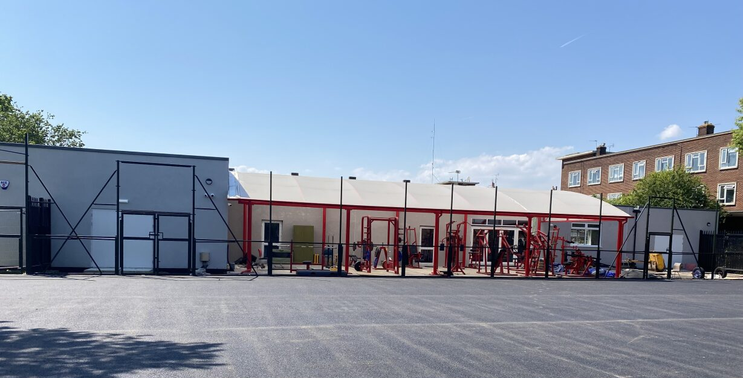
Europa Weightlifting Ltd

Setting the scene
Temple Hill has been a popular youth club and gym since the 1970s, changing the lives of young people in one of the most deprived wards in Kent.
Over the past 20 years the facilities have been on a downward spiral. A lack of investment has resulted in the main building deteriorating, the Multi-Use Games Area (MUGA) surface being deemed unsafe, and the floodlights no longer working.
The situation finally came to a head when the group running the facility was reduced to one person who reached out to Europa Weightlifting for help.
As a result, Europa formed a partnership with Temple Hill Youth Club and have embarked on a journey to repair and reinstate the facility, agreeing the overall aim “to improve the quality of life, mental health and wellbeing for the people in Dartford through sport activities.”
Following an intense period of consultation and campaigning, in 2021 Europa were able to secure a 30-year lease from Dartford Borough Council as well as circa £630k of funding from various partners to enable the rebuild of the main building.
Despite their best efforts, Europa still required investment to repair the MUGA, the floodlights, and provide the equipment for the gym. This represented the final piece of the jigsaw to transform the offer and business model of the site.

Making a difference to the community
With the MUGA reinstated, Europa forecast they will accommodate approximately 80,000 unique visits every year, roughly half of which will be provided free of charge through partnership with Temple Hill Youth Club, 2 local Primary schools and a new community football team (Temple Hill Tigers).
The gym offer is priced competitively to reflect the local area and will be managed by Europa, who bring their specialist expertise in weightlifting, with more qualified coaches than any other club in the UK.
When the facilities are not in use by the partners, the youth club building will be made available for the community groups to hire.
Given the previous history of the facility and the popularity of the MUGA, bringing the building back to life will have a huge benefit particularly to young people in the area.

Funding the project
The total capital award from the Community Ownership Fund is £220k which includes a 5% contingency. The majority of the capital expenditure will be on reinstating a multi-use games area which is critical to increase the wider community use and provide revenue for the project.
In addition, there is an award of £25k in revenue funding, which will cover the cost of an assistant manager in year 1, enabling the facility to open for a longer period and free up more time for business development.
Europa have also been able to secure partnership funding of c. £54k from Kent County Council and a local business for their match funding.

Getting the right support
Europa were one of the first groups able to benefit from the COF support programme. Following a diagnostic, the support package was primarily targeted at bringing the business plan up to date. This was prepared in 2019 and only covered the period to 2022.
The business plan improved to provide further evidence of the need for the facility and show the importance of revenue funding in the first year. It also highlighted the balance of the business model that Europa are aiming for: Making sure the facility is accessible and affordable to the most disadvantaged local people, while also ensuring there is enough revenue for the facility to be sustainable.
Final thoughts
Andrew Callard who has been the driving force behind the project highlights the importance of sticking with it. “Don’t give up. We’ve been on a long journey but once you’ve taken that first step to commit to doing it you need to accept there will be ups and downs. A particular low point for us was when there was a break in, and people stole tools from the workmen. Exactly the people we were setting out to help were stopping our progress.”
“But we know the difference a project like this will make. So, focus on the positives and how good it will feel when you can open the doors to the facility you know will make a difference to your community”.

(Story available on the MyCommunity website - https://mycommunity.org.uk/reviving-temple-hill-restoring-youth-club-gym)

South Seeds
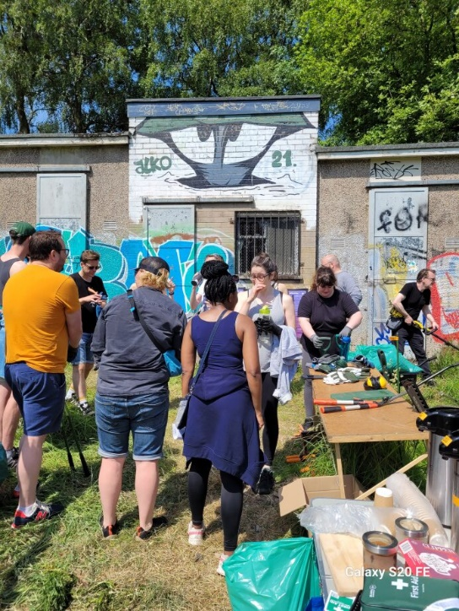
South Seeds is based in Glasgow and was set up ten years ago with the mission to enable Southsiders to lead more sustainable lives. It has grown into a successful, community-led charity with an impressive track record in engaging residents in its wide-ranging programmes and activities.
South Seeds has ambitious plans for the old changing rooms and the land on Queen’s Park Recreation Ground, with a view to saving this important asset and developing a community hub on the site.

Engaging the community
In the summer of 2021, South Seeds consulted with over 170 residents seeking views by means of an online survey and five in-person consultation events. All participants familiar with the area were of the view that the rejuvenation of the site was long overdue. Typical comments were that the graffiti-covered building was an ‘eyesore’ in its current condition. Many who responded felt strongly that the space could have a meaningful role to play in bringing people together and improving wellbeing locally.

“We are delighted that we have enabled local residents to get involved with the transformation of the vacant Changing Rooms on the recreation ground. People are learning new skills and making new friends. Best of all the building and surrounding land is looking much more cared for. Soon we hope, with support from the Community Ownership Fund to put it back in to community use.” - Lucy Gillie, General Manager, South Seeds

Funding the project
South Seeds have received £256,793 from the community ownership fund (£219,003 capital funding and£37,790 revenue). COF funding will be used to create a Community Net-Zero hub, providing a range of low-carbon information, training operations and resources, alongside urban nature-based wellbeing activities for Glasgow residents.
The plan is that the central section of the existing building will be demolished and replaced by an area of hard standing with a timber shelter protecting a section of the outdoor space. On the south of the central space will be a kiosk/café with outdoor seating beyond it, and to the north, the remaining cubicles will be converted into a small meeting room and workshop and storage space. The surrounding land will be developed with further raised beds.
South Seeds aim to use all the expertise at their disposal to ensure a very resource and energy-efficient build, reflecting the ethos of the organisation and ensuring the lowest running costs for the space as can reasonably be achieved.

Getting the right support
A diagnostic session undertaken by Development Trust Association Scotland (DTAS) identified that the Outline Business Plan the group had developed was strong but could be improved in some areas. A support package was put together identifying areas where the group could make improvements themselves and others that were more suited to an external consultant (DTAS Associate). The group set to work on a number of improvements, such as clarifying the strategic fit with the wider development plan for the park, adding case studies from users and outlining the lease terms agreed with the local authority.
The Associate's main task was to incorporate updated capital costs into the business plan and outline a clear funding strategy as well as developing five-year financial forecasts. A risk register was also completed, focusing specifically on the capital project and a theory of change added to show a clear path from activities to the wider impact in the community.
The work was completed quickly as the group were keen to meet the funding window deadline and they were very satisfied with the support they received through the programme.
(Story available on the MyCommunity website - https://mycommunity.org.uk/south-seeds-from-neglected-changing-rooms-to-thriving-community-hub)

The Vale of Aeron Pub

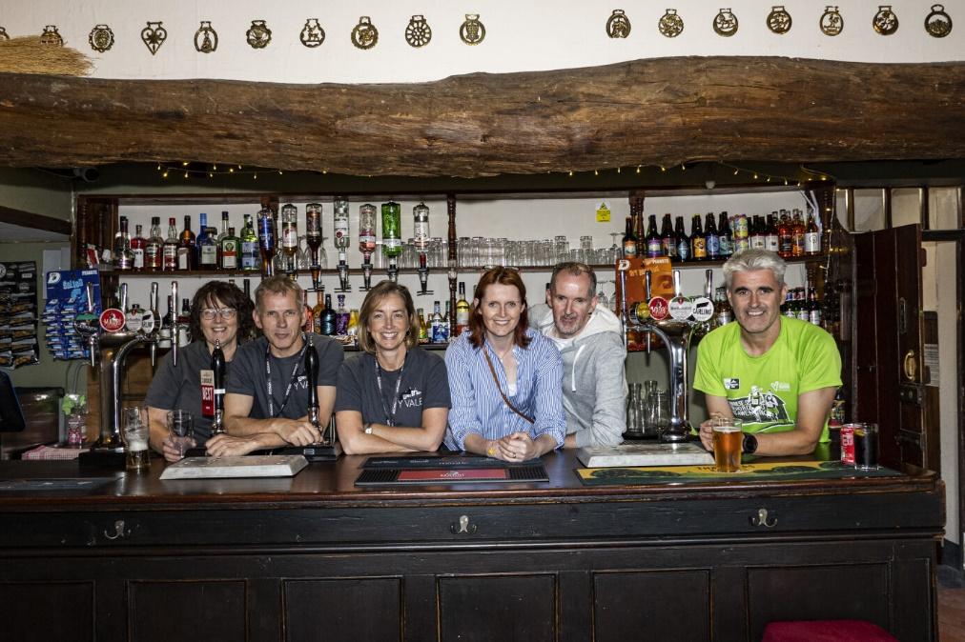
Setting the scene
The Vale of Aeron pub in Ystrad Aeron, was a favourite haunt of the legendary poet Dylan Thomas. In 2021 a group of local people set up Tafarn Cymunedol Dyffryn Aeron Cyf with the aim of bringing this much-loved establishment into community ownership.

Making a difference to the community
The community has big plans for the pub. They bought the pub in 2023 but this is only the start. In order to ensure the whole community to access the pub the group have planned a lot of renovations to bring the building into the 21st Century – and beyond - and enable the venture to be a sustainable business for the future.
The Community Ownership Fund has allowed them to develop a restaurant, employ local people, run a wide range of events that appeal to all members of the community – music and comedy nights, coffee mornings, be the ‘clubhouse’ for the various sports clubs, Welsh lessons etc.
The community of Dyffryn Aeron is predominantly Welsh speaking and this project was not only about ensuring the village had somewhere people can come to meet up and connect, but it was also to ensure that the Welsh language was preserved and nurtured.
Tafarn Cymunedol Dyffryn Aeron Cyf see this project as putting Dyffryn Aeron on the map, transforming the village and the surrounding areas - bringing people together, reducing isolation and loneliness and making the community together, stronger (as the Welsh football Team would say!)

Funding the project
Tafarn Cymunedol Dyffryn Aeron Cyf started with a community share offer which raised an impressive £383,000 from the community with support from famous Welsh people such as Matthew Rhys and Rhys Ifans. Shares were sold with a minimum price of £200 meaning that they now have 645 members all working to make the pub the best it can be. Running the share offer first meant that they could demonstrate the high level of community support and commitment to save the pub.
The group has now been awarded £250,000 from COF and a further £30,000 of revenue funding. This will enable them to make the significant renovations needed to ensure the business was open to everyone and was resilient. The revenue funding will cover staff costs for the first year which means that it will be built on solid foundations and have the best chance of becoming a sustainable business into the future.

Getting the right support
After an unsuccessful initial application to the Community ownership Fund, Tafarn Cymunedol Dyffryn Aeron were left feeling disillusioned, unsure of which direction to go.
This is when Cwmpas came into the picture. Cwmpas supported the group with assessing the business plan, financial forecasting, supportive feedback through acting as a critical friend and helping them to add detail to their answers. Looking through the previous unsuccessful application to the fund, it was clear there was lots of passion and community support for the project, but they needed support around understanding answering technical questions. Much of what they wrote assumed familiarity with the project and that often left them selling themselves short of the great work they had done, and the work they planned to do.
Carys Lloyd said “Following this support from Cwmpas we now feel empowered to apply for other large grants as we feel we learnt a lot about how to answer questions, in particular we found it really useful to have our statements challenged from someone outside our organization as sometimes we assumed everyone knows as much as we do about what we are trying to do!”

Final thoughts
Tafarn Cymunedol Dyffryn Aeron’s have a number of recommend for groups exploring COF and community ownership:
- Get support early support from expert organisations such as Cwmpas.
- My Community website has a huge amount of support.
- The COF application is a huge, complex task, make sure you have solid foundations in place with a good business plan, in-depth community engagement and your match funding.
(Story available on the MyCommunity website - https://mycommunity.org.uk/reviving-spirit-dylan-thomas-community-rescues-historic-welsh-pub)

Stretford Public Hall

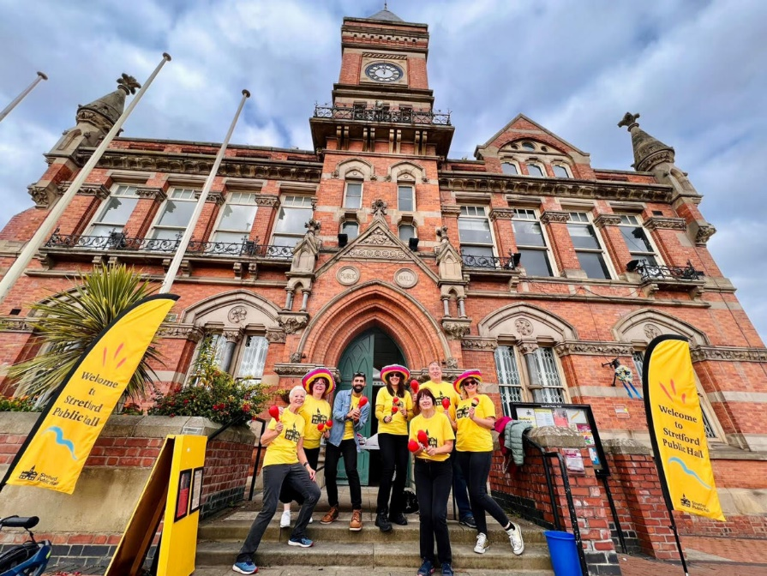
Setting the scene
Stretford Public Hall, a beloved institution in Trafford, Manchester, dates back to 1878, thanks to the philanthropy of John Rylands. Over the years, it has served as a civic hall, town library, theatre, and council offices.

Making a difference to the community
Now under community ownership, it plays a vital role in the local community, hosting arts events and providing essential services. However, to ensure its sustainability and functionality for the future, it requires crucial investments.
One priority is improving energy efficiency to reduce costs and the Hall’s carbon footprint, while also creating more event spaces. Most urgently, the aging roof needs repairs, as it has struggled with recent climate changes, causing damage that affects key areas like the artists' studios and the ballroom.
By addressing these repairs, they can offer weddings and corporate events to generate income for affordable community activities. This transformation will secure a vibrant future for Stretford Public Hall, preserving its legacy.

Funding the project
Stretford Public Hall has been awarded £288k by the Community Ownership Fund. This will go toward enhancing energy efficiency within the hall and addressing urgent roof repairs. This investment will ensure a resilient future for the hall, safeguarding its role as a community hub and enabling a diverse range of activities.
This includes £48k in revenue funding, that will primarily cover professional fees associated with capital works, including an architect practice.
In November, they are set to launch a new community share offer to raise the match funding required. The group received a small grant alongside in-depth support, which will be used to help develop and deliver a community engagement campaign for the new offer.
This follows a successful share offer in 2017. The area surrounding the hall has experienced significant redevelopment since then, and they are particularly focused on engaging new residents of Stretford, as well as previous investors and current users of the hall.

Getting the right support
The group received support from Cooperatives UK through the Community Ownership Fund support programme. This support has been vital in helping them prepare their Community Ownership Fund (COF) application and in crafting a robust business plan for the next five years.
This support has enabled Stretford Public Hall to decide their most immediate investment priorities and helped them develop and prepare for their ambitious longer-term refurbishment plans.
(Story available on the MyCommunity website - https://mycommunity.org.uk/preserving-heritage-building-future-stretford-public-hall-cof)

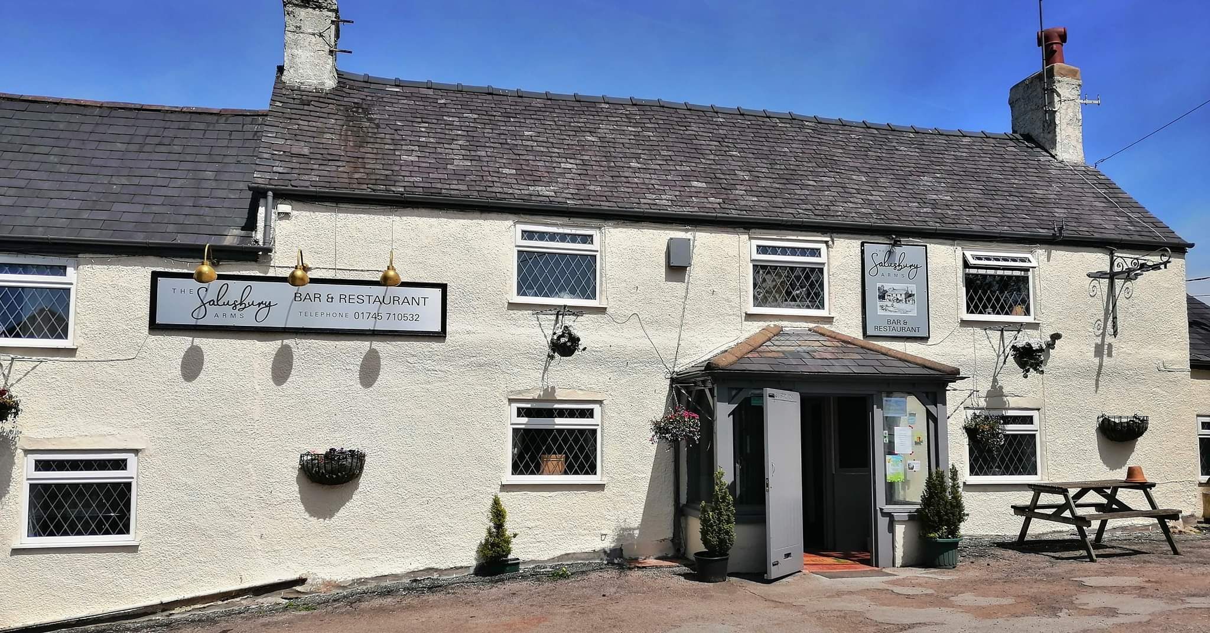
The Salusbury Arms

Setting the scene
The Salusbury Arms in Tremeirchion, North Wales was privately owned for 30 years. When the owner felt it was time to sell, they approached the village with a positive attitude to community ownership. The pub has provided many generations of the Tremeirchion community with their first pay packet, their first pint, even their first quiz night, and the community believed it should be their responsibility to ensure it survives for many more.

Making a difference to the community
The Salusbury Arms is the last pub in a village with little or no other services. There are plans for a café in the pub along with a shop that will largely be stocked with produce from local farms and businesses. The pub will offer employment opportunities to local residents, particularly younger people. The group are keen to offer pop-up opportunities around services such as banking, the Post Office, and the Citizens Advice Bureau. The Salusbury Arms hopes to become a universal community space for a population that has little opportunity to connect.

Funding the project
Tremeirchion Community Pub Limited was awarded £160,000 as capital grant from the Community Ownership Fund with a further £15,000 in revenue funding. This was more than matched by the £195,800 raised by the group’s community share offer, and it put the group in a position not only to buy the pub, but to get started immediately on necessary renovations.

Getting the right support
Throughout their application, the group received help from the Plunkett Foundation, who are one of the official support partners for the Community Ownership Fund. Plunkett were fortunately able to allocate an expert adviser already familiar with the project to help the group. The support provided covered matters such as running a community share offer, the Community Shares Standard Mark, and a full review of the application before it was submitted.

Advice
- Don’t spend too long pondering the EOI, just do it.
- Read the prospectus carefully. It’s a great guide and can often lead to questions that you may not have asked of the project.
- Speak to your local council about their plans for social impact. Can your project complement rather than duplicate what exists.
- The COF is like climbing a mountain. You’ll get to the top but there are days when you just need to concentrate on taking the next step.
- Use the local talent pool. Every community has enthusiastic, helpful, and skilled individuals. Make the most of them.

(Story available online on the MyCommunity page - https://mycommunity.org.uk/the-salusbury-arms-keeping-the-pub-in-the-community)

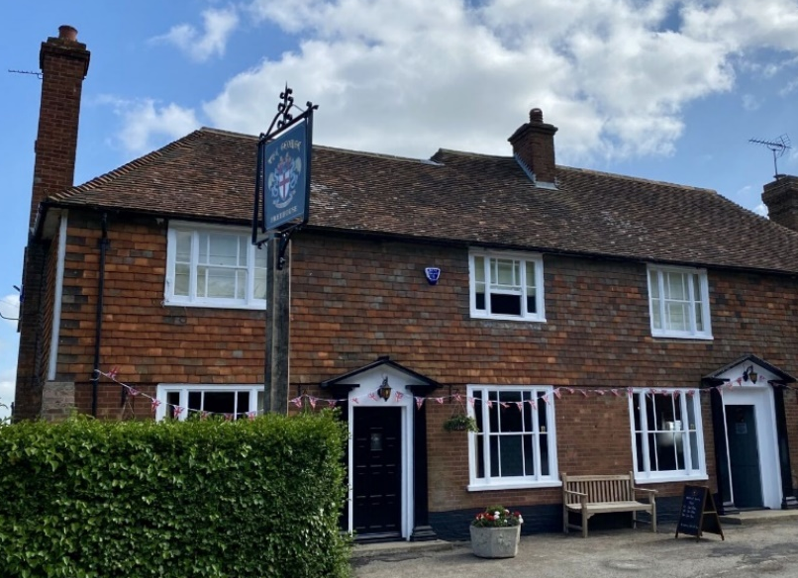
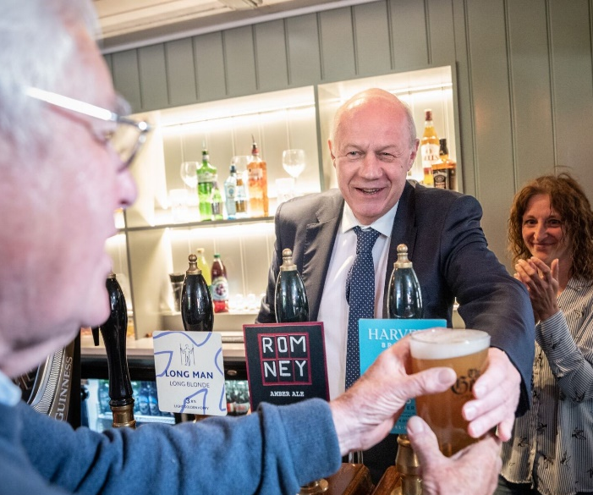
The George Community

Setting the scene
At the heart of Bethersden in Kent, The George pub has been the social centre of village life for several decades.
“It’s always been part of everything’s that’s happening,” said local resident Alex Withington.

“If ever there’s a village event, the George is involved somehow. It had a local pool team – and has supported Macmillan coffee mornings and other fundraising events. It’s where people gather after weddings and funerals. The George has always served good value food and drink. It’s the kind of place you just pop in to see people you know.”

When the Covid-19 pandemic hit, the pub shut down – and the owners decided to sell up and retire. Keen to save a crucial part of village life, Alex and a group of other Bethersden-ers rallied to find a way to keep The George going.

Funding the project
They initially held talks with a local businessman who wanted to raise money from private investors to buy the pub, with a focus on profit and dividends. But it soon became clear that a community enterprise was a more suitable model. So, the group formed The George Community Limited, which received a grant from the Community Shares Booster fund to help develop a share offer.

“With the £5,500 grant from the Booster Fund our plans were brought forward by the best part of a year. It allowed us to properly and professionally build our share offer and attain the Community Shares Standard Mark – the guarantee of a quality offer.”

With the help of their professional prospectus, the George Community’s share offer raised £358,000 from 189 investors. They also received £25,000 match funding from the Community Shares Booster Fund.
“The Booster Fund investment was a massive help. Every single pound is important in a venture like this and £25,000 is around a quarter of our renovation budget. This means we’ve been able to go further to create the community space our village needs.

“Co-operatives UK’s support and funding process is very good – and it enabled us to speak to other organisations that have done the same thing.”

The George also received £250,000 from the Community Ownership Fund.
“That was a game changer too,” said Alex. “We wouldn’t be here without all the funds we received and raised.”

With renovations finished in less than four months, The George re-opened on 26 May 2023.

(Story available online on the MyCommunity page - https://mycommunity.org.uk/the-george-community-saving-a-popular-pub-at-the-centre-of-village-life)

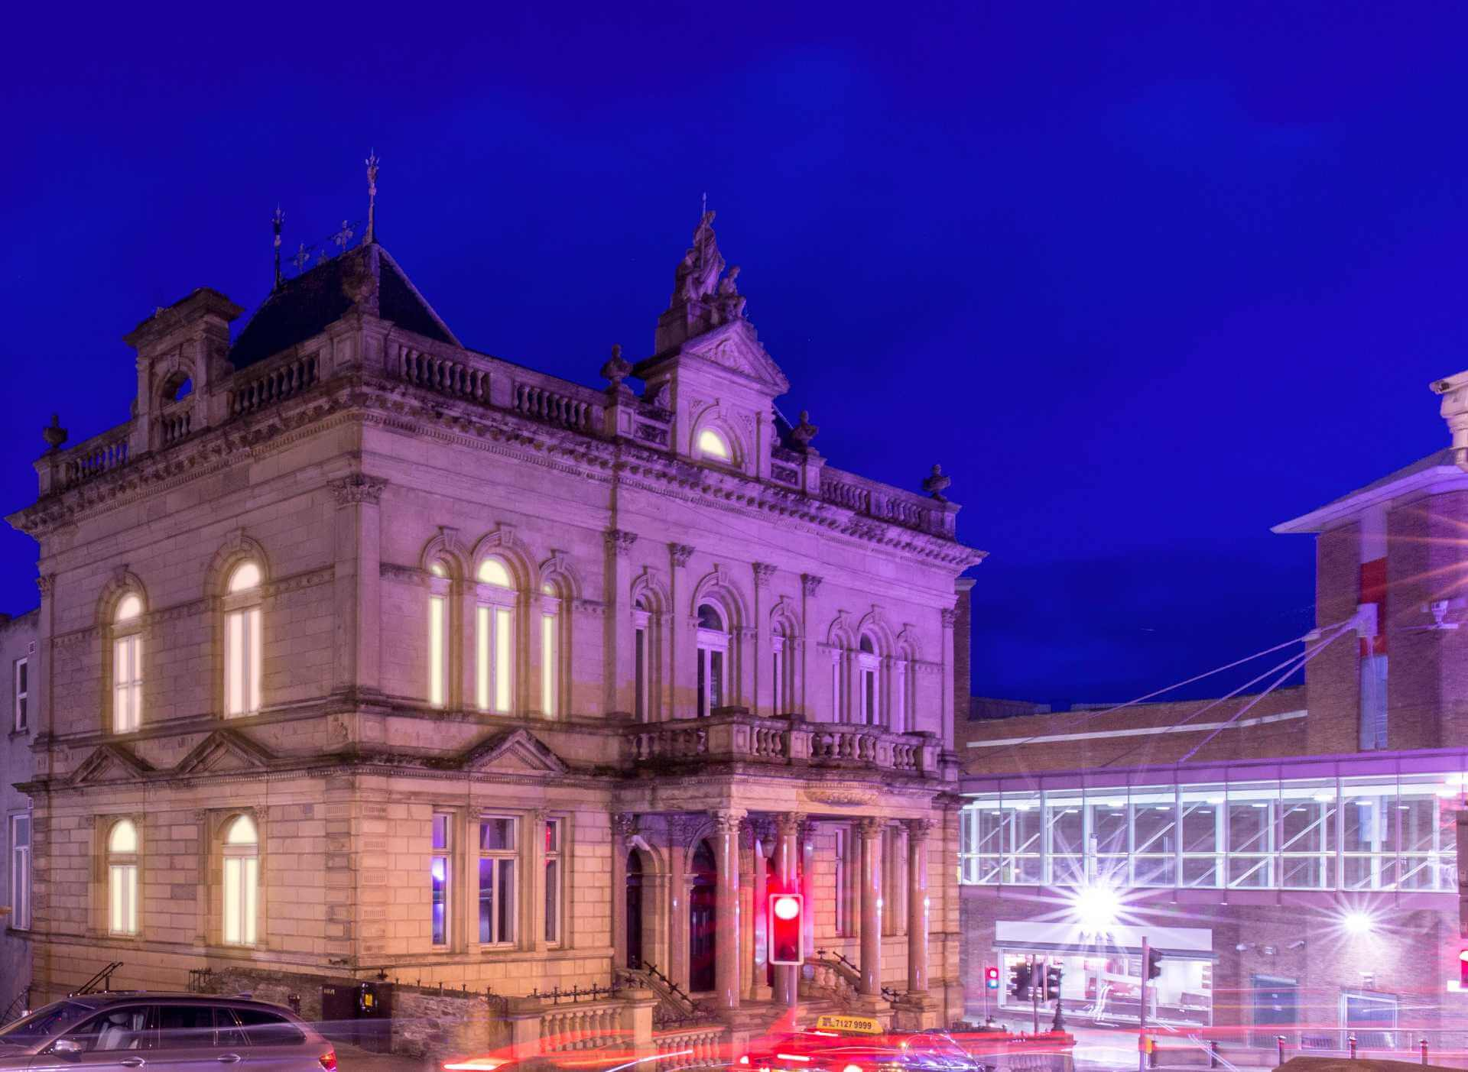
St Columb’s Hall

Setting the scene
St Columb’s Hall Trust is bringing ‘The People's Hall’ back to its proud roots to once again perform a central role in the life of Derry’s citizens.

Grade A listed St Columb’s Hall is a strategically important building located adjacent to the East Wall of Derry’s renowned historic walls. Using donations from the “rich and poor of the city”, the Hall was built as part of the Temperance movement in 1886-8 by the St Columb’s Catholic Total Abstinence Society. It soon became known as The People’s Hall and served as a place of refuge and education, and then a venue for a host of community activities, including public meetings cinema, theatre, dances, band practices and retreats.

Over the years, the Hall hosted several influential speakers, including Eleanor Marx, Emmeline Pankhurst and Irish statesman and political leader, Eamon De Valera. By the 1980s, the Hall was attracting performers like Jim Reeves, Roy Orbison and Chubby Checker, as well as high-profile classical musicians and talented local bands, such as The Undertones.

In the past few decades, however, the building has suffered from a lack of investment. Water ingress has caused serious damage to its fabric, and the condition of the Hall has worsened.

Making a difference to the community
St Columb’s Hall Trust was established in 2019 to regenerate the Hall so it can once again benefit the citizens of Derry. It proposes to create a flexible venue that will accommodate a mixture of uses, including an iconic live music venue; a ground-breaking creative therapy centre of excellence, tackling trauma, addiction, mental health and dementia; a shared space for thought and debate, including youth assembly; and a film hub and flexible office space for the creative industries.

Funding the project
A Project Viability Grant from the Architectural Heritage Fund (members of the Community Ownership Fund consortium) allowed the Trust to carry out a detailed condition survey of the building and engage stakeholders in the community; identify key partners and financial supporters; develop conceptual drawings; consider appropriate operation models; identify the economic impact and benefits of the proposed project; and to make recommendations on the best way forward in their Viability Report.

This groundwork helped to unlock further support from the National Lottery Heritage Fund, The Pilgrim Trust and Ulster Garden Villages. Recently, the Trust secured a substantial grant from the Community Ownership Fund of £181,000 to allow it to work with conservation specialists to improve accessibility and plan for future adaptations, and to complete urgent works, including repairs to the floors and upgrading of the electrics. The funding is also helping the Trust to capture oral histories; work with groups to research the heritage of the hall and its future; and reactivate community connection with the Hall - a valuable asset and gathering place for the whole city.

(Story available online on the MyCommunity page - https://mycommunity.org.uk/returning-the-peoples-hall-to-the-people-of-derry)

Zion Bristol

Setting the scene
Zion Bristol is much more than a café, it is a vital community hub that provides spaces for local people to meet and for groups to deliver vital services. This space, comprising a café, hall and room for hire has been at the heart of the local community in the Bedminster Down area of Bristol for more than a decade.
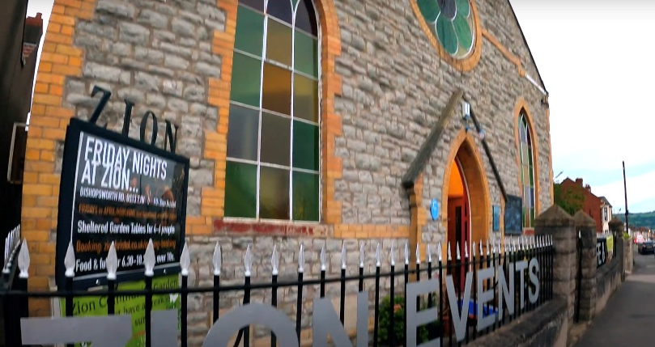
“There’s always something going on at Zion Bristol,” says Centre Manager Emma Moore. “We host groups for mental health, creative writing, breast feeding support, dementia support and more”.

“We host 200 events a year. There’s a group for under-fives, crochet and cribbage for older people, with a free meal on a Monday. We offer our space to community groups for free – because while we need to generate income, we want to offer what we can to the community”.

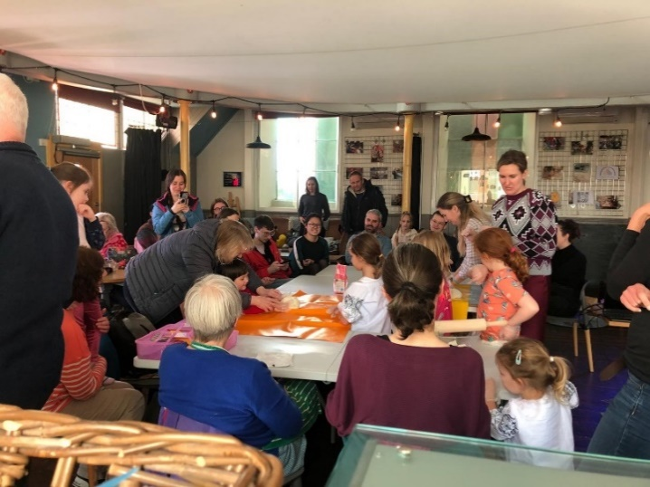
This is why, the local community were so keen to step up and save the space when the need came.

Making a difference to the community
Zion Bristol was originally set up by local resident Jess Wright who bought the empty Methodist chapel and turned it into a community café.

During Lockdown Jess decided to step away from the project and the community came together to discuss buying the building. Emma was a volunteer at the time. Like other volunteers and users of the centre, she wanted to keep Zion at the heart of the community.

“The place really came into its own during Covid. All the mutual aid partnerships set up during Covid highlighted how important this community space is. We were also a cost-of-living hub for the council last winter, offering free meals and providing hygiene bags. And we extended our opening hours so people could come in, have coffee and keep warm.”

Funding the project
To enable the community to take ownership of the centre, Emma and a team of residents set up a community benefit society and then launched a community share offer to raise the capital. They worked with Co-operatives UK’s Booster Fund, first to get a development grant to develop the share offer documents, business plan and receive the Standard Mark.

With a target of £475,000 plus stamp duty to raise, local people rallied, lending their skills and expertise to the campaign in areas including finance and marketing.

Zion received £240,000 from the Community Ownership Fund. In August 2022, they successfully raised £234,908 from their community share offer, which included £25,000 match investment from the Community Shares Booster Fund, funded by Power to Change Trust.

370 people invested, 288 of which came from immediate local area showing the level of local support.

“We would not be here without the share offer and COF funding”, said Emma. “At one point we were considering a mortgage. When we started crunching the figures on the mortgage, we realised we would not have been able to survive six months.

The sale completed in April 2023 and now Emma and her colleagues plan to build on the good
work. Zion Bristol now has seven local people on the payroll, a group of dedicated volunteers, and there is real hope for the future.

“Taking the centre into community ownership has been a huge learning curve” said Emma. “It has been a challenge, sometimes frustrating process. But, more importantly, it’s a hugely positively step and I’m excited for the future.”

“We’re proof that you can save an asset. We’re an area where things are always being taken away and not being replaced. It’s a big boost for the local community that we can affect change and save assets – it’s an empowering thing.”

Zion Bristol are now working to grow their community offering, making links with the local GP surgery to support older people and working with the NHS in South Bristol to tackle inequalities and improve health outcomes.

(Story available online on the MyCommunity page - https://mycommunity.org.uk/zion-bristol-keeping-a-vital-resource-at-the-heart-of-a-community)

Heart of Newhaven

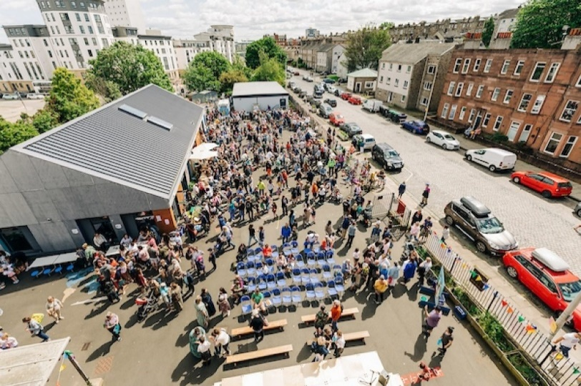
Setting the scene
When it became clear the Heart of Newhaven, Edinburgh’s oldest working primary school, could no longer accommodate the number of pupils in the area, the community feared the building would fall into private hands.

Situated within a conservation area, the iconic main building, built in 1844, is a local landmark. Grade B listed and part of the original Newhaven village, its cultural heritage and connections to the community go back to the area’s roots in fishing.

In 2020 the Heart of Newhaven Community SCIO was formed and undertook a successful Community Asset Transfer on behalf of the community. Funding to buy the school was then secured from The Scottish Land Fund. Saving the buildings ensured they will continue as a much-needed community space in an area where these types of spaces are in short supply.

Making a difference to the community
Following the successful transfer of the building, the community has wasted no time in establishing a wide range of activities at the Heart. Their focus is on delivering projects across three main themes of ‘Culture & Heritage’, ‘Learning and Enterprise’ and ‘Health and Wellbeing’. Sitting across these is an overarching commitment to intergenerational work, bringing people together and keeping a connection to the previous use of the building as a school.

The community hub that is now run from the Heart offers spaces for theatre and dance groups, choir and music groups, sport and performances of all kinds, artists’ studios, community meeting rooms for rent, a Victorian School Room, run by partner the History of Education Centre, The Wee Museum with displays of local heritage, Dementia meeting place, Pregnancy café, community teaching kitchen, much needed early years’ provision, a Community Garden and The Creel (a portacabin) for the Men’s Shed to carry on their activities.

Funding the project
Heart of Newhaven was awarded £300,000 from the Community Ownership Fund, £250,000 in capital and £50,00 of revenue to deliver the restoration and renovation of a former primary school for community use. The grant needs to be matched with equivalent funding and work continues to secure further amounts.
A number of organisations assisted with essential support and advice as the project was developed. The Community Ownership Support Service provided guidance throughout the asset transfer, helping to navigate the complexities involved with this process. The Scottish Land Fund advisor was important in helping with the early stages of the project and guiding the community through the acquisition of the building. Architectural Heritage Fund provided funding and support to meet architect fees.

A local organisation, Pilmeny Development Project, was instrumental in supporting the Heart to become established, advising on developing intergenerational projects. They remain a key delivery partner.

Important partnerships are now being developed with other organisations in the area. Heart of Newhaven Community are part of Restoration Forth, led by World Wildlife Fund with The Heart being one of 6 community hubs around the Firth of Forth aiming to re-introduce seagrass and oysters. In addition, working with a range of public and third sector partners on primary care development ensures the Heart contributes to a strategic approach to wellbeing in Newhaven.

Final thoughts
- Considering and planning all your match funders requirements and deadlines is essential to ensure funding isn’t lost.
- Volunteer-led projects are challenging for those involved, a considerable level of knowledge and time is required to interact with what can be challenging processes. Bring in paid staff or make use of expert advisors whenever possible.
- Well evidenced community consultation is essential for any project – get it done properly and at an early stage.

(Story available online on the MyCommunity page - https://mycommunity.org.uk/protecting-the-heart-of-newhaven)

Margaret Haes Riding School

Setting the scene
Margaret Haes Riding Centre, in the North West of England, has been offering life-changing experiences to children and young adults with special educational needs and disabilities for over 50 years. However, the centre faced an uncertain future when the landowner decided to sell.

Acquiring the site will ensure local people are still able to experience the benefits of being with horses - empowering children and adults with learning disabilities, physical and mental health disabilities, and emotional and social challenges, to lead active and fulfilling lives through equestrian activities.

Making a difference to the community
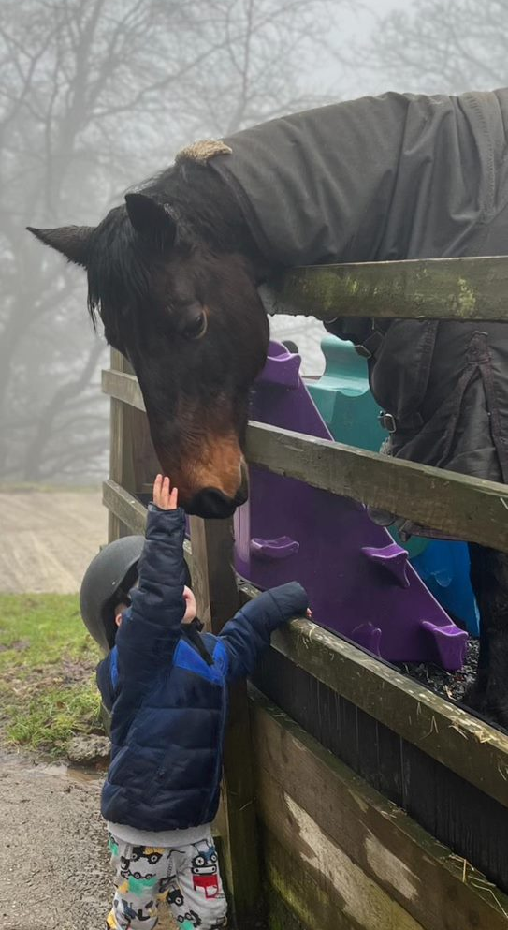
The riding centre has 12 horses suitable for riders of all abilities, available for use in both indoor and outdoor arenas, as well as for local hacks on country lanes and moors. By securing the future of the Centre, up to 160 vulnerable children and adults in the local community will have the opportunity to engage with the horses and develop their equestrian skills.
Debra Batchelor, a trustee at Margaret Haes, said:

"The response to our funding appeal from the community and wider, has been incredible, showing how much riding, or simply being with horses, at the riding centre has touched the lives of so many over the years…. The future is secure, and we can now unlock so many exciting opportunities to develop our facilities, and further benefit our community."

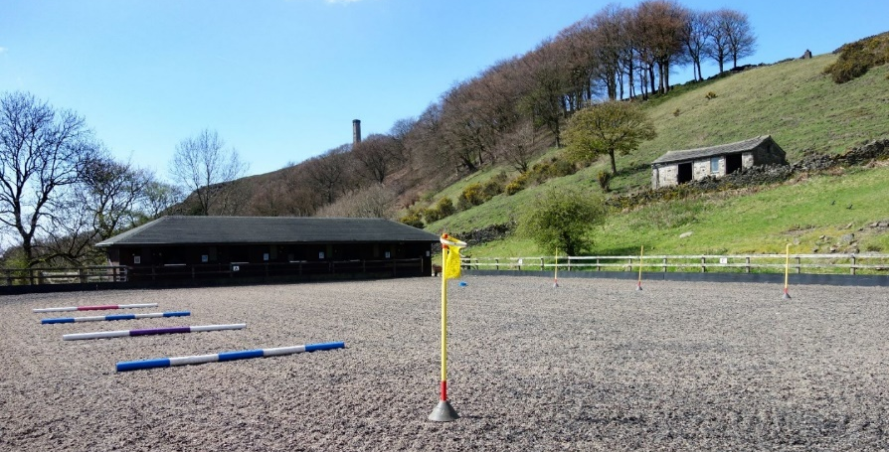
As part of the Community Ownership Fund (COF) application, the team are working to bring an old storeroom into use as a flexible community space. This community room will enable the riding centre to better accommodate visitors, host events, and bring additional revenue into the business.

Funding the project
The Margaret Haes Riding Centre was awarded a £150,000 capital grant and a £21.5k revenue grant through COF. The capital grant was matched by a combination of a crowdfunding campaign and a donation from a benefactor, with the money used to secure the purchase of the facilities. The crowdfund attracted contributions from more than 400 people, raising over £30, 000. The revenue grant will help reach the milestones set for the next 12 months which are focused on growing the centre as a cultural and wellbeing hub. This will include renovating the community room and hosting other activities such as theatre events in the outdoor arena.

Getting the right support
Although the Riding Centre had begun their application before the support programme was in place, they believe the process was beneficial to their project.
Submitting an Expression of Interest was valuable for the Riding Centre, even though it did not guarantee success. It helped the team to focus and commit time to the project. Additionally, it gave them a tangible discussion point for the landowner, who needed reassurances that their offer was progressing.
Preparing supporting documents for the full application. such as the business plan, also made things easier once the award was granted.

Advice
- Reach out beyond your normal network. Talk to the wider community and bring people in as partners and supporters. Many will stay with you beyond the campaign.
- The best stories come from beneficiaries. Work with the local media to amplify their voices.

(Story available online on the MyCommunity page - https://mycommunity.org.uk/securing-the-future-of-a-riding-centre-for-people-with-disabilities-and-special-educational-needs)

St Albans Community Center

Setting the scene
For 39 years, St Albans Community Centre has been an integral part of its community. The Centre relied on local authority funding for many years. Moreover, having leased their building on a peppercorn rent, they were then asked to sign a lease for over £20k per year.
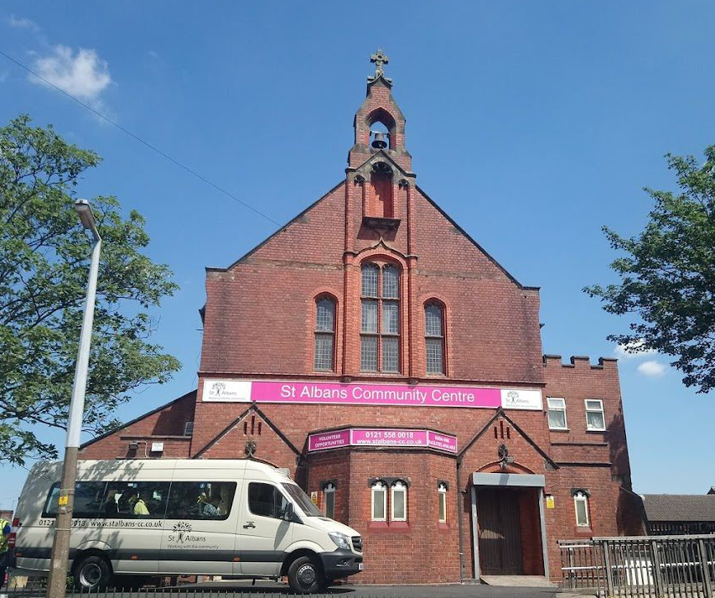
In response, the team looked for new funding options to keep their services going including how they could develop their trading income by delivering more fee paying and contracted community services like day care services. Through perseverance and support from Power to Change and other sources, they were able to purchase the asset in 2019/2020.
The COVID-19 pandemic brought additional obstacles, as the centre had to shift its focus to meet the evolving needs of the community, and pivoting services to meet the communities need.
Over the last five years, there has been a significant increase in demand for services, whether that be day services, access to community advice and advocacy, and space requirements from community groups and organisations. To meet this need, St Albans recognised the building needed renovation and reconfiguration, and new ways of generating income had to be found to not only sustain these services but develop new services to meet changing needs. Despite these challenges, the team remained committed to the survival and sustainability of their vital services.

Making a difference to the community
St Albans Community Centre aims to improve accessibility for disabled people by reconfiguring their building to provide inclusive services to their entire community. Renovations will enable the space to become more flexible and provide a range of additional uses for the community including spaces for family support services, better advice and information facilities, more community hire spaces and a food pantry. These changes will not only benefit the community but will also increase the centre's self-sufficiency by providing additional funding/rental opportunities.

Funding the project
St Albans Community Centre secured £250K in capital funding and £50K in revenue funding from the Community Ownership Fund, along with additional match-funding sourced from the community, which further engaged them with the project. The revenue grant has already helped cover the architect's costs and consultation expenses. According to the team, the Community Ownership Fund has exceeded their expectations:
“The COF has opened up the doors and has gone above and beyond what we expected. Locally, there is a lot of love and affinity for this building, and we are all so excited to get started with this project”.

Advice
- Seek early expert advice and plan ahead.
- Stay goal-focused, ensuring sustainability is a top priority.

(Story available online on the myCommunity page - https://mycommunity.org.uk/changing-the-game-at-the-st-albans-community-centre)

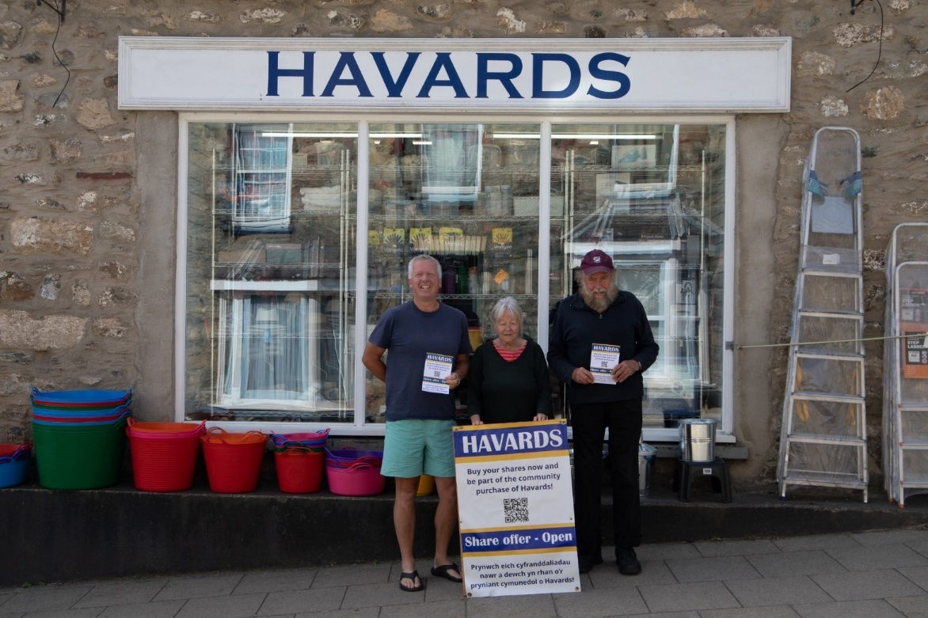
Havards Shop

Setting the scene
Havards Store is a traditional ironmongers shop that has been serving the people of Newport, Pembrokeshire since the early 1800s. The shop is a much loved local institution, offering a diverse range of products from lightbulbs to birdseeds and drawing customers in from far and wide. Unfortunately, in 2021, the store faced the possibility of permanent closure, with the owner struggling to find a buyer. In response, community members banded together, organised a public meeting and proposed a community buyout. The idea was met with resounding support. 100% of attendees backed the proposal and pledges totalling over £260,000 were made.

Funding the project
The community rallied behind Havards, raising an impressive £445,000 through a Community share offer. This show of support made a compelling case for additional funding, resulting in £200,000 capital funding from the Community Ownership Fund and a further £30,000 in revenue funding. With these funds, the group was able to secure the building and implement changes to make the business more resilient. Staff costs were also covered for the first year, establishing a solid foundation and ensuring long-term sustainability.

Getting the right support
Cwmpas (an official support partner of the Community Ownership Fund) helped the team develop their business plan and standard mark assessment, establish their CBS, and provided advice on the share prospectus and fundraising. They also offered guidance on appropriate business structures, environmental and sustainability policies. Cwmpas' support was crucial to the success of the share offer and setting the community shop on a sustainable path.

Advice
- To seek support early from experienced organisation like Cwmpas.
- To read the Community Ownership Fund prospectus carefully.

(Story available online on the MyCommunity page - https://mycommunity.org.uk/the-uks-first-community-owned-hardware-store-and-community-hub)

Landyrnog Village Shop and Post Office

Setting the scene
The Village Shop in Llandyrnog has been a vital part of the community since its establishment in 1841. However, due to the impact of Covid and the owner's inability to find a buyer, the shop has stopped trading. Currently, only the Post Office section of the shop is operational, but it too faces the risk of closure as the property has been listed for sale, with potential interest to convert it into a residential property.
Two village shops, three pubs (two with restaurants), and a butcher's shop used to serve the community, but now only one pub and the Post Office remain.

Taking action
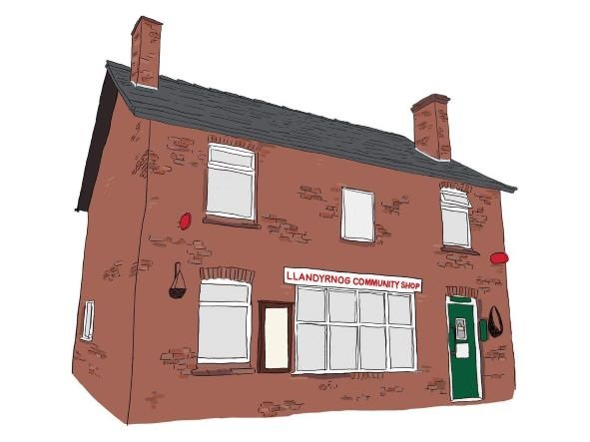
Initially a post was placed on the community Facebook page to gauge the level of interest in seeing the Shop re-opened as a Community Shop. The post received over 120 responses in 10 days, prompting a public meeting with a capacity crowd of 150 attendees. An amazing 57 volunteers came forward offering a range of skills after the meeting.
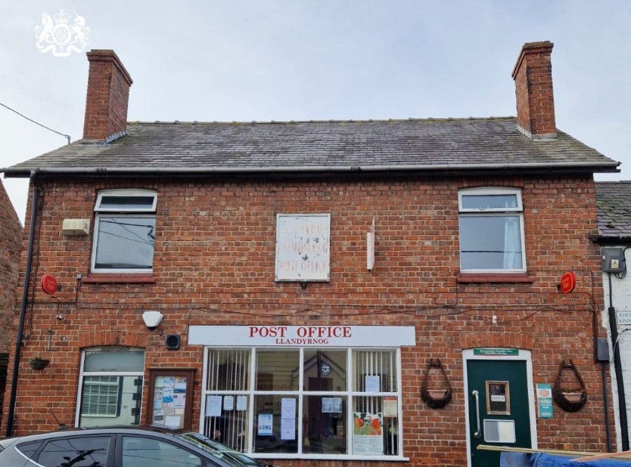
The new Community Shop will introduce a Community/Coffee Hub and offer a wide range of products and services, aiming to become a "destination" for locals, and visitors to the nearby Area of Outstanding Natural Beauty.

Funding the project
The community wanted to keep the asset in community ownership for perpetuity. Due to the cost of the building and renovations, they needed grant support alongside their community share offer.
The Community Ownership Fund (COF) awarded £180,000 in capital funding and £20,000 in revenue grant funding to assist in achieving Community Ownership for both the purchase and first year’s salary which will greatly enhance the sustainability of the business.

Getting the right support
Cwmpas (an official support partner of the Community Ownership Fund) provided valuable assistance to the team in developing our business plan, forecasting, and COF (Community Ownership Fund) application. They offered guidance on both the strategic and practical aspects of the application, providing over 100 hours of direct support. They also helped us apply for other grants for matching funds and preparing our community share offer. Additionally, the team received significant support from their local MP.

Advice
- Ensure you are familiar with all the rules and requirements.
- Work with a specialist support provider like Cwmpas (or regional equivalent) for guidance.
- Seek advice from someone who has been through the process before.

(Story available on the MyCommunity website - https://mycommunity.org.uk/bringing-llandyrnog-village-shop-and-post-office-into-community-hands)

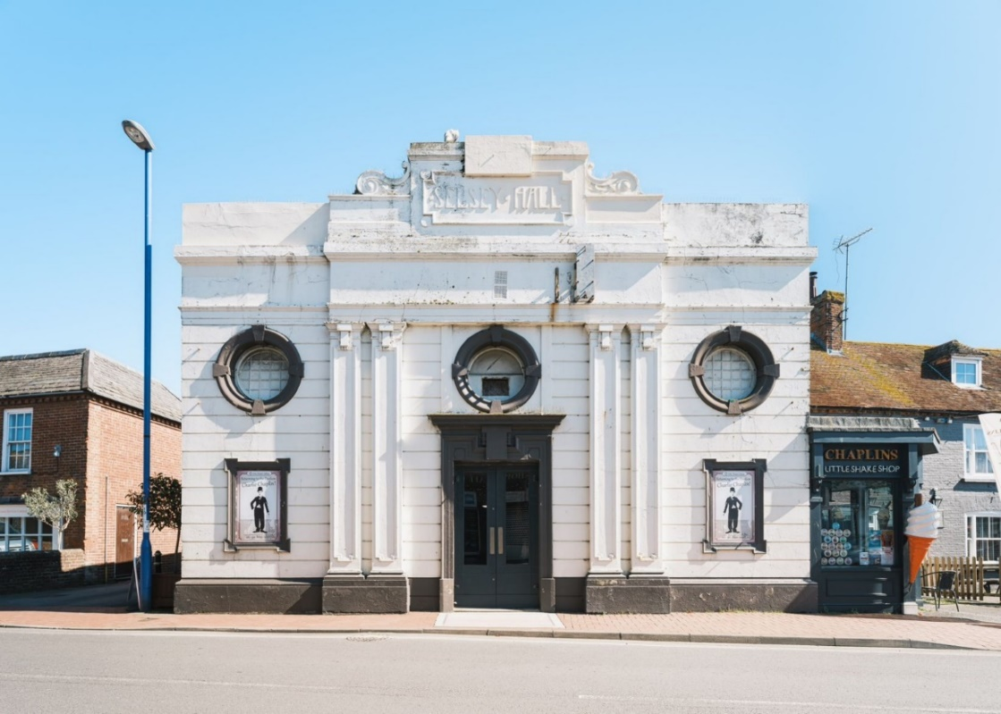
Selsey Pavillion

Setting the scene
The Selsey Pavilion was built in 1913 on the site of a former bakehouse. It is a rare and original theatre, cinema and live entertainment venue. Much of the Pavilion remains as it was its 1920s heyday when it hosted many famous performers – including the Russian Ballet!
However, despite its glamorous history, the venue closed its doors in the early 1970s and has since fallen into disrepair.

Making a difference in the community
Selsey Pavilion Trust aims to restore and revive the Pavilion – making it into a vibrant live entertainment venue, cinema, and community hub for the whole area. The Trust plan to put on a range of events and activities, catering for both the people of Selsey and tourists (Selsey is home to Seal Bay Resort, one of the largest holiday parks in Europe).
Selsey is severely lacking in spaces suitable for older people to meet and socialise. The Pavilion Trust plan to provide activities for older people and to partner with local community organisations that provide minibus shuttles to offer door-to-door drop offs. Selsey also has a significant population of seasonal migrant workers. To help promote community cohesion, the Trust plan to put on regular screenings of eastern-European cinema and subtitled blockbusters.
The reopening of the Pavilion will also help rejuvenate the town centre through providing career opportunities and bringing the high street back to life. As one resident put it:
“Given its location in the heart of Selsey, the Pavilion should also be at the heart of the town's cultural activities, with an important role in the social and economic life of the town.’

Getting the right support
Prior to their Community Ownership Fund bid, Selsey Pavilion Trust sought and received advice and funding from various sources. The viability and project development work carried out in these early stages put them in an ideal position to apply for the Fund.
An initial Project Viability Grant was awarded through the Architectural Heritage Fund’s (AHF- an official support partner of the Community Ownership Fund) Transforming Places through Heritage programme in 2021. This helped the Trust to Carry out an independent valuation of the property, Develop concept designs, estimate costs for their plans and develop an outline business and funding plan.
In 2022, a further Project Development Grant from the AHF supported the Trust to prepare their application to the Community Ownership Fund. In particular, it helped to progress architectural designs, update cost estimates, fund building surveys and bring on board professional fundraising consultancy support.

The Trust also received support from their local M.P., Theatres Trust, Selsey Town Council and Chichester District Council.

Funding the project
Selsey Pavilion Trust has been awarded a Community Ownership Fund grant of £299,400. This includes a capital grant of £249,500 and a revenue grant of £49,900. The team have described the fund as a ‘lifeline’ which has brought them one step closer to the dream of returning a significant local asset to centre stage for the Selsey community.
The revenue funding will help the Trust cover all costs incurred during the purchase process, surveys, and architectural planning for later phases.
The capital funding will cover 50% of the costs of purchasing the Pavilion. It will also contribute towards essential maintenance and repairs to ensure that the building is safe and secure.
Once these repairs have been carried out, the Trust plans to deliver their first season of cinema and live entertainment. The Trust believe that bringing the community in at this stage will help support and raise awareness for Phase Two of their project, which involves further redevelopment of the main hall, balcony and rear hall.
Selsey Pavilion Trust have already been awarded £35,000 from the local council, which will be put towards match-funding for the capital grant. To raise the rest of the match-funding, the Trust will be approaching major funders for support.

Fixing the past to build the future
The Pavilion is seen as an important symbol of Selsey’s past and there is real hope that its restoration can breathe new life into the town. As one local resident put it:
“This building is really iconic to Selsey. It is part of Selsey's history and should be preserved for future generations who will be able to enjoy”.

(Story available on the MyCommunity website - https://mycommunity.org.uk/re-taking-centre-stage-reviving-selsey-pavilion)

PHOTOS OF PROJECTS
Hartcliffe City Farm
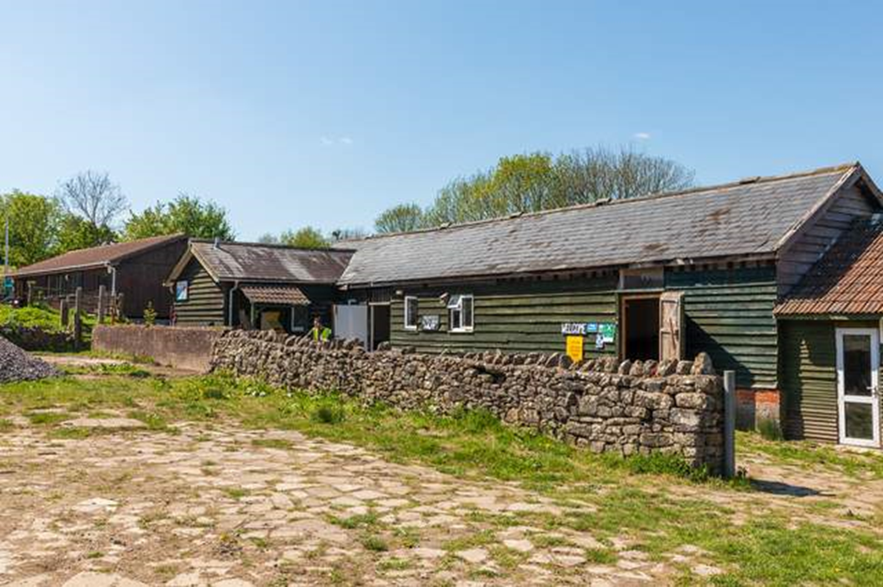

Leigh Spinners Mill Community Regeneration
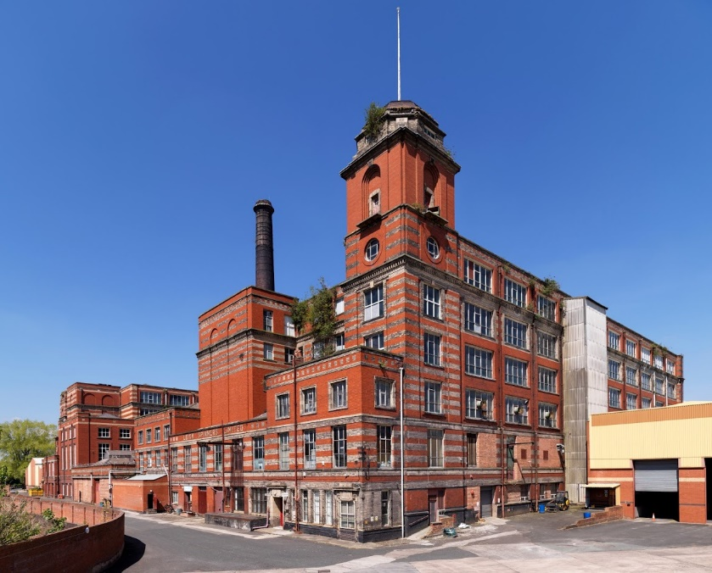

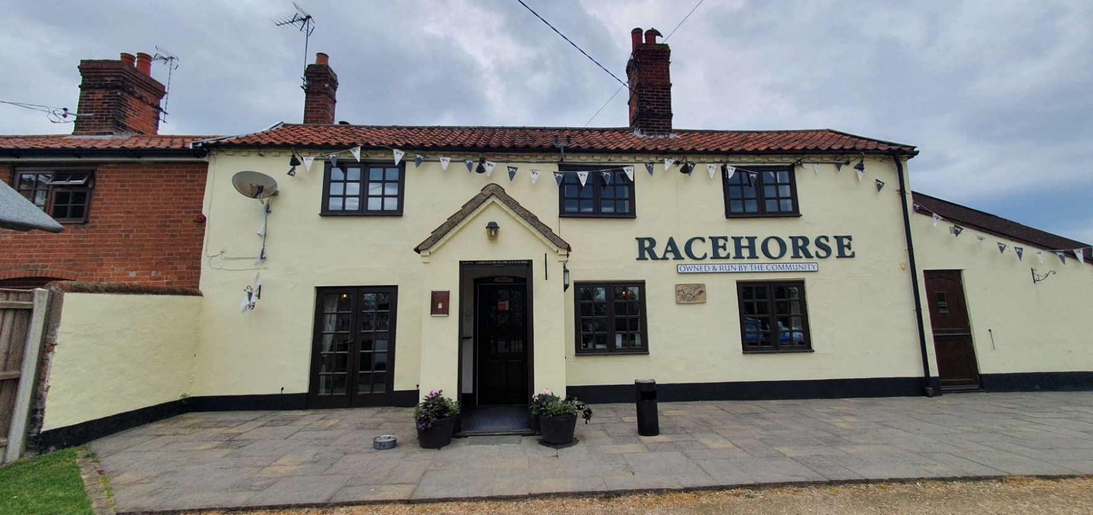
Racehorse Community Pub

Ballymacash Sports Academy
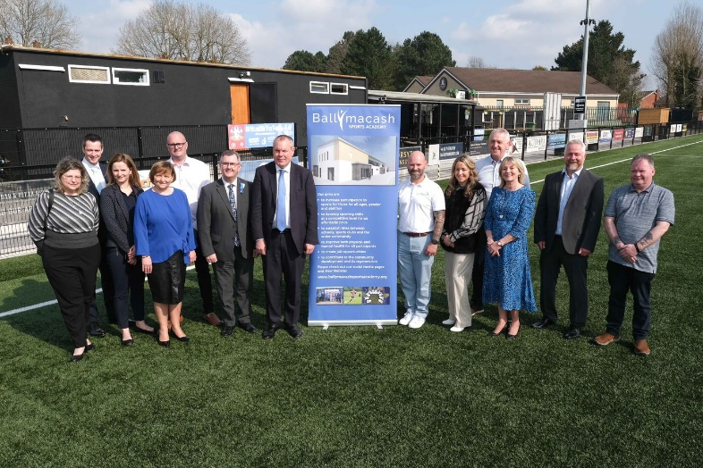

SUCCESSFUL PROJECTS
Project Name | Local Authority
10 Market Place, Shepton Mallet BA4 | Somerset
88 Victoria Street | North East Lincolnshire
Achub Tyn Llan Save Tyn Llan | Gwynedd
Acquiring Plas Antaron, a place for wellbeing and hope | Ceredigion
ACT Family Community Centre | Gateshead
Adwick Park Community Hub | Doncaster
Aero Space Kinross | Perth and Kinross
ARK - a new cultural space for Cliftonville | Thanet
Aurora | Derry City and Strabane
Banking on Seacourt | Ards and North Down
Barrowden Community Hub | Rutland
BHCG Black Horse | Melton
Blandford Forum Corn Exchange | Dorset
Bovey Tracey Paradiso Arts | Teignbridge
Brickfields Sports and Community Hub | Plymouth
Bringing the Old Changing Rooms back in to community use | Glasgow City
Broughshane Community Centre | Mid and East Antrim
Bury Community Football Stadium | Bury
Bury Knowle Multi-activity Hub | Oxford
C.O.J.A.C. Centre | Glasgow City
Callander Visitor Information Centre | Stirling
Centre of Social Enterprise and Creativity | County Durham
Chinley & Buxworth Community Centre Rebuild | High Peak
Clayton Community Wellbeing Hub | Hyndburn
Community Building for Whitley Bay | North Tyneside
Community Hub Project (Phase 2) 2022 | Lisburn and Castlereagh
Community ownership of the Fontmell Magna Village Shop | Dorset
Completing the Moor Pool Community Jigsaw | Birmingham
Cotherstone Community Park purchase of Land freehold & title | County Durham
Countrymans Community Pub | North Yorkshire
Craigavon Leisure Centre Regeneration Project | Armagh City, Banbridge and Craigavon
Cromer Artspace on the Prom | North Norfolk
Crown Court Public Toilets Renovation | Waverley
D7 Omnibus Restoration | Bromsgrove
designermakers21 building purchase | South Norfolk
Dornie Community Hub | Highland
East Boldre Chapel Stores | New Forest
Europa Weightlifting, Dartford Gym | Dartford
Expansion and security of Haverhub CIC | Pembrokeshire
Forres Town Hall – An Enterprising Community Venue | Moray
Friends Of The Black Horse Cranham Ltd | Stroud
FuZe Together for Community Longevity | Rhondda Cynon Taf
Gargunnock Community Shop | Stirling
Glens Digital Hub | Causeway Coast and Glens
Gobowen Station Community Enhancement Project | Shropshire
Gorton Central | Manchester
Guarlford Village Hall | Malvern Hills
Hartcliffe City Farm | Bristol, City of
Haveringland Community Hub | Broadland
Heart of the Community | Ceredigion
Hendon Highstreet Revolution | Sunderland
Henry Jenkins Community Pub | Harrogate
Hereford Athletics Track | Herefordshire, County of
Herriot Hospice@The Lambert | North Yorkshire
Holton Pits - Community Open Space | East Suffolk
Horrabridge Replacement Sports Pavilion | West Devon
Horse and Jockey Community Pub | Shropshire
Improving Facilities at Moneydarragh Hub | Newry, Mourne and Down
Inveraray Pier | Argyll and Bute
JAMES Tramshed Keighley | Bradford
John O'Groats Mill: a power for the community | Highland
Keep Overton Swimming | Basingstoke and Deane
Kimpton Pavilion Refurbishment Project | North Hertfordshire
Kingswood House Restoration | Southwark
Knutsford Market Hall | Cheshire East
KWVR Bridge 27 rebuild | Bradford
LADYBIRDS PARENT, CHILDREN & FAMILY CENTRE | Ards and North Down
Lancaster Music Co-op | Lancaster
Langside Sports Club - Clubhouse and Pavilion Renovation | Glasgow City
Laxdale Hall Refurbishment | Na h-Eileanan Siar
Leigh Spinners Mill Community Regeneration | Wigan
LifeLine Community Centre | Barking and Dagenham
Llandyrnog Community Shop and Post Office Project | Denbighshire
Lochranza Country Inn | North Ayrshire
Melvin Recreational Centre | Fermanagh and Omagh
Moor Imagination Centre, Buckfastleigh | Teignbridge
New Galloway Town Hall SOS Save Our Space | Dumfries and Galloway
North Edinburgh Arts | City of Edinburgh
Northside Community Building | Derry City and Strabane
Old Horn Community Pub | North Yorkshire
Open House Opening Up | Sheffield
Over Wallop Community Pavilion | Test Valley
Oxford Arms Pub and Hub | Herefordshire, County of
Paignton Picture House | Torbay
Petersfield Community and Sports Hub | Cheltenham
Portobello Town Hall | City of Edinburgh
Progressing the Internal Envelope | County Durham
Project Well Hall | Greenwich
Pugin Studios | Thanet
Purchase and Renovation of The Jubilee Centre | Bradford
PURCHASE OF ALLOTMENT LAND | Wyre Forest
Purchase of Leybourne Woods | Tonbridge and Malling
Purchase of the freehold for The Centurion Pub | Cheshire West and Chester
Purchase of the Parish Buildings for Community Use | Newry, Mourne and Down
Rannoch Hub | Perth and Kinross
Re: New Trotters | East Ayrshire
Re-Development of the Former New Farm Loch Community Centre | East Ayrshire
Refurbishment and Redevelopment of the Queens Ballroom | Blaenau Gwent
Refurbishment of historic Cricketers Arms for community use | Swindon
Regeneration of 45 Main Street, Randalstown | Antrim and Newtownabbey
Renovation & extension of Oxhill Village Hall | Stratford-on-Avon
Renovation of the former Laurencekirk Community Centre | Aberdeenshire
Replacement of Wixford Village Hall | Stratford-on-Avon
Revival: Food & Mood | Canterbury
Salusbury Arms Tremeirchion | Denbighshire
sangat centre renovations | Bradford
Save Rock Hall | Bolton
Save the Hop Pole | Wiltshire
Save The Step | Haringey
SavetheSilks | Wiltshire
Saving Badgers Hill | Somerset
Saving the Old Benny | Portsmouth
Sawyers Community Centre | Brentwood
Sea Cloud Hall, Leeds | Leeds
Selsey Pavilion | Chichester
Shipley Sustainable Community Hub | Bradford
Siop Havards | Pembrokeshire
Skelton-on-Ure Pub & Hub | Harrogate
Spencer Park Pavilion | Coventry
St Albans Community Centre | Sandwell
St Georges Fatfield Community Annexe and Cafe project | Sunderland
St Germain’s Barn and St Michael’s Changing Rooms | St Albans
Sterts Theatre Re-build | Cornwall
Storthes Hall Sports Facility | Kirklees
Stretford Public Hall - Investment for the Future | Trafford
Sunnyside Pavilion | Falkirk
TAAG refurbishment | Teignbridge
Tabernacle Morriston Community Resilience Hub | Swansea
Tafarn Crymych Arms Community Wellbeing Hub | Pembrokeshire
Tafarn Cymunedol Dyffryn Aeron | Ceredigion
TBIFCG | Melton
Teach Uidhilín | Newry, Mourne and Down
Temperance Hall Printworks. | Pembrokeshire
The Aberfeldy Sports Club | Perth and Kinross
The Cabin NEW BUILD | Kirklees
The CANA Resource and Training Centre | Blaenau Gwent
The Centenary Hall ,Penzance | Cornwall
The Cockburn Centre | Leeds
The Crown Project | Birmingham
The Emporium@55 for adults with learning disabilities | Bournemouth, Christchurch and Poole
The Fishers Arms | Northumberland
The Future of The Roxy | Westmorland and Furness
THE GEORGE COMMUNITY | Ashford
The George Community Hub | Forest of Dean
The George Community Pub Project | East Suffolk
The Greenhouse, Wiveliscombe | Somerset
The Heart | City of Edinburgh
The Hub Community Centre and Cafe, Manor Field, Thurnby | Harborough
The International Centre | Middlesbrough
The John Jenkins Stadium | Portsmouth
The Judge’s Lodging: constructing a viable community resource | Powys
The Leys Multi-activity Hub | West Oxfordshire
The Meeting House Bushmills | Causeway Coast and Glens
The Oddfellows Arms, Higham on the Hill | Hinckley and Bosworth
The Old Barracks, Dungannon | Mid Ulster
The Old Forge Community Benefit Society: a community owned pub | Highland
The Old Library | Cornwall
The Old Red Lion: A rich history, an exciting future | Islington
The Old School House, Milford | Armagh City, Banbridge and Craigavon
The Old Synagogue Belfast | Belfast
The Oxted ‘Park Hub’ | Tandridge
THE PORTLAND INN PROJECT | Stoke-on-Trent
The Prince of Wales | Cornwall
The Radnor Arms Hotel | Powys
The Raven Inn Community pub | Warrington
The Rising Sun Woodcroft Community Pub Project | Forest of Dean
The Spirit of the Horse | Bury
The Wharf Marple Community Hub. | Stockport
The Y Centre | Perth and Kinross
Titchfield Haven Community Hub | Fareham
TMS 31-33 High Street | Thanet
Tollesby Playing Fields | Middlesbrough
Victoria House (The Oldham Boxing Club) | Oldham
Vogrie Hall Refurbishment | Midlothian
Wadebridge Sports and Leisure Centre | Cornwall
Westhall Racehorse Community Pub | East Suffolk
Whetstone Community Hub | Blaby
Whithorn ReBuild Renewing the Old Town Hall | Dumfries and Galloway
Winchcombe Arts & Community Hub | Tewkesbury
Woodvale Community Wellbeing Hub | Mid and East Antrim
Wormley Community Centre | Broxbourne
Y Cross Cas-lai Community Benefit Society Ltd. | Pembrokeshire
York Supplies Community Co-op | Birmingham
Zion Community Art Space | Bristol, City of

Q&A

General Q&A

Q: Taking ownership of an asset is complicated, what support will be put in place to help?
A: We recognise that talking ownership of an asset can be challenging for community groups. The Fund will help ensure that community groups have the necessary help, both practical and financial, to support them in taking ownership of an asset.
Development support is now available to applicants via the My Community website. Our development support provider offers initial support and advice to all interested applicants up to the EOI stage. This includes explaining the eligibility requirements and offering top tips on setting projects up for success. After the EOI stage, certain applicants will be able to access in-depth support for the development of their application and business case.

The development support provider will also provide resources for successful projects. The support offered will include advice via webinars or workshops, guidance materials, and facilitating peer support.

You can find more information on the development support provider in section 14 of the prospectus.

Fund-Specific Q&A
Q: How long will the fund run for?
A: The Fund will run from July 2021 for 4 years until 2025.

Q: Is project X eligible for funding?
A: Full eligibility requirements are published in the bidding prospectus.

Q: How many times can applicants submit an EOI Form to the Fund?
A: The EOI stage of the application process is always open, meaning applicants can submit the form at the time that is right for their projects. There are no limits on how many times you can submit an EOI like there is for the main application stage, however if your project is ineligible you should not submit a new EOI unless the circumstances have changed and you now think your project will be eligible for the Fund.

Q: Do I have to wait before submitting another EOI if I am unsuccessful?
A: There is no time limit on re-submitting an EOI after receiving an unsuccessful outcome from a previous EOI submission. Nonetheless, you should only submit another EOI if there has been a marked change in your projects circumstances that may deem it to be eligible. We may determine that your project will never be eligible for the Fund and will advise you accordingly, in which case you will not be able to submit another EOI.

Q: Do I need to resubmit and EOI for the fund now there have been changes?
A: If you have previously submitted a successful EOI you will not need to submit a new EOI for the same project. EOIs remain valid for all application windows, as long as your project proposal remains the same. If you have received a successful EOI outcome, you will be invited to submit a full application for the fund when each full application window opens.

Q: Can I expect feedback on my EOI submission?
A: You can expect to receive feedback on the outcome of your EOI application within three weeks. Those applicants who are unsuccessful will receive feedback summarising where their application did not meet our eligibility requirements.

Q: What happens if my EOI is successful?
A: You will be written to confirming an invitation to apply for funding. A link to the full application form will be included in this correspondence for you to complete. An invitation to apply for funding does not guarantee a grant from us, but it does indicate that we see potential in your idea.

Q: If my EOI is successful can I still apply in any bidding window?
A: Yes, if applicants pass the EOI stage, they can then apply in any bidding window suitable for the timings of their project. Applicants should not rush to apply in the next main bidding window if this does not leave enough time to properly develop the project.

Q: If my EOI was previously unsuccessful because of something you have now changed, can I apply?
A: Yes, but you will need to submit a new EOI and have this approved before being invited to submit a full application.

Q: Will funding be provided in grant or loan form?
A: Applicants can bid for a capital grant of up to £2 million for all asset types, but we expect that most awards will be for up to £250,000 of capital funding. This is always provided as a grant and is not paid back.

Q: Are you able to advise projects on how best to develop their application?
A: All the information needed to submit a compelling and evidence-based application is available in the prospectus. To ensure fairness for all applicants and uphold the integrity of the bidding process, we are unable to advise applicants beyond what is publicly available on how best to develop and present their application. Although we cannot advise on how to develop applications, we may be able to clarify points in the prospectus that applicants are unsure of.

Q: My asset is not at immediate risk of loss but could still do with support for refurbishments/improvements etc. Can I apply?
A: This Fund exists to prevent important assets being lost to the community. In order to meet the Community Ownership Fund eligibility requirements, applicants need to provide evidence that demonstrates that the asset is at risk of being lost to the community without intervention. The risk can be from closure, sale, neglect and dereliction under current ownership, or unsustainable operations under the current business model.

Round 3 Changes Q&A

Q: Does the size of my project/funding amount requested affect my chances of being successful?
A: No. Applications will not be disadvantaged by their asset size or funding amount requested. Applications are assessed by a fair and transparent framework that is publicly available on GOV.UK and the eligibility for the fund and bidding criteria is consistent across all parts of the United Kingdom.

To ensure larger value projects do not crowd out smaller value projects, we have added an additional consideration which allows the Secretary of State to exercise discretion when making funding decisions on shortlisted bids to ensure a balance between small and large value projects when making funding decisions.

Q: Why haven't you allowed other asset types to apply for the higher amount of funding before?
A: Successful projects have demonstrated their ability to save assets at risk of loss with this funding amount.

We want to make positive changes to the Community Ownership Fund to ensure that as many community organisations as possible across the UK can save their treasured local assets at risk of loss. We therefore actively engage with our stakeholders and applicants and listen to their feedback to understand how the Fund can be improved and made more accessible to potential applicants, throughout its lifespan. We recognise that some non-sporting assets also require a higher level of funding in order to ensure their long-term sustainability and so will be extending the cap for all asset types from round 3 onwards.

Q: Why do some projects only need 10% match and others 20% match?
A: Listening to stakeholder and applicant feedback and recognising that a 50% match funding requirement was a blocker to some projects we have reduced the match funding requirement from 50% to 20% for all projects. We expect most projects will be able to leverage the COF grant to secure the required 20% match, however, in exceptional cases, projects who receive in-depth support may also be recommended by the delivery support provider for a further reduced match funding rate, reduced from 20% to 10%. Their recommendation will be based on the needs of the applicant, and the level of existing social infrastructure in the local area. The Community Ownership Fund team will have the final say on which projects are eligible for a lower amount of match funding. Read full details of the decision-making process.

Q: Why can’t the Community Ownership Fund provide funding to save publicly owned assets?
A: The Community Ownership Fund grant cannot fund the costs of purchasing publicly owned assets where the public authority would credit a capital receipt, except in the case of parish councils (and town and community councils). This is because the fund is intended to benefit community groups, with grant monies going directly to them rather than to local authorities. Parish councils more closely reflect the community groups the fund aims to support, operating at the hyper local level consisting of local people passionate about the community they serve.

In all cases, the Fund will work alongside existing Community Asset Transfers to support these transfers by funding the costs of renovation and refurbishment. For example, if an applicant was able to secure an asset transfer or raise the funds through another route, they could be eligible for funding from the Community Ownership Fund for any refurbishment needed in order to save that asset.

Q: Why can parish councils now credit a capital receipt through COF?
A: As above, parish, town and community councils are now eligible to apply for COF and receive funding from the programme. As these councils are now able to receive direct funding, to ensure consistency, it is also permissible for them to receive a capital receipt where a community group is seeking to purchase an asset from the council. The other additional eligibility criteria related to asset transfers from a public authority still apply.

Q: Why have you now removed the application cap?
A: Some applicants that were previously ineligible for the fund may now be eligible under the new guidance and criteria or may have had a significant change in their circumstances which means they will now be more likely to succeed, we do not want to stop these applicants from now applying if the time is right for their project. However, there may be some instances where we determine that the project is fundamentally ineligible and is unlikely to ever me eligible for the fund, in these instances we retain the right to reject an application permanently.

Q: Can I withdraw my application and reapply in a future window?
A: You can withdraw your application and reapply. However, you should be aware that COF is a competitive fund and there is no guarantee that an application that was successful in a past window would be successful in the future.

The changes we have made will increase the number of projects who would be eligible for funding through COF. This may make the fund more competitive than it was previously when your application was last assessed.

If you intend to withdraw and apply in a different bidding window, we recommend you consider how this will impact the timelines in your business plan, how this may affect your other funding arrangements and the potential impact this may have on the level of risk facing your asset.

If you have any further questions, please get in touch with your DLUHC Area Team contact who will contact the Community Ownership Fund Team.

THANK YOU,
THE COMMUNITY OWNERSHIP FUND

