January 2024.
Social media posts
NHS Stop smoking
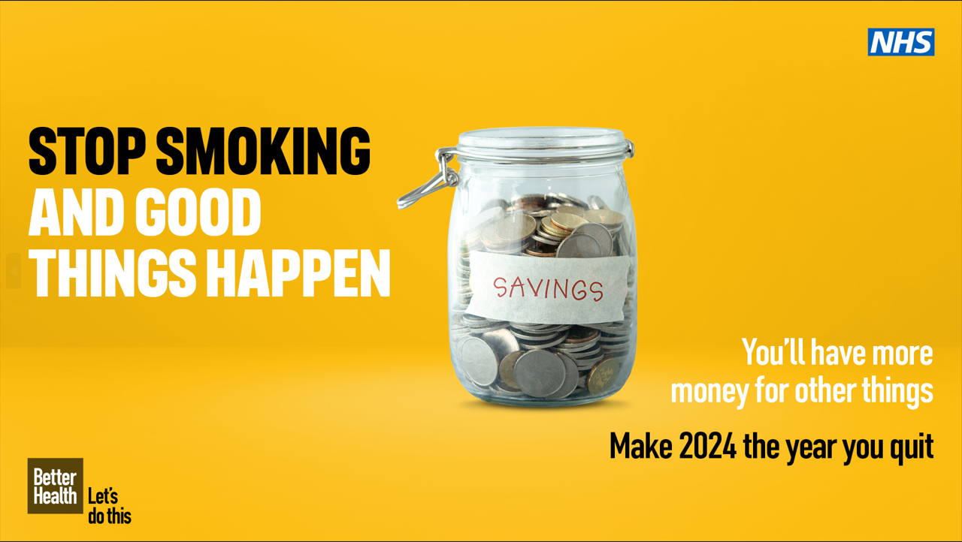

Make 2024 the year you quit smoking for good! Find a combination of quit-smoking tools and support that’s right for you by getting in touch with your FREE local stop smoking service Live Life Better Derbyshire on 0800 085 2299 (Derbyshire) / Livewell on 01332 641254 (Derby) delete as appropriate.
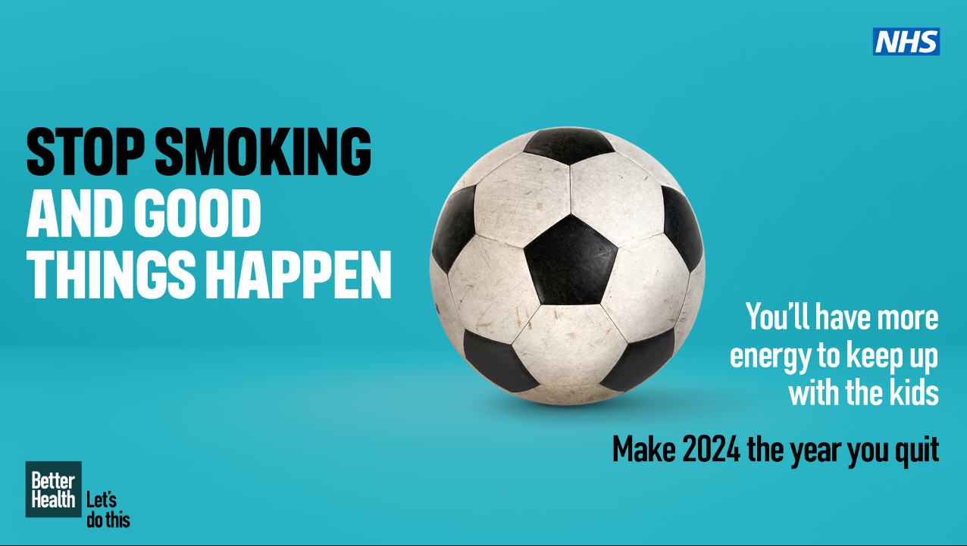

Derbyshire residents
It’s never too late to quit smoking. You will notice immediate improvements to your health when you stop. Make 2024 the year you quit smoking for good! For FREE, local stop smoking support visit https://www.livelifebetterderbyshire.org.uk/services/stopping-smoking/stopping-smoking.aspx

Derby residents
It’s never too late to quit smoking. You will notice immediate improvements to your health when you stop. Make 2024 the year you quit smoking for good! For FREE, local stop smoking support visit https://www.livewellderby.co.uk/stop-smoking

Dry January

1. It's #DryJanuary - a time to take a little break from alcohol. Get lots of tips for cutting down on the tipples here: https://alcoholchange.org.uk/help-and-support/cut-down/tips-for-cutting-down
2. It's #DryJanuary and if you'd like help or support around alcohol issues then the Derbyshire Addictions Advice service can help. Give them a call on 01246 206 514 or visit daas.uk.com
3. If you'd like support to lower your drinking during #DryJanuary then why not download the Lower My Drinking App? It offers FREE advice & help for anyone who'd like to decrease their alcohol intake. Search for the app here: derbyshire.orcha.co.uk

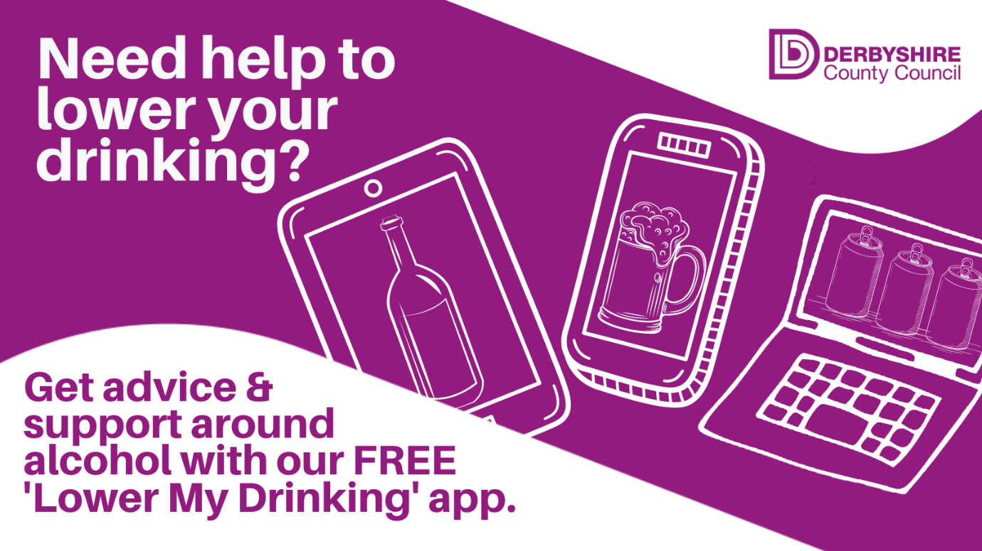

Online health and wellbeing
1. Did you know you can get quality assured #health and #wellbeing apps at the touch of a button? Visit derbyshire.orcha.co.uk to search and download apps.
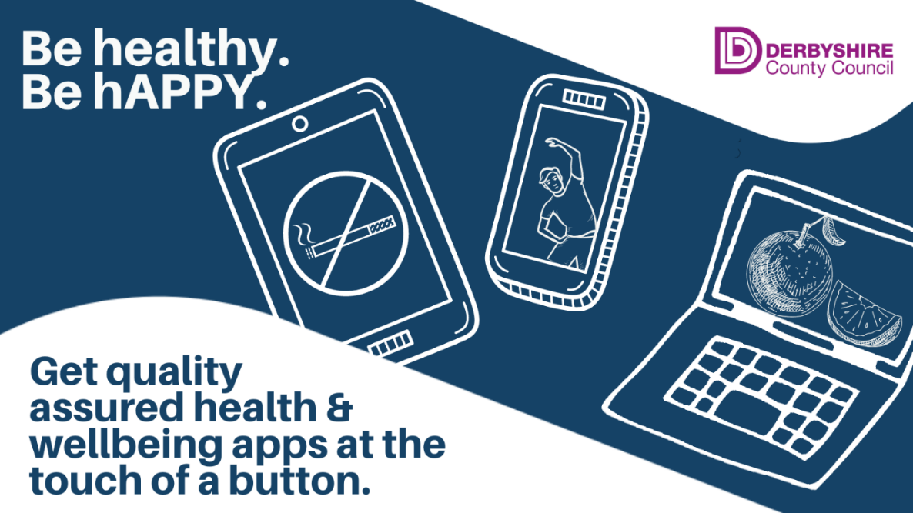

2. Ready to take control of your #health – there’s an app for that! You can search and download 100s of quality assured health and wellbeing apps on the Orcha library. Visit derbyshire.orcha.co.uk to find out more
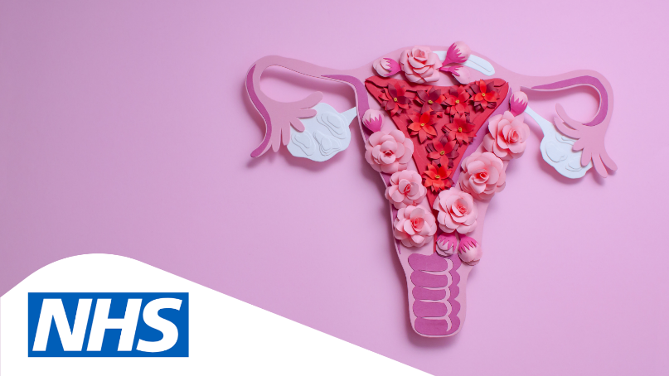
Cervical Cancer Prevention week 22nd – 28th January

1. It’s Cervical Cancer Prevention week and there’s lots of advice & support available about the condition online at @JoTrust https://www.jostrust.org.uk/
2. During #cervical cancer prevention week, find out more about the importance of taking part in cervical screening when you’re invited: https://www.nhs.uk/conditions/cervical-screening/
3. During #cervical cancer prevention week find out more about the condition, symptoms & treatment on the NHS website here: https://www.nhs.uk/conditions/cervical-cancer/
4. You can find lots of info about #cervicalcancer at @JoTrust online here: https://www.jostrust.org.uk/information/cervical-cancer/about-cervical-cancer/symptoms

Brew Monday 15th January

Before 15th Jan. This #BrewMonday (15 January) the Samaritans are reminding us all to reach out for a cuppa and a catch-up with the people we care about. Find out more: https://www.samaritans.org/support-us/campaign/brew-monday/
On 15th Jan. It’s #BrewMonday – a chance for us to grab a cuppa & have a chat about how we’re feeling. The Samaritans have lots of advice on how to be a good listener here: https://www.samaritans.org/how-we-can-help/if-youre-worried-about-someone-else/how-support-someone-youre-worried-about/what-do-if-you-think-someone-struggling/

Newsletter / intranet / payslip copy
Health and wellbeing at the touch of a button
Did you know you can get quality assured health and wellbeing apps at the touch of a button?
Derbyshire County Council is working with Orcha - The Organisation for the Review of Care and Health Applications - to provide an online library of digital health and wellbeing support.
From support for long term health conditions to apps that can help you to stop smoking, sleep better and improve your mood, there's 100s to choose from.
Each app has been assessed against a wide range of criteria including clinical assurance, ease of use and data protection.
Visit derbyshire.orcha.co.uk to search and download apps.
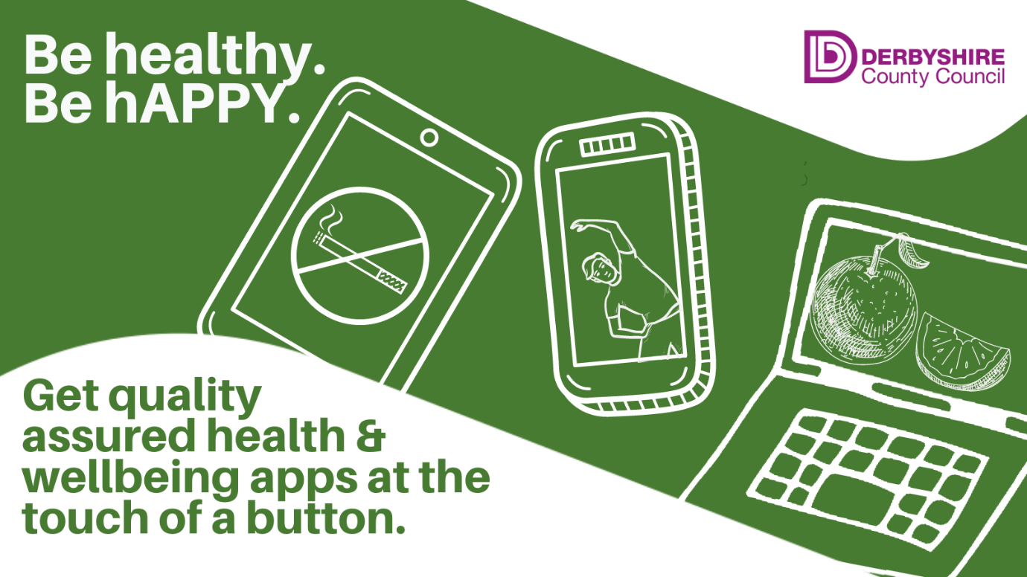
You can follow us on the following social media accounts:
Twitter: @DCCPublichealth
Facebook: www.facebook.com/derbyshirepublichealth
Instagram: www.instagram.com/livelifebetterderbyshire

