WE NEED YOU!

Volunteer Recruitment Morning
Join our “VOLUNTEER RECRUITMENT MORNING”
WHERE: Monkey Park Community Hub, 128A Chester Street, Brampton, S40 1DN WHEN: Saturday 16th March 2024, 10.30am – 12.30pm

LIKE TO SHARE A TALENT? | Drive to make a difference? | KIND NATURED? | Gifted with people?
Like talking to people? | LOVE COFFEE AND CAKE? | Community minded?

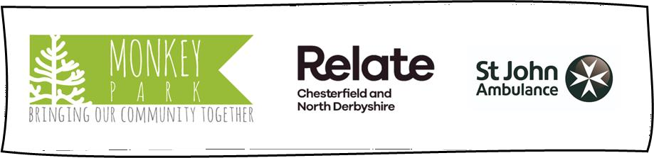
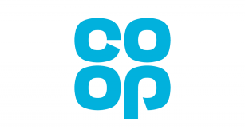

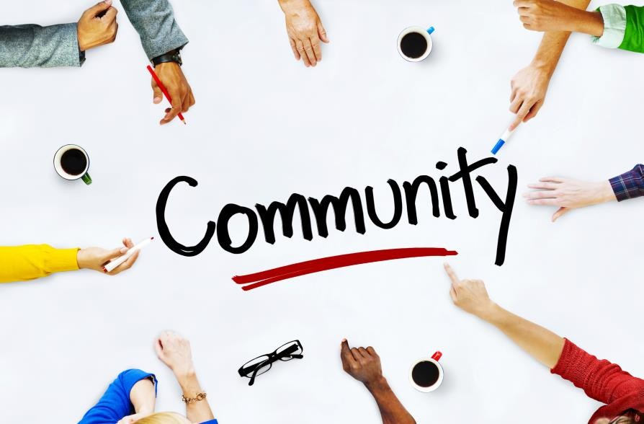
Volunteer Recruitment Morning

WHERE: Monkey Park Community Hub, 128A Chester Street, Brampton, S40 1DN WHEN: Saturday 16th March 2024, 10.30am – 12.30pm

Volunteering “for me”  *Gain new and lasting friendships  *Gain a sense of purpose and belonging  *Give back to my community  *Feel-good-factor: “the helper’s high”  *Get out and about  *Learn new skills and flex my existing ones | Volunteering “for my community”  *My talents and skills could make a real difference  *I could really help someone in need  *My community could become more connected  *I could help people’s health and wellbeing  *My personality and humour could make someone  smile

I am a VOLUNTEER – I make a damn difference
I love to
talk to people; being on reception works for me!
I love problem-
solving and organising fundraising events

I help my local youth club and plan activities

