FOR IMMEDIATE RELEASE

Spongefest Music Festival is Set to Rock Worksop- In Sam’s Name
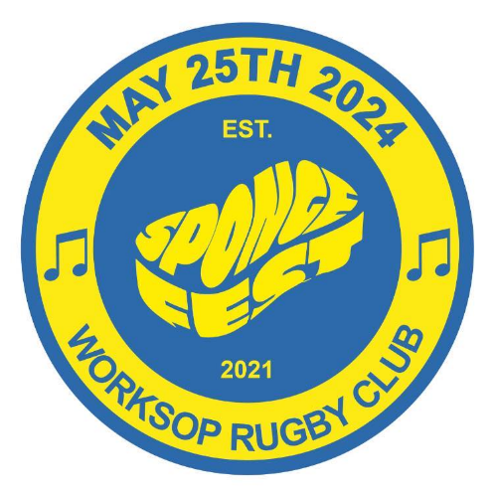

Prepare for a musical extravaganza as Spongefest, a vibrant music festival, is set to hit Worksop on Saturday, 25th May 2024, at the iconic Worksop Rugby Club. The event promises a day filled with live music performances, more entertainment to be announced, and a celebration of the legendary party animal himself.
The festival will kick off with a selection of talented artists and bands taking the stage, setting the perfect tone for a day of unforgettable music. As the sun sets, the beats will transition seamlessly into the evening, with a line-up of bands ready to keep the party going into the night.
Spongefest is not just about the music; it's a celebration of life and the spirit of the ultimate party enthusiast. Attendees are encouraged to come and revel in the festive atmosphere, donning their dncing shoes and embracing the lively energy that Spongefest promises to deliver.
Richard McHugh, Chair of Trustees, In Sam’s Name, said;
“Sam (Sponge) loved music and was the best gig buddy I have ever known. We set up In Sam’s Name so that nobody in Bassetlaw ever feels like they can’t carry on. Our support groups and walks are a safe space for anyone seeking support. Spongefest is a celebration of Sam’s life and the happiness he brought to his family and friends. We hope that the people of Bassetlaw and the wider Nottinghamshire area will support the event and come along to enjoy a brilliant day of music and friendship, whilst supporting the charity at the same time”
All profits from the event will go to the charity In Sam's Name, which was set up in memory of Sponge. By attending Spongefest, festival-goers not only honour his memory but also contribute to his charity to ensure that the support available in Bassetlaw for people experiencing mental health concerns can continue for as long as possible.
To make this celebration even more memorable, exclusive Spongefest and In Sam’s Name merchandise will be available for purchase on the day.
Tickets for Spongefest will be on sale from Friday 2nd February.
For the latest information and announcements, follow Spongefest on Facebook. Additionally, if you or your organisation would like to support this exciting event in any way, or you would like to volunteer as an event steward, please reach out to us at info@insamsname.co.uk.
Let's come together on May 25th, 2024, at Worksop Rugby Club, to celebrate the life of Sponge and create memories that will last a lifetime.
For media inquiries, please contact: info@insamsname.co.uk

About In Sam's Name
In Sam's Name is a registered charity dedicated to making a positive impact in the community by supporting residents with their mental health through the provision of regular talking groups and monthly walks.

