Welcome to **‘A Little TLC’** … **Tackling Loneliness Collaborative’s** ‘useful information’ – **29th February 2024!**

Please feel free to have a glance through…

The focus this time is on: **‘Posters!’**

It includes:

1. New Coffee Morning in Warsop – see poster below
2. Dementia Drop In – new venue – Nottingham – see poster below
3. Place of Welcome Hosts - [Inspire Culture - All Challenges (volunteermakers.org)](https://inspireculture.volunteermakers.org/get-involved/) various areas
4. Living Better Together Sessions – Blidworth – for your interest. See poster below.
5. Art Sessions – ‘When Women Gather’ - see poster below
6. Talking Tuesday’s at Ashfield – see poster below
7. ***FUNDING***  [Spring 2024 Grants Open, Guidance and Webinar notes available. - McCarthy Stone Foundation](https://mccarthystonefoundation.org/spring-2024-grants-open-guidance-and-webinar-notes-available/) Closing Date March 16th ***
8. Action for Happiness – March Calendar - see picture below
9. Newark and Sherwood Funding Fair – see poster below
10. Multiply Food, Money,  Move Courses – see poster below
11. [Mental Health Awareness training (Nottinghamshire inc. Bassetlaw) Tickets, Mon 22 Apr 2024 at 12:30 | Eventbrite](https://www.eventbrite.co.uk/e/mental-health-awareness-training-nottinghamshire-inc-bassetlaw-tickets-848232264537?utm_source=eventbrite&utm_medium=email&utm_content=follow_notification&utm_campaign=following_published_event&utm_term=Mental+Health+Awareness+training+%28Nottinghamshire+inc.+Bassetlaw%29&aff=ebemoffollowpublishemail&utm_experiment=follow_template.B)
12. [Regional Programme Manager 2024 Job Description .docx (usrfiles.com)](https://889ff7d1-4982-4140-81c9-5ea0f8245c8b.usrfiles.com/ugd/889ff7_508fecbb76194264abe2fef24530f081.pdf) Marmalade Trust (founders of Loneliness Awareness Week)
13. [Group Development Officer (Bassetlaw) | Bassetlaw CVS (bcvs.org.uk)](https://www.bcvs.org.uk/bcvsvacancies) Closing Date 14th March 2024
14. Poem Sharing on Zoom! – International Poetry sharing session. Thurs 7th March 2:30pm-3:15pm GMT <https://us05web.zoom.us/j/85344857016?pwd=R1VmMW84ZURZUGltY2Z6VWp3Y1E3UT09>

There are lots of things planned in for us to discuss and work together on within the TLC.  It would be great if we can keep sharing the wonderful things we are doing and continue to work together where we can!

***TLC dates for your diary:***

* **The TLC Little Catch Up!** – our informal peer networking lunch gathering – **Wednesday 6th March** **– 1pm-1:45pm**.  All welcome; it’s great to meet a little more informally.

[**Click here to join the Little TLC Catch Up! meeting**](https://teams.microsoft.com/l/meetup-join/19%3ameeting_MDZjOWU2MTEtNmQ3Yi00ZWU3LWE5ODItZTJiMzdlNTI5MThk%40thread.v2/0?context=%7b%22Tid%22%3a%224df4435f-8800-4e1e-a615-b287fcaa7120%22%2c%22Oid%22%3a%220325b866-b80d-4b91-9992-7e06eb2c7739%22%7d)

* Our next **wider Tackling Loneliness Collaborative (TLC) meeting** takes place on **Tuesday 12th March 2024 9:30am-11:00am** on MS Teams.

[**Click here to join the Wider TLC 12th March TLC meeting**](https://teams.microsoft.com/l/meetup-join/19%3a058d99892c25477ba09b0e7d1fbc2d11%40thread.tacv2/1611318150833?context=%7b%22Tid%22%3a%223a4e48d5-2a9d-45aa-8001-70f6a8186d0e%22%2c%22Oid%22%3a%22c4fdd0c2-c73b-4913-b114-429273bf0be4%22%7d#_blank)    If you have anything you want to share in this meeting please feel free to!  Also, feel free to drop into part of the meeting if it’s hard to make the full time.

Many thanks, Kirsty

Tackling Loneliness Collaborative Lead

Find us on [Facebook](https://www.facebook.com/tacklinglonelinesscollaborative)  and ‘X’ ([Twitter](https://twitter.com/TLCNotts))

Loneliness Page - [Tackling Loneliness Collaborative Nottingham and Nottinghamshire | Bassetlaw CVS (bcvs.org.uk)](https://www.bcvs.org.uk/tlcnn)

Research and Service Database -  [www.tlin.co.uk](http://www.tlin.co.uk/)

           …………………………………………………………………………………………………………………………………………………………………………………………………………………………………………………………………………….…….

**Items to follow:**



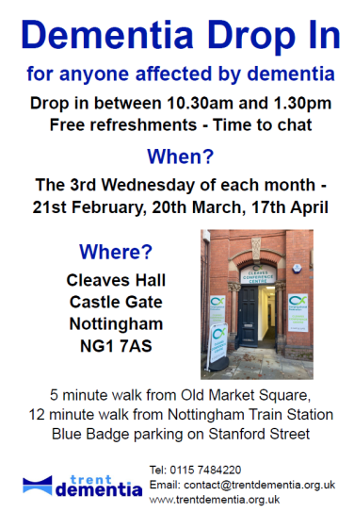

#### **­­­­­­­­­­­**[**Inspire Mansfield Central Library**](https://www.facebook.com/InspireMansfieldLibrary?__cft__%5b0%5d=AZVB5x_NQDRY-pIdKPo9xvs9U1dKfAk6Bdm13rzn1DF8r5ZA4fTIP7noGCWIO12ziSiiOqm4sGBDQ0PWLfmTykcsvLx4J4nIoCbIK8yJRY0UkES1us28VN8Eq-pJFRBj9Bd9siiPRUYvSFZKcKxlcIqTA5jqByL64Jsrje1hrHagBNW7Z0I1gBwv0uD90kcqxZU&__tn__=-UC%2CP-R)

We are looking for friendly and welcoming volunteers who are happy to chat and listen to people from all walks of life to support our Places of Welcome group at Forest Town Library ☕

Are you able to:

• Attend a 2-hour session at a regular time once a week?

• Make and serve refreshments to attendees?

• Talk to people about a variety of topics but, more importantly, be a good listener?

• Share your knowledge of local organisations?

Then this could be the opportunity for you! Talk to library staff or visit: [https://t.ly/TPjoo](https://l.facebook.com/l.php?u=https%3A%2F%2Ft.ly%2FTPjoo%3Ffbclid%3DIwAR2JIMwFKfShMU0k3P2MmiaNi3NZBEhIrdPY510-bFIpO_GbsPpQNI6b6Vg&h=AT3AcAINxR8NmT0BKp2Gi7iJY1GD5HkWXwN14bAIxcA0ueyyei5P3BmRjIUJ_emRL13ZQr4DyBWRi2HKa5WQjDiHnMWrPxwEZQ223j5EGPqKe6SCrI5tbnCJMJ-0CgfkE1ex&__tn__=-UK-R&c%5b0%5d=AT0mpmxRagDUv3zDZRgYgwrNq88LpbQqIgjdAFAno87BarkYy11vFPwxUW5r1Y4GdKzO_9W-JN32uwVIub7-VZzEmTfTFtY8IzbuJILFTkw14S7otUy-eFJFJvDqMPdobVFYi5hPLycLB4ZfNvH3LEa40-QgpMI379VuTmca3OmG6bduSefD4VvWsTy_NmH_8wHPTqhqz2KWO1H7qBU)

[Inspire Culture - All Challenges (volunteermakers.org)](https://inspireculture.volunteermakers.org/get-involved/)

There are lots of opportunities; it’s worth a look through!

[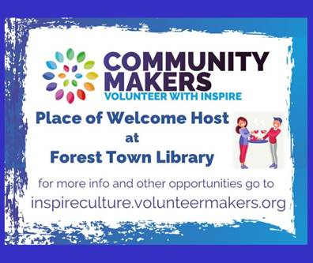](https://inspireculture.volunteermakers.org/get-involved/)

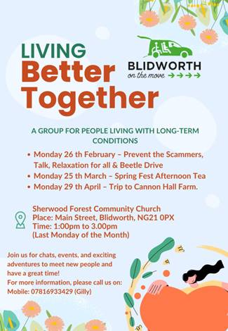





Enjoy a cuppa and a good chat, and make some new friends 🥰  
Free to attend and refreshments provided ☕️

**\*\*\*\*\*\*\*\*\*\*\*\*\*\*\*\*\*\*\*\*\*\*\*\*\*\*\*\*\*\*\*\*\*\*\*\*\*\*\*\*\*\*\*\*\*\*\*\*\*\*\*\*\***

[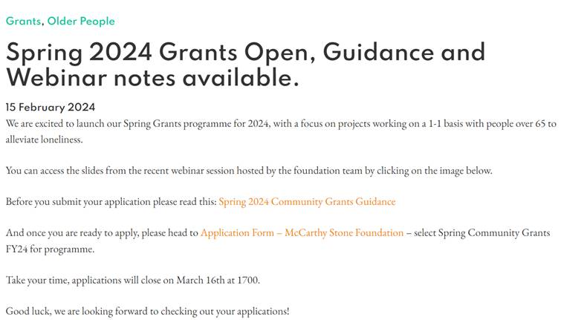](https://mccarthystonefoundation.org/spring-2024-grants-open-guidance-and-webinar-notes-available/)

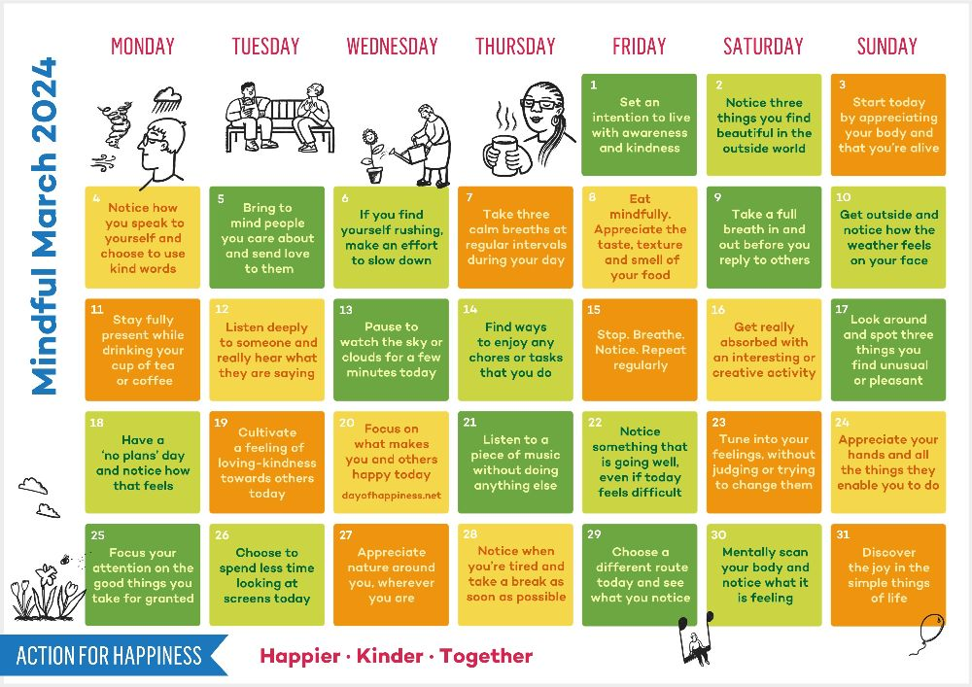



**Book via the Eventbrite website**



**To Coincide with Ageism Action Day 20th March**

[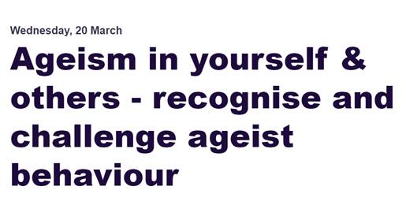](Ageism%20in%20yourself%20&%20others%20-%20recognise%20and%20challenge%20ageist%20behaviour%20Tickets,%20Wed%2020%20Mar%202024%20at%2014:00%20|%20Eventbrite)

[Ageism in yourself & others - recognise and challenge ageist behaviour Tickets, Wed 20 Mar 2024 at 14:00 | Eventbrite](https://www.eventbrite.com/e/ageism-in-yourself-others-recognise-and-challenge-ageist-behaviour-tickets-845830761577?utm_source=eventbrite&utm_medium=email&utm_content=follow_notification&utm_campaign=following_published_event&utm_term=Ageism+in+yourself+%26+others+-+recognise+and+challenge+ageist+behaviour&aff=ebemoffollowpublishemail&utm_experiment=follow_template.B)

[](https://www.eventbrite.co.uk/e/mental-health-awareness-training-nottinghamshire-inc-bassetlaw-tickets-848232264537?utm_source=eventbrite&utm_medium=email&utm_content=follow_notification&utm_campaign=following_published_event&utm_term=Mental+Health+Awareness+training+%28Nottinghamshire+inc.+Bassetlaw%29&aff=ebemoffollowpublishemail&utm_experiment=follow_template.B)

[Mental Health Awareness training (Nottinghamshire inc. Bassetlaw) Tickets, Mon 22 Apr 2024 at 12:30 | Eventbrite](https://www.eventbrite.co.uk/e/mental-health-awareness-training-nottinghamshire-inc-bassetlaw-tickets-848232264537?utm_source=eventbrite&utm_medium=email&utm_content=follow_notification&utm_campaign=following_published_event&utm_term=Mental+Health+Awareness+training+%28Nottinghamshire+inc.+Bassetlaw%29&aff=ebemoffollowpublishemail&utm_experiment=follow_template.B)

[Hands-on Growing - Creating a Raised Bed - Kirkby-in-Ashfield Library - Adult Learning | Inspire - Culture, Learning, Libraries (inspireculture.org.uk)](https://www.inspireculture.org.uk/skills-learning/community-learning/hands-on-growing-creating-a-raised-bed-kirkby-in-ashfield-library-adult-learning/)

[](https://www.inspireculture.org.uk/skills-learning/community-learning/hands-on-growing-creating-a-raised-bed-kirkby-in-ashfield-library-adult-learning/)             [](https://www.inspireculture.org.uk/skills-learning/community-learning/hands-on-growing-creating-a-raised-bed-kirkby-in-ashfield-library-adult-learning/)

[Regional Programme Manager 2024 Job Description .docx (usrfiles.com)](https://889ff7d1-4982-4140-81c9-5ea0f8245c8b.usrfiles.com/ugd/889ff7_508fecbb76194264abe2fef24530f081.pdf) Marmalade Trust – founders of Loneliness Awareness Week  (contact them for the closing date)

[](Regional%20Programme%20Manager%202024%20Job%20Description%20.docx%20(usrfiles.com))

**[](https://www.bcvs.org.uk/bcvsvacancies)**

[Group Development Officer (Bassetlaw) | Bassetlaw CVS (bcvs.org.uk)](https://www.bcvs.org.uk/bcvsvacancies)