April
Social media posts
Stress Awareness Month
It's #StressAwareness month & if you're finding it hard to cope then there's lots of help and advice at @NHS here: www.nhs.uk/conditions/stress-anxiety-depression/understanding-stress
During #StressAwareness month, why not try out some of the #fiveways to wellbeing. Small, simple things we can do each day to give us a boost: www.derbyshire.gov.uk/wellbeing
If you’re feeling stressed, worried or anxious then you can call the Derbyshire Mental Health Helpline for free on 0800 028 0077. Find out more online here: www.derbyshirehealthcareft.nhs.uk/services/helpline-and-support-service
April is #StressAwareness month. If you’re struggling with your mental wellbeing, then there’s lots of advice online at the Derby and Derbyshire Emotional Health and Wellbeing website here: derbyandderbyshireemotionalhealthandwellbeing.uk
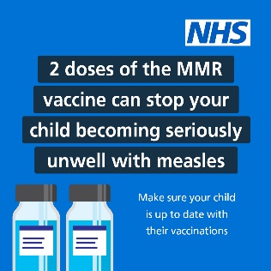
MMR vaccination
Measles cases are rising across England.
2 doses of the MMR vaccine provide the best protection against measles, mumps and rubella.
For more information and how to book ➡️ nhs.uk/MMR

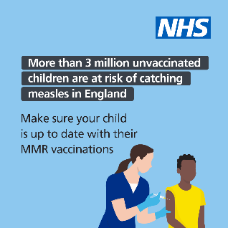
More than 3 million unvaccinated children are at risk of catching measles in England. Make sure your child is up to date with their MMR vaccinations.
You can make an appointment with your GP practice to catch up on missed doses.
For more info ➡️ nhs.uk/MMR
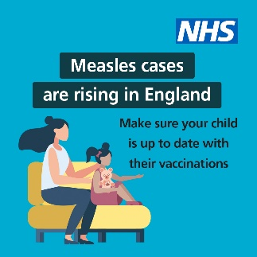
Measles is highly infectious and can be passed on even before a rash appears.
Make sure you are protected from becoming seriously unwell from measles by making sure you are up to date with your MMR (measles, mumps and rubella) vaccinations.
More info ➡️ nhs.uk/MMR

Bowel Cancer Awareness Month

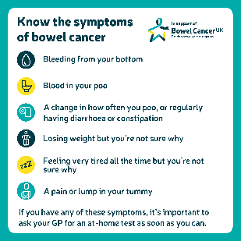
This #BowelCancerAwarenessMonth, @bowelcanceruk want you to know this #OneThing – the earlier bowel cancer is spotted, the more treatable it’s likely to be.
Learn more: https://www.bowelcanceruk.org.uk/about-bowel-cancer/symptoms/

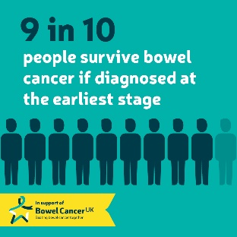
#OneThing we want to share with you this #BowelCancerAwarenessMonth is @bowelcanceruk’s message – the earlier #BowelCancer is spotted, the more treatable it’s likely to be.
Learn more about the possible symptoms of the disease: https://www.bowelcanceruk.org.uk/about-bowel-cancer/symptoms/

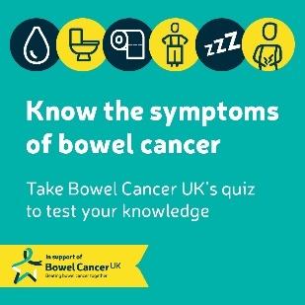
This #BowelCancerAwarenessMonth, the #OneThing @bowelcanceruk want you to do is test your knowledge about the disease.
Enter https://www.bowelcanceruk.org.uk/support-us/bowel-cancer-awareness-month/quiz/

Other National Campaigns you may want to share
World Health Organisation. World Health Day. Sunday April 7th
You can download materials to support this year’s theme: 75 years of Improving Public Health here: https://www.who.int/campaigns/world-health-day
World Immunisation Week
24th to 30th April is World Immunisation Week.
Find out more, and download campaign assets, online at the World Health Organisations website here: www.who.int/campaigns/world-immunization-week

Newsletter / intranet / payslip messaging
Stress Awareness Month
Stress is something that we all experience at some point. Whether it's a work deadline, financial worries or something more serious.
Low-level stress can sometimes be helpful or motivational but equally too much stress can affect our mood, our body and even our relationships.
There's lots you can try to help reduce your stress levels.
- plan ahead for stressful days or events – planning long journeys or making a list of things to remember can really help
- use time-management techniques to help you take control
- Try talking about your feelings to a friend, family member or health professional
You can get help and advice around dealing with stress on the NHS website here: www.nhs.uk/conditions/stress-anxiety-depression/understanding-stress
If you’re feeling stressed, worried or anxious then you can call the Derbyshire Mental Health Helpline for free, any time day or night, on 0800 028 0077.
Find out more online here: www.derbyshirehealthcareft.nhs.uk/services/helpline-and-support-service
There’s also lots of advice online at the Derby and Derbyshire Emotional Health and Wellbeing website here: derbyandderbyshireemotionalhealthandwellbeing.uk

Bowel Cancer Awareness Month
April is Bowel Cancer Awareness Month, a fantastic annual opportunity to raise awareness of bowel cancer, the fourth most common cancer in the UK.
The earlier bowel cancer is spotted, the more treatable it’s likely to be. In fact, more than 9 in 10 people survive bowel cancer when it is diagnosed at the earliest stage.
Why not get involved this April and help spread the word:
- take the bowel cancer quiz, and then share it with your friends and family
- attend an online awareness talk given by a volunteer with real life experience of bowel cancer
- follow Bowel Cancer UK on Twitter, Instagram, Facebook and LinkedIn then tag, share and encourage others to get involved
For more information about bowel cancer and details of how to get involved during Bowel Cancer Awareness Month, visit bowelcanceruk.org.uk/bowel-cancer-awareness-month

