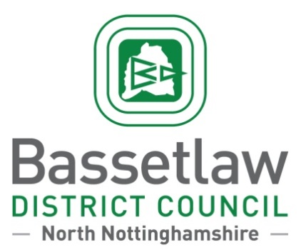
PRESS RELEASE
Queen’s Buildings, Potter Street, Worksop, Nottinghamshire, S80 2AH
Contact: Will Spence Date: 17/04/2024
Communications Team Leader
Tel: 01909 533 533 Ref: PR 2839
Have your say on £20M projects in Worksop!
Residents and businesses are being asked to share their views as part of a six-week consultation that will shape how £20million of Government Funding could be spent in Worksop.
In October last year, the Government named Worksop as one of 55 towns that will receive an endowment-style fund of £20million, released over the next 10 years, which could provide long-term certainty to deliver projects and interventions based on local priorities.
Earlier this year, a Worksop Town Board was established to lead on these projects, which has representation from a wide range of key local leaders including those in the Bassetlaw community and third sector, business representatives, the Bassetlaw MP, the District and County Councils, and Police.
So that the Board can prepare and produce a long-term plan for the town, which includes a 10-year strategy and a more detailed three-year delivery programme, a public consultation has been launched to identify key priorities across three themes – Safety and Security; High Streets, Heritage and Regeneration; and Transport and Connectivity.
The consultation is now live and will be available until Friday 24th May and seeks to collect the views of residents and businesses who visit, live, and are based in the town. This is being administered by Focus Consultants to ensure the consultation is conducted independently of the Council and the Board.
To be part of this consultation, please visit:
Consultation for residents: www.smartsurvey.co.uk/s/WorksopResidents/
Consultation for businesses: www.smartsurvey.co.uk/s/WorksopBusinesses/
Chair of Worksop Town Board and BCVS Chief Executive, Andria Birch, said: “This is great news for Worksop and we hope all local residents and businesses will feed into the consultation and inform the next phase of delivery of Towns Fund developments.
“This is an exciting opportunity to create a long-term plan for the town that deals with a wide range of issues, both from a business and visitor perspective, but also the much wider community reach it will have. On behalf of BCVS, we are pleased to be able to support this local partnership.”
Following the results of the consultation, the board will use these insights to identify the issues and priorities for the Long-Term Plan and produce a strategy and business case that will be submitted to Government before 1st August 2024.
The Board will then work with Bassetlaw District Council to develop the Long-Term Plan for the town, setting out how local partners can use their knowledge, powers, assets and this new funding to deliver for the community, leverage external investment, and oversee the delivery of projects.
To learn more about the Government’s Long-Term Plan for Towns, please visit - Our Long-Term Plan for Towns - GOV.UK (www.gov.uk)

