Welcome to **‘A Little TLC’** … **Tackling Loneliness Collaborative’s** ‘useful information!’ – **16th April 2024.**

Please feel free to have a glance through the headlines or further down…

The focus this time is: **‘Posters to show the variety of activities!’**

**It includes:**

1. Hucknall Boogie Nights – see poster below
2. Moving together – accessible and gentle exercise – Nottingham - see poster below
3. Pre-swim Coffee Morning – Nottingham – see poster below
4. Renewal Trust Activities – see poster below
5. Nottinghamshire Talking Therapies -  see poster below - [Nottinghamshire Talking Therapies (notts-talk.co.uk)](https://notts-talk.co.uk/)
6. Diversity Fitness – see poster below - [www.nottinghamshiremind.org.uk](http://www.nottinghamshiremind.org.uk)
7. Mansfield Library varied activities – see poster below - [Mansfield Library | Inspire - Culture, Learning, Libraries (inspireculture.org.uk)](https://www.inspireculture.org.uk/reading-information/find-a-library/mansfield-central-library/?fbclid=IwAR20sLx-92uY1oGClkiIddOEShDWId3SrXSraWiuh4_nn5dzSnQ5jSlmOw0)
8. Nottinghamshire Deaf Society Coffee Mornings – see poster below  - [Welcome to Nottinghamshire Deaf Society | Nottinghamshire Deaf Society (nottsdeaf.org.uk)](https://www.nottsdeaf.org.uk/)
9. Women’s Walking Wednesdays - [**Nottingham Muslim Women's Network**](https://www.facebook.com/nottinghammuslimwomensnetwork?__cft__%5b0%5d=AZWH_duWcJduNRXipX9Uxz4Y0mcRXUzynBc3jf7RhGcN5gB1cfXFgJJf_ykiIk3jXOZ4-pnW3rZMsvGqvcv7HLeONWfgzB317eKV8Sm8Bqtm3Yst6hxH3XehABeUA9zH5p_E3s7mum1Iu-vMAWARN50e3r_UR5arA5rrIjHcYDBmldFG9gcdjvNplsnlDxNr1mh79V4MadOfdBi4Hyl7QOws&__tn__=-UC%2CP-R) **–** see poster below - <https://nottinghammuslimwomensnetwork.co.uk/>
10. [Mental Health Awareness training (Nottingham, Nottinghamshire & Bassetlaw) Tickets, Wed 15 May 2024 at 09:30 | Eventbrite](https://www.eventbrite.co.uk/e/mental-health-awareness-training-nottingham-nottinghamshire-bassetlaw-tickets-884029615377?utm_source=eventbrite&utm_medium=email&utm_content=follow_notification&utm_campaign=following_published_event&utm_term=Mental+Health+Awareness+training+%28Nottingham%2C+Nottinghamshire+%26+Bassetlaw%29&aff=ebemoffollowpublishemail&utm_experiment=follow_template.B) Harmless Webinars
11. [Informal Get Together - May 2024 Tickets, Wed 22 May 2024 at 09:30 | Eventbrite](https://www.eventbrite.co.uk/e/informal-get-together-may-2024-tickets-856940450957?aff=erelpanelorg) Jo Cox Foundation Webinar
12. [Making Every Contact Count Session | Bassetlaw CVS (bcvs.org.uk)](https://www.bcvs.org.uk/civicrm/event/info?reset=1&id=43) online – 24th April
13. [Small grants - King Charles III Charitable Fund (kccf.org.uk)](https://www.kccf.org.uk/small-grants/) ** FUNDING**
14. Send your Nottinghamshire Heritage Pics for the Inspire Archive [Send us your photos and videos! | Iszy.ai](https://iszy.ai/inspirepicturearchive)  view the archive - [**Inspire Picture Archive.**](https://inspireculture.us2.list-manage.com/track/click?u=f4f77a49ea807369ed5bc7dbd&id=931cc43d82&e=5ad57c36bb)
15. [Carers Active April | Carers UK](https://www.carersuk.org/help-and-advice/your-health-and-wellbeing/carers-active-hub/carers-active-april/) – Click on this link for more information

Plus…

[Better Health Every Mind Matters Loneliness | Better Health Every Mind Matters | Campaign Resource Centre (dhsc.gov.uk)](https://campaignresources.dhsc.gov.uk/campaigns/better-health-every-mind-matters/loneliness-campaign/) – resources to use

**Loneliness Awareness Week -** <https://www.marmaladetrust.org/law>**and  The Jo Cox Inspired Great Get Together -** <https://www.jocoxfoundation.org/our-work/stronger-communities/great-get-together/>**both in June.**

***TLC dates for your diary:***

* **The Little TLC Catch Up!** – our informal peer networking lunch gathering – **Friday 3rd May** **– 1pm-1:45pm**.  All welcome; it’s great to meet a little more informally and share tips or what we are up to.

[**Join the Little TLC Catch Up! 3rd May meeting**](https://teams.microsoft.com/l/meetup-join/19%3ameeting_NWQ3MTFiMWItZjE4Mi00Y2RmLWEyNTktMTUzNWZhYzg5YmU2%40thread.v2/0?context=%7b%22Tid%22%3a%224df4435f-8800-4e1e-a615-b287fcaa7120%22%2c%22Oid%22%3a%220325b866-b80d-4b91-9992-7e06eb2c7739%22%7d)

* Our next wider **Tackling Loneliness Collaborative (TLC) meeting** takes place on **Tuesday 14th May 2024 9:30am-11:00am** on MS Teams.

[**Click here to join the wider TLC meeting**](https://teams.microsoft.com/l/meetup-join/19%3a058d99892c25477ba09b0e7d1fbc2d11%40thread.tacv2/1709836741123?context=%7b%22Tid%22%3a%223a4e48d5-2a9d-45aa-8001-70f6a8186d0e%22%2c%22Oid%22%3a%22c4fdd0c2-c73b-4913-b114-429273bf0be4%22%7d)If you have anything you want to share in this meeting please feel free to!  Also, feel free to drop into part of the meeting if it’s hard to make the full time.

Many thanks, Kirsty

Tackling Loneliness Collaborative Lead

Find us on [Facebook](https://www.facebook.com/tacklinglonelinesscollaborative)  and ‘X’ ([Twitter](https://twitter.com/TLCNotts))

Loneliness Page - [Tackling Loneliness Collaborative Nottingham and Nottinghamshire | Bassetlaw CVS (bcvs.org.uk)](https://www.bcvs.org.uk/tlcnn)

Research and Service Database -  [www.tlin.co.uk](http://www.tlin.co.uk/)

           …………………………………………………………………………………………………………………………………………………………………………………………………………………………………………………………………………….…….

**Items to follow:**

[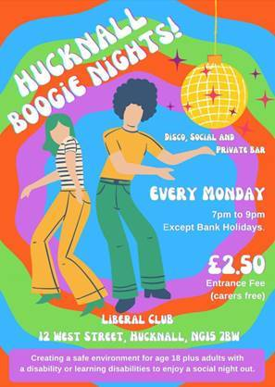](mailto:carersinhucknall@yahoo.co.uk)

[carersinhucknall@yahoo.co.uk](mailto:carersinhucknall@yahoo.co.uk)

[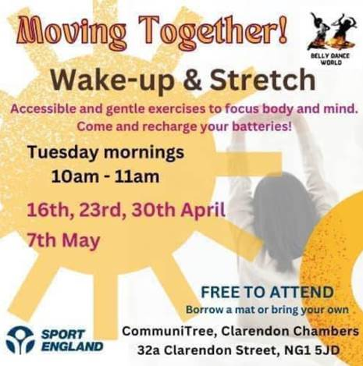](https://www.facebook.com/p/Belly-Dance-World-100063604718588/?paipv=0&eav=Afb01EpplgHXQl2DgiMK1JHv_86nF28wNePq1PvH0ISn3ChqjjEdcncjeX4Voa65gRw&_rdr)             <https://www.facebook.com/p/Belly-Dance-World-100063604718588/?paipv=0&eav=Afb01EpplgHXQl2DgiMK1JHv_86nF28wNePq1PvH0ISn3ChqjjEdcncjeX4Voa65gRw&_rdr>



[enquiries@renewaltrust.org.uk](mailto:enquiries@renewaltrust.org.uk)

[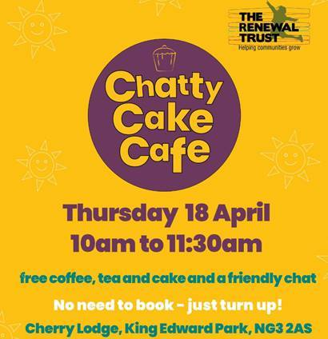](mailto:enquiries@renewaltrust.org.uk)[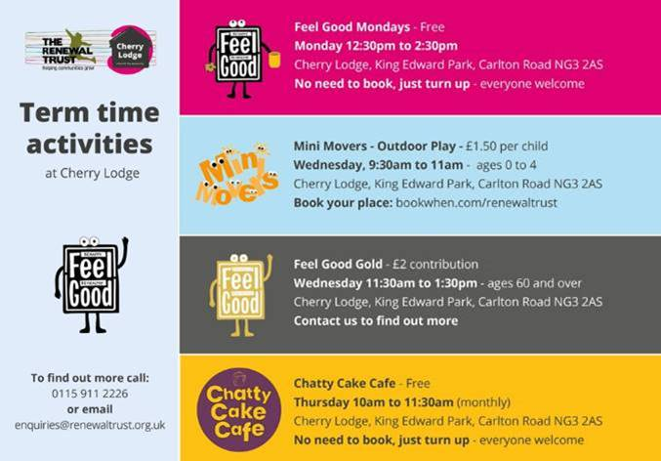](mailto:enquiries@renewaltrust.org.uk)

[](http://www.notts-talk.co.uk/)[Nottinghamshire Talking Therapies (notts-talk.co.uk)](https://notts-talk.co.uk/)

[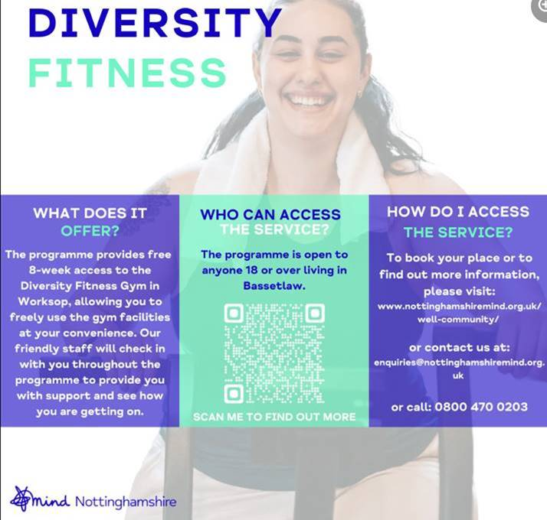](http://www.nottinghamshiremind.org.uk/)

[www.nottinghamshiremind.org.uk](http://www.nottinghamshiremind.org.uk)

[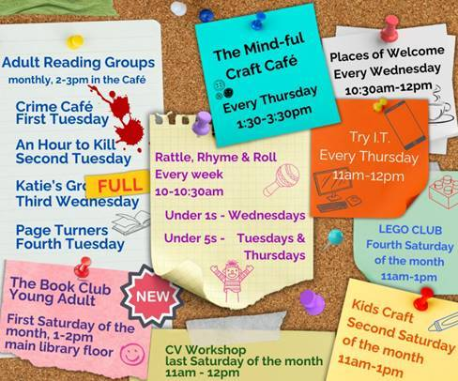](https://www.inspireculture.org.uk/reading-information/find-a-library/mansfield-central-library/?fbclid=IwAR20sLx-92uY1oGClkiIddOEShDWId3SrXSraWiuh4_nn5dzSnQ5jSlmOw0)

[Mansfield Library | Inspire - Culture, Learning, Libraries (inspireculture.org.uk)](https://www.inspireculture.org.uk/reading-information/find-a-library/mansfield-central-library/?fbclid=IwAR20sLx-92uY1oGClkiIddOEShDWId3SrXSraWiuh4_nn5dzSnQ5jSlmOw0)

**Nottinghamshire Deaf Society**

[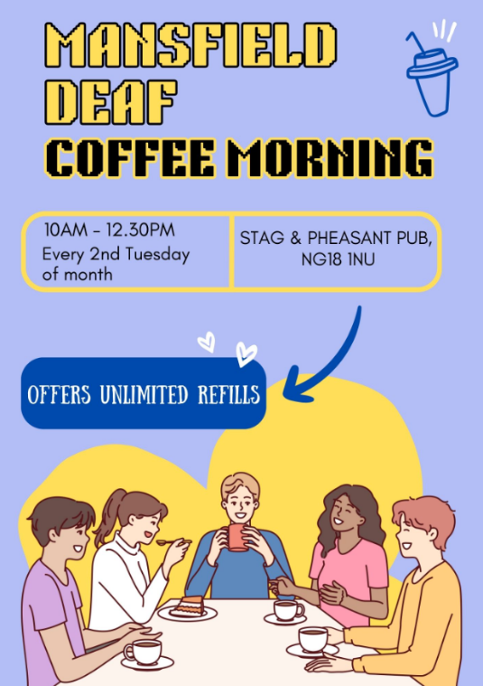](https://www.nottsdeaf.org.uk/)Dates - April 30th 10am - 12pm - one off this month

then every 2nd week of every month –

May 14th, June 11th, July 9th, Aug 13th,

Sept 10th, Oct 8th, Nov 12th and Dec 10th.

New dates for Mansfield Coffee Morning - socialising, meet people, support from Nottinghamshire Deaf Society - community work, interpreters, employment, Welfare Rights and Advocacy.

<https://www.nottsdeaf.org.uk/>



#### [**Nottingham Muslim Women's Network**](https://www.facebook.com/nottinghammuslimwomensnetwork?__cft__%5b0%5d=AZWH_duWcJduNRXipX9Uxz4Y0mcRXUzynBc3jf7RhGcN5gB1cfXFgJJf_ykiIk3jXOZ4-pnW3rZMsvGqvcv7HLeONWfgzB317eKV8Sm8Bqtm3Yst6hxH3XehABeUA9zH5p_E3s7mum1Iu-vMAWARN50e3r_UR5arA5rrIjHcYDBmldFG9gcdjvNplsnlDxNr1mh79V4MadOfdBi4Hyl7QOws&__tn__=-UC%2CP-R)

[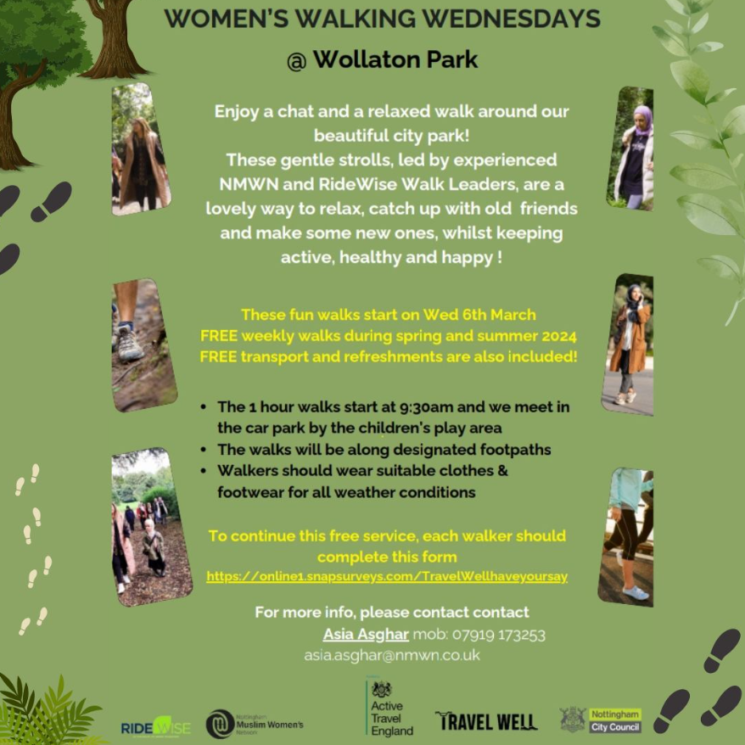](mailto:Asia.asghar@nmwn.co.uk)🚶🏽‍👣🌲Join us for a rejuvenating walk surrounded by the beauty of nature with WOMEN'S WALKING WEDNESDAYS led by experienced NMWN and RideWise Walk Leaders for women at Wollaton Park! 🌳Connect, unwind, and embrace wellness together! 🚶‍♀️💫

📍Meeting point: the car park by the children's play area 👟Walking starts at 9:30am

👉🏼To register, complete the form

[https://online1.snapsurveys.com/TravelWellhaveyoursay](https://online1.snapsurveys.com/TravelWellhaveyoursay?fbclid=IwAR3reugWmC5KXPtjveVr2Mrl5YpN07Izwtr6a5LjRKk8eAxDXFcIRztI1Dw)

For more information

📍contact Asia Asghar

* 07919 173253 📧[asia.asghar@nmwn.co.uk](mailto:asia.asghar@nmwn.co.uk)

📍contact us

☎️07826464722 / 01158372627

* email us at [enquiries@nmwn.co.uk](mailto:enquiries@nmwn.co.uk)
* <https://nottinghammuslimwomensnetwork.co.uk/>

[Mental Health Awareness training (Nottingham, Nottinghamshire & Bassetlaw) Tickets, Wed 15 May 2024 at 09:30 | Eventbrite](https://www.eventbrite.co.uk/e/mental-health-awareness-training-nottingham-nottinghamshire-bassetlaw-tickets-884029615377?utm_source=eventbrite&utm_medium=email&utm_content=follow_notification&utm_campaign=following_published_event&utm_term=Mental+Health+Awareness+training+%28Nottingham%2C+Nottinghamshire+%26+Bassetlaw%29&aff=ebemoffollowpublishemail&utm_experiment=follow_template.B)

[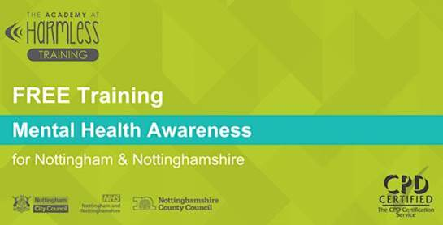](https://www.eventbrite.co.uk/e/mental-health-awareness-training-nottingham-nottinghamshire-bassetlaw-tickets-884029615377?utm_source=eventbrite&utm_medium=email&utm_content=follow_notification&utm_campaign=following_published_event&utm_term=Mental+Health+Awareness+training+%28Nottingham%2C+Nottinghamshire+%26+Bassetlaw%29&aff=ebemoffollowpublishemail&utm_experiment=follow_template.B)

[Informal Get Together - May 2024 Tickets, Wed 22 May 2024 at 09:30 | Eventbrite](https://www.eventbrite.co.uk/e/informal-get-together-may-2024-tickets-856940450957?aff=erelpanelorg)

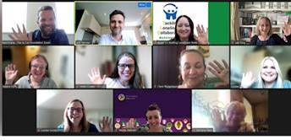   

**W﻿hat is this event?**

T﻿his event is an informal, safe and welcoming online space for people working in communities anywhere in the UK to connect with each other.

We provide gentle facilitation to allow you to get to know a little about each other, share challenges, listen and exchange ideas.

These meetings take place every month, but the times and dates vary. Numbers also vary, but it's typically around 10 people. Some people pop in just once, others come and go, and some come regularly, but there's usually a couple of new people each time.

**Who is this for?**

If you are working to address disconnection, loneliness and social isolation in our communities then this meeting is for you.

Y﻿ou might work in a large, national organisation or you might volunteer with a small group supporting your local neighbourhood.

**What will you get out of it?**

After attending one of these informal get togethers:

* 87% feel connected to others, versus 59% before participating
* 89% feel motivated about their work, versus 71% before participating
* 89% feel a good sense of wellbeing , versus 72% before participating

We encourage you to prioritise yourself and come along, because for many these spaces are a helpful respite from the usual formality of networking events and the relentlessness of work issues.

[The Jo Cox Foundation Events - 7 Upcoming Activities and Tickets | Eventbrite](https://www.eventbrite.co.uk/o/the-jo-cox-foundation-44881263953)

[Loneliness and social isolation: a new decade of action - The Jo Cox Foundation](https://www.jocoxfoundation.org/2020/01/23/loneliness-and-social-isolation-a-new-decade-of-action/)

[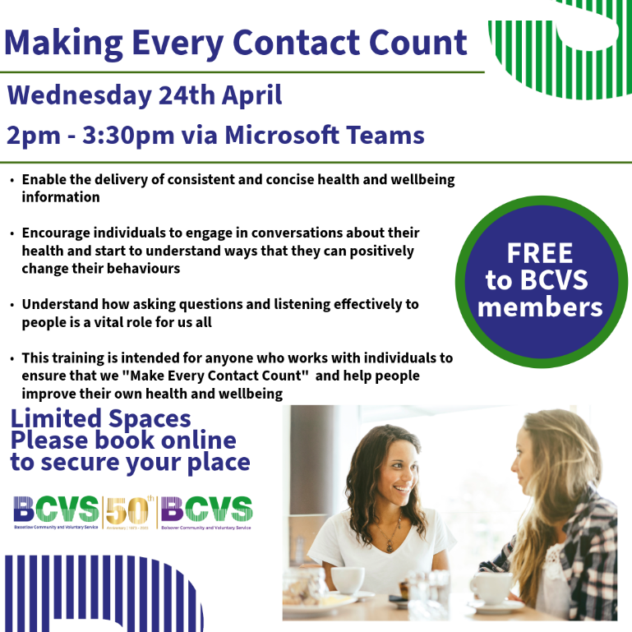](https://www.bcvs.org.uk/civicrm/event/info?reset=1&id=43)

[Making Every Contact Count Session | Bassetlaw CVS (bcvs.org.uk)](https://www.bcvs.org.uk/civicrm/event/info?reset=1&id=43)

Email: [bcvs@bcvs.org.uk](mailto:bcvs@bcvs.org.uk)

# King Charles III Charitable Fund

9th February



 The Fund is awarding small grants of up to £5,000 to registered non-profit organisations. They are especially interested in receiving applications from organisations within the East Midlands.

To be eligible, organisations must:

* have an annual income of less than £1 million.
* have completed at least two years of activity.
* have less than six months of free reserves.
* have a total project cost of less than £200,000.

The Fund cannot fund organisations that are tackling food waste, food poverty or food insecurity as there is a separate Coronation Food Project grant programme for these organisations.

[Small grants - King Charles III Charitable Fund (kccf.org.uk)](https://www.kccf.org.uk/small-grants/)

[Send us your photos and videos! | Iszy.ai](https://iszy.ai/inspirepicturearchive)

[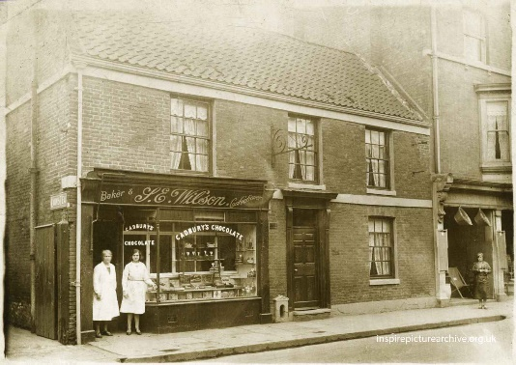](Send%20us%20your%20photos%20and%20videos!%20|%20Iszy.ai)

**Photos at your fingertips**

We're quite sure many of you indulged in some sweet treats last weekend which makes this early 20th-century photo of Wilson's Confectioners Shop in Retford perfectly fitting!

You can explore our Inspire Picture Archive holding over 40,000 images that encapsulate Nottinghamshire’s history from the 16th century to the 21st century by visiting [**Inspire Picture Archive.**](https://inspireculture.us2.list-manage.com/track/click?u=f4f77a49ea807369ed5bc7dbd&id=931cc43d82&e=5ad57c36bb)

Join us and be part of our community effortin keeping history alive by sharing your photos, new or old, with us. It’s really easy to do and it’s free!

[Send us your photos and videos! | Iszy.ai](https://iszy.ai/inspirepicturearchive)

[Carers Active April | Carers UK](https://www.carersuk.org/help-and-advice/your-health-and-wellbeing/carers-active-hub/carers-active-april/)

[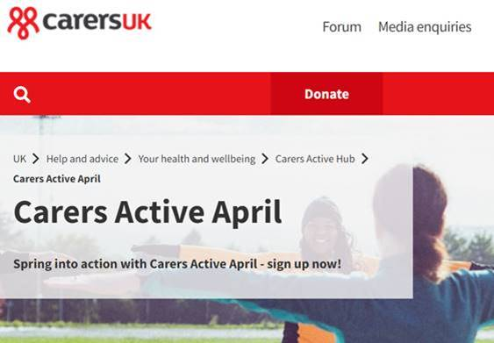](Carers%20Active%20April%20|%20Carers%20UK)

**Loneliness Resources:**

[Better Health Every Mind Matters Loneliness | Better Health Every Mind Matters | Campaign Resource Centre (dhsc.gov.uk)](https://campaignresources.dhsc.gov.uk/campaigns/better-health-every-mind-matters/loneliness-campaign/)

[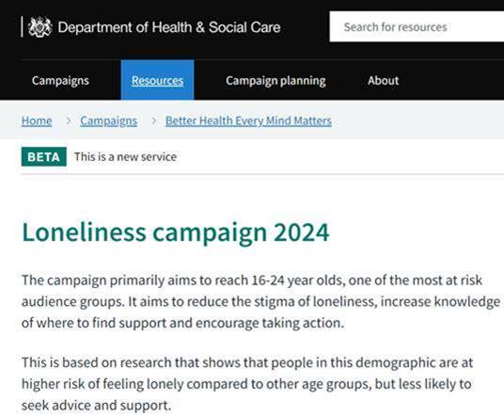](Better%20Health%20Every%20Mind%20Matters%20Loneliness%20|%20Better%20Health%20Every%20Mind%20Matters%20|%20Campaign%20Resource%20Centre%20(dhsc.gov.uk))Other resources are available  [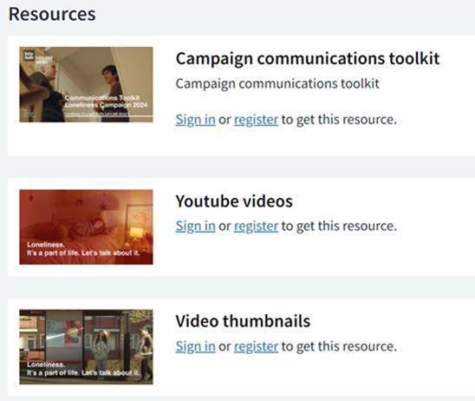](Better%20Health%20Every%20Mind%20Matters%20Loneliness%20|%20Better%20Health%20Every%20Mind%20Matters%20|%20Campaign%20Resource%20Centre%20(dhsc.gov.uk))

**National Loneliness Campaigns:**

**These will be discussed as part of our next TLC meeting in May.**

There are two campaigns running in June,  will you be signing up to one and creating an event or attending one?

**21st – 23rd June – the great get together :** <https://www.jocoxfoundation.org/our-work/stronger-communities/great-get-together/>

**10th – 16th June – Loneliness awareness week:** <https://www.marmaladetrust.org/law>