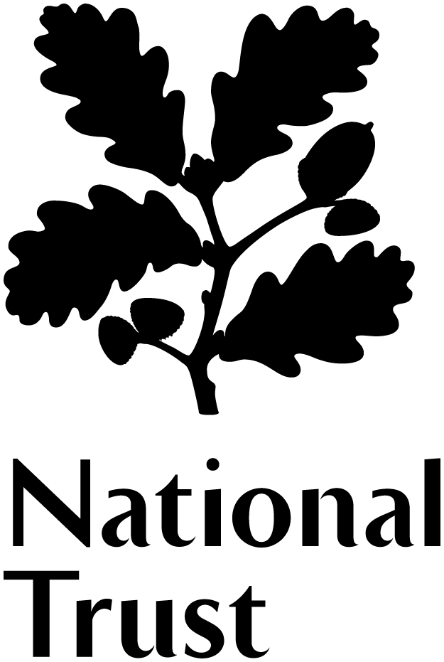
Volunteer Role Summary
Second Hand Bookshop – Hardwick Hall

Our Bookshop Volunteers know where to find the poetry section, or holiday reads, and love helping our visitors to find something they will enjoy. Come and join the Hardwick Hall Secondhand Bookshop Team. You will be a vital part of our Visitor Experience team and the money raised will help look after our special place.

By getting involved, you could

- Use your customer service skills and knowledge of literature to help visitors
- Help with raising money to Grow Support for our work.
- Join an enthusiastic team and meet new people.

What’s involved?

- Making visitors feel welcome and helping them enjoy their day
- Taking in donations of books, pricing up and sorting them into categories

- Keeping the bookshop looking inviting and well stocked

- Taking card and cash payments in the bookshop

- Help to research the value of rare and valuable books.

- Promoting the bookshop, thinking of new ways to promote and helping out with relevant events

- Learning what’s on offer at Hardwick, so you can help visitors to enjoy a memorable day on the estate.

- Being proactive in dealing with customer queries and being able to think on your feet to help deliver exceptional customer service.

- Adopting a flexible attitude to your volunteering e.g. open to taking on new challenges in your role and if possible being able to be flexible with the days you volunteer.

- Completion of mandatory training.

- Being aware of any security risks, and raising any concerns you have with staff
- Becoming familiar with and then following the National Trust’s Health and Safety Policy at all times

- There might occasionally be some other activities that are of interest to you, that we could use your help with.

This role will suit you if you are …
- In love with books – even when they’re a little bit dusty!
- Keen to help each customer find something they like
- Interested in helping us fundraise and Grow Support for Hardwick Hall
- Available at least once a fortnight

Extra Information

Your place | National Trust Hardwick Hall
Time commitment | Once a week or fortnight
Volunteer Manager | Jenny Banton
Training/Resources | Induction, training and development opportunities available
Expenses | Out-of-pocket travel costs between home and volunteering place will be paid, and other reasonable expenses agreed in advance

About the National Trust

The National Trust is a registered charity and is completely independent of Government. We rely for income on membership fees, donations and legacies and money raised from our commercial operations. We are supported by 3.8 million members and 61,000 volunteers without whom we simply could not manage. We protect and open to the public over 300 historic houses and gardens and 49 industrial monuments and mills. But it doesn’t stop there. We also look after forests, woods, fens, beaches, farmland, downs, moorland, islands, archaeological remains, castles, nature reserves, villages – for places, for ever, for everyone.

