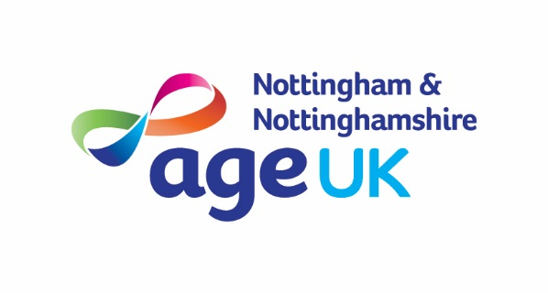

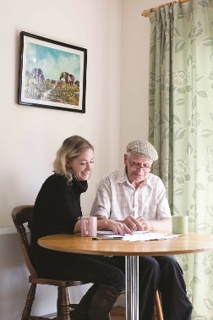
Communication & Customer Service
Planning & Organisation
Recording and Monitoring
Leadership
Quality
Charity Focus
Specialist Knowledge
Team Work

Community Support Worker

Hours: 37 per week

Salary: £22,395.36 per annum

Based: Home and community based (primarily within Nottingham City)

Tenure: Permanent

Age UK Nottingham and Nottinghamshire operate a range of community based support services. These are primarily short-term support services, with the aim of allowing people to remain independent in their own home for as long as possible. Our services promote independence and overall wellbeing by providing information and support to people experiencing difficulties around isolation, physical health, financial, and housing issues.

The successful candidate will deliver services to people in Nottingham City primarily, but also support people in other districts as required. The post holder will provide telephone and face to face support which includes welfare checks, confidence building, help with shopping, benefit support, and information/signposting. They will need an awareness of the issues vulnerable people face and be empathetic, sensitive, and able to empower people to self-manage their needs.

The ideal candidate is expected to demonstrate a high level of organisation, IT, and communication skills, and will be a team player yet self-motivated, professional, and committed to the values of Age UK Notts.
As an employee of Age UK Nottingham & Nottinghamshire you will be eligible for our attractive package which includes 24 days annual leave (Pro Rata), public holidays, flexible working and a 4% employer contribution pension (in line with auto-enrolment rules).

How to Apply
For full details and to download an application pack, please visit our website at www.ageuk.org.uk/notts. Alternatively, please contact our HR department for an application pack by email recruitment@ageuknotts.org.uk or telephone 0115 859 9265.

The closing date for receipt of completed applications is
9am on Monday 1st July 2024

Age UK Nottingham & Nottinghamshire promotes equality and diversity.
Registered Charity Number: 1067881

