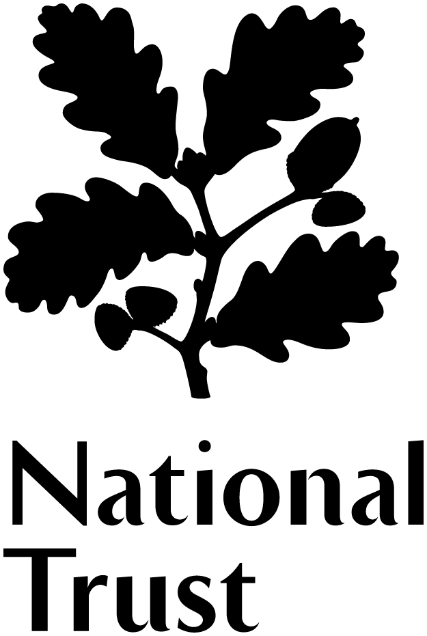

Volunteer Role Description
Mill Guide 2024

What is a Mill Guide?

Stainsby Mill is a historic water powered flour mill that has an interesting and engaging story to tell about our industrial heritage. Mill Guides provide a warm and friendly welcome to all visitors giving a brief explanation of the history, technology and the people connected to the mill down the years. Working with the team to provide a consistently good, inclusive and effortless journey for our visitors, inspiring them to return time and time again.

National Trust Volunteering Charter

Whatever the reason for volunteering and whatever the team or the role, we want every volunteer to have a positive experience.

The Volunteering Charter has been created for and by volunteers and staff so that everyone understands:
- Why volunteering is important and
- How we can work together to create a great place to volunteer

You will be introduced to the Volunteering Charter at your initial volunteer induction.

What’s in it for you?

- Becoming part of a friendly and dedicated team of staff and volunteers.
- Meeting people from all walks of life and making new friends.
- Enjoying new experiences and learning something new every day
- Suitable training will be given in all aspects of the role.
- Opportunity to be involved in cross team learning calendar, additional training, and Hardwick team socials.

What’s involved?

- Providing an outstanding welcome and being curious about the different needs of every visitor.

- Attending the volunteer estate wide induction and ongoing training events to get to know the National Trust’s values and bring them to life when volunteering.

- Be supportive of my wider team (staff and volunteers) when I’m volunteering.
- Learning what’s on offer at Hardwick, so you can answer any questions and encourage visitors to make the most of their day on the estate.
- Helping visitors to discover more by answering questions, giving short talks to individuals and small groups.
- Completion of mandatory training, including Everyone Welcome and customer service training.

- Being proactive in dealing with customer queries and being able to think on your feet to help deliver exceptional customer service.

- Becoming familiar with and then following the National Trust’s Health and Safety Policy at all times. Making my safety and wellbeing a priority, along with that of others around me.

- Being aware of any security risks and raising any concerns you have with staff.

- Adopting a flexible attitude to your volunteering e.g. open to taking on new challenges in your role and if possible being able to be flexible with the days you volunteer.

This role will suit people who… have an enthusiastic and friendly manner, enjoy meeting people, like operating as part of a team and who are keen to learn.

Extra information

Your place | Stainsby Mill
Time commitment | The mill is open Friday, Saturday, Sunday during School holidays.
Staff Contact  (if different)  Volunteer Manager | WSA team / Volunteer Manager  Jenny Banton
Training/Resources | Volunteer induction and familiarisation of the Mill
Expenses | Out-of-pocket travel costs between home and volunteering place will be paid.

About the National Trust
The National Trust is a registered charity and is completely independent of Government. We rely for income on membership fees, donations and legacies, and money raised from our commercial operations. We are supported by 3.8 million members and 61,000 volunteers without whom we simply could not manage. We protect and open to the public over 300 historic houses and gardens and 49 industrial monuments and mills. But it doesn’t stop there. We also look after forests, woods, fens, beaches, farmland, downs, moorland, islands, archaeological remains, castles, nature reserves, villages – for places, for ever, for everyone.

About Stainsby Mill
Stainsby Mill is a Victorian flour mill. Operated and maintained by three Millers and a dedicated team of Mill Guides.
The mill became part of the Hardwick Estate in 1593, providing flour to the family and locals alike. In 1850, the 6th Duke of Devonshire reconstructed the mill in order to make white flour, which was becoming increasingly popular. The machinery remained in place until the 1990s, when the dilapidated mill was restored to the 6th Duke’s designs.

