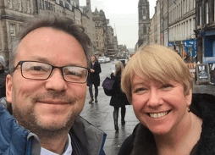
Welcome to the Summer 2024 Think CO e-newsletter from the Gas Safe Charity.

Below are information and resources that will help you raise carbon monoxide (CO) awareness with the people you support in all our communities, as well as with your work or volunteering colleagues.

Normally, this time of year we would assume few people would have their heating on and it would all be shorts and BBQs. However, this year has been different so far, and very chilly in a lot of places!

We continue to provide Think CO online training (some are spaces available in July, as well as some new dates in August and September 2024 - book here: Free Think CO workshop), plus face-to-face workshops are planned for some parts of the UK later in the year.

Simon and Hilary

P.S. We are running our annual survey in July to help capture the impact of the Think CO training and help us plan for the future.

Please click on this link: TCO Feedback Survey - 23-24

We will be offering a free CO Alarm to the most useful and interesting response to the TCO Programme (judge’s decision is final!). Thanks for taking the time.

1) GSC is a registered charity and a company limited by guarantee registered in England and Wales. Charity number 1131987. Company number 07012694
_________________________________________________________________________

CO Awareness Week 2024
Following a successful Week last November, work is on-going to assess the week’s impact. Early indications are that 2023’s CO Awareness Week has had its widest reach to date.

The range of resources and assets from the Week are all still available to download and use – just click on the link here: https://www.coalarmssavelives.com/carbon-monoxide-awareness-week-23

Watch out for information from Think CO this autumn about CO Awareness Week 2024 - 18-24 November

________________________________________________________________________

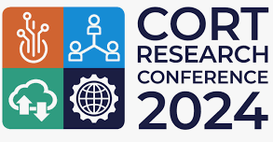
Highlights of Carbon Monoxide Research Trust Conference 2024, Birmingham

Practitioners, academics, policy makers and policy influencers from across Britain came to Birmingham on 18-19 June to attend the Carbon Monoxide Research Trust (CORT) Conference, and Think CO was there.

CORT aims to reduce the incidents of death and serious injury from CO poisoning, with a key focus on research. It provides grant funding, advice and support to organisations wanting to carry out research and evidence fathering related to CO safety - www.coresearchtrust.org

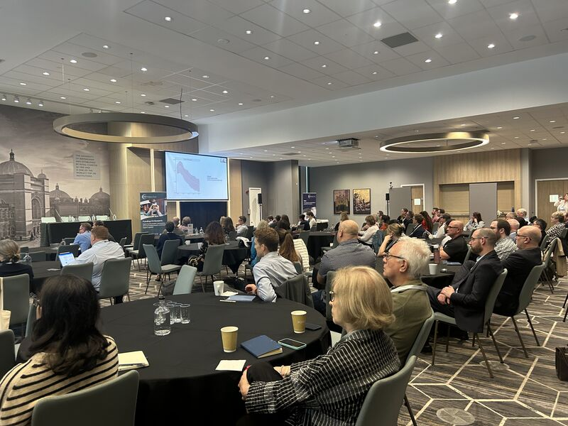
Day 1 of the conference shared information about a range of research projects including CO and pregnant women and the unborn child, enabling greater CO awareness amongst disadvantaged communities, and understanding pathways for detection, prevention and treatment of CO.

Day 2 focused on CO data.

Emerging data is indicating that:

- Responding to CO incidents cost £7.2 million in 2023 – that’s the costs to the Gas Distribution Networks and fire & rescue services, but not the health service whose costs aren’t included in this figure
- In 2023, there were 239 CO fatalities and injuries in England
- 55,520 CO incidents were recorded in England in 2023

This data is taken from a new initiative called COPE – the Carbon Monoxide Partner Ecosystem. COPE aims to address the CO data gap. As anyone who has been on a Think CO workshop or done the e-learning knows, data on CO is difficult to get for a number of reasons including misdiagnosis.

COPE is a partnership between a number of organisations including the Gas Distribution Networks, fire & rescue services, alarm manufacturers and health bodies like NHS England. The conference showed an early version of its brand new data platform called CORA (the CO Research & Analytics platform). CORA brings together CO data from many organisations so data and statistics about CO can be analysed and used.

CORA is still in development and not yet available publicly, so watch this space.
Face-to-Face Think CO Workshops in Gloucester (6 November) and Newport, Wales (20 November)

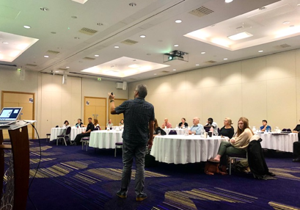
Working in partnership with Wales & West Utilities, we are running two face-to-face workshops this autumn. Further details will be available soon, but we plan to focus the workshops in Gloucester and Newport on CO in a cost-of-living crisis. Open to organisations and departments across local authorities, the NHS, community and voluntary organisations, the morning will focus on CO awareness, plus we will share practical help and support for people on energy costs and energy management. Get in touch if you would like a face-to-face workshop in your area.
Gas Cooker alert
The Office for Product Safety and Standards (OPSS) has undertaken a programme (since Sept 2023) to repair certain gas hobs on the UK market. However, there are still many cooker owners who haven’t been contacted for a range of reasons. Therefore, we are promoting this initiative. The manufactures’ names and logos are on the poster and you can also find more details, including models, on the OPSS’s website here.

The affected gas hobs may be fitted with a connector that is at risk of failing in certain circumstances whether the hob is in use or not. Should this occur, this could lead to a gas leak or fire. The corrective action involves arranging for an engineer to visit the property and check and, where necessary, replace, the connector.

If you visit a home with a gas cooker, check the brand and whether the owner has been contacted and if any action has been taken. If not, encourage them to contact the manufacturer via the web link above.

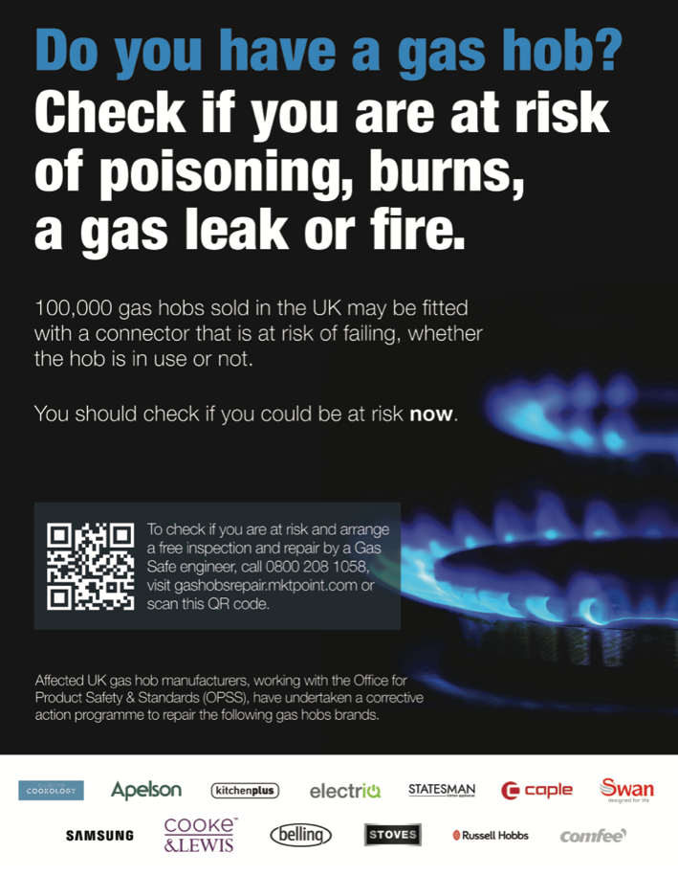

___________________________________________________________________________

Zoom workshop offer - for your organisation only
We’ve run and are planning to run Zoom Think CO workshops for specific organisations. To date, these have included the National Energy Foundation, National Energy Action, Derbyshire Citizens Advice and Kent County Council. The online workshops can be for your staff/volunteers only or they can include partner organisations you work with as well.

Let us know if your organisation would be interested. The online workshops are free and last about an hour and cover what CO is, it’s sources signs and symptoms and how to help prevent CO poisoning. We expect a minimum of 25 attendees. Contact thinkco@gassafecharty.org.uk for more information.

__________________________________________________________________

Pack Safe Appeal
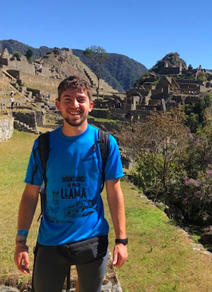
On the 30 August 2023, Hudson Foley tragically died of carbon monoxide (CO) poisoning while staying in Homestay accommodation in Quito, Ecuador at just 24 years of age.

Backpackers like Hudson travel abroad, often unaware of the health and safety risks in the places they stay. Hudson Foley’s passing is the latest tragedy in the dark history of Britain’s passing away from CO poisoning while holidaying abroad.
The Pack Safe Appeal: Hudson‘s campaign for carbon monoxide travel safety exists because of a tragic, avoidable accident. Its work is inspired by Hudson’s life.
Its mission is to raise awareness of the dangers of CO and to prevent unnecessary loss of life, particularly among the young person travelling community.
The overall campaign goals are to ensure holiday providers check CO safety in accommodation and that young backpackers and holiday makers pack CO alarms.
They aim to achieve this through:
- Travel guides and websites to feature CO related safety notices.
- Accommodation providers to adopt safety measures such as ensuring CO alarms and gas safety checks in accommodation.
- Travel providers to include CO alarms in kit lists and provide safety briefings to customers
- Government travel guidance to communicate CO related travel safety issues to travellers
Keep a look out for more information about the Pack Safe Appeal over the summer.
___________________________________________________________________________
Customised e-learning package
Over the last couple of years, Think CO has worked with organisations to develop e-learning courses customised for that organisation. We agree a customised introductory section, with the organisation’s branding throughout the package and then develop relatable case studies in partnership with the organisation. The core e-learning package that we use in our e-learning is included and remains the same. Recent organisations we have worked with include the National Fire Chiefs Council and the Scouts.

We’ve just produced this video about the customised package and how it works – click on the link below and have a look….

Customised e-learning video for your organisation

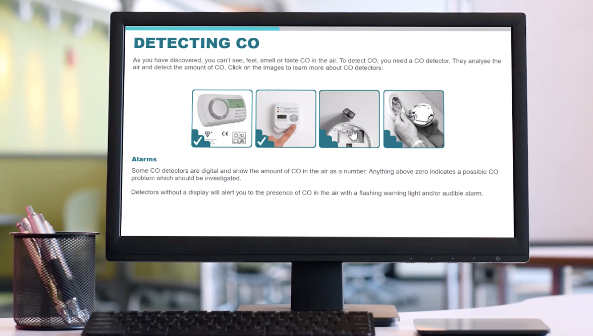

A customised e-learning package is cheaper and quicker to produce than you might think - if you’re interested, get in touch with us at ThinkCO@gassafecharity.org.uk

RoSPA CO Hub – with a focus on landlords and tenants
RoSPA – once known as the Royal Society for the Prevention of Accidents - is the leading voice in health and safety that campaigns to reduce avoidable accidents at home, on the road at work and at leisure.

RoSPA recently launched its CO Hub. Created in collaboration with Wales & West Utilities, its hub offers year round guidance and resources. Usefully, it has easy to understand information for landlords and for tenants about the law and people’s rights.

For more information click here www.rospa.com/policy/home-safety/carbon-monoxide-hub/carbon-monoxide-landlords
___________________________________________________________________________

Think CO resources – all free

E-learning
Anyone can register for the Think CO e-learning course by sending your name and email address to
e-learning@gassafecharity.org.uk The course is accessible all year round.

Zoom workshops
There is a schedule of one-hour Zoom workshops currently available to Sept 2024. To book on click on this link: Free Think CO workshop

Face-to-face workshops
If you would like to discuss arranging a face-to-face workshop in your area, please contact us on thinkco@gassafecharity.org.uk

Materials
We have a range of guides/leaflets that can be downloaded via this link: Gas Safe Charity

