Press Release
For Immediate Release
In Sam’s Name Secures Funding to Launch New Podcast


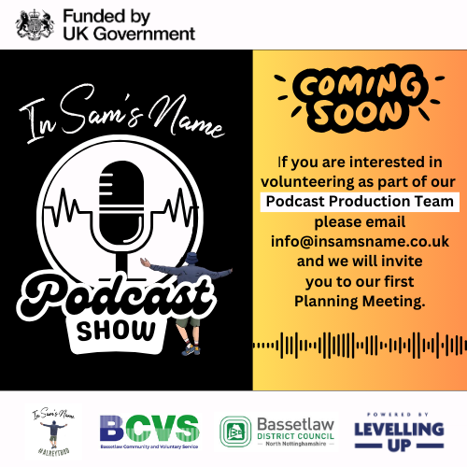

We are thrilled to announce that Nottinghamshire-based mental health support charity, In Sam’s Name, has been successful in their funding bid to the Shared Prosperity Fund Levelling Up Community Grants. Administered by Bassetlaw Community and Voluntary Service and their Volunteer Grant Panel, the project has been selected for funding, enabling the charity to embark on an exciting new venture: launching their very own podcast!

This podcast initiative is designed to reach those who are unable to attend the support groups, or who may not be ready to participate in person just yet. The podcast will feature interviews with individuals who have lived experiences with mental health challenges, as well as health professionals offering valuable advice. The aim of the podcast is to provide support, share stories, and extend community reach in an exciting and accesible way.

To bring this podcast to life, In Sam’s Name are seeking a team of volunteers to form a "Podcast Production Team." If you have an interest in podcasting, they would love your support in editing sound clips and videos. Thanks to the funding, they are also offering podcast editing training to those interested in being part of this long-term project.

Rachel Wood and Richard McHugh, Trustees of In Sam’s Name, expressed their gratitude: "We are so grateful to have been accepted for this funding as we can now expand our services to more people, give individuals a chance to share their stories, and offer free training in podcasting, which is a highly sought-after skill. We are looking forward to getting a dedicated team together and hope to officially launch the first episode at an event marking World Mental Health Day. We would also like to express our thanks to BCVS and their Grant Panel for choosing our project for this funding".

For more information about volunteering opportunities or to learn more about our podcast project, please email info@insamsname.co.uk

We look forward to this exciting new chapter and the positive impact it will have on our community.

