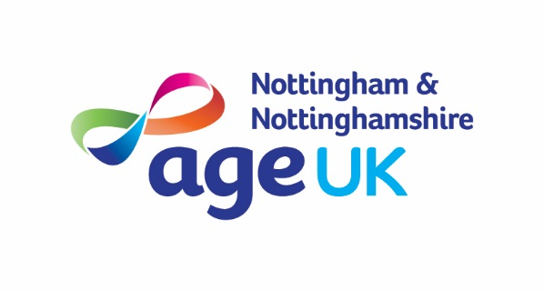



**Communication & Customer Service**

**Planning & Organisation**

**Recording and Monitoring**

**Leadership**

**Quality**

**Team Work**

**Charity Focus**

**Specialist Knowledge**

**Support Worker (Specialist Dementia Day Service)**

**Hours: Several posts 15 - 21 hours a week (with additional paid hours providing cover as required)**

**Salary: £11.44 per hour**

**Based: Sybil Levin Specialist Dementia Day Service, Nuthall Road, Nottingham**

**Tenure: Permanent**

The Sybil Levin Day Service is a specialist day service supporting people with dementia using an innovative, person-centered approach.

You will support people with dementia through group or one to one activity. Alongside this you will provide personal care in a compassionate and sensitive manner. The ability to interact with people with dementia in a friendly and authentic way is essential. Good communication skills are also essential, along with the ability to support people in a kind and caring way. A flexible approach is essential including covering for staff absence as required.

*As an employee of Age UK Nottingham & Nottinghamshire you will be eligible for our attractive package which includes 24 days annual leave (pro rata), public holidays, flexible working and a 4% employer contribution pension (in line with auto-enrolment rules).*

**How to Apply**

For full details and to download an application pack, please visit our website at: [www.ageuk.org.uk/notts](http://www.ageuk.org.uk/notts).

Alternatively, please contact our Human Resources department for an application pack by email [recruitment@ageuknotts.org.uk](mailto:recruitment@ageuknotts.org.uk) or telephone 0115 8599265.

**The closing date for receipt of completed applications is 9am Monday 9th September 2024**

**Interviews w/c Monday 16th September 2024**

Age UK Nottingham & Nottinghamshire promotes equality and diversity.

*Registered Charity Number: 1067881*