**Press Release**

**For Immediate Release**

**Rhubarb Farm Wins Social Value Award at NHS Nottingham and Nottinghamshire Health and Care Awards**

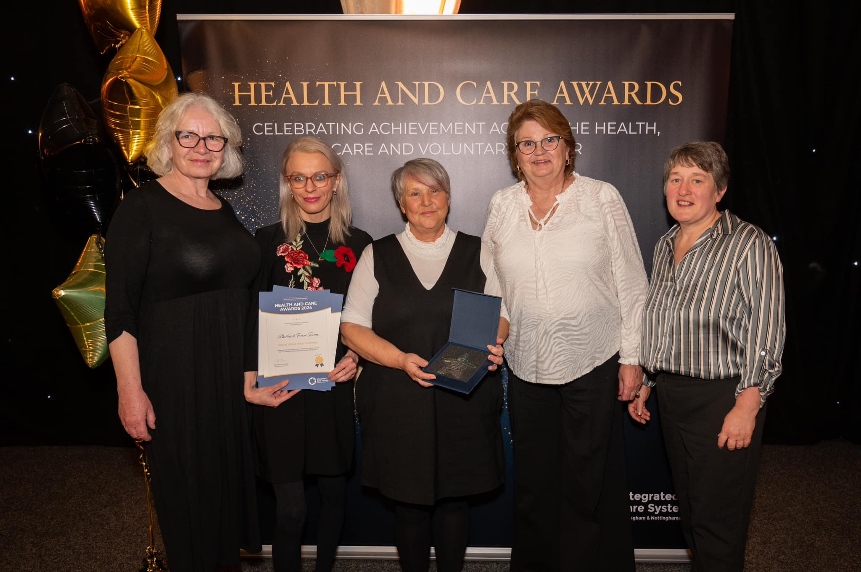

Rhubarb Farm is thrilled to announce that they were chosen as the winners of the Social Value Award at the NHS Nottingham and Nottinghamshire Health and Care Awards, celebrated last week. The ceremony was held at the glittering John Fretwell Centre in Warsop. Five members of the Rhubarb Farm team were in attendance to accept the award on behalf of all staff, volunteers and supporters of The Farm.

Rhubarb Farm provides employment and training opportunities to individuals facing social and economic challenges, including those in addiction recovery and individuals with criminal records. Through a compassionate and inclusive approach, Rhubarb Farm equips people with essential skills, resulting in growth and confidence building, and opening doors to new possibilities for those who may otherwise be marginalised.

In addition to employment and training, Rhubarb Farm addresses food insecurity in the local community by operating a Community Pantry. This initiative provides nutritious and affordable food bags twice a week, ensuring families and individuals have access to fresh and healthy options in times of need.

Reflecting on the win, Anita Ollerenshaw, Farm Manager, expressed her pride in the team’s dedication to making a positive impact: “This award is a testament to the tireless efforts of our team and the incredible resilience of the people we serve. At Rhubarb Farm, we believe that everyone deserves a second chance and the support to build a better future. This recognition is a powerful reminder that when people work together, we can create sustainable change and transform lives.”

Rhubarb Farm’s success at the awards is underscored by its commitment to going beyond standard service delivery, engaging with a broad network of local partners to provide impactful, long-term solutions for the community. Through these partnerships, The Farm has established itself as a much needed support provider for the area’s most vulnerable populations.

The team at Rhubarb Farm would also like to congratulate neighbouring winners and finalists, the Oasis Centre and Bassetlaw Action Centre. “Having three finalists and two winners from Bassetlaw at these awards truly highlights the exceptional work being done in our district to uplift and support our communities,” Ollerenshaw added.

For further information, please contact: **enquiries@rhubarbfarm.co.uk**