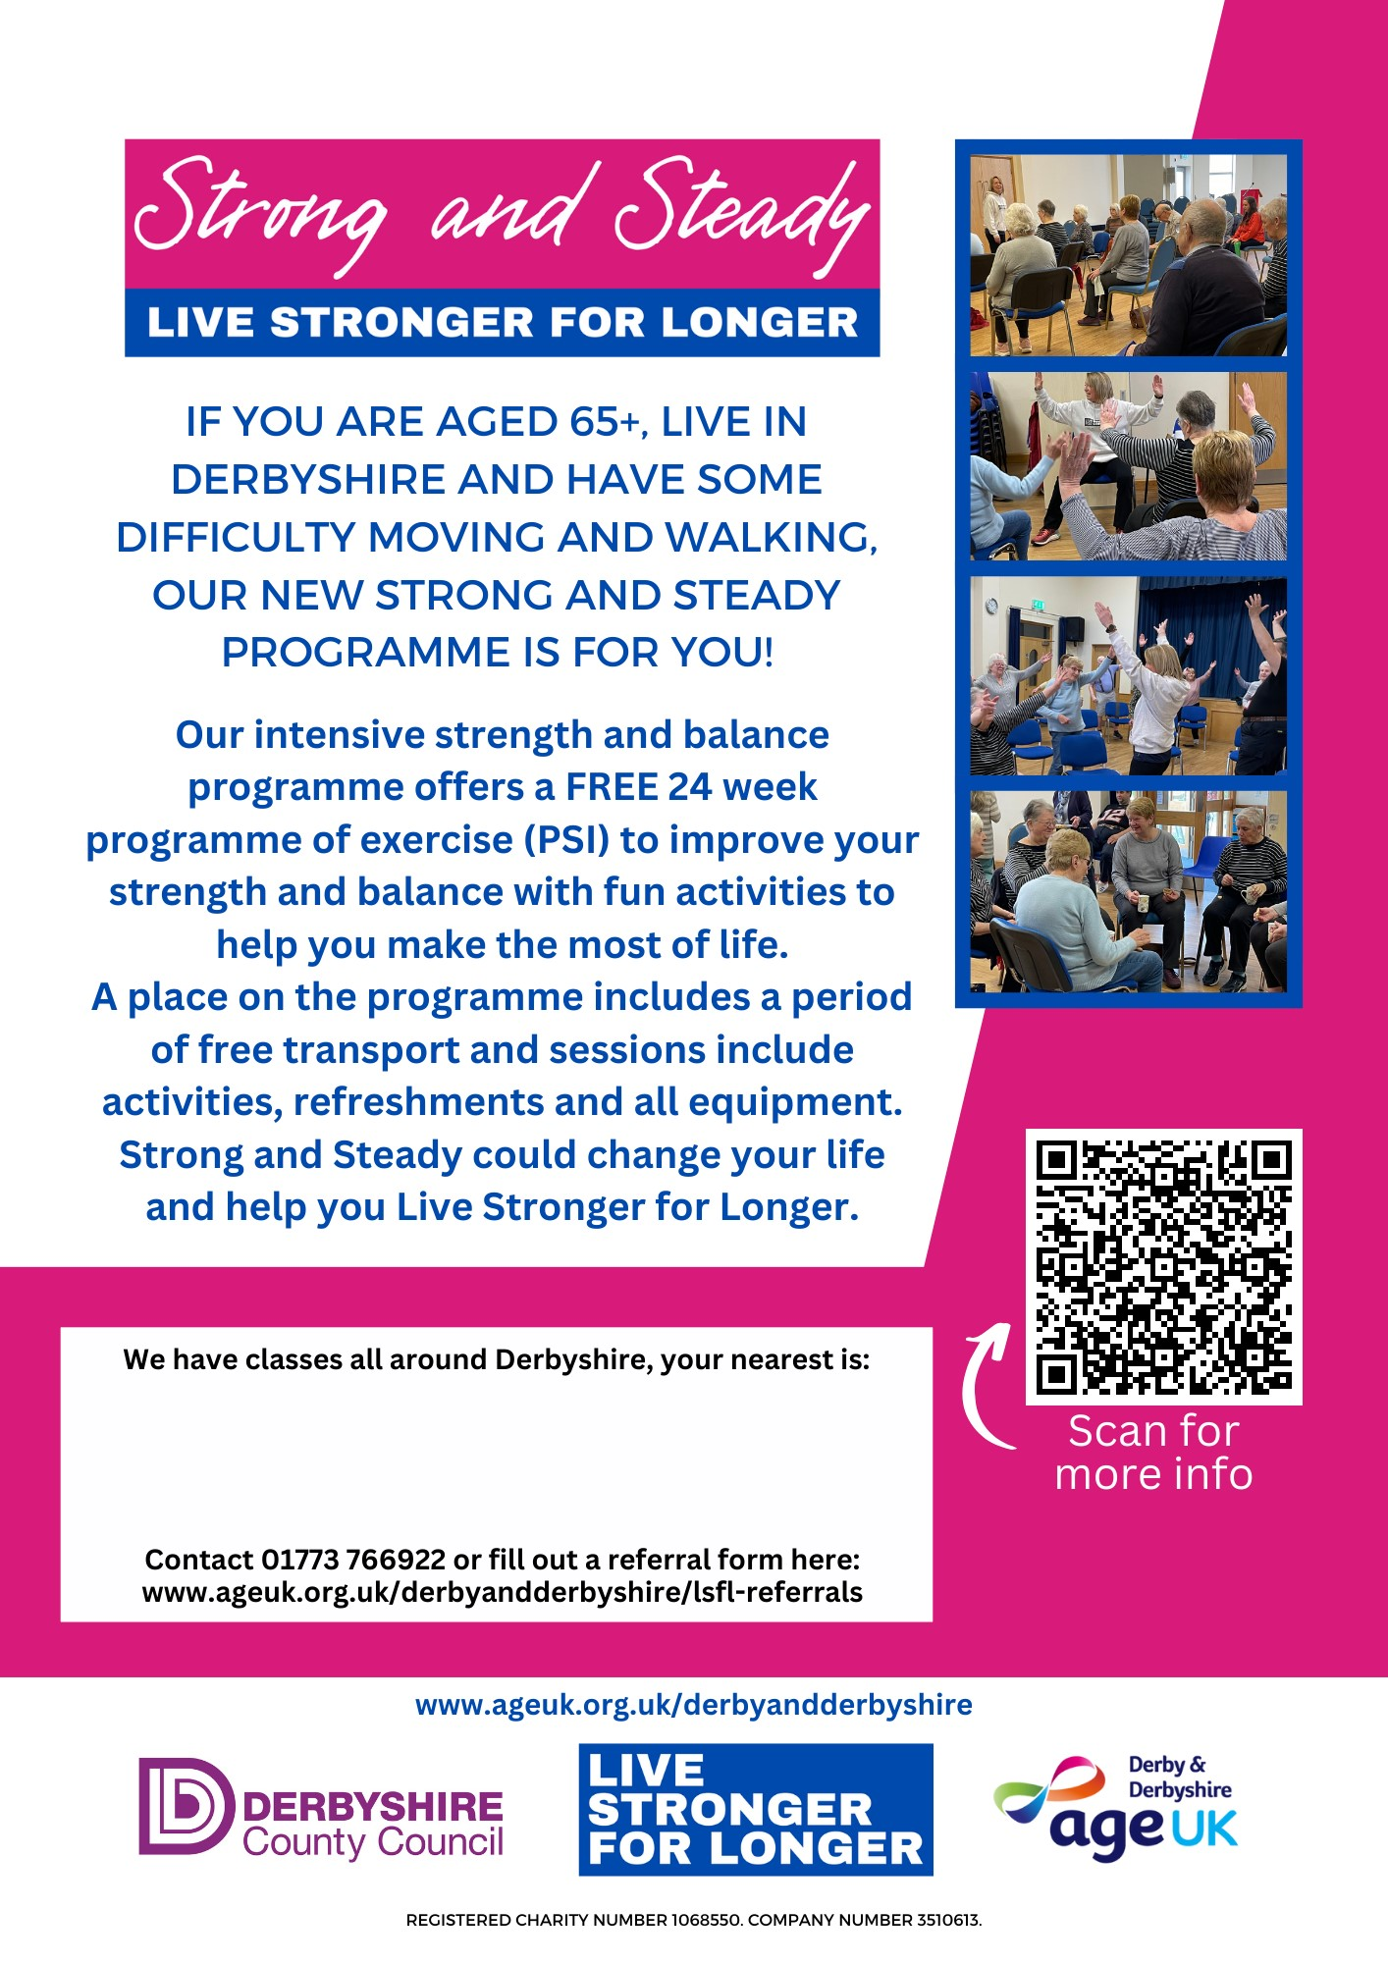

**Bolsover-Parish Rooms**

**Thursday 9.30am-12.30am**