

Welcome to **‘A Little TLC’** … **Tackling Loneliness Collaborative’s** ‘useful community information!’ – **18th** **December 2024.**

Please feel free to have a glance through the headlines or see details further down..…

Not long now until everything slows down until the New Year! 🎄

**A Massive Thank You…**

I wanted to thank you for a really productive year. There have been some fabulous partnership activities and so much useful information shared; it’s an amazing place to be part of.

We as a Collaborative wanted to work on a TLC website to be able to champion much of what you are doing – this is very close to being uploaded and connects to the ‘Friendly Connector’ social action model which has been worked through and is planned to be piloted and rolled out in 2025.

We also put on the first Tackling Loneliness in Nottingham & Nottinghamshire conference in November, which was a rich mixture of listening, learning and networking with others, many of the conversations were really interesting and thought provoking.

We are building a plan for 2025 which encompasses much of what we have worked on during this year and takes it to the next level. This takes into account what we have spoken about in meetings over the last few months.

*Please take time for yourself over this period of time (where you can!) and if you have time to message or call someone you haven’t seen for a while, please do – it can make such a difference.*

**TLC Update:**

**The TLC Website** – thank you to everyone who has contributed so far!

Content is being added and the website is evolving and will be ‘live’ soon.

The hosting and analytics are being sorted at the moment.

If you’ve expressed interest in trying out the website, I’ll be able to send out a draft version.

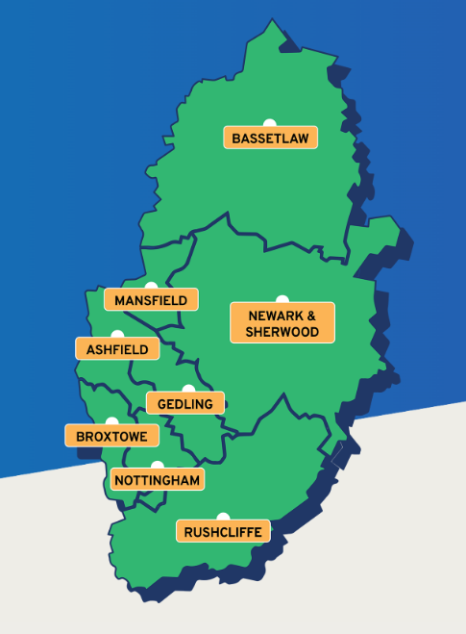

If you have any stories or photos too – please send them in to me.

I’ve had a variety sent through and would really appreciate a mixture

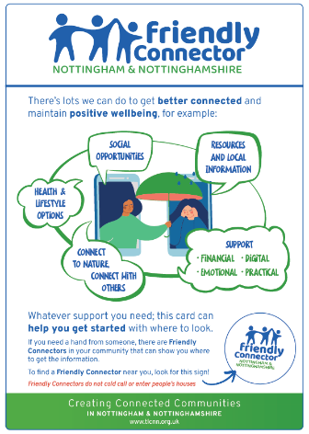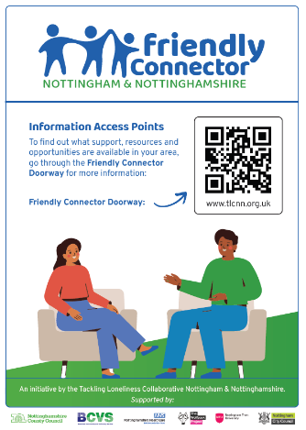

The Friendly Connector – again, thank you to everyone that has commented and is keen to support this signposting model.

This will be piloted before being rolled out. As it is linked to the TLC website this will be launched in 2025!

**Meetings:**

**The next ‘Little TLC Catch Up!’ informal drop in meeting will take place on: Wednesday 8th January – 12pm–12:45pm** [**Join the Little TLC Catch Up! meeting**](https://teams.microsoft.com/l/meetup-join/19%3ameeting_YWQ2ZWE0MDctNmFhOS00ODBhLTg5ZTQtZmFhNWRlZGI1NTM5%40thread.v2/0?context=%7b%22Tid%22%3a%224df4435f-8800-4e1e-a615-b287fcaa7120%22%2c%22Oid%22%3a%220325b866-b80d-4b91-9992-7e06eb2c7739%22%7d)

Meeting ID: 371 879 010 71   Passcode: nz3N7UW7

**The next full TLC meeting will take place on: Tuesday 14th January – 9:30-11am.** [**Click here to join the TLC meeting**](https://teams.microsoft.com/l/meetup-join/19%3a058d99892c25477ba09b0e7d1fbc2d11%40thread.tacv2/1709836741123?context=%7b%22Tid%22%3a%223a4e48d5-2a9d-45aa-8001-70f6a8186d0e%22%2c%22Oid%22%3a%22c4fdd0c2-c73b-4913-b114-429273bf0be4%22%7d) Meeting ID: 336 531 989 505   Passcode: QZpdbm        **An agenda will be sent out before.**

**Headlines:**

1. **BAND – B**roxtowe **A**ction **N**etwork **for D**ementia – are wanting people with an interest in Dementia to get involved in an 1 hour long monthly online meeting. See the poster of information below.
2. **Let’s connect Café** – see poster below
3. [Movement for Good - Nominate a charity for an award.](https://movementforgood.com/?utm_source=Email-giving&utm_campaign=12days24-launch&cmp=1&utm_medium=HTMLEmail#nominateACharity) Until 19th December 2024 so do it now!!
4. **Get Winter Vaccinations poster – Pop Up Empty Belly Poster – attached.**
5. **Eastwood Warm Spaces – see attached poster**
6. [Finding and engaging harder to reach older people in housing settings Tickets, Mon, Jan 13, 2025 at 3:00 PM | Eventbrite](https://www.eventbrite.co.uk/e/finding-and-engaging-harder-to-reach-older-people-in-housing-settings-tickets-1106304740259?aff=erelpanelorg)
7. [One Stop Community Partnership - Groundwork](https://www.groundwork.org.uk/one-stop-community-partnership/?fbclid=IwZXh0bgNhZW0CMTAAAR2IpkRJI7Mpa9Rv8wCw-2j-J6cosgENG_qzdU0jKR0OhaUEagrBZ9oy-kI_aem_84iDhuElDuCIRZb2UG1_hQ) – funding grants of up to £1000
8. **Links to the Tackling Loneliness Conference** Presentation slides and recordings of the interviews and some conference content: <https://www.bcvs.org.uk/tlc-conference>

Many thanks, Kirsty

Tackling Loneliness Collaborative Lead

Find us on [Facebook](https://www.facebook.com/tacklinglonelinesscollaborative)  and ‘X’ ([Twitter](https://twitter.com/TLCNotts))

Loneliness Page – [Tackling Loneliness Collaborative Nottingham and Nottinghamshire | Bassetlaw CVS (bcvs.org.uk)](https://www.bcvs.org.uk/tlcnn)

Research and Service Database -  [www.tlin.co.uk](http://www.tlin.co.uk/)

Book a Meeting with me: <https://calendly.com/kirsty-veitch-sorsby/tlc-informal-meeting>

           …………………………………………………………………………………………………………………………………………………………………………………………………………………………………………………………………………….…….

***Items to follow:***

1. 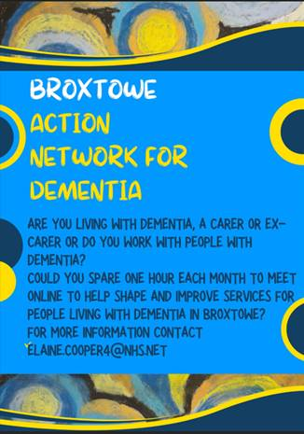

***­­­­­­­­­­­­­­­­­­­­­­­­***



1. [Movement for Good - Nominate a charity for an award.](https://movementforgood.com/?utm_source=Email-giving&utm_campaign=12days24-launch&cmp=1&utm_medium=HTMLEmail#nominateACharity) Closing date for nominations is 19th December 2024 – so act now if you want to nominate!
2. **Get Winter Vaccinations poster** – Pop Up Empty Belly Poster – attached.

***­­­­­­­­­­­***

1. **Eastwood Warm Spaces** – see attached poster

[Finding and engaging harder to reach older people in housing settings Tickets, Mon, Jan 13, 2025 at 3:00 PM | Eventbrite](https://www.eventbrite.co.uk/e/finding-and-engaging-harder-to-reach-older-people-in-housing-settings-tickets-1106304740259?aff=erelpanelorg)

Useful webinar from the Good Practice Mentors



[One Stop Community Partnership - Groundwork](https://www.groundwork.org.uk/one-stop-community-partnership/?fbclid=IwZXh0bgNhZW0CMTAAAR2IpkRJI7Mpa9Rv8wCw-2j-J6cosgENG_qzdU0jKR0OhaUEagrBZ9oy-kI_aem_84iDhuElDuCIRZb2UG1_hQ)

***Please click on this link to access the presenters slides and the excerpt from the play from the Tackling Loneliness Conference (this is the list available).  Please get in touch with me if you require any further details.***

[**https://www.bcvs.org.uk/tlc-conference**](https://www.bcvs.org.uk/tlc-conference)

[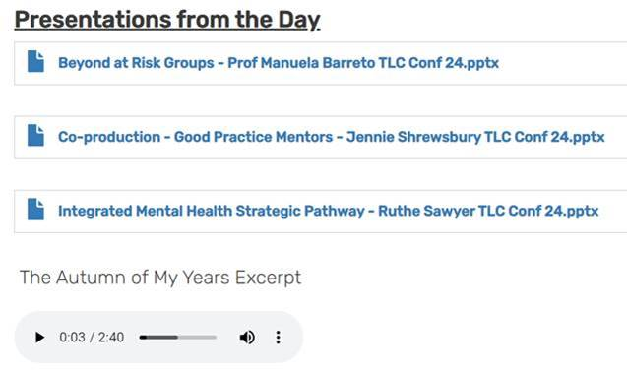](https://www.bcvs.org.uk/tlc-conference)

