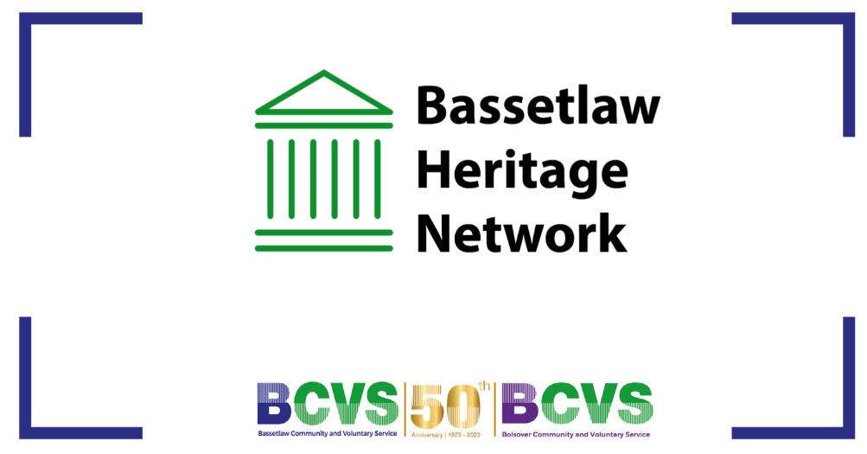

Teams link if joining on teams:

Join on your computer, mobile app or room device
Click here to join the meeting
Meeting ID: 335 986 578 752
Passcode: tbgLTK
Download Teams | Join on the web
Learn More | Meeting options

Agenda – Wednesday 23rd August

- Welcome, Attendance and Apologies
- Matter arising from last meeting
- Introduction – Marie Brown, BCVS Heritage Project Lead & Fundraising Manager
- Open Heritage Weekend Plans
- Current Funding Opportunities
- AOB

