A year of raising
[Stand alone email]
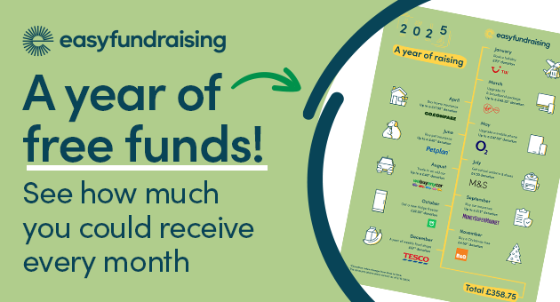
[Subject] This year, fundraise the easy way ✅
Over a year, just one person could raise £358 for your voluntary organisation, charity, or CIC for free without doing anything other than shopping online.
If that’s what just one person can do, what can a group of people do? Join easyfundraising to find out.
The online platform turns mundane bills and online purchases into free unrestricted funding your organisation can use to help pay for whatever it needs.
This ‘Year of Raising’ infographic highlights the big buys and one-off purchases people tend to get yearly, but let’s not forget the everyday items. easyfundraising works with over 8,000 online retailers, so a last-minute birthday present from Etsy or a jumper from John Lewis can also earn your organisation smaller but more frequent donations.
Those donations added up to over £6.6 million last year for community groups – and this year your organisation can get a share too.
It’s time to fundraise the easy way; sign your organisation up today: www.easyfundraising.org.uk/bassetlaw
_________________________________________
[Newsletter]

Over a year, just one person could raise £358 for your voluntary organisation, charity, or CIC for free without doing anything other than shopping online. Imagine what a group of people could do. And what you could buy for your organisation.
Join easyfundraising to find out. They work with over 8,000 online retailers, so your organisation can receive free unrestricted donations when anyone associated with your organisation shops online. £362 per person can be raised through those big annual one-off purchases - holidays, insurance, but let’s not forget the everyday items too. A last-minute birthday present from Etsy or a jumper from John Lewis can also earn your organisation smaller but more frequent donations.
A new year with new fundraising goals should start with a new way to raise. Sign your organisation up today: www.easyfundraising.org.uk/bassetlaw
_________________________________________
[Social]
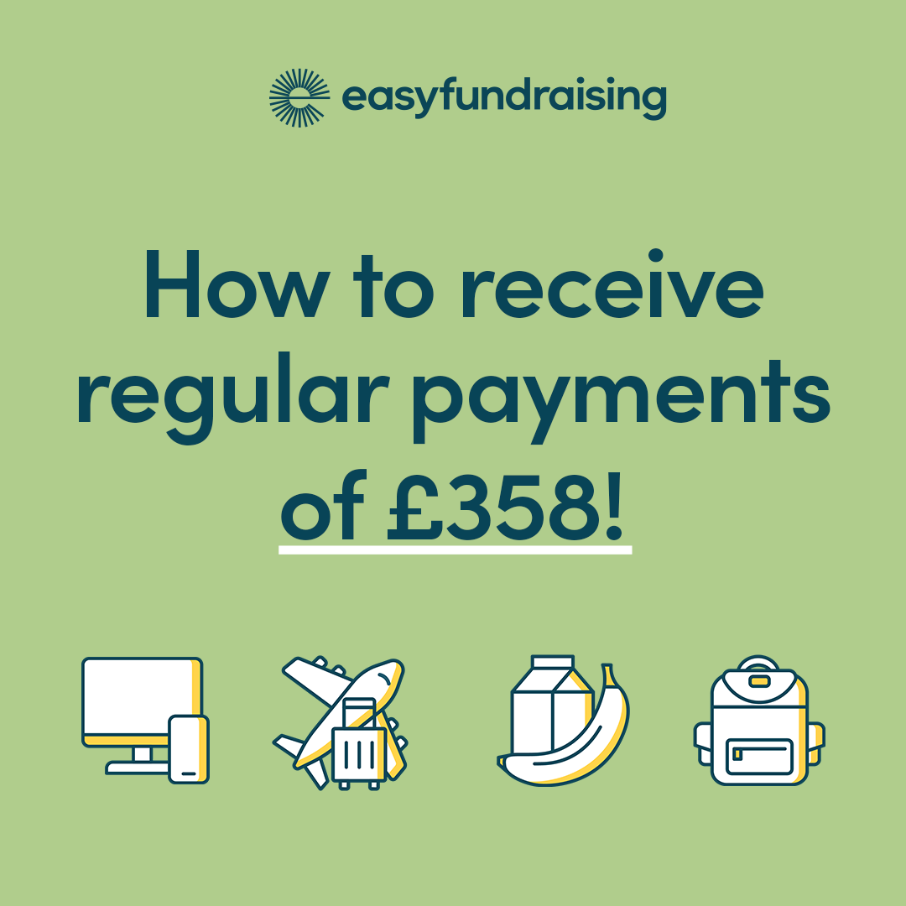
Over a year, just one person could raise £358 for your organisation for free without doing anything other than shopping online. 😲
Yes, it really is that simple ✅. Sign your organisation up to easyfundraising so one-off annual purchases and everyday items bought from over 8,000 retailers can earn your organisation free donations. 💰
It’s time to fundraise the easy way; sign up today: wwww.easyfundraising.org.uk/bassetlaw

