Hello,

Welcome to **‘A Little TLC’** … **Tackling Loneliness Collaborative’s** ‘useful community information!’ **– 14th February 2025.**

Please feel free to have a glance through the headlines or see details further down..…

**TLC Update:**

**The TLC Website** – thank you to everyone who has contributed so far!

Content is being added (almost done for the soft launch), the website is evolving and will be ‘live’ soon.

The hosting and analytics are nearly sorted.

If you’ve expressed interest in trying out the website, I’ll be able to send out a draft version.

If you have any stories or photos too – please continue to send them in to me.

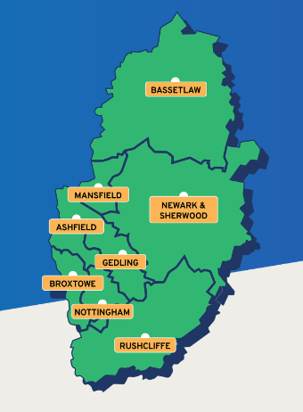I’ve had a variety sent through and would really appreciate a mixture.

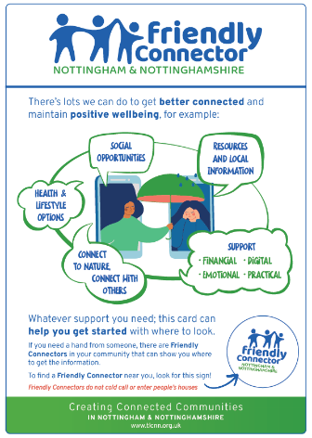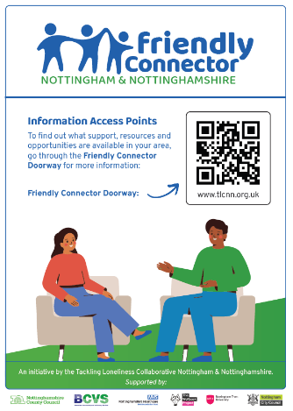

**The Friendly Connector** – again, thank you to everyone that has commented and is keen to support this signposting model.

This will be piloted before being rolled out. As it is linked to the TLC website this will be launched in pilot form soon!

**Meetings:**

**The next ‘Little TLC Catch Up!’ informal drop in meeting will take place on: Tuesday 4th March – 12:00pm-12:45pm**  [**Join the Little Catch Up! meeting**](https://teams.microsoft.com/l/meetup-join/19%3ameeting_NTdjOGQ0YTAtMGQ1Zi00ODBkLWIxZTQtZTg3MTU0OWIxYjA3%40thread.v2/0?context=%7b%22Tid%22%3a%224df4435f-8800-4e1e-a615-b287fcaa7120%22%2c%22Oid%22%3a%220325b866-b80d-4b91-9992-7e06eb2c7739%22%7d)

Meeting ID: 323 225 108 981   Passcode: XL6rM7em                On MS Teams. **It’s a chance to catch up and share items in a friendly way.**

**The next full TLC meeting will take place on: Tuesday 11th March – 9:30-11am.** [**Click here to join the TLC meeting**](https://teams.microsoft.com/l/meetup-join/19%3a058d99892c25477ba09b0e7d1fbc2d11%40thread.tacv2/1709836741123?context=%7b%22Tid%22%3a%223a4e48d5-2a9d-45aa-8001-70f6a8186d0e%22%2c%22Oid%22%3a%22c4fdd0c2-c73b-4913-b114-429273bf0be4%22%7d)       Meeting ID: 336 531 989 505   Passcode: QZpdbm

**An agenda will be sent out before – if you would like a space on the agenda to share what you are doing - please get in touch.**

**TLC Conference Link to Slides:** [**TLC Conference | Bassetlaw CVS**](https://www.bcvs.org.uk/tlc-conference)

**Headlines:**

1. **Community Friendly Nottinghamshire – see poster below**
2. [Mind Your Co-production Language! Tickets, Tue, Mar 18, 2025 at 11:00 AM | Eventbrite](https://www.eventbrite.co.uk/e/mind-your-co-production-language-tickets-1249222430919?aff=ebdsoporgprofile)
3. ***The Autumn of My Years – Intergenerational Event in Sheffield 26th February 2025 – See the attached poster***
4. [UK Measures of National Well-being Dashboard - Office for National Statistics](https://www.ons.gov.uk/peoplepopulationandcommunity/wellbeing/articles/ukmeasuresofnationalwellbeing/dashboard) – latest statistics.
5. [Do chatbots fill a social void? Research examines their role for lonely teens](https://www.psypost.org/do-chatbots-fill-a-social-void-research-examines-their-role-for-lonely-teens/) – link to article
6. [How people think about being alone shapes their experience of loneliness | Nature Communications](https://www.nature.com/articles/s41467-025-56764-3) – an interesting article about how loneliness is portrayed and perceived by people
7. **Festival of Science and Curiosity: science fun day -** [Book for the science fun day](https://links-2.govdelivery.com/CL0/https:%2F%2Fwww.inspireculture.org.uk%2Fwhats-on%2Fevents%2Ffestival-of-science-and-curiosity-science-fun-day%2F%3Futm_campaign=%26utm_content=%26utm_medium=email%26utm_source=govdelivery%26utm_term=/2/0101019504b5b195-2cf32c9c-086e-45ef-a2c2-b97ebcb118fd-000000/Ck6KP8rcB454w_tgwOA29CThI6LjVMk7DF5etjWKcXM=392)
8. Walking Tennis in Retford – See poster below for information
9. [Suicide Bereavement training (Nottingham & Nottinghamshire) Tickets, Fri 14 Mar 2025 at 12:30 | Eventbrite](https://www.eventbrite.co.uk/e/suicide-bereavement-training-nottingham-nottinghamshire-tickets-1244571770669?aff=ebemoffollowpublishemail&ref=eemail&utm_campaign=following_published_event&utm_content=follow_notification&utm_medium=email&utm_source=eventbrite)
10. [Social Sewing Group Tickets, Tue, Mar 11, 2025 at 11:00 AM | Eventbrite](https://www.eventbrite.co.uk/e/social-sewing-group-tickets-1245084534359?aff=ebemoffollowpublishemail&ref=eemail&utm_campaign=following_published_event&utm_content=follow_notification&utm_medium=email&utm_source=eventbrite)
11. [Places to Connect | Inspire - Culture, Learning, Libraries](https://www.inspireculture.org.uk/reading-information/health-and-wellbeing/places-to-connect/)
12. [Nottingham and Nottinghamshire Talking Therapies Conference 2025 Tickets, Fri 21 Mar 2025 at 09:30 | Eventbrite](https://www.eventbrite.co.uk/e/nottingham-and-nottinghamshire-talking-therapies-conference-2025-tickets-1223632510779?aff=oddtdtcreator)

[Nottingham and Nottinghamshire Talking Therapies Conference Tickets, Fri, Apr 25, 2025 at 10:00 AM | Eventbrite](https://www.eventbrite.co.uk/e/nottingham-and-nottinghamshire-talking-therapies-conference-tickets-1242023879859?aff=oddtdtcreator)

And finally…  **Ey Up Eastwood!** [Verity Cowley - 21/01/2025 - BBC Sounds](https://www.bbc.co.uk/sounds/play/p0kd9n7f)

***[cid:image007.jpg@01DB73F7.524791A0](Verity%20Cowley%20-%2021/01/2025%20-%20BBC%20Sounds)***

***[cid:image008.png@01DB73F7.524791A0](Verity%20Cowley%20-%2021/01/2025%20-%20BBC%20Sounds)***If you were unable to listen to this breakfast show, please do [click here to access show](https://www.bbc.co.uk/sounds/play/p0kd9n7f), available for a few more days!  [click here to access show](https://www.bbc.co.uk/sounds/play/p0kd9n7f),

There are so many positive groups, activities and stories in Eastwood, it is really great to hear about it!

Many thanks, Kirsty

Tackling Loneliness Collaborative Lead

Find us on [Facebook](https://www.facebook.com/tacklinglonelinesscollaborative)  and ‘X’ ([Twitter](https://twitter.com/TLCNotts))

Loneliness Page – [Tackling Loneliness Collaborative Nottingham and Nottinghamshire | Bassetlaw CVS (bcvs.org.uk)](https://www.bcvs.org.uk/tlcnn)

Research and Service Database -  [www.tlin.co.uk](http://www.tlin.co.uk/)

Book a Meeting with me: <https://calendly.com/kirsty-veitch-sorsby/tlc-informal-meeting>

           …………………………………………………………………………………………………………………………………………………………………………………………………………………………………………………………………………….…….

***Items to follow:***

***1.***

***[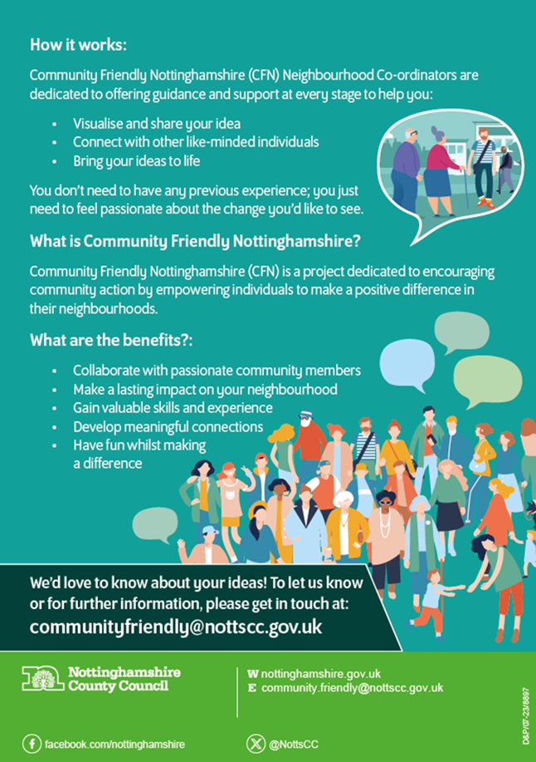](https://www.nottinghamshire.gov.uk/business-community/community-and-voluntary-sector/early-help-support/community-friendly-nottinghamshire)***

[Community Friendly Nottinghamshire | Nottinghamshire County Council](https://www.nottinghamshire.gov.uk/business-community/community-and-voluntary-sector/early-help-support/community-friendly-nottinghamshire)

***2.***

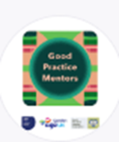

[Mind Your Co-production Language! Tickets, Tue, Mar 18, 2025 at 11:00 AM | Eventbrite](https://www.eventbrite.co.uk/e/mind-your-co-production-language-tickets-1249222430919?aff=ebdsoporgprofile)

Co-production is a simple concept, but it can feel very complex and out of reach. It can also mean different things depending on your perspective. The jargon used around this approach doesn’t help either, as it can leave people feeling confused, misguided, and that co-production it’s something too difficult to comprehend and too costly to do, often with concerns about getting it right!

This session will help to cut through any misunderstandings, get to the heart of what co-production is and what it really means to everyone involved.

***3. The Autumn of My Years – Intergenerational Event in Sheffield 26th February 2025 – See the attached poster***

***4.***

[UK Measures of National Well-being Dashboard - Office for National Statistics](https://www.ons.gov.uk/peoplepopulationandcommunity/wellbeing/articles/ukmeasuresofnationalwellbeing/dashboard)

The latest figures just out.

# UK Measures of National Well-being Dashboard

An overview of well-being in the UK on an individual, community and national level. Considers change across 59 measures of well-being, grouped by 10 topic areas.

11 February 2025

***5.***

[Do chatbots fill a social void? Research examines their role for lonely teens](https://www.psypost.org/do-chatbots-fill-a-social-void-research-examines-their-role-for-lonely-teens/)

A recent study published in the [*International Journal of Human-Computer Studies*](https://www.sciencedirect.com/science/article/pii/S1071581924001927) sheds light on how Danish high school students use chatbots for social interactions. The study found that while most students do not engage in friend-like conversations with chatbots, a small proportion do use chatbots to seek emotional support or engage in casual social conversations. These students reported significantly higher levels of loneliness and lower levels of perceived social support than their peers.

***­­­­­­­­­***

***6.***

[How people think about being alone shapes their experience of loneliness | Nature Communications](https://www.nature.com/articles/s41467-025-56764-3)

# How people think about being alone shapes their experience of loneliness

* [Micaela Rodriguez](https://www.nature.com/articles/s41467-025-56764-3#auth-Micaela-Rodriguez-Aff1),
* [Kathryn E. Schertz](https://www.nature.com/articles/s41467-025-56764-3#auth-Kathryn_E_-Schertz-Aff1) &
* [Ethan Kross](https://www.nature.com/articles/s41467-025-56764-3#auth-Ethan-Kross-Aff1-Aff2)

## Abstract

Loneliness is a widespread issue routinely targeted by the media and public health campaigns. We propose that these efforts, though well-intentioned, may exacerbate this problem by negatively influencing a potential driver of loneliness: people’s beliefs about being alone. Supporting this thesis, we show that contemporary U.S. news articles are 10 times more likely to describe being alone as harmful than beneficial (Study 1, *N* = 144 articles) and that exposure to such articles causally impacts people’s beliefs about being alone.

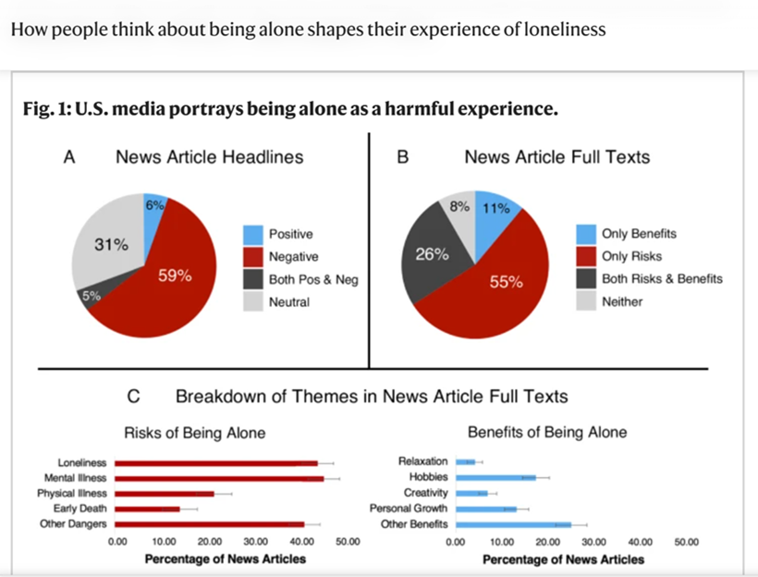

**7.**

**Festival of Science and Curiosity: science fun day**

**Mansfield Central Library, NG18 1NH**

**Thursday 20 February, 10am to 2pm**

**Free**

Do you have any budding scientists at home? Look no further than the Festival of Science and Curiosity this half term. The festival aims to let families explore the wonders of science in an engaging and accessible way. This year, the festival is celebrating a decade of sparking curiosity and inspiring young minds across Nottinghamshire.

### [Book for the science fun day](https://links-2.govdelivery.com/CL0/https:%2F%2Fwww.inspireculture.org.uk%2Fwhats-on%2Fevents%2Ffestival-of-science-and-curiosity-science-fun-day%2F%3Futm_campaign=%26utm_content=%26utm_medium=email%26utm_source=govdelivery%26utm_term=/2/0101019504b5b195-2cf32c9c-086e-45ef-a2c2-b97ebcb118fd-000000/Ck6KP8rcB454w_tgwOA29CThI6LjVMk7DF5etjWKcXM=392)

[See what else is on at the Festival of Science and Curiosity](https://links-2.govdelivery.com/CL0/https:%2F%2Fwww.inspireculture.org.uk%2Fwhats-on%2Fevents%2F%3Futm_campaign=%26utm_content=%26utm_medium=email%26utm_source=govdelivery%26utm_term=/1/0101019504b5b195-2cf32c9c-086e-45ef-a2c2-b97ebcb118fd-000000/-OqzH1GxtMjTkF78SLZ4iTGmp8xu9D2OcuvdFsCYU04=392)

**8.**

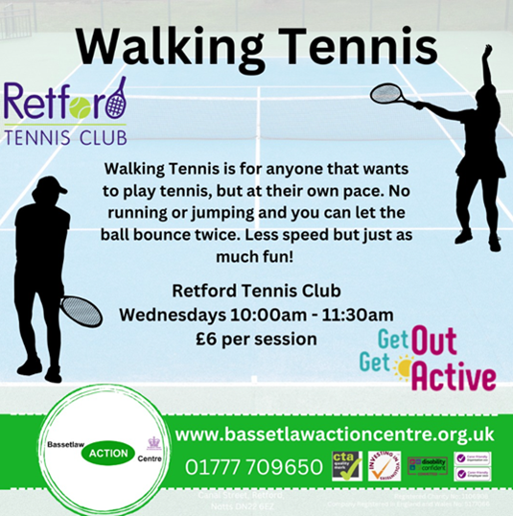

**9.**

### **LIVE ONLINE TRAINING via MS Teams**

### **Nottinghamshire County Council, Nottingham City Council and NHS Nottingham and Nottinghamshire ICB have commissioned Harmless to deliver a range of Mental Health, Self Harm awareness and Suicide prevention courses.**

### **Half-day Suicide Bereavement training**

[Suicide Bereavement training (Nottingham & Nottinghamshire) Tickets, Fri 14 Mar 2025 at 12:30 | Eventbrite](https://www.eventbrite.co.uk/e/suicide-bereavement-training-nottingham-nottinghamshire-tickets-1244571770669?aff=ebemoffollowpublishemail&ref=eemail&utm_campaign=following_published_event&utm_content=follow_notification&utm_medium=email&utm_source=eventbrite)

[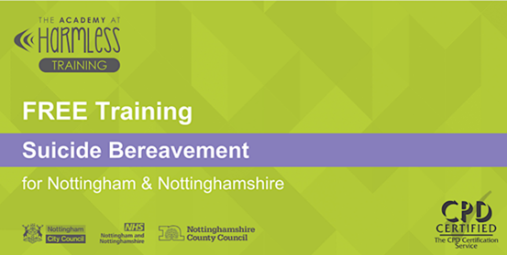](https://www.eventbrite.co.uk/e/suicide-bereavement-training-nottingham-nottinghamshire-tickets-1244571770669?aff=ebemoffollowpublishemail&ref=eemail&utm_campaign=following_published_event&utm_content=follow_notification&utm_medium=email&utm_source=eventbrite)

**10.**

[](https://www.eventbrite.co.uk/e/social-sewing-group-tickets-1245084534359?aff=ebemoffollowpublishemail&ref=eemail&utm_campaign=following_published_event&utm_content=follow_notification&utm_medium=email&utm_source=eventbrite)

Our sewing group can help you! Come and sew in a friendly social group with help from our expert and the rest of the group.

Sessions will be every Tuesday 11am-1.30pm

Venue: All Souls Community Centre, Ilkeston Road, Nottingham, NG7 3HF.

Cost of this class - Pay What You Can Donation (suggested £10)

You will get use of our sewing machines included in the cost as well as refreshments.

There will be a small selection of fabric and haberdashery available to buy to support your sewing projects.

[Social Sewing Group Tickets, Tue, Mar 11, 2025 at 11:00 AM | Eventbrite](https://www.eventbrite.co.uk/e/social-sewing-group-tickets-1245084534359?aff=ebemoffollowpublishemail&ref=eemail&utm_campaign=following_published_event&utm_content=follow_notification&utm_medium=email&utm_source=eventbrite)

**11.**

[Places to Connect | Inspire - Culture, Learning, Libraries](https://www.inspireculture.org.uk/reading-information/health-and-wellbeing/places-to-connect/)

[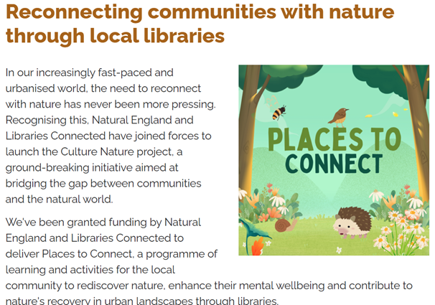](Places%20to%20Connect%20|%20Inspire%20-%20Culture,%20Learning,%20Libraries)

**12.**

**Talking Therapies Conference x 2**

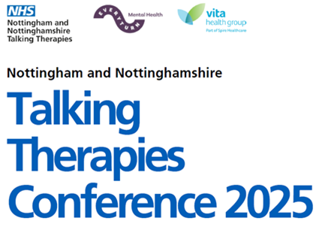

**Nottingham City and South Notts Friday 21st March 2025 Indian Community Association (ICCA)99 Hucknall Road, Nottingham NG5 1QZ 9:30am-3pm** [Nottingham and Nottinghamshire Talking Therapies Conference 2025 Tickets, Fri 21 Mar 2025 at 09:30 | Eventbrite](https://www.eventbrite.co.uk/e/nottingham-and-nottinghamshire-talking-therapies-conference-2025-tickets-1223632510779?aff=oddtdtcreator)

**Mid Notts and Bassetlaw Friday 25th April 2025 The Summit Centre, Pavilion Road, Kirkby in Ashfield, NG17 7LL — 10am-3pm** [Nottingham and Nottinghamshire Talking Therapies Conference Tickets, Fri, Apr 25, 2025 at 10:00 AM | Eventbrite](https://www.eventbrite.co.uk/e/nottingham-and-nottinghamshire-talking-therapies-conference-tickets-1242023879859?aff=oddtdtcreator)