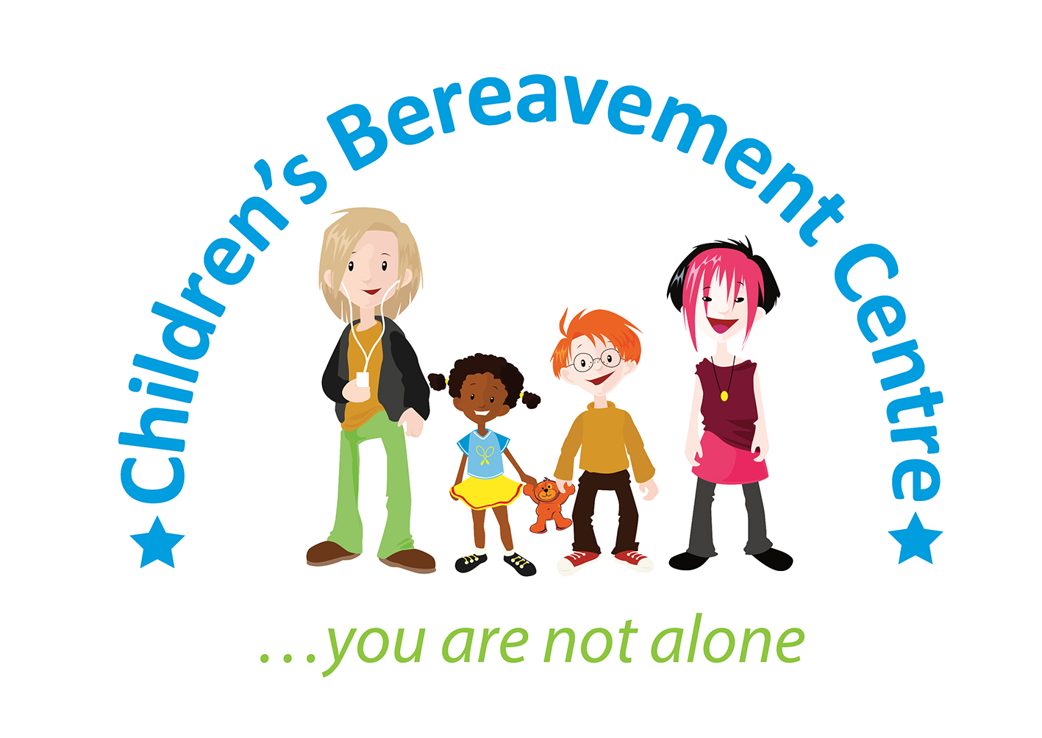

**Bereavement Counsellor/Therapist**

**Salary: £23,056-£25,084 per annum (FTE £28,821-£31,356) dependent on experience**

**Hours: 30 hours per week**

**Location: In and around Mansfield & Ashfield**

**Closing Date: Monday 14th April 2025 at 5pm.**

The Children’s Bereavement Centre is a highly respected Nottinghamshire charity who has been providing bereavement support and counselling to children, young people and their families since 2003.

This is an exciting opportunity for a person-centred Bereavement Counsellor, qualified to a minimum Level 4 counselling or therapy qualification, to benefit local children and families affected by terminal-illness or the death of someone important to them. There is possible progression to a Senior Bereavement Counsellor role.

Building on existing services, the successful candidate will be responsible for developing and delivering 1:1 bereavement counselling and carrying out family assessments and dependent on experience, supporting volunteer bereavement support workers and delivering group activities.

As an ambitious charity with high demand for support in Nottinghamshire, we want to expand our services to benefit as many families as possible. If you as passionate as we are, we would love to hear from you.

For full details about the role and to apply to be a part of our small team, please download an application pack from our website

[**https://www.childrensbereavementcentre.co.uk/careers**](https://www.childrensbereavementcentre.co.uk/careers)or to discuss the role in more detail please call our Chief Executive Kate Baxter on 07703 566170 or email [kate@childrensbereavementcentre.co.uk](mailto:kate@childrensbereavementcentre.co.uk)

*Appointments are subject to receiving an enhanced disclosure from the Disclosure and Barring Service which we consider acceptable and two satisfactory references. We offer a great working environment, ongoing training and support, and pension scheme. We are an equal opportunity employer.*

**Children’s Bereavement Centre, 3 Kings Road, Newark, Notts, NG24 1EW.**

**Registered Charity Number: 1098935**