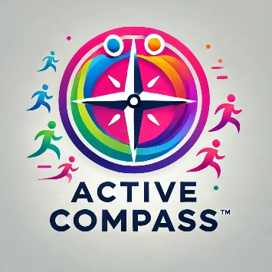

**Join Active Compass as a Volunteer Trustee!**

Are you passionate about using physical activity to create positive change? Active Compass, a dedicated community group, is looking for Volunteer Trustees to help guide our mission and make a real impact.

Bring your skills, experience, and enthusiasm to a team committed to improving lives through movement. Join us today!

**Interested?** Get in touch at [steve.morris@bcvs.org.uk](mailto:steve.morris@bcvs.org.uk)