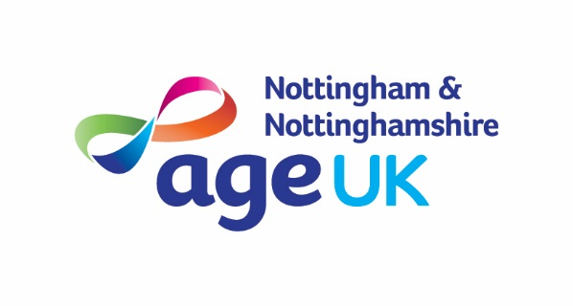

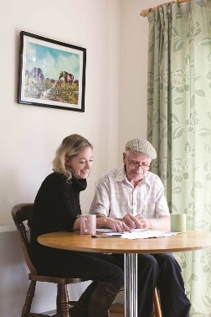

**Communication & Customer Service**

**Planning & Organisation**

**Recording and Monitoring**

**Leadership**

**Quality**

**Charity Focus**

**Specialist Knowledge**

**Team Work**



**Benefits Advisor**

**Hours: 37 hours per week**

**Salary: £24,916 per annum (AUNN Band E)**

**Based: Hybrid – home, office and field based**

**Tenure: Permanent**

The Age UK Nottingham and Nottinghamshire Advice team provides welfare benefits advice tailored to the needs of older and vulnerable people in Nottingham and Nottinghamshire. With a small team of paid staff, the service works extensively with volunteers to provide services including office appointments, telephone sessions and home visits across Nottingham and Nottinghamshire.

The postholder will focus on maximising income by completing welfare benefit entitlement checks and providing support to make the relevant claims and challenge decisions where applicable. They will also help to support a team of volunteers within the service.

The role requires excellent attention to detail, organisation and communication skills and the ability to accurately maintain comprehensive case notes and produce reports in line with contractual deadlines. The ability to work independently and be flexible to accommodating the changing demands of the service is a must. Previous experience working within the advice or benefits sector is essential, although additional training can be provided as required.

*As an employee of Age UK Nottingham & Nottinghamshire you will be eligible for our attractive package which includes 24 days annual leave (Pro Rata), public holidays, flexible working and a 4% employer contribution pension (in line with auto-enrolment rules). You will also have access to a Blue Light Card, BUPA Employee Assistance Programme and a range of retail, travel and lifestyle employee discounts.*

**How to Apply**

For full details and to download an application pack, please visit our website at [www.ageuk.org.uk/notts/about-us/work-for-us/](http://www.ageuk.org.uk/notts/about-us/work-for-us/). Alternatively, please contact our Human Resources department for an application pack by email [recruitment@ageuknotts.org.uk](mailto:recruitment@ageuknotts.org.uk) or telephone 0115 859 9265.

**The closing date for receipt of completed applications is**

**Tuesday 22nd April 2025 at 9am.**

The vacancy may close early if a high volume of applications are received.

*Age UK Notts promotes equality and diversity.*

*Registered Charity Number: 1067881*